COMMUNITY EMPOWERMENT (SCOTLAND) ACT 2015
FALKIRK COUNCIL ASSET TRANSFER REQUEST FORM
IMPORTANT NOTES:
This is an application form which can be used to make an Asset Transfer request to Falkirk Council.
Any Community Body interested in making an Asset Transfer Request is advised to contact the Asset Team on strategicpropertyreview@falkirk.gov.uk before making the request so that we can discuss your proposal.
Please complete the asset transfer request form if the property/land is owned/leased/managed by Falkirk Council.
It is essential that you read the Asset Transfer guidance provided by the Scottish Government before making a request.
When completed, this form should be emailed to strategicpropertyreview@falkirk.gov.uk or sent to
The Asset Team
Falkirk Council
4 Stadium Way
Falkirk
FK2 9EE

Section 1: Information about the Community Transfer Body (CTB) making the request
  - Name of the CTB making the asset transfer request
Rainbow Muslim Women’s Group
  - CTB address. This should be the registered address, if you have one.
Postal address:
Postcode:

  - Contact details. Please provide the name and contact address to which correspondence in relation to this asset transfer request should be sent.
Contact name: [REDACTED]
Postal address:
[REDACTED]
[REDACTED]
Postcode:
[REDACTED]
Email:
[REDACTED]
Telephone: [REDACTED]
☐ We agree that correspondence in relation to this asset transfer request may be sent by email to the email address given above. (Please tick to indicate agreement)
You can ask Falkirk Council to stop sending correspondence by email, or change the email address, by telling them at any time, as long as 5 working days’ notice is given.

  - Please mark an “X” in the relevant box to confirm the type of CTB and its official number, if it has one.
 | Company and its company number is ………….
X | Scottish Charitable Incorporated Organisation (SCIO) and its charity number is | SC047758
 | Community Benefit Society (BenCom) and its registered number is ………………………………
 | Unincorporated organisation (no number)

Please attach a copy of the CTB’s constitution, articles of association or registered rules.
Please note that under The Community Empowerment (Scotland) Act 2015, where a CTB is seeking ownership rather than a lease, the organisation must have at least 20 members. See the Scottish Government’s Guidance for Community Transfer Bodies.
  - Has the organisation been individually designated as a community transfer body by the Scottish Ministers?
No ☐
Yes ☐
Please give the title and date of the designation order:

  - Does the organisation fall within a class of bodies which has been designated as community transfer bodies by the Scottish Ministers?
No ☐
Yes ☐
If yes what class of bodies does it fall within?
Scottish Charitable Incorporated Organisation (SCIO)

- Information about the land and rights requested
  - Please identify the property/land to which this asset transfer request relates.
You should provide a street address or grid reference and any name by which the land or building is known. If you have identified the land on the relevant authority’s register of land, please enter the details listed there.
It may be helpful to provide one or more maps or drawings to show the boundaries of the land requested. If you are requesting part of a piece of land, you must attach a map and give a full description of the boundaries of the area to which your request relates. If you are requesting part of a building, please make clear what area you require. A drawing may be helpful.
Details of Property:
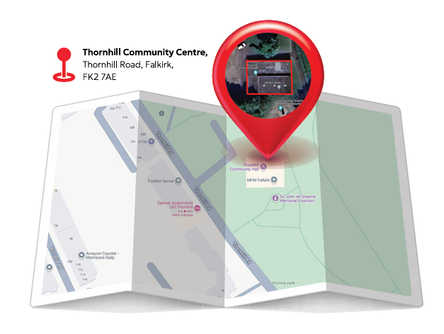
Figure 1: Thornhill Community Centre Location
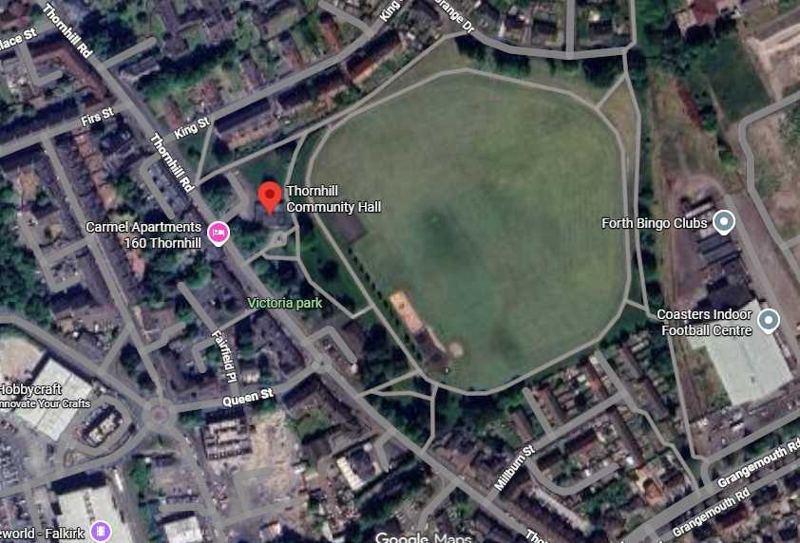
Figure 2: Aerial Overview
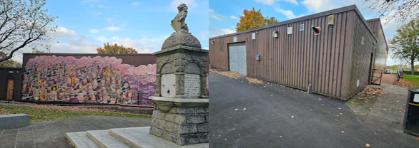
Figure 3: Exterior View
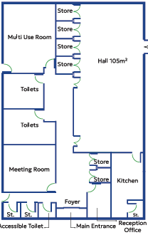
Figure 4: Building Layout (proposed)
Address:
Thornhill Community Centre
Thornhill Road
Falkirk
Postcode:
FK2 7AE

  - Please provide the UPRN (Unique Property Reference Number), if known.

UPRN: 136029150

- Type of request, payment and conditions
  - Please tick what type of request is being made:

X for ownership (under section 79(2)(a)) - go to section 3A

for lease (under section 79(2)(b)(i)) – go to section 3B

for other rights (section 79(2)(b)(ii)) - go to section 3C

3A – Request for Ownership
What price are you prepared to pay for the land requested?
Proposed price: £1
Please attach a note setting out any other terms and conditions you wish to apply to the request.

3B – Request for Lease

What is the length of lease you are requesting?

How much rent are you prepared to pay? Please make clear whether this is per year or per month.

Proposed rent: £ per

Please attach a note setting out any other terms and conditions you wish to be included in the lease, or to apply to the request in any other way.

3C – Request for other Rights
What are the rights you are requesting?

Do you propose to make any payment for these rights?
Yes ☐
No ☐
If yes, how much are you prepared to pay? Please make clear what period this would cover, for example per week, per month, per day?
Proposed payment: £ per

Please set out any other terms and conditions you wish to apply to the request.

- Community Proposal
  - Please set out the reasons for making the request and how the land or building will be used.
This should explain the objectives of your project, why there is a need for it, any development or changes you plan to make to the land or building, and any activities that will take place there.
4.1.1 Objectives of Project
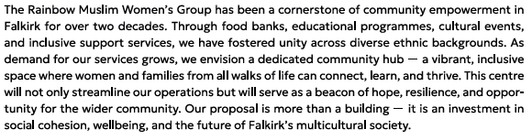
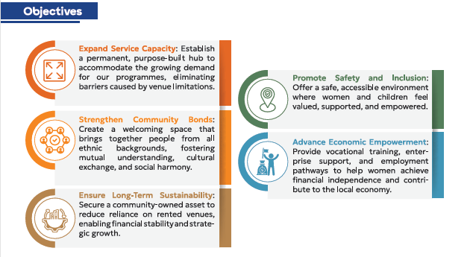

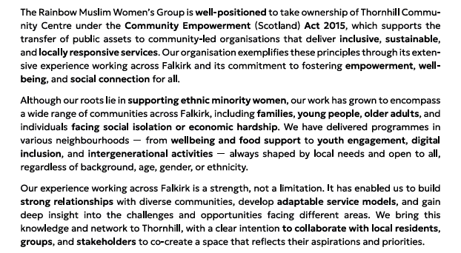

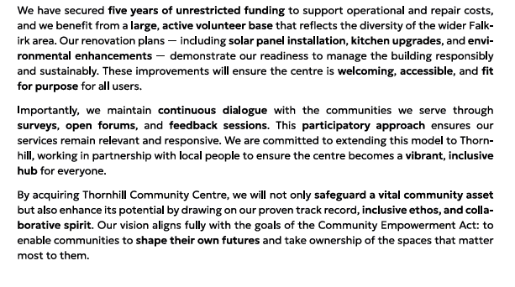
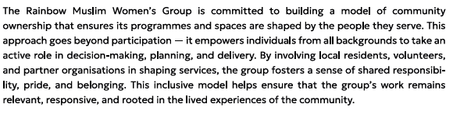

4.1.2 Why there is a need for your Project?
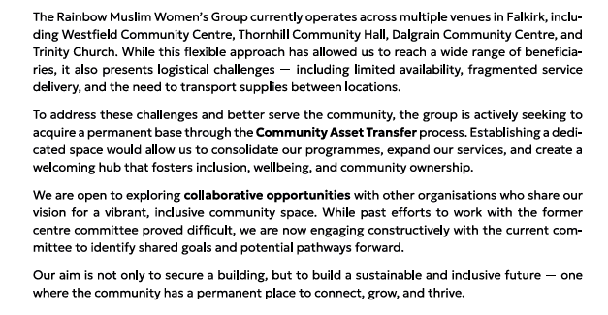
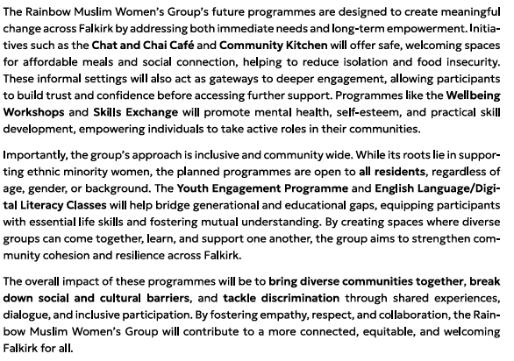
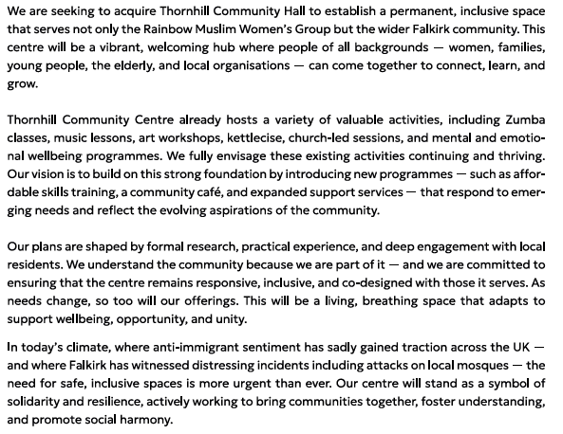


4.1.3 Will any Development/changes/modifications to the asset be required?
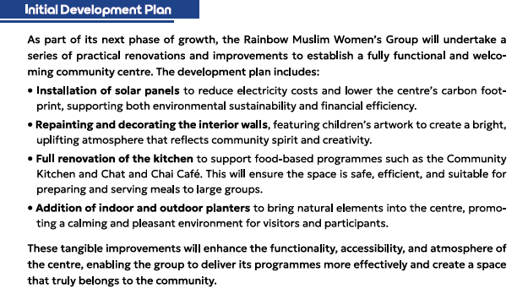

4.1.4 What activities will take place?

There is currently a number of different lets that operate from the Thornhill Community Centre – we aim to continue these lets for the foreseeable future. These types of let, are indicative of the types of services and activities, that are required by the local community.

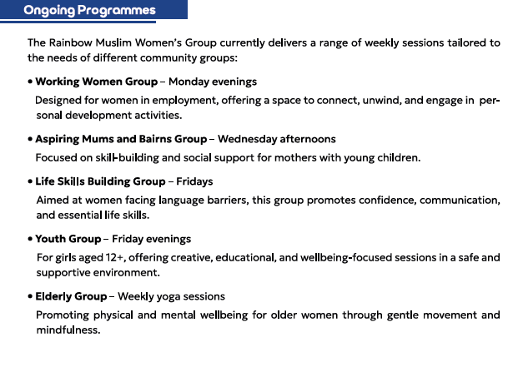

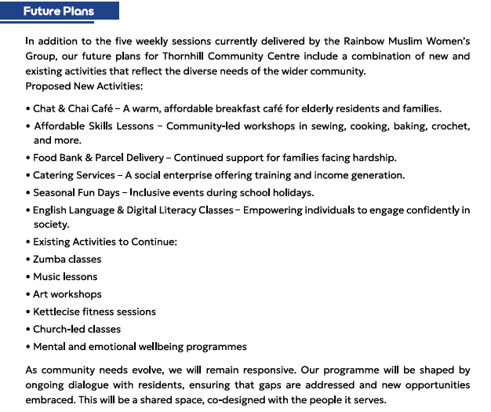
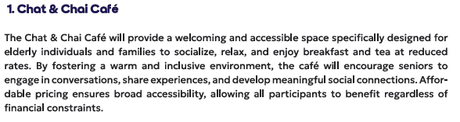
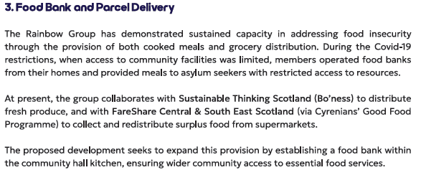
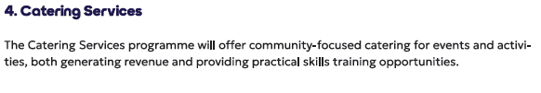

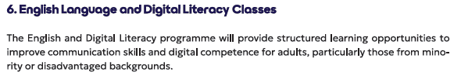

4.1.5. If the asset is to be used by the public, please provide details of lettings policy and opening times.
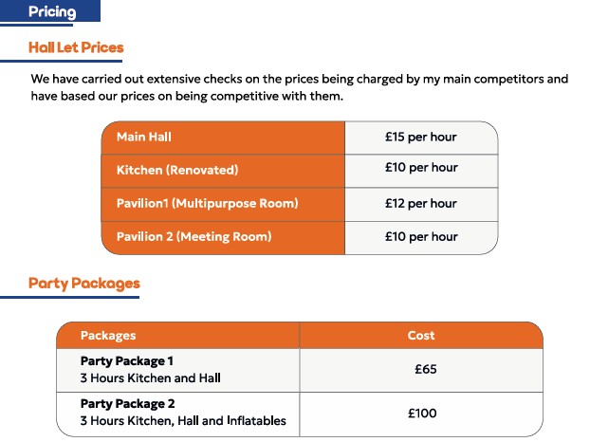

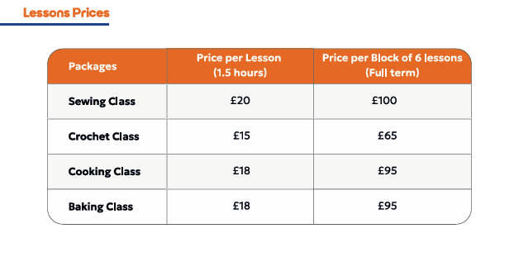

4.1.6 What provision will be provided for people with disabilities?

The community centre is all on one level, and the centre is fully accessible. We will ensure that all activities, where possible, are accessible by all.

4.1.7 Any other relevant information?

Current activities organised by the Rainbow Muslim Women’s Group:

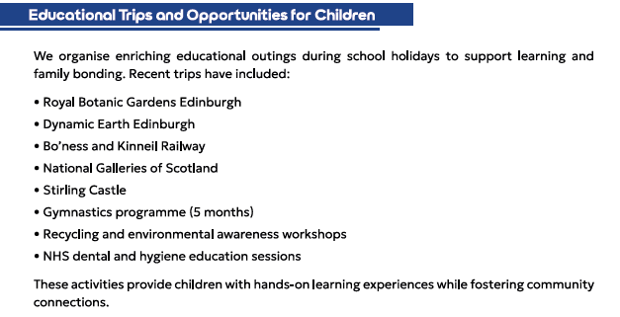
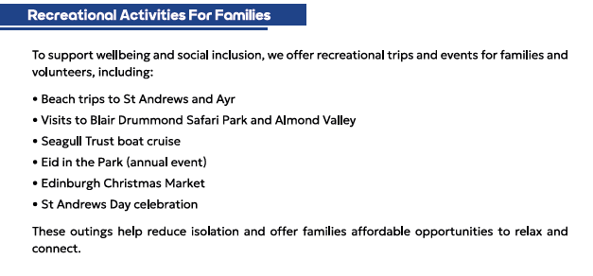
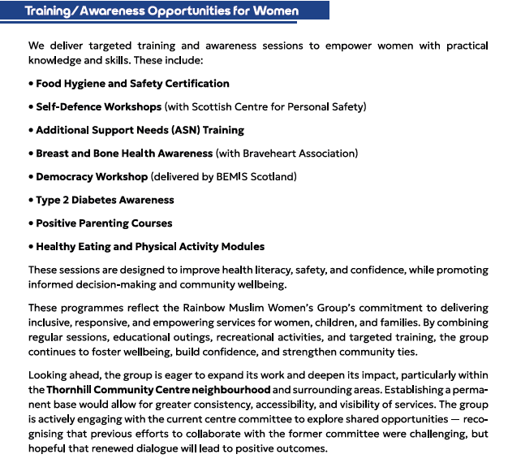

Benefits of the proposal
  - Please set out the benefits that you consider will arise if the request is agreed to.
Local Authorities are permitted to dispose of property at less than market value where there are wider public benefits to be gained. This is set out in the Disposal of Land by Local Authorities (Scotland) Regulations 2010. These public benefits are listed below.
In this section, please explain how the project will benefit your community, and others. Please refer to the Scottish Government guidance on how the Council will consider the benefits of a request.
Please explain how the project will benefit your community by detailing how your project will promote or improve:-

4.2.1. Economic development/income generation

ie. Please include details of any job creation or volunteering and training opportunities that will be available as a result of the Asset Transfer. Also details of how your organisation will involve the local community and of any incentives that may be available to encourage the local community to use the proposed services.

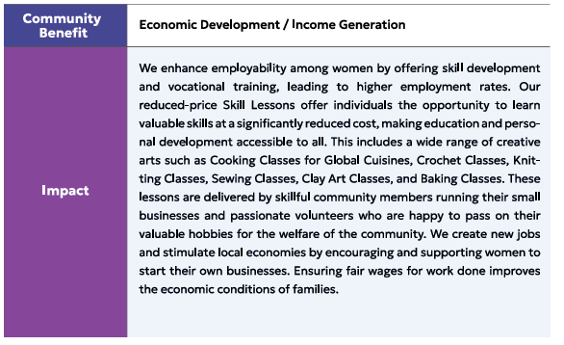


    - Regeneration

i.e. Please include details of whether your organisation will contribute to the physical regeneration of the area, and how your proposal will impact the regeneration of the area, in terms of volunteering or employment, giving examples.
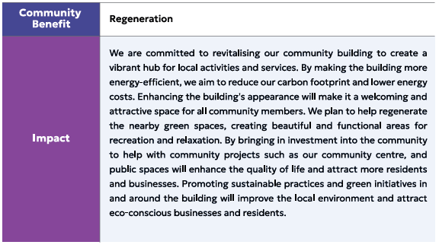
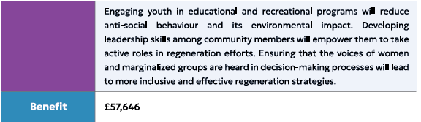

    - Public Health

i.e. How likely is the proposal to improve the Public Health of the Community, in terms of physical and mental health, for example through volunteering, training, or taking part in activities, giving examples.


    - Social Wellbeing

i.e. How will the proposal improve the Community's Social Well-Being and mental health, or how might it improve the learning offer and activities available in the area? Please give brief examples of these activities.
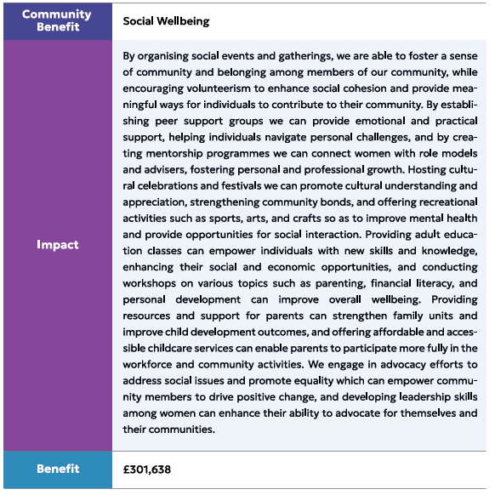

    - Environmental Wellbeing / Environmental Benefits

i.e. Will the proposal bring green / environmental benefits and / or have an impact on the local environment? Will it help mitigate the effects of climate change? If so please give details.

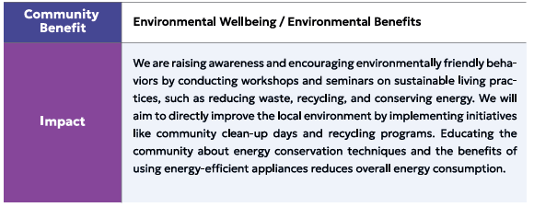
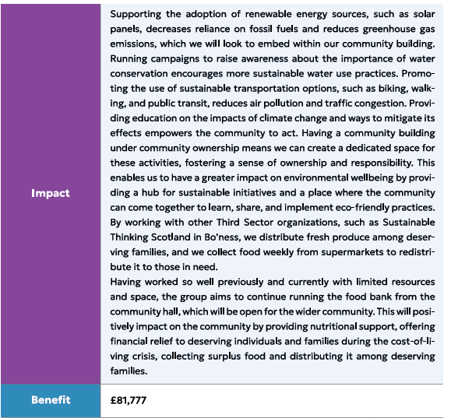

    - Does your project contribute to the reduction of inequalities?

i.e. Will the proposal enable the community to access activities not otherwise available; will these activities be available at an affordable rate; how will your organisation work with other local providers to reduce inequalities?

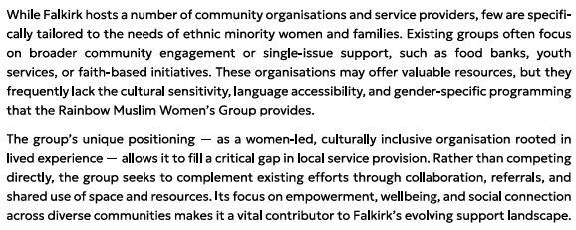

4.2.7 Will local people be engaged in the use and management of the Asset?

A “community of interest” may not represent the people living near to the asset. Please provide evidence of how local people and communities will be engaged in the use and management of the asset, and how they have been consulted.

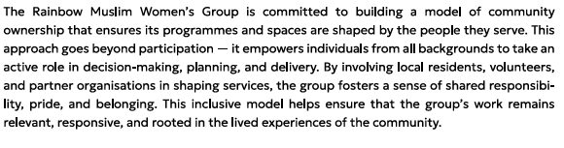
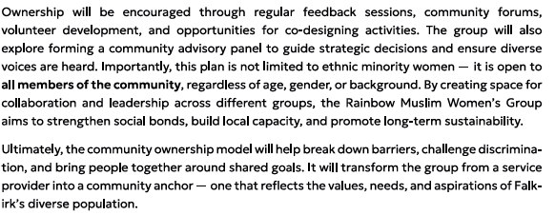

4.2.8 How will you monitor whether the Asset Transfer is benefiting the community?

ie. Will you survey the users / invite feedback / compare user numbers with a baseline etc

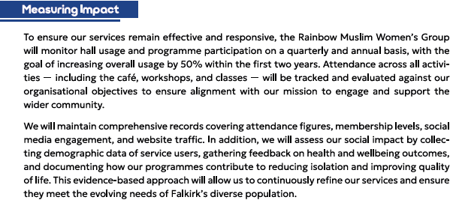

4.2.9 Any other relevant information?
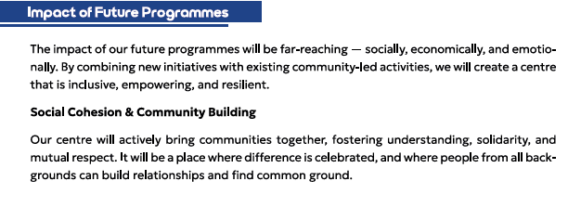
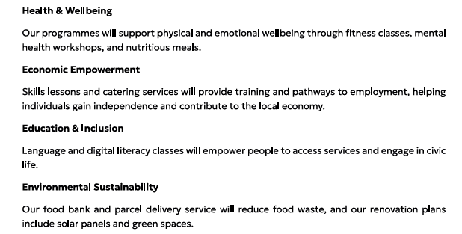

Restrictions on use of the land
  - If there are any restrictions on the use or development of the land, please explain how your project will comply with these.
Restrictions might include, amongst others, environmental designations such as a Site of Special Scientific Interest (SSI), heritage designations such as listed building status, controls on contaminated land or planning restrictions.
No known restrictions

Negative consequences
  - What negative consequences (if any) may occur if your request is agreed to? How you propose to minimise / reduce these?
You should consider any potential negative consequences for the local economy, environment, or any group of people, and explain how you could reduce these.
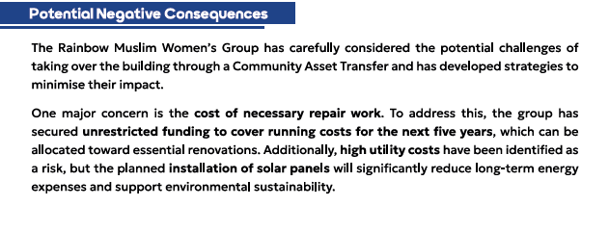
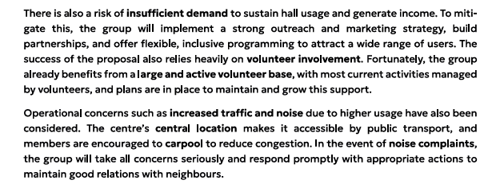

Capacity to deliver
  - Please show how your organisation will be able to manage the project and achieve your objectives.
This could include the skills and experience of members of the organisation, any track record of previous projects, whether you intend to use professional advisers, etc.
4.5.1 Has your organisation or any of its members managed projects or owned / leased property/land prior to this?
Yes X
No
The organisation has successfully managed a range of different projects in the past. The group has successfully organised, managed, and delivered educational trips during school holidays – from the Royal Botanic Gardens to Stirling Castle; and recreational trips for the whole family – from beach trips to Ayr and St Andrews, to a day spent at the Edinburgh Christmas Market.

Please provide details of:
4.5.2 Skills and experience of the members of the organisation
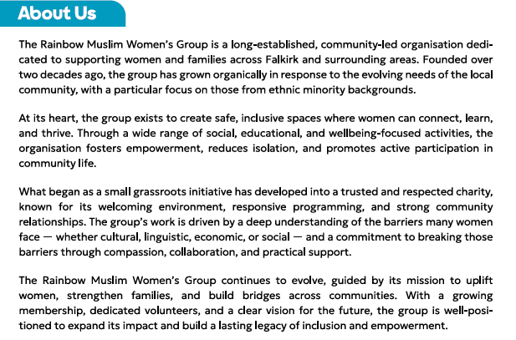
[NAMES REDACTED]

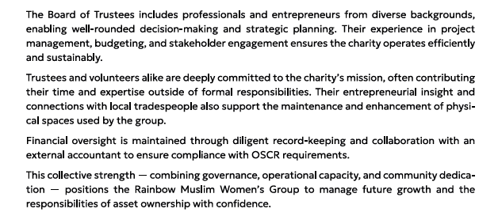

4.5.3 Do you intend to use professional advisors? Please provide details.
We will carry out the necessary record-keeping/book-keeping for the centre. We instruct an Accountant to independently examine our accounts before we complete our annual Return with OSCR.
We will instruct a solicitor to negotiate our agreement with Falkirk Council.
We intend to instruct several surveyors, architects, etc, as the need arises.

4.5.4 Do you currently lease/manage a property from Falkirk Council? If yes, please provide details.
We do not currently lease or manage a property direct from Falkirk Council at present. We aim to take on an FRI Licence of the Thornhill Community Centre, which will give us invaluable hands-on experience of managing and operating a community asset.

4.5.4 Please detail how you plan to manage the building?
For example opening and closing the building / managing lets / will you have staff etc?
The centre will be managed by a dedicated group of volunteers, who will manage the opening and closing of the building, and booking of lets. The committee is considering funding a project worker post in the future, but in the interim all projects will be managed by the Rainbow Muslim Women’s Group staff and volunteers.

4.5.5 Please provide any other information you think may be relevant.
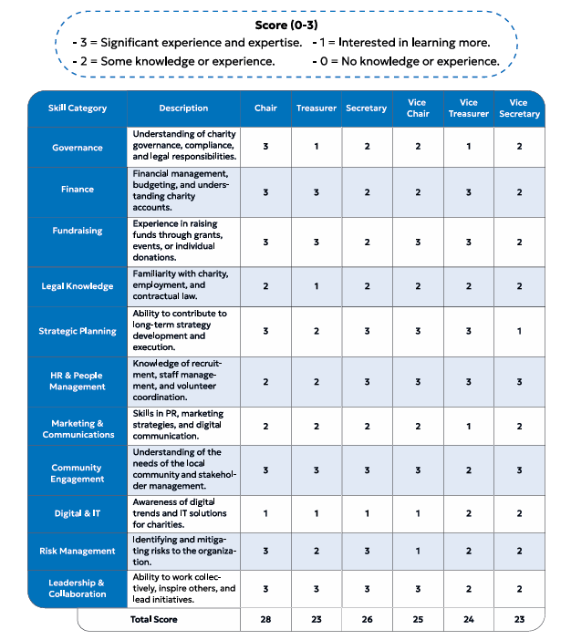Figure 5: Skills Audit


- Level and nature of support
  - Please provide details of the level and nature of support for the request, from your community and, if relevant, from others.
This could include information on the proportion of your community who are involved with the request, how you have engaged with your community beyond the members of your organisation and what their response has been. You should also show how you have engaged with any other communities that may be affected by your proposals.

5.1.1. What community engagement has taken place to help develop your business plan? Please provide evidence, for example any completed surveys, questionnaires, letters of support, minutes of public meetings etc.
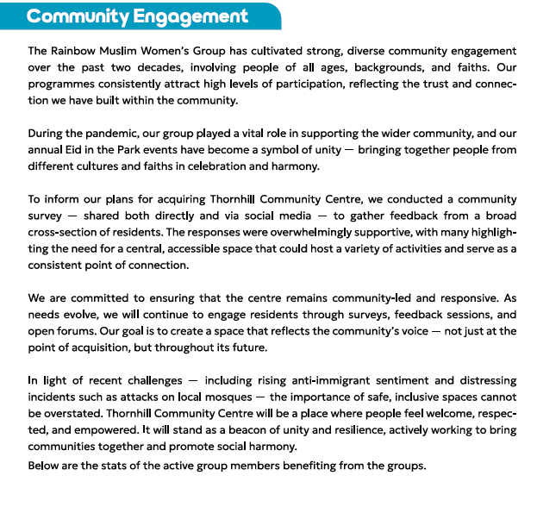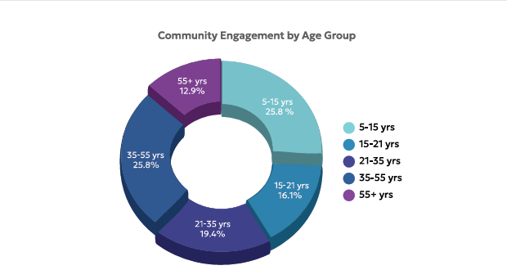
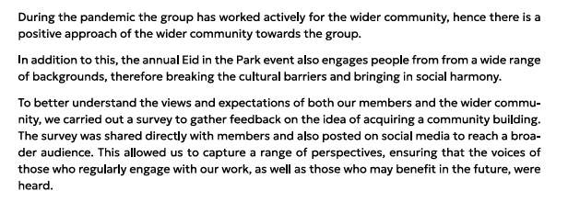
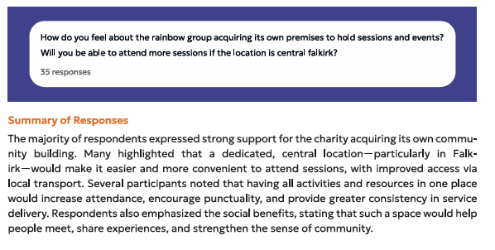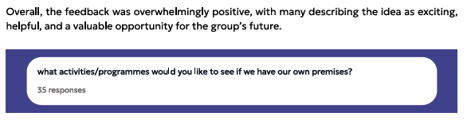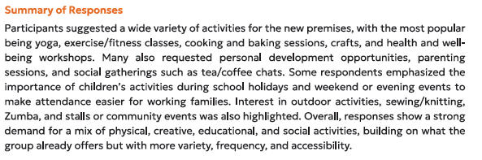

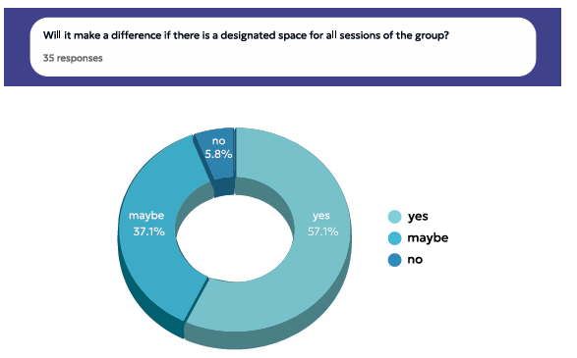

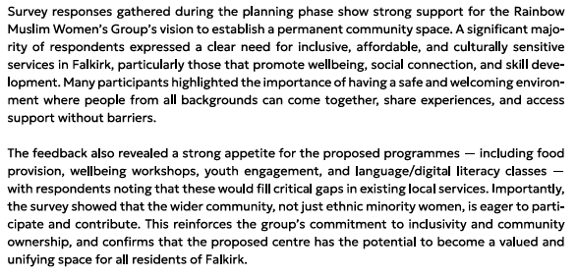
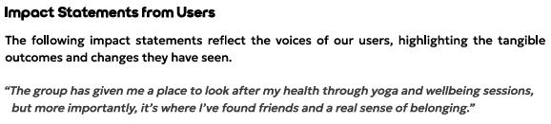
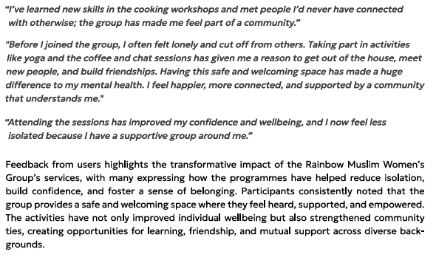

5.1.2 Have you consulted with other local stakeholder groups or agencies? Please provide evidence.

We have worked with CVS Falkirk & District, who have supported the group with drafting the business plan, finances, governance support, amongst other things.
We maintain close contact with Falkirk Council around the provision of school holiday food and activities.
We have received a number of letters of support from Braveheart, FEL, Sustainable Thinking Scotland, and others.

5.1.4 Have you been in contact with any other communities or community groups that may be affected? Please give details.

We have engaged with the community, the current users of the centre, potential future users of the centre, and the current management committee of the centre.

5.1.5 Please provide any other information you think may be relevant.
[REDACTED]
Figure 6: Letter of Support

Figure 7: Letter of Support
Figure 8: Letter of Support
[NAMES REDACTED]
Figure 9: Letter of Support
[NAMES REDACTED]

- Financial Viability of Project
Your Business Plan should contain full information about the financial viability of the project, evidencing that the organisation will be able to sustain the project in the long term.
Please submit
- at least 1 year’s audited accounts to evidence your organisations financial stability (if available)
- where audited accounts are not available (for instance for new groups) please provide a bank statement.
- a projected 5 year income and expenditure account
- a cash flow forecast for the proposed asset transfer.
6.1 Please outline the Policies and Procedures your organisation has in place to govern the group’s finances
We have submitted our accounts for all previous years that we have been operational to OSCR, complete and on time, as is required of registered SCIOs. Our finances are presented and scrutinised on a regular basis at our board meetings. We follow OSCR’s Guidance and Good Practice for Charity Trustees (oscr.org.uk) to ensure we manage our finances correctly.
The rates for each of our spaces have been set for the coming year, and these will be reviewed yearly at our AGM.
Our 5-Year Cash Flow, accounts, have been submitted along with this application.
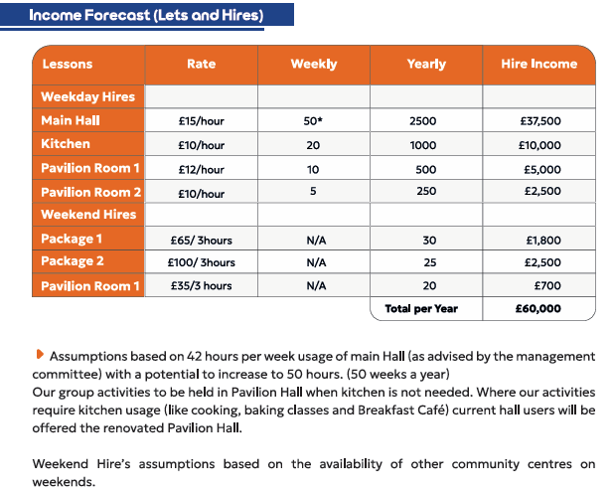
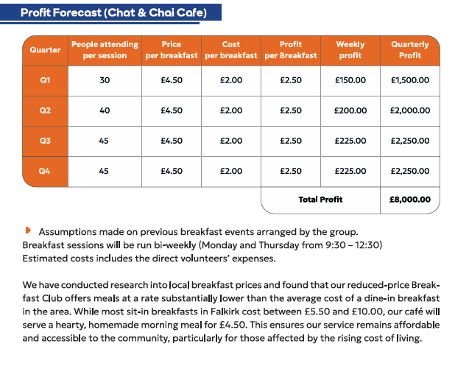
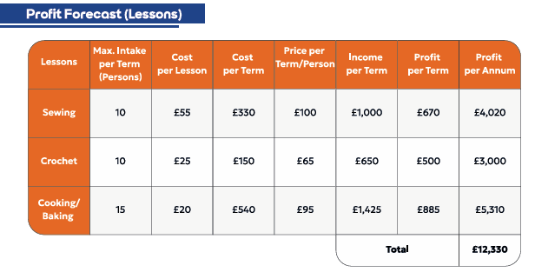

- Funding
  - Please outline how you propose to fund the price or rent you are prepared to pay for the land, and your proposed use of the land.
If you intend to apply for grants or loans you should demonstrate that your proposals are eligible for the relevant scheme, according to the guidance available for applicants.
7.1.1 Please show your calculations of the costs associated with the transfer of the land or buildings and your future use of it, including any redevelopment, ongoing, maintenance and the costs of your activities. All proposed income and investment should be identified, including volunteering and donations.

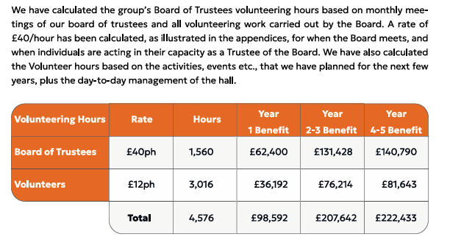
Please see our Cash Flow for all our planned start up, ongoing, maintenance and planned redevelopment costs. Our Cash Flow also shows all proposed income and investment.
We aim to host fundraising events on a frequent basis to help generate additional income for the group.
All proceeds from lets will be used to continue our charitable purposes.
We recognise we will require a solicitor to review and negotiate the terms of our agreement.

7.1.2 Please supply details of what funding you have received so far, and of any conditions attached to it.
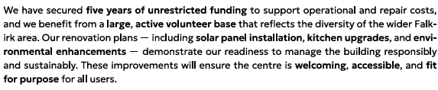
This funding is from the Corra Foundation, supporting documentation will be sent with the application.

7.1.3 Please supply details of any funding you have applied for but have not yet received a response or decision. Please include timescales if known.
At present, we have no funding applications outstanding.

7.1.4 Details of any other funding you will have access to? i.e. voluntary contributions, borrowing etc.
We hold a significant level of reserves so that we are confident in our ability to take on the asset through community ownership.
Alongside the lettable income which will come from the centre, we also have our projected lesson and cafe income, we will also look to hold a number of fundraising events throughout the year, and we also welcome donations from the community, local businesses, and other groups. We receive regular donations from the community for the work that we do, and we do not foresee any reason why this would not continue.
As a SCIO, we will have access to all relevant financial products and services if required.

7.1.5 Please outline your funding strategy if you have one, as well as any other relevant information.
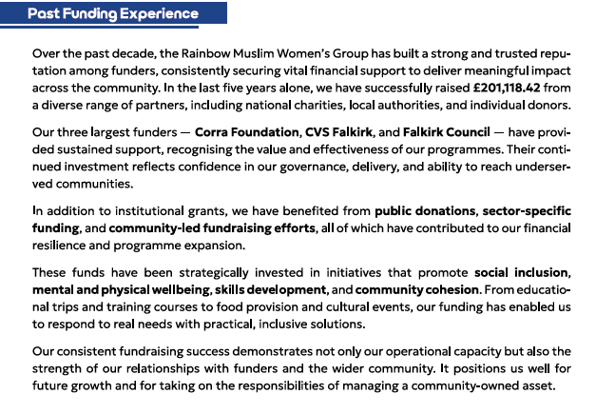
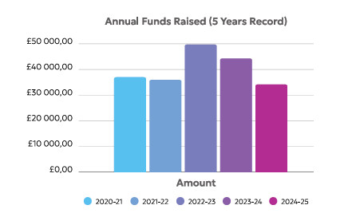

- Enablement Fund
Falkirk Council will hand the building over wind and watertight and compliant. However, this is quite light-touch and would involve (for example) patching of a leaky roof. For more significant building works, groups can apply to the Enablement Fund, to pay for capital improvements such as energy efficiency improvements or larger capital renewals which support the viability of the project going forward. Only capital items are eligible. Running repairs are revenue costs and are not eligible. You are strongly advised to email strategicpropertyreview@falkirk.gov.uk to confirm eligibility criteria before you submit this application.
Requests to the Fund must be supported by estimates / quotations from professionals which should be provided as supporting documents.
Please provide details of your request to the Enablement Fund, if applicable.
Enablement Fund request for larger capital renewals which support the viability of the CAT
Item | Estimate Provided By | Amount not more than (including VAT)
Solar Panels | [REDACTED] | £31,200
Kitchen Renovation | [REDACTED] | £17,400
Pavilion Renovation | [REDACTED] | £51,990
Total including VAT |  | £100,590

Checklist of accompanying documents
To check that nothing is missed, please tick which additional documents are accompanying this form.
☐Section 1 – You must attach your organisation’s constitution, articles of association or registered rules
☐Section 2 – Any maps, drawings or description of the land requested
☐Section 3 – Note of any terms and conditions that are to apply to the request
☐Section 4 – Any additional evidence regarding your proposals, their benefits, any restrictions on the land or potential negative consequences, and your organisation’s capacity to deliver.
☐Section 5 – Evidence of community support
☐Section 6 – Financial – Copies of accounts, forecasts, etc
☐Section 7 – Funding – Copy of Business Case etc
☐Section 8 – Enablement Fund – copies of estimates

Declaration
Two office-bearers (board members, charity trustees or committee members) of the community transfer body must sign the form. They must provide their full names and home addresses for the purposes of prevention and detection of fraud.
This form and supporting documents will be made available online for any interested person to read and comment on. Personal information will be redacted before the form is made available.

We, the undersigned on behalf of the community transfer body as noted at Section 1, make an asset transfer request as specified in this form.
We declare that the information provided in this form and any accompanying documents is accurate to the best of our knowledge.
Name [REDACTED]
Address [REDACTED]

Date 30/09/2025
Position Chairperson
Signature [REDACTED]

Name [REDACTED]
Address [REDACTED]

Date 30/09/2025
Position Treasurer
Signature [REDACTED]

