COMMUNITY EMPOWERMENT (SCOTLAND) ACT 2015

FALKIRK COUNCIL ASSET TRANSFER REQUEST FORM
IMPORTANT NOTES:
This is an application form which can be used to make an Asset Transfer request to Falkirk Council.
Any Community Body interested in making an Asset Transfer Request is advised to contact the Asset Team on strategicpropertyreview@falkirk.gov.uk before making the request so that we can discuss your proposal.
Please complete the asset transfer request form if the property/land is owned/leased/managed by Falkirk Council.
It is essential that you read the Asset Transfer guidance provided by the Scottish Government before making a request.
When completed, this form should be emailed to strategicpropertyreview@falkirk.gov.uk or sent to
The Asset Team
Falkirk Council
4 Stadium Way
Falkirk
FK2 9EE

Section 1: Information about the Community Transfer Body (CTB) making the request
  - Name of the CTB making the asset transfer request
Bonnybridge Football and Sports Club
  - CTB address. This should be the registered address, if you have one.
Postal address: Anderson Park Pavilion, Falkirk Road, Bonnybridge, Stirlingshire

Postcode: FK4 1BA

  - Contact details. Please provide the name and contact address to which correspondence in relation to this asset transfer request should be sent.
Contact name: [REDACTED]
Postal address: [REDACTED]

Postcode: [REDACTED]
Email: [REDACTED]
Telephone: [REDACTED]
☐ We agree that correspondence in relation to this asset transfer request may be sent by email to the email address given above. (Please tick to indicate agreement)
You can ask Falkirk Council to stop sending correspondence by email, or change the email address, by telling them at any time, as long as 5 working days’ notice is given.

  - Please mark an “X” in the relevant box to confirm the type of CTB and its official number, if it has one.
 | Company and its company number is ………….
 | Scottish Charitable Incorporated Organisation (SCIO) and its charity number is ……………….. | X  Charity Number SC053733
 | Community Benefit Society (BenCom) and its registered number is ………………………………
 | Unincorporated organisation (no number)

Please attach a copy of the CTB’s constitution, articles of association or registered rules.
Please note that under The Community Empowerment (Scotland) Act 2015, where a CTB is seeking ownership rather than a lease, the organisation must have at least 20 members. See the Scottish Government’s Guidance for Community Transfer Bodies.
  - Has the organisation been individually designated as a community transfer body by the Scottish Ministers?
No ☐
Yes ☐
Please give the title and date of the designation order:

  - Does the organisation fall within a class of bodies which has been designated as community transfer bodies by the Scottish Ministers?
No ☐
Yes ☐
If yes what class of bodies does it fall within?
2 tier SCIO

- Information about the land and rights requested
  - Please identify the property/land to which this asset transfer request relates.
You should provide a street address or grid reference and any name by which the land or building is known. If you have identified the land on the relevant authority’s register of land, please enter the details listed there.
It may be helpful to provide one or more maps or drawings to show the boundaries of the land requested. If you are requesting part of a piece of land, you must attach a map and give a full description of the boundaries of the area to which your request relates. If you are requesting part of a building, please make clear what area you require. A drawing may be helpful.
Details of Property: Anderson Park pavilion

Address: Falkirk Road, Bonnybridge, Stirlingshire

Postcode: FK4 1BA

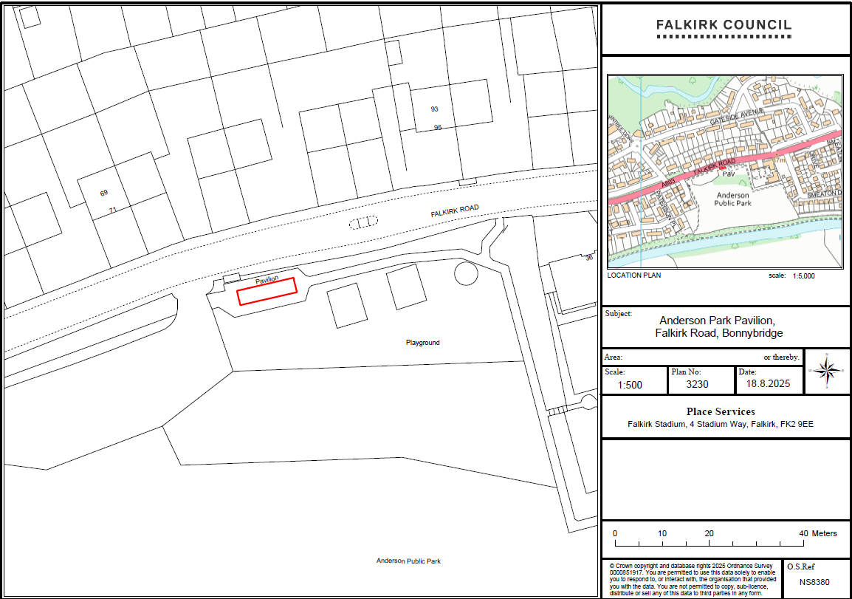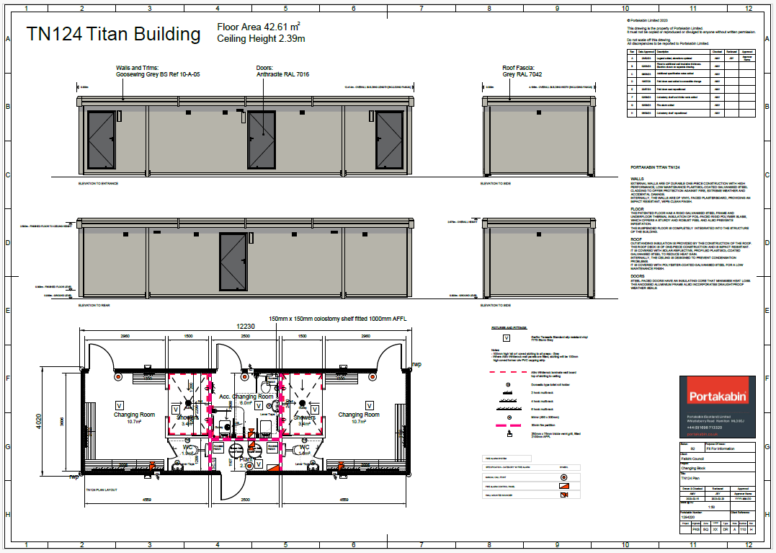

  - Please provide the UPRN (Unique Property Reference Number), if known.

UPRN: 136078919

- Type of request, payment and conditions
  - Please tick what type of request is being made:

for ownership (under section 79(2)(a)) - go to section 3A
√
for lease (under section 79(2)(b)(i)) – go to section 3B

for other rights (section 79(2)(b)(ii)) - go to section 3C

3A – Request for Ownership
What price are you prepared to pay for the land requested?
Proposed price:
Please attach a note setting out any other terms and conditions you wish to apply to the request.

3B – Request for Lease

What is the length of lease you are requesting?
15 years

How much rent are you prepared to pay? Please make clear whether this is per year or per month.

Proposed rent: £ 1.00 per annum

Please attach a note setting out any other terms and conditions you wish to be included in the lease, or to apply to the request in any other way.
Not Applicable

3C – Request for other Rights
What are the rights you are requesting?
Not Applicable

Do you propose to make any payment for these rights?
Yes ☐
No ☐
If yes, how much are you prepared to pay? Please make clear what period this would cover, for example per week, per month, per day?
Proposed payment: £ per

Please set out any other terms and conditions you wish to apply to the request.

- Community Proposal
  - Please set out the reasons for making the request and how the land or building will be used.
This should explain the objectives of your project, why there is a need for it, any development or changes you plan to make to the land or building, and any activities that will take place there.
4.1.1 Objectives of Project

Bonnybridge Football and Sports club provides training facilities that enable the local community to enjoy and participate in football. These facilities include changing rooms, football pitches and equipment that the local community have access to. This is to enable Bonnybridge Football and Sports club the provision of recreational facilities, or the organisation of recreational activities, with the object of improving the conditions of life for people in Bonnybridge and the surrounding areas.
If we are successful in our vision to have more local groups and sports clubs use the property, then the organisation will agree a small donation as part of the lease agreement, to cover the utility costs whilst using the facilities.

4.1.2 Why there is a need for your Project?

Anderson Park and pavilion allow Bonnybridge Football and Sports Club to provide training facilities and host competitive matches as part of the Scottish Football Association player pathway scheme.

We currently use Anderson Park pavilion for the local community to use the toilets during training and matches, and for home and away teams to get changed pre and post games.

Without the pavilion, we would cease to exist as a football club and the current group of 100+ participants will be without a team to play for since the SYFA does not permit matches to take place where there are no changing / toilet facilities. Further to that, we would not want our children or indeed adult coaches / spectators in a situation where they couldn’t use a toilet if required.

It will also allow us to work with other local groups and sports clubs to use the facilities.

An online community survey was circulated to local residents, parents, and members of Bonnybridge Football and Sports Club via social media and mailing lists.
- Number of responses: 27 in total.
- Respondent profile: A combination of local residents, parents of young players, and club members.
- Results: 100% supportive of the proposal to lease Anderson Park Pavilion. Respondents consistently highlighted the need for local sports facilities, the importance of providing structured opportunities for young people, and the role of the pavilion as a hub for wider community activity.
- How input shaped plans:
  - Feedback reinforced the demand for improved facilities and confirmed strong local backing.
  - Responses emphasised inclusivity and affordability, which will be reflected in future programming to ensure access for all community members.
  - The strong community support evidenced through this consultation provides a clear mandate for progressing with the Community Lease.

Ongoing Community Engagement
Bonnybridge Football and Sports Club is committed to maintaining an open dialogue with the community following the transfer of Anderson Park Pavilion. Engagement will continue through:
- Regular open days and community events at the pavilion to gather feedback and encourage wider use.
- Ongoing surveys and feedback forms (both online and in person) to ensure local voices guide future programming.
- Representation from parents, volunteers, and local residents on advisory groups to influence decision-making.
- Direct communication with user groups and teams, ensuring that activities remain inclusive and responsive to community needs.
This approach will ensure that the facility continues to meet local priorities, remains accessible to all, and develops in line with community expectations.
4.1.3 Will any Development/changes/modifications to the asset be required?

Not Applicable

4.1.4 What activities will take place?

Recreational facilities and organisation of recreational activities, with the object of improving the conditions of life for people in Bonnybridge and the surrounding areas; including football teams for people to train and compete in the Scottish Football Association (SFA) competitions; the operation of training grounds and pitches.

Anderson Park pavilion will offer the following range of services for the organisation, local groups and members of the community.
- Changing facilities.
- Showers and toilets.

4.1.5. If the asset is to be used by the public, please provide details of lettings policy and opening times.

Bonnybridge Football and Sports Club wish to offer the use of Anderson Park pavilion to the local community. There will be volunteers that will open and close the facilities for the local community.

4.1.6 What provision will be provided for people with disabilities?

The building is a new portakabin that has appropriate facilities for disabled people. We aim to maintain access in good working condition.

4.1.7 Any other relevant information?

Benefits of the proposal
  - Please set out the benefits that you consider will arise if the request is agreed to.
Local Authorities are permitted to dispose of property at less than market value where there are wider public benefits to be gained. This is set out in the Disposal of Land by Local Authorities (Scotland) Regulations 2010. These public benefits are listed below.
In this section, please explain how the project will benefit your community, and others. Please refer to the Scottish Government guidance on how the Council will consider the benefits of a request.
Please explain how the project will benefit your community by detailing how your project will promote or improve:-

4.2.1. Economic development/income generation

ie. Please include details of any job creation or volunteering and training opportunities that will be available as a result of the Asset Transfer. Also details of how your organisation will involve the local community and of any incentives that may be available to encourage the local community to use the proposed services.

The asset transfer of Anderson Park pavilion will allow Bonnybridge Football and Sports Club to continue our main objectives of providing football teams for people to train and compete in the Scottish Football Association (SFA) competitions, and the operation of training grounds and pitches.

All of our SFA coaches are volunteers. It is envisaged we will require more volunteer coaches for our future vision of increasing the number of football teams associated with our organisation.

Bonnybridge presently work with schools in the local area to advertise and increase the number of youths who are participants of our club. This will generate extra income for our charitable organisation to fulfil and enhance our services for the local community.

Anderson Park pavilion is planned to offer the following range of services for the organisation, local groups and members of the community.
- Changing facilities.
- Showers and toilets.

It hasn’t been built into the business plan, but it is envisaged that there will be a small revenue opportunity to rent the facilities to sections of the local community (Eg Local sports clubs wishing to use changing facilities).

Our football and sports club provides essential services that might otherwise be inaccessible due to the financial constraints of our local community.
We are a volunteer run club and the opportunities we provide to volunteers will help residents develop new skills and gain valuable work experience. Volunteering can serve as a stepping stone to future employment, enhancing the employability of individuals and contributing to the overall skill level of the community. Offering educational and training programs can help bridge the gap for those who are not in full-time education or employment.
Our football and sports club fosters social cohesion and well-being, which are essential for a thriving economy.
    - Regeneration

i.e. Please include details of whether your organisation will contribute to the physical regeneration of the area, and how your proposal will impact the regeneration of the area, in terms of volunteering or employment, giving examples.

By taking community ownership of Anderson Park Pavilion, we will look to regularly maintain the interior and exterior of the pavilion. We will aim to maintain the current appearance of the pavilion, to ensure that it remains aesthetically pleasing to our community.

    - Public Health

i.e. How likely is the proposal to improve the Public Health of the Community, in terms of physical and mental health, for example through volunteering, training, or taking part in activities, giving examples.

Taking ownership of Anderson Park pavilions will allow Bonnybridge Football and Sports Club to continue to promote and encourage the advancement of public participation in sport for the local community, especially of football according to the laws approved by the Scottish Football Association (SFA). This will increase the physical and mental wellbeing of members of the local community.
By improving the overall health of the community, our group aims to help ease the pressure on public and social services, and on other facilities. By engaging in regular social activities, our community can reduce stress, improve mood, and gain a sense of purpose. Physical activities we provide for children of different age groups help maintain physical health and mobility for all those who attend them. Together, these benefits contribute to a healthier, happier, and more connected community. When individuals have access to programmes that support their social, mental, and physical health, they are less likely to require intervention from public services. This proactive approach to community health not only benefits individuals, but also reduces the burden on public resources, allowing them to be allocated more effectively, to areas where they are needed the most.
Regular social activities can reduce stress, improve mood, and provide a sense of purpose, which can decrease the reliance on health services.
Offering educational programs on nutrition, mental health, and preventative care can empower residents to take control of their health. The community centre can collaborate with local health services to provide accessible health screenings, vaccinations, and other essential services. This can be particularly beneficial in ensuring that vulnerable populations receive the care they need.
    - Social Wellbeing

i.e. How will the proposal improve the Community's Social Well-Being and mental health, or how might it improve the learning offer and activities available in the area? Please give brief examples of these activities.

Bonnybridge Football and Sports Club plan to take lease of Anderson Park pavilion to provide facilities that enable members of the local community to participate in training and football matches. Participation in sport has a positive impact on people’s mental and physical wellbeing.
The activities and social interactions facilitated by the club, will contribute significantly to both the mental and social wellbeing of our community. We provide a safe space for the local community to meet and engage with each other through our training, matches, activities and events.
Offering volunteer opportunities within the football club can enhance social cohesion and provide residents with a sense of purpose. Volunteering can help individuals develop new skills, gain confidence, and feel more connected to their community.
By facilitating intergenerational activities, the centre can bridge the gap between different age groups. Intergenerational activities can foster mutual understanding and respect and provide opportunities for learning and mentorship.

    - Environmental Wellbeing / Environmental Benefits

i.e. Will the proposal bring green / environmental benefits and / or have an impact on the local environment? Will it help mitigate the effects of climate change? If so please give details.

We plan to continue to work in an environmentally conscious way to reduce our carbon footprint on the environment and local community. We will look to implement energy-efficient technologies and sustainable practices so the pavilion can reduce its environmental impact. We can engage the community in environmental initiatives, such as clean-up drives, tree planting events, and recycling programs. These activities can foster a sense of community pride and responsibility, encouraging residents to take an active role in protecting their local environment.

    - Does your project contribute to the reduction of inequalities?

i.e. Will the proposal enable the community to access activities not otherwise available; will these activities be available at an affordable rate; how will your organisation work with other local providers to reduce inequalities?

Bonnybridge Football and Sports Club promote and encourage the playing and participation in football by providing inclusive opportunities for all. With no discrimination on age, gender, religion, race, sexuality or football ability.
Families with multiple siblings in Bonnybridge Football and Sports Club are provided concessionary rates.
Families that cannot pay the monthly subscription are not discriminated against. The organisation will endeavour to reach an agreement where such persons can participate in Bonnybridge Football and Sports Club.

4.2.7 Will local people be engaged in the use and management of the Asset?

A “community of interest” may not represent the people living near to the asset. Please provide evidence of how local people and communities will be engaged in the use and management of the asset, and how they have been consulted.

Bonnybridge Football and Sports Club has over 20 volunteers that coach and help run our organisation. These volunteers presently manage the pavilion and football pitch at Anderson Park and will continue after lease of the building has been granted to our organisation.

4.2.8 How will you monitor whether the Asset Transfer is benefiting the community?

ie. Will you survey the users / invite feedback / compare user numbers with a baseline etc

We will measure the impact of taking lease of the building by increased participation from the local community through more participants and new teams being part of the club.

Another measurable impact will be increased engagement and collaboration with other groups and sports clubs within the local community.

4.2.9 Any other relevant information?

Restrictions on use of the land
  - If there are any restrictions on the use or development of the land, please explain how your project will comply with these.
Restrictions might include, amongst others, environmental designations such as a Site of Special Scientific Interest (SSI), heritage designations such as listed building status, controls on contaminated land or planning restrictions.
Bonnybridge Football and Sports Club doesn’t propose any changes to the building and therefore doesn’t envisage planning permission or building warrants are required.

Negative consequences
  - What negative consequences (if any) may occur if your request is agreed to? How you propose to minimise / reduce these?
You should consider any potential negative consequences for the local economy, environment, or any group of people, and explain how you could reduce these.

Potential Negative Consequences and Mitigation Measures
While the community consultation was unanimously supportive, we recognise that the increased use of Anderson Park Pavilion may have some potential negative consequences. These include:
- Noise: Greater activity, especially during training sessions and matches, could increase noise levels.
  - Mitigation: Scheduling activities within agreed hours, minimising evening noise, and ensuring coaches/volunteers manage behaviour respectfully.
- Traffic and Parking: Increased footfall may result in more cars in the area.
  - Mitigation: Encouraging car sharing and active travel (walking, cycling).
- Litter and Waste: More use of the pavilion and grounds could create waste management issues.
  - Mitigation: Promoting “leave no trace” policies with players and spectators, and organising regular community clean-up events. Encouraging coaches to ensure everyone uses the bins provided for any waste.
- Wear and Tear on Facilities: Higher usage could accelerate maintenance requirements.
  - Mitigation: Establishing a clear maintenance schedule, carrying out regular inspections. We have a facilities management team who will carry out regular checks. We also have a cleaning rota and have kept the pavilion in spotless condition since we have been using it.
By addressing these potential issues proactively, Bonnybridge Football and Sports Club aims to ensure the Pavilion is a well-managed, welcoming facility for all, minimising disruption to local residents while maximising community benefit.

Capacity to deliver
  - Please show how your organisation will be able to manage the project and achieve your objectives.
This could include the skills and experience of members of the organisation, any track record of previous projects, whether you intend to use professional advisers, etc.
4.5.1 Has your organisation or any of its members managed projects or owned / leased property/land prior to this?
Yes ☐
No ☐

Please provide details of:
4.5.2 Skills and experience of the members of the organisation
Bonnybridge Football and Sports Club have the skills and experience to operate and maintain the building in Anderson Park. Present members have been responsible for maintaining the building in our present long term lease arrangement with Falkirk Council.
We have members with varied professional backgrounds including financial services and the wider business sphere. As well as all trades and business owners well versed in business operations and financial management.
We have people who work in financial services, risk management, property management, IT, healthcare and other professional services as well as many skilled tradespeople such as joiners, plumbers, bricklayers and roofers.
Our links with the community are inseparable and the consensus amongst the local population is that we will come together and ensure the success of the pavilion and football team.
Our treasurer carries out the necessary record keeping, and our accounts are audited annually by an independent body in advance of our AGM.
- [REDACTED] - Secretary & Coach
- [REDACTED] works with Falkirk Council in the health and social care sector, bringing experience in administrative roles and supporting adults and children with learning difficulties. In addition to her full time work, she contributes to the maintenance of community facilities by cleaning the pavilions. Within our club, [REDACTED] plays a vital role, coaching our 2016’s team, managing our social media, registering players and officials with the Scottish Football Association (SFA), handling PVG checks, and overseeing additional signatories for club operations. She is also a qualified Child Wellbeing and Protection Officer, ensuring the safety and welfare of all participants. [REDACTED]’s combination of administrative expertise, hands-on care experience, and dedication to safeguarding makes her an invaluable member of both our community and our club.
- [REDACTED] - Chairman & Coach
[REDACTED] has been a dedicated member of the club for many years, contributing his extensive experience in club management, meetings, and organisation. A former player and coach, he has been instrumental in developing new teams, guiding them from their formation and supporting their growth. His long-standing commitment and hands-on involvement make him a cornerstone of the club’s success. He also coaches our 2013’s team.
- [REDACTED] – Coach & Facilities Management
- [REDACTED] coaches our 2018’s team and plays a key role in facilities management for the club. As a multiskilled operative, he brings experience across a wide range of areas, contributing both on and off the field to ensure the smooth running and development of the club.
- [REDACTED] – Facilities Management & Coach
- [REDACTED] oversees facilities management for the club and is a qualified electrician with a wide range of trade skills to support his role. He also coaches our 2016’s team, combining his technical expertise and football knowledge to contribute both on and off the pitch.
- [REDACTED] – Treasurer & Coach
- [REDACTED] serves as the club’s treasurer and brings extensive experience and skill as a salesman. He also coaches our 2017’s team, combining his leadership and organisational skills to support both the financial and sporting aspects of the club.
- [REDACTED] – Coach Coordinator & Coach
- [REDACTED] is our Coach Coordinator and a qualified Child Wellbeing and Protection Officer, a role he has held for the past five years. He has been with the club for many years and brings professional experience from the business management field, ensuring both the smooth running of coaching activities and the safety and welfare of all players. He also coaches our 2015’s team.
- [REDACTED] – Child Wellbeing & Protection Officer
- [REDACTED] serves as one of our Child Wellbeing and Protection Officers. She brings extensive experience supporting children, having worked in hospitals, as a nursery nurse, and currently as a support assistant in a school for children with learning difficulties, ensuring the safety and welfare of all players in the club.
4.5.3 Do you intend to use professional advisors? Please provide details.
Bonnybridge Football and Sports Club has engaged the services of the Cumbernauld Law Practice to conclude the legal aspects of our organisation assuming lease of the property as part of the community asset transfer. The organisation is also going to employ an accountant to examine our yearly accounts to satisfy the requirements of being a SCIO.

4.5.4 Do you currently lease/manage a property from Falkirk Council? If yes, please provide details.
Bonnybridge Football and Sports Club presently lease the pavilions and pitches at Anderson Park and Duncan Stewart Park.

4.5.4 Please detail how you plan to manage the building?
For example opening and closing the building / managing lets / will you have staff etc?
Bonnybridge Football and Sports Club plan to manage the building with the network of volunteers we already have in the organisation.
Bonnybridge Football and Sports Club will mainly use the building from 6pm to 8pm during the week and from 9am to 1pm on Saturdays. This will be when training activities and football games are held.
Bonnybridge Football and Sports Club will have keyholders for the property that will provide access to groups of the wider community. The organisation will provide an online booking system for groups to book times to use the building. Groups and sports clubs will also be asked to sign a lease agreement with that will cover the dates, length of time, and level of donation to cover utility costs whilst using the facilities.

4.5.5 Please provide any other information you think may be relevant.

- Level and nature of support
  - Please provide details of the level and nature of support for the request, from your community and, if relevant, from others.
This could include information on the proportion of your community who are involved with the request, how you have engaged with your community beyond the members of your organisation and what their response has been. You should also show how you have engaged with any other communities that may be affected by your proposals.
5.1.1. What community engagement has taken place to help develop your business plan? Please provide evidence, for example any completed surveys, questionnaires, letters of support, minutes of public meetings etc.
Bonnybridge Football and Sports Club – Member Meetings
Bonnybridge Football and Sports Club holds meetings every few months with our members. In addition to in-person meetings, we maintain communication via a WhatsApp group and have distributed contact details to all trustees.
At our most recent meeting, 13 members were present. During this meeting, we provided a comprehensive update on club activities and operations and also considered suggestions and feedback from members. The minutes from this meeting have been attached to reflect the discussions and decisions made.
Bonnybridge Football and Sports Club were provided a letter of support from local Councillor Baillie William Buchanan and Jack Redmond. We have also been provided a letter of support from [REDACTED]who operates a successful football coaching organisation. Copy of these letters are detailed in Appendix A.
Bonnybridge Football and Sports Club also created a survey that was sent to parents, local schools and wider community. Results from the survey are detailed in Appendix B.
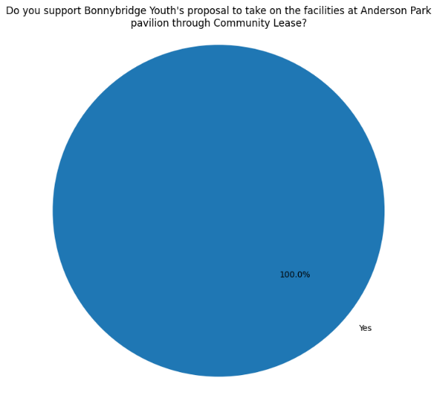

5.1.2 Have you consulted with other local stakeholder groups or agencies? Please provide evidence.
Bonnybridge Football and Sports Club has worked with CVS to develop the business plan and CAT application. We also have close links with the local schools to help increase the number of youths participating in football training, games and organised events.

5.1.4 Have you been in contact with any other communities or community groups
that may be affected? Please give details.
We have been in touch with local members of our community. There are currently no other organisations who use the park or pavilion at present.

5.1.5 Please provide any other information you think may be relevant.

- Financial Viability of Project
Your Business Plan should contain full information about the financial viability of the project, evidencing that the organisation will be able to sustain the project in the long term.
Please submit
- at least 1 year’s audited accounts to evidence your organisations financial stability (if available)
- where audited accounts are not available (for instance for new groups) please provide a bank statement.
- a projected 5 year income and expenditure account
- a cash flow forecast for the proposed asset transfer.
6.1 Please outline the Policies and Procedures your organisation has in place to govern the group’s finances
We recognise our organisation’s requirements as a registered SCIO. We will continue to submit audited accounts yearly to OSCR. Our finances are presented and scrutinised at every board meeting. We will follow OSCR’s Guidance and Good Practice for Charity Trustees (oscr.org.uk) to ensure we manage our finances correctly.
We have set rates for our subscriptions and will review these yearly at our AGM.

- Funding
  - Please outline how you propose to fund the price or rent you are prepared to pay for the land, and your proposed use of the land.
If you intend to apply for grants or loans you should demonstrate that your proposals are eligible for the relevant scheme, according to the guidance available for applicants.
7.1.1 Please show your calculations of the costs associated with the transfer of the land or buildings and your future use of it, including any redevelopment, ongoing, maintenance and the costs of your activities. All proposed income and investment should be identified, including volunteering and donations.

We recognise we will require a solicitor to review and negotiate the terms of our lease of the building.
Please see our Cash Flow for all our planned start up, ongoing, maintenance and planned redevelopment costs. Our Cash Flow also shows all proposed income and investment.
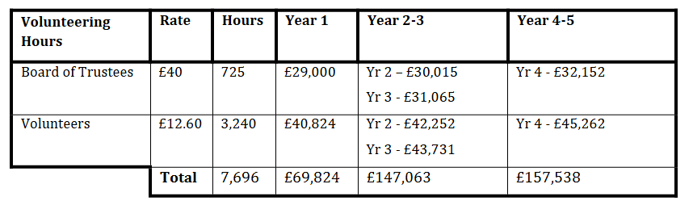

7.1.2 Please supply details of what funding you have received so far, and of any conditions attached to it.
Corra Boost Small Grant Fund unrestricted funding of £3,000
UKSPF Capital Equipment Grant funding of £8,000. Restricted funding to purchase the items identified in the application. This money was spent by 31/1/25

7.1.3 Please supply details of any funding you have applied for but have not yet received a response or decision. Please include timescales if known.
We are now a SCIO and have the letter of comfort from Falkirk Council, and therefore our next planned steps are to identify with CVS the appropriate funders to help meet our vision and positive impact on the local community.
7.1.4 Details of any other funding you will have access to? i.e. voluntary contributions, borrowing etc.
Bonnybridge Football and Sports Club is supported by local businesses that sponsor the different teams within our organisation. Funding has been provided to display their business on football strips worn by our teams. This funding has been used to purchase football kit and training equipment to provide our product and services to the local community.
Bonnybridge Football and Sports Club organises their own fundraising events to generate further revenue streams for the club. These events have been a great success and have been well supported by the local community.
7.1.5 Please outline your funding strategy if you have one, as well as any other relevant information.
Bonnybridge Football and Sports Club has successfully become a SCIO. Our funding strategy is to work with CVS to identify potential funders that we fit the criteria to be successful applicants. This funding will primarily be used to enable us to help meet our vision and positive impact on the local community.
However the revenue stream from our membership allows us to be self-sufficient and take lease of the building at Anderson Park.

- Enablement Fund
Falkirk Council will hand the building over wind and watertight and compliant. However, this is quite light-touch and would involve (for example) patching of a leaky roof. For more significant building works, groups can apply to the Enablement Fund, to pay for capital improvements such as energy efficiency improvements or larger capital renewals which support the viability of the project going forward. Only capital items are eligible. Running repairs are revenue costs and are not eligible. You are strongly advised to email strategicpropertyreview@falkirk.gov.uk to confirm eligibility criteria before you submit this application.
Requests to the Fund must be supported by estimates / quotations from professionals which should be provided as supporting documents.
Please provide details of your request to the Enablement Fund, if applicable.
Enablement Fund request for larger capital renewals which support the viability of the CAT
Item Estimate Provided By Amount not more than (including VAT)

Total including VAT

Appendix A – Letter of Comfort from Baillie Buchanan
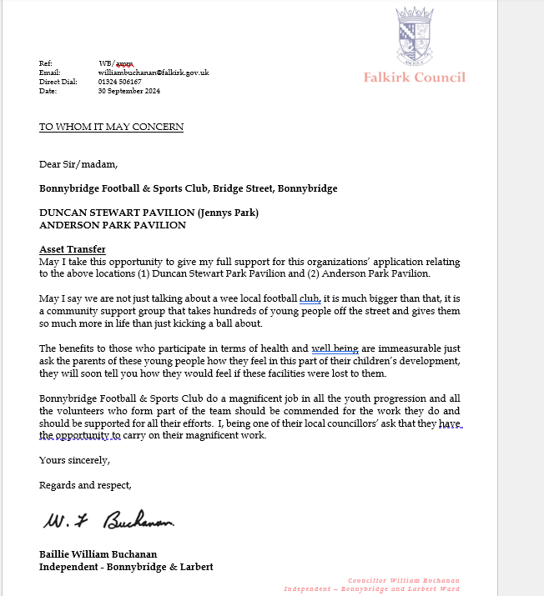

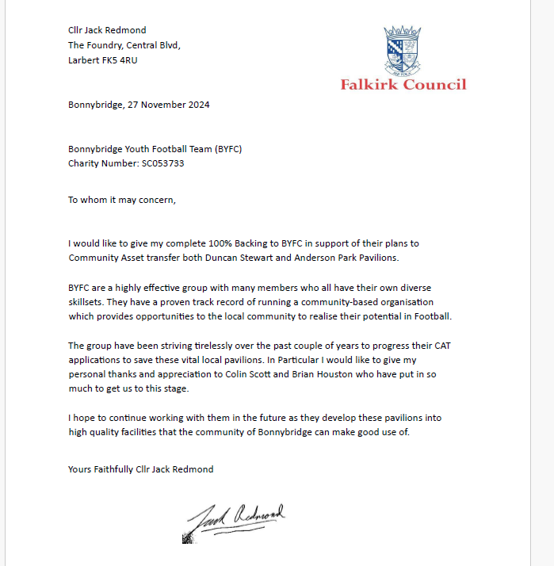

Appendix B – Survey Results
A summary of the results from a local community survey supporting Bonnybridge Football and Sports Club taking a lease on Anderson Park pavilion is as follows:
We had 27 responses were a mixture of parents, local community and members of the organisation.

Do you support Bonnybridge Football and Sports Club proposal to take on the facilities at Anderson Park pavilion?

Why it would be good for Bonnybridge Football and Sports Club to have the facilities
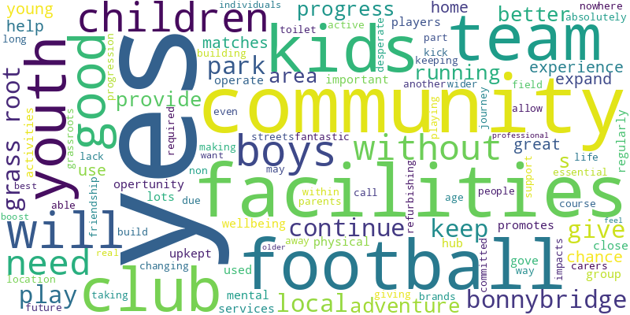

Additional comments supporting the application.
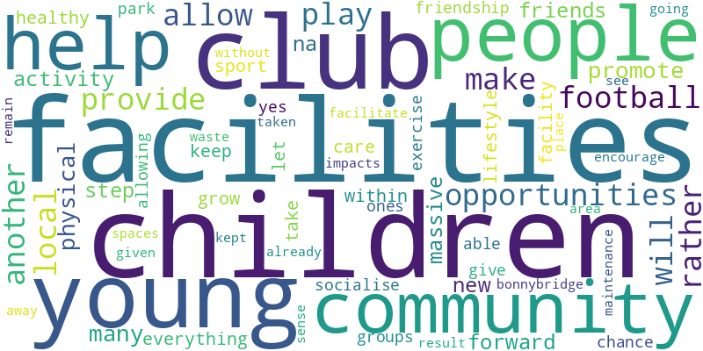

Quotes/Testimonials from current users:
Do you support Bonnybridge Football and Sports Club proposal to take on the facilities at Anderson Park pavilion?
“Absolutely - without these facilities our children have nowhere to play football due to a lack of changing and toilet facilities” - Parent

“The park is an essential part of the community and to help the youth football teams to continue, without these parks they would have no where for matches and therefore may not be able to continue some of the teams. Even the non football team youths use the park for a kick about” - Parent

“Yes for refurbishing a building and for all boys parents carers and community to use” - Parent

“The facilities will keep the kids off the streets” - Community Member

“Yes, that way we can build on the progression of Bonnybridge youth football club giving the club the chance to expand” - Community Member

“As the Bonnybridge Youth teams expand to more age brands, it would be great to have this as another location to play matches and call it our home” - Parent

“Yes. The club provides a fantastic experience for our young people through making life long friendship within the community and of course keeping active” - Parent

“Yes as it’s required to support the team with a playing field and facilities and give kids the facilities that are in desperate need for a football team, it also helps the wider community and for future kids that get into grass roots football. Taking it away impacts the kids and community.” - Member

“Yes, it would allow them to continue their grassroots journey.”
“Yes, very committed individuals running the club and want the best for our children and community. It would be a real boost for the club. Would be great to have a more professional feel for the kids.” - Member

“Will give a home for young kids and older to play football.” - Parent

Newsletter example:

Appendix D – Corra Foundation Boost Fund Application

REDACTED AS INACCESSIBLE

Checklist of accompanying documents
To check that nothing is missed, please tick which additional documents are accompanying this form.
☐Section 1 – You must attach your organisation’s constitution, articles of association or registered rules
☐Section 2 – Any maps, drawings or description of the land requested
☐Section 3 – Note of any terms and conditions that are to apply to the request
☐Section 4 – Any additional evidence regarding your proposals, their benefits, any restrictions on the land or potential negative consequences, and your organisation’s capacity to deliver.
☐Section 5 – Evidence of community support
☐Section 6 – Financial – Copies of accounts, forecasts, etc
☐Section 7 – Funding – Copy of Business Case etc
☐Section 8 – Enablement Fund – copies of estimates

Declaration
Two office-bearers (board members, charity trustees or committee members) of the community transfer body must sign the form. They must provide their full names and home addresses for the purposes of prevention and detection of fraud.
This form and supporting documents will be made available online for any interested person to read and comment on. Personal information will be redacted before the form is made available.

We, the undersigned on behalf of the community transfer body as noted at Section 1, make an asset transfer request as specified in this form.
We declare that the information provided in this form and any accompanying documents is accurate to the best of our knowledge.
Name [REDACTED]
Address [REDACTED]
Date 1/8/25
Position Chairperson
Signature

Name [REDACTED]
Address [REDACTED]

Date 1/8/25
Position Treasurer
Signature

