COMMUNITY EMPOWERMENT (SCOTLAND) ACT 2015

FALKIRK COUNCIL ASSET TRANSFER REQUEST FORM
IMPORTANT NOTES:
This is an application form which can be used to make an Asset Transfer request to Falkirk Council.
Any Community Body interested in making an Asset Transfer Request is advised to contact the Asset Team on strategicpropertyreview@falkirk.gov.uk before making the request so that we can discuss your proposal.
Please complete the asset transfer request form if the property/land is owned/leased/managed by Falkirk Council.
It is essential that you read the Asset Transfer guidance provided by the Scottish Government before making a request.
When completed, this form should be emailed to strategicpropertyreview@falkirk.gov.uk or sent to
The Asset Team
Falkirk Council
4 Stadium Way
Falkirk
FK2 9EE

Section 1: Information about the Community Transfer Body (CTB) making the request
  - Name of the CTB making the asset transfer request
First 4 Kids
  - CTB address. This should be the registered address, if you have one.
Postal address: Head Office
Unit 4
Grangemouth Enterprise Centre
Falkirk Road
Grangemouth

Postcode: FK3 8XS

  - Contact details. Please provide the name and contact address to which correspondence in relation to this asset transfer request should be sent.
Contact name: [REDACTED]
Postal address: Head Office
Unit 4
Grangemouth Enterprise Centre
Falkirk Road
Grangemouth

Postcode: FK3 8XS
Email: [REDACTED]
Telephone: [REDACTED]
x We agree that correspondence in relation to this asset transfer request may be sent by email to the email address given above. (Please tick to indicate agreement)
You can ask Falkirk Council to stop sending correspondence by email, or change the email address, by telling them at any time, as long as 5 working days’ notice is given.

  - Please mark an “X” in the relevant box to confirm the type of CTB and its official number, if it has one.
 | Company and its company number is ………….
X | Scottish Charitable Incorporated Organisation (SCIO) and its charity number is ……………….. | SC047149
 | Community Benefit Society (BenCom) and its registered number is ………………………………
 | Unincorporated organisation (no number)

Please attach a copy of the CTB’s constitution, articles of association or registered rules.
Please note that under The Community Empowerment (Scotland) Act 2015, where a CTB is seeking ownership rather than a lease, the organisation must have at least 20 members. See the Scottish Government’s Guidance for Community Transfer Bodies.
  - Has the organisation been individually designated as a community transfer body by the Scottish Ministers?
No x
Yes ☐
Please give the title and date of the designation order:

  - Does the organisation fall within a class of bodies which has been designated as community transfer bodies by the Scottish Ministers?
No ☐
Yes x
If yes what class of bodies does it fall within?
SCIO

- Information about the land and rights requested
  - Please identify the property/land to which this asset transfer request relates.
You should provide a street address or grid reference and any name by which the land or building is known. If you have identified the land on the relevant authority’s register of land, please enter the details listed there.
It may be helpful to provide one or more maps or drawings to show the boundaries of the land requested. If you are requesting part of a piece of land, you must attach a map and give a full description of the boundaries of the area to which your request relates. If you are requesting part of a building, please make clear what area you require. A drawing may be helpful.
Details of Property:
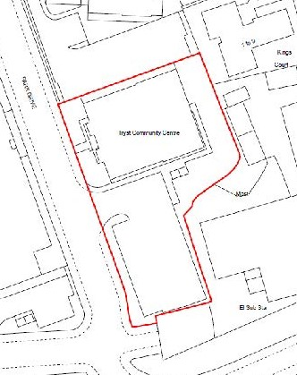
Figure 3: Proposed Boundary (subject to change)
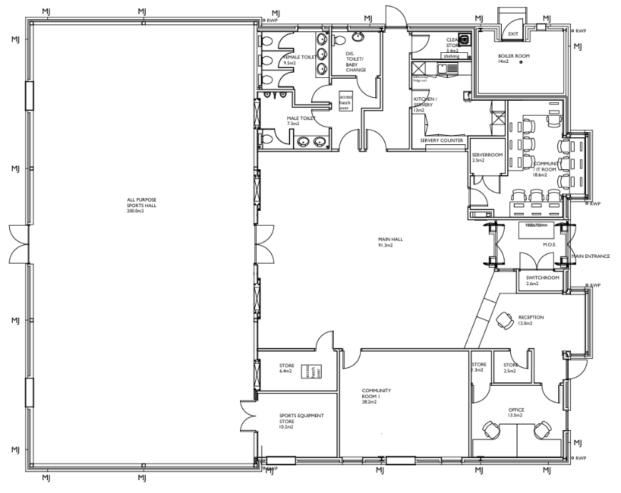
Figure 4: Floorplan of The Tryst Community Centre
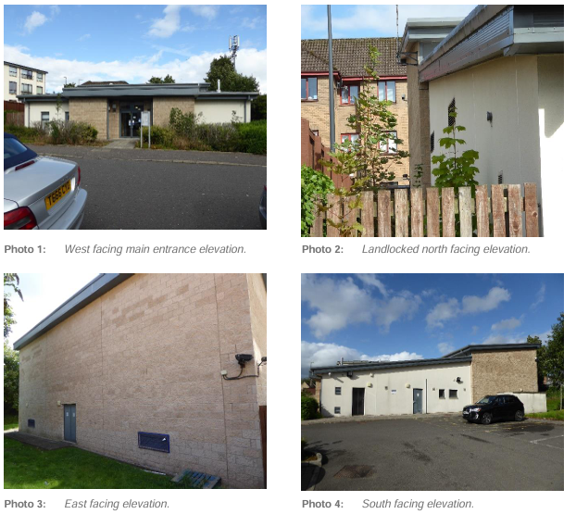
Figure 5: External photos of the building
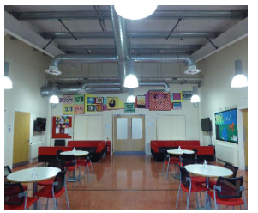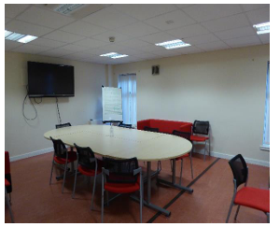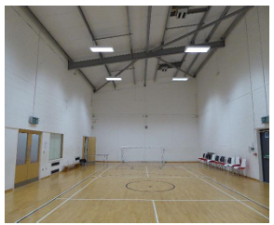
Figure 6: Internal photos of the Cafe, Conference Room and Hall

Address: Tryst Community Centre, Park Drive, Stenhousemuir, Larbert

Postcode: FK5 3BB

  - Please provide the UPRN (Unique Property Reference Number), if known.

UPRN: 136075701

- Type of request, payment and conditions
  - Please tick what type of request is being made:
X
for ownership (under section 79(2)(a)) - go to section 3A

for lease (under section 79(2)(b)(i)) – go to section 3B

for other rights (section 79(2)(b)(ii)) - go to section 3C

3A – Request for Ownership
What price are you prepared to pay for the land requested?
Proposed price: £ 1
Please attach a note setting out any other terms and conditions you wish to apply to the request.

3B – Request for Lease

What is the length of lease you are requesting?

How much rent are you prepared to pay? Please make clear whether this is per year or per month.

Proposed rent:

Please attach a note setting out any other terms and conditions you wish to be included in the lease, or to apply to the request in any other way.

3C – Request for other Rights
What are the rights you are requesting?

Do you propose to make any payment for these rights?
Yes ☐
No ☐
If yes, how much are you prepared to pay? Please make clear what period this would cover, for example per week, per month, per day?
Proposed payment: £ per

Please set out any other terms and conditions you wish to apply to the request.

- Community Proposal
  - Please set out the reasons for making the request and how the land or building will be used.
This should explain the objectives of your project, why there is a need for it, any development or changes you plan to make to the land or building, and any activities that will take place there.
4.1.1 Objectives of Project

Initial Aims
- Be Care Inspectorate ready, so local After School Care and Holiday clubs can be located in the centre, bringing 100 local families to the centre each week.
- Embed Stenhousemuir FC Community Foundation activity programme into the centre
- Consult with the community to identify any gaps for services or activities.
- Develop a centre website, promote the services and programme already in the centre.
- Develop the centres online presence on socials and improve interaction with the wider community.

Long Term Aims
- Promote the benefits of Play for all ages to build connection and resilience.
- Have a full programme of activities that include all categories of the local community.
- Be instrumental in developing the local economy by supporting mental health, well-being and reducing poverty.
- Re-vitalise the space to develop a warm friendly environment that supports strong community connection and reduces isolation.
- Promote positive public health messaging, zero screens, active engagement, reducing sedentary behaviours and contribute to overall fitness in the community.

Our key objectives are:
- To offer the people of Larbert, Stenhousemuir and surrounding villages, a quality service and to build a successful community hub giving it a financially secure future.
- To improve health and wellbeing of the local community
- Provide increased social benefits
- Empower our community and families
- Reduce poverty in the area by providing essential services to help the wellbeing of the community
- Provide a space for children to help alleviate child poverty in the area

4.1.2 Why there is a need for your Project?

The Tryst Centre has lacked in any programme to develop and drive usage; we believe that we have the necessary skills to manage our building and get the best for our community.
Our proposal is from two well established community organisations who partner with other local community groups, schools, and families coming together to build a programme in the centre to meet a wide variety of need.
First 4 Kids SCIO will be the lead organisation and take ownership and responsibility. There will be a strong partnership with Stenhousemuir FC Community Foundation and together they will pool resources, skills and community connections into the centre, so it has that ‘central to the community’ feel about it.

First 4 Kids Purpose: The organisation is established for charitable purposes only to benefit the community of Falkirk and the surrounding areas (the “Community”).
First 4 Kids Mission Statement: To provide quality, affordable childcare throughout the Falkirk Area where children and young people can access fun play environments.
First 4 Kids Vision Statement: is to provide child-centred play spaces where all children entrusted to our care will be respected, engaged and flourish in a stimulating, safe and creative play-led environment; supported by highly passionate, motivated and valued staff that will be given the opportunity to achieve their full potential.

4.1.3 Will any Development/changes/modifications to the asset be required?

We will seek permission once we have the appropriate drawings and cost to:
Enclose the area at the back of the centre to enable us to provide a secure outdoor area for children and families using the service.
Enclose the reception area to give more privacy to user groups and those working in reception area – increase ability of shared use of the centre.
Instal a barrier at the entrance to the carpark to ensure when the centre is busy there are sufficient parking facilities (not used by people not using centre).
Add signage to the front of the building.
In the longer term we will look to improve the energy efficiency of the building and make an application to the enablement fund once we have the full report from Business Energy Scotland and quotes for the work required.

4.1.4 What activities will take place?

As well as the childcare that is on offer from First 4 Kids, and the vast suite of community programmes on offer from Stenhousemuir FC Community Foundation, the centre will offer the following range of services:
- Access to facilities for recreational activities, available for both one-off bookings and long-term hires
- Use of the space by other community groups, supporting both occasional and ongoing arrangements.
- Availability of the venue for functions, such as celebrations, meetings, and events.

4.1.5. If the asset is to be used by the public, please provide details of lettings policy and opening times.

Lets will be managed by First 4 Kids and Stenhousemuir FC Community Foundation and we will implement a letting policy.

Opening times for the centre will be: 9am to 9pm Monday to Friday and by booking at weekends

4.1.6 What provision will be provided for people with disabilities?

The centre is all on the ground floor and accessible to all.

4.1.7 Any other relevant information?

Benefits of the proposal
  - Please set out the benefits that you consider will arise if the request is agreed to.
Local Authorities are permitted to dispose of property at less than market value where there are wider public benefits to be gained. This is set out in the Disposal of Land by Local Authorities (Scotland) Regulations 2010. These public benefits are listed below.
In this section, please explain how the project will benefit your community, and others. Please refer to the Scottish Government guidance on how the Council will consider the benefits of a request.
Please explain how the project will benefit your community by detailing how your project will promote or improve:-

4.2.1. Economic development/income generation

ie. Please include details of any job creation or volunteering and training opportunities that will be available as a result of the Asset Transfer. Also details of how your organisation will involve the local community and of any incentives that may be available to encourage the local community to use the proposed services.
Impact

First 4 Kids plays a vital role in supporting economic development across the Falkirk area by providing quality, affordable childcare that enables parents—particularly women—to participate more fully in the workforce. Operating seven clubs across the region and serving families from over 15 schools, the organisation offers wraparound care that aligns with school schedules, including after-school and holiday club services. This flexibility is essential for working parents and carers, many of whom would otherwise struggle to maintain consistent employment or pursue further education.

The organisation’s structure as a Scottish Charitable Incorporated Organisation (SCIO) ensures that all income from childcare fees is reinvested directly into the operation of the charity. This includes staff wages, training, resources, and administrative costs. As a result, First 4 Kids not only provides employment opportunities for childcare professionals, administrators, and managers, but also contributes to the local economy by supporting a skilled and professional workforce. All staff are registered with the Scottish Social Services Council, ensuring high standards of care and professionalism.

First 4 Kids supports economic inclusion through volunteer and placement opportunities. These roles help individuals gain valuable experience and develop skills that enhance their employability. Staff training in areas such as playwork principles and food hygiene further contributes to the development of a capable and confident local workforce.

The organisation also strengthens the local economy by engaging with community resources. Clubs make use of libraries, sports halls, and outdoor spaces, supporting local infrastructure and service providers. Governance is community-led, with a voluntary board of trustees composed mainly of parents and co-opted members who bring additional expertise. This model fosters economic empowerment and ensures that decision-making reflects the needs and aspirations of local families.
Long-term economic benefits are also evident. By enabling parents to work and children to thrive in safe, stimulating environments, First 4 Kids contributes to reduced child poverty, stronger business and enterprise sectors, and increased workforce diversity. The organisation’s early intervention approach helps reduce future public spending by alleviating pressure on social services and improving educational outcomes. In doing so, First 4 Kids supports a more resilient and prosperous community.

    - Regeneration

i.e. Please include details of whether your organisation will contribute to the physical regeneration of the area, and how your proposal will impact the regeneration of the area, in terms of volunteering or employment, giving examples.

First 4 Kids is poised to play a transformative role in the regeneration of the local area by taking over and managing a community building, which will become a new hub for their after-school care and wider community engagement. In a time when many local venues and amenities are closing due to economic pressures and the cost-of-living crisis, this initiative represents a vital investment in the future of the community.
By acquiring and maintaining the building, First 4 Kids will ensure that a key community asset remains open, vibrant, and accessible. The new hub will provide a safe, stimulating, and inclusive environment for children and families, while also serving as a focal point for local regeneration efforts. Plans to enhance both the indoor space and the surrounding garden area will create a welcoming venue for a wide range of activities, from after-school clubs to community events and family support services.
This revitalised space will not only support children’s development through imaginative, child-led play, but also foster stronger community connections. By hosting events, supporting local businesses, and collaborating with schools and other partners, First 4 Kids will help to re-energise the local area. Increased footfall and community engagement will stimulate local economic activity, making the area more attractive for residents and potential new businesses.
The new hub will also provide opportunities for volunteering, training, and employment, contributing to the development of local skills and capacity. Importantly, it will offer a consistent and inclusive space for children with additional support needs, ensuring that regeneration efforts are equitable and accessible to all.
Through this initiative, First 4 Kids is not only preserving a valued community space but actively contributing to the regeneration of the area—creating a more connected, resilient, and vibrant place to live and grow.

    - Public Health

i.e. How likely is the proposal to improve the Public Health of the Community, in terms of physical and mental health, for example through volunteering, training, or taking part in activities, giving examples.

By taking on the management of a community building, First 4 Kids will be able to expand its role in promoting public health and wellbeing across the Falkirk area. The new hub will not only serve as a centre for childcare but also as a proactive space for improving the physical, mental, and emotional health of children, families, and the wider community.
First 4 Kids already contributes to public health through its zero-screen policy and emphasis on imaginative, child-led play. These practices help children build resilience, develop social skills, and engage in physical activity—all of which are essential for long-term mental and physical wellbeing. The organisation’s play programmes are designed to support children’s emotional and social development, helping to address the lingering effects of the pandemic and the increasing reliance on digital entertainment.
The new community hub will allow First 4 Kids to extend these benefits by offering additional health-focused activities and programmes. These could include physical activities such as dance, movement, and outdoor play, which are particularly valuable in a community where access to recreational spaces may be limited. Such activities support mobility, reduce sedentary behaviour, and contribute to overall fitness—especially important for children and older adults alike.
Mental health and social isolation are growing concerns in many communities, including Falkirk. Through regular social interaction, creative play, and inclusive programming, First 4 Kids helps children feel safe, valued, and connected. The new hub will provide opportunities to expand this support to parents and carers, offering a space for peer connection, wellbeing workshops, and potentially partnerships with local health services.
By improving the overall health of the community, First 4 Kids helps reduce the burden on public services. Healthier, more resilient individuals are less likely to require medical or social interventions, allowing public resources to be directed where they are most needed. The organisation’s inclusive approach—particularly its support for children with additional needs—ensures that health benefits are equitably distributed across the community.
In managing this community space, First 4 Kids will be well-positioned to collaborate with local health providers to offer screenings, preventative care, and educational programmes. This proactive, community-led approach to public health will contribute to a happier, healthier, and more connected Falkirk.

    - Social Wellbeing

i.e. How will the proposal improve the Community's Social Well-Being and mental health, or how might it improve the learning offer and activities available in the area? Please give brief examples of these activities.

By taking on the management of a community building, First 4 Kids will significantly enhance social wellbeing across the Falkirk area. The new hub will serve as a welcoming, inclusive space where children, families, and community members can connect, participate, and thrive. In a time when social isolation and fragmentation are growing concerns, this initiative offers a proactive and compassionate response.
First 4 Kids has long been committed to creating environments where children feel safe, respected, and engaged. Through play-led programmes developed in partnership with children, the organisation fosters creativity, confidence, and social interaction. These experiences are essential for building strong interpersonal skills and emotional resilience, especially for children who may struggle with social engagement or confidence.
The new community hub will allow First 4 Kids to extend these benefits beyond the school day. By offering regular activities, events, and opportunities for volunteering, the space will become a focal point for community life. Families will have a place to gather, share experiences, and build relationships, helping to reduce isolation and strengthen social bonds.
Importantly, the hub will be inclusive and accessible, welcoming children with additional support needs and ensuring that all families feel valued and supported. The organisation’s ethos of respect and partnership will guide the development of programmes that reflect the diverse needs and interests of the community.
Social wellbeing is also supported through the empowerment of parents and carers. By providing reliable childcare and opportunities for engagement, First 4 Kids helps families feel more connected and confident in their roles. The community building will offer space for peer support, parenting workshops, and collaborative initiatives that promote wellbeing and mutual aid.
In managing this space, First 4 Kids will create a vibrant, nurturing environment that supports the social fabric of the community. Through play, connection, and shared purpose, the hub will contribute to a more cohesive, compassionate, and resilient Falkirk.

    - Environmental Wellbeing / Environmental Benefits

i.e. Will the proposal bring green / environmental benefits and / or have an impact on the local environment? Will it help mitigate the effects of climate change? If so please give details.

By taking on the management of a community building, First 4 Kids will significantly enhance social wellbeing across the Falkirk area. The new hub will serve as a welcoming, inclusive space where children, families, and community members can connect, participate, and thrive. In a time when social isolation and fragmentation are growing concerns, this initiative offers a proactive and compassionate response.
First 4 Kids has long been committed to creating environments where children feel safe, respected, and engaged. Through play-led programmes developed in partnership with children, the organisation fosters creativity, confidence, and social interaction. These experiences are essential for building strong interpersonal skills and emotional resilience, especially for children who may struggle with social engagement or confidence.
The new community hub will allow First 4 Kids to extend these benefits beyond the school day. By offering regular activities, events, and opportunities for volunteering, the space will become a focal point for community life. Families will have a place to gather, share experiences, and build relationships, helping to reduce isolation and strengthen social bonds.
Importantly, the hub will be inclusive and accessible, welcoming children with additional support needs and ensuring that all families feel valued and supported. The organisation’s ethos of respect and partnership will guide the development of programmes that reflect the diverse needs and interests of the community.
Social wellbeing is also supported through the empowerment of parents and carers. By providing reliable childcare and opportunities for engagement, First 4 Kids helps families feel more connected and confident in their roles. The community building will offer space for peer support, parenting workshops, and collaborative initiatives that promote wellbeing and mutual aid.
In managing this space, First 4 Kids will create a vibrant, nurturing environment that supports the social fabric of the community. Through play, connection, and shared purpose, the hub will contribute to a more cohesive, compassionate, and resilient Falkirk.

By taking on the management of a community building, First 4 Kids will have the opportunity to embed environmental wellbeing into the heart of its operations. The transformation of this space into a vibrant, child- and community-focused hub will include plans to upgrade and enhance the surrounding garden area, creating a safe, accessible, and engaging outdoor environment for play, learning, and community use.
Outdoor play is a core part of First 4 Kids’ ethos. The organisation recognises the importance of nature-based and adventurous play in supporting children’s physical and mental health. By developing the garden space, First 4 Kids will provide children with daily opportunities to connect with nature, explore their environment, and build resilience through imaginative, unstructured play. These experiences are vital in a world where many children spend increasing amounts of time indoors or on screens.
The new hub will also promote environmental awareness and stewardship among children and families. Through activities such as gardening, outdoor learning, and eco-themed play, children will develop a deeper understanding of sustainability and the natural world. These early experiences can foster lifelong values of care and responsibility for the environment.
The upgraded outdoor space will serve the wider community. It will offer a green, welcoming area for families to relax. This contributes to the overall environmental quality of the neighbourhood and supports wellbeing by providing access to nature and open space.
By managing this community asset with a focus on sustainability and outdoor engagement, First 4 Kids will contribute to a healthier, greener, and more resilient local environment. This approach aligns with national priorities around climate action, community wealth building, and child wellbeing, ensuring that environmental benefits are embedded in the long-term vision for the space.

    - Does your project contribute to the reduction of inequalities?

i.e. Will the proposal enable the community to access activities not otherwise available; will these activities be available at an affordable rate; how will your organisation work with other local providers to reduce inequalities?

We will offer a discounted rate to charitable groups to hire our space.
Many of our user groups that require the facility to remain operational, contribute to the reduction of inequalities in our local community.
We work continually to develop partnerships with local organisations and community groups, which helps to support this aim.

4.2.7 Will local people be engaged in the use and management of the Asset?

A “community of interest” may not represent the people living near to the asset. Please provide evidence of how local people and communities will be engaged in the use and management of the asset, and how they have been consulted.

The group operates as a 2-tier membership organisation managed by a board of trustees and a broader membership base. Our members, many of whom from the local community, may vote on matters to be decided at all Annual General Meetings.

As part of our Community Engagement, we asked local people what they would like to see at the centre and we will continue to engage with the local community to ensure that local needs are met.

4.2.8 How will you monitor whether the Asset Transfer is benefiting the community?

ie. Will you survey the users / invite feedback / compare user numbers with a baseline etc

We will measure the usage of the Hall monthly, quarterly and annually against our aim to increase usage as follows:
Estimated usage September 2025 - 40 people over 21years per week.
We aim to increase usage by 200% in the first two years.
User groups will keep a record of people attending for a fire register and these details will be collated to allow us to monitor growth.
The number and length of lets will be recorded and monitored to measure increases.
We will develop a website for the centre and generate a social media presence. The engagement with digital services will also be measured with the aim to increase interaction and sharing of information.
We also plan to access funding to commission a social value calculation and report on the work we do and the added benefit we will bring to the local community. Initially this will look at how we gather information and then how services contribute to increasing community wellbeing.
We will regularly ask through our social media how well we are doing and gather feedback to improve the centres performance

4.2.9 Any other relevant information?

Restrictions on use of the land
  - If there are any restrictions on the use or development of the land, please explain how your project will comply with these.
Restrictions might include, amongst others, environmental designations such as a Site of Special Scientific Interest (SSI), heritage designations such as listed building status, controls on contaminated land or planning restrictions.
No known restrictions

Negative consequences
  - What negative consequences (if any) may occur if your request is agreed to? How you propose to minimise / reduce these?
You should consider any potential negative consequences for the local economy, environment, or any group of people, and explain how you could reduce these.
Costly energy performance work required which will require project management, with potential closure while work is carried out.
Risk of not attracting sufficient trustees to ensure our work is progressing
Reliant on continued and consistent involvement from volunteers to enable centre to be available extended hours
Increase in traffic and parking due to increased use
Possible increase in noise pollution due to more footfall and traffic.

Capacity to deliver
  - Please show how your organisation will be able to manage the project and achieve your objectives.
This could include the skills and experience of members of the organisation, any track record of previous projects, whether you intend to use professional advisers, etc.
4.5.1 Has your organisation or any of its members managed projects or owned / leased property/land prior to this?
Yes x
No ☐

Please provide details of:
4.5.2 Skills and experience of the members of the organisation
The Chairperson has been in post for four years she works as the UK Commercial Lead for a world leading producer of glass containers; she is a very experienced leader in her field and lends her professionalism to leading First 4 Kids SCIO.
The Vice Chairperson is relatively new in post with one year under his belt, but comes with an attractive skills package, he is a chartered civil engineer with years of experience in risk management and project management.
The Treasurer has been with First 4 Kids for more than nine years and brings a wealth of experience with numbers he has a strong scientific, logical and analytical skill set, he's a whiz with a spreadsheet, predictions and forecasts, to support the financial responsibilities of the organisation.
The other members of the team are equally professional:
A Risk Analyst in a large bank who brings reason and attention to detail which keeps the team focused
A Communication specialist who is currently Marketing Manager for an investment service, she has a wealth of experience in getting the message across.
An experienced builder and businessman who brings the knowledge, practical skills and contacts to get most things organised when it comes to running a building.
The wider membership of over 250 families is made-up from those we support in the community we service.
By partnering with other strong local community groups such as Stenhousemuir FC Community Foundation and KLSB (Keep Larbert and Stenhousemuir Beautiful) we can share skill sets and provide a well-balanced range of activity and support to those in the surrounding area.
We have a staff team who also have a wide skill base:
The CEO is an experienced Development Officer having worked in the public and charitable sector for the best part of four decades, she has led many national projects and secured funding and resources of millions for local projects. She also comes with a strong skill base in participation, listening and consulting. She has led teams, trained, upskilled and developed communities.
The two Area Managers have strong people skills, with a focus on children and families, developing services that support local family’s needs, and build trusting relationships to help communities thrive.
The admin team keep everything ship shape and in the right place, they build strong systems and processes that underpin the consistent quality that we offer to families. They are particularly skilled in Ms office, SAGE accounting software and customer management software that supports all our core work with the families in Falkirk.
This team will ensure all records are kept appropriates and any legal updates submitted to appropriate bodies.
There is a team of 20 + part time childcare staff who support children to thrive and families to participate in activities that support their growth, from pre-employment sessions to full-time education and employment.

4.5.3 Do you intend to use professional advisors? Please provide details.
We intend to instruct a solicitor to agree the terms of our Community Asset Transfer from Falkirk Council.
We will carry out the necessary record-keeping/book-keeping. We pay an Accountant to complete our annual Return to OSCR.

4.5.4 Do you currently lease/manage a property from Falkirk Council? If yes, please provide details.
We currently lease Unit 4 Grangemouth Enterprise Centre as an office space and let various rooms within Falkirk Council schools…
4.5.4 Please detail how you plan to manage the building?
For example opening and closing the building / managing lets / will you have staff etc?
First 4 Kids and Stenhousemuir FC Community Foundation will have access to the centre throughout the day. We will have availability for morning lets and evening lets for community groups to let our main hall.
4.5.5 Please provide any other information you think may be relevant.

- Level and nature of support
  - Please provide details of the level and nature of support for the request, from your community and, if relevant, from others.
This could include information on the proportion of your community who are involved with the request, how you have engaged with your community beyond the members of your organisation and what their response has been. You should also show how you have engaged with any other communities that may be affected by your proposals.
5.1.1. What community engagement has taken place to help develop your business plan? Please provide evidence, for example any completed surveys, questionnaires, letters of support, minutes of public meetings etc.
We currently have a live survey on social media engaging with the community, asking if they wish the building to stay open and be developed and what activities/groups they would like to see in the centre.
The survey is live on First 4 KIDS social media; it will be shared on KLSB social media and Stenhousemuir FC Community Foundation social media. We have requested it to be shared on the social media for the parents’ associations of Stenhousemuir Primary School, Ladeside Primary School and Larbert Village Primary schools. We have also asked the schools to send it to all families via their school communication channels.
In a couple of weeks we should have a wide range of available data to carry out quantitative and qualitative analysis.
We have extensive impact statements from families who use our services regarding how they value the service and First 4 Kids as an organisation, particularly the impact on their capacity to work or train and relieve possibility of poverty.
I am a student nurse in my last year of my degree first 4 kids allow me to increase my days required to complete my placement hours with them i would be unable to finish my degree.
First 4Kids is helping our wee boy to spend a good and fun time while we complete our working day. It is an essential support for our family, where both parents work full time.
I'm a single parent granny and have just got back into work I'm also a kinship carer. If I never had the service, I would not be able to earn an income or go to work as I have no other form of family to help out.

If I didn’t have after school care I wouldn’t be able to work. I currently work for the nhs and my work have already accommodated my childcare needs around after school care. I have no family support and after school care is my only option.
Not just an essential resource during term time, but over school holidays also.
Essential to keyworker families, especially when both parents work in these roles (or single parents)
My son has limited opportunities to mix with peers, child minders in the area cannot meet his additional needs therefore if first 4 kids wasn’t available, I would be unable to continue to work/study
If there was no childcare, then I would not be able to work. I am a teacher and require the wrap around care to enable me and my husband to go out and work.
5.1.2 Have you consulted with other local stakeholder groups or agencies? Please provide evidence.
We have worked closely with CVS Falkirk & District. They have supported the group with drafting the business plan, finances, governance support and more.
We have been working in partnership with Stenhousemuir FC Community Foundation to develop a programme for the centre and have their support and the support of KLSB and the local Primary Schools.

5.1.4 Have you been in contact with any other communities or community groups
that may be affected? Please give details.
We plan to attend relevant forums and networks through CVS Falkirk & District, including their Community Ownership Group which is attended by other groups going through the Community Asset Transfer process in the area.

5.1.5 Please provide any other information you think may be relevant.

- Financial Viability of Project
Your Business Plan should contain full information about the financial viability of the project, evidencing that the organisation will be able to sustain the project in the long term.
Please submit
- at least 1 year’s audited accounts to evidence your organisations financial stability (if available)
- where audited accounts are not available (for instance for new groups) please provide a bank statement.
- a projected 5 year income and expenditure account
- a cash flow forecast for the proposed asset transfer.
6.1 Please outline the Policies and Procedures your organisation has in place to govern the group’s finances
We have submitted our accounts for all previous years that we have been operational to OSCR, complete and on time, as is required of registered SCIOs. Our finances are presented and scrutinised on a quarterly basis at our board meetings. We will follow OSCR’s Guidance and Good Practice for Charity Trustees (oscr.org.uk) to ensure we manage our finances correctly.
The rates for each of our spaces have been set for the coming year, and these will be reviewed yearly at our AGM.

- Funding
  - Please outline how you propose to fund the price or rent you are prepared to pay for the land, and your proposed use of the land.
If you intend to apply for grants or loans you should demonstrate that your proposals are eligible for the relevant scheme, according to the guidance available for applicants.
7.1.1 Please show your calculations of the costs associated with the transfer of the land or buildings and your future use of it, including any redevelopment, ongoing, maintenance and the costs of your activities. All proposed income and investment should be identified, including volunteering and donations.
Please see our Cash Flow for all our planned start up, ongoing, maintenance and planned redevelopment costs. Our Cash Flow also shows all proposed income and investment.
All proceeds from lets will be reinvested into the centre.
We recognise we will require a solicitor to review and negotiate the terms of our CAT agreement.

7.1.2 Please supply details of what funding you have received so far, and of any conditions attached to it.
First 4 Kids has a good track record in identifying and applying for funding over the last couple of years we have received:
FC school holiday activity and food funding for various holidays totalling £12k
National Lottery funding to enhance staffing £20k
UKSPF through FC ETU for staff development £9206
Business Gateway 1:1 expert to design and build new website
Just Enterprise 1:1 expert to develop a logic model, identifying outcomes and mapping policy
Just Enterprise 1:1 expert to set up data collection and generate social value calculation.

7.1.3 Please supply details of any funding you have applied for but have not yet received a response or decision. Please include timescales if known.
Current application to Todhill Wind Farm Community Fund £5000 towards fencing outdoor area, garden tidy, benches and planters Nov 25
7.1.4 Details of any other funding you will have access to? i.e. voluntary contributions, borrowing etc.
Will apply to Awards for All for funding to develop and launch a website for the centre, with booking facility and manage social media platforms to ensure we are getting the information out and connecting and engaging with the community.
Other appropriate funders depending on development need.

7.1.5 Please outline your funding strategy if you have one, as well as any other relevant information.
We recognise that there is a need to continually update and upgrade our facilities, and we keep up to date with the various funding opportunities available to us, thanks to our local third sector interface, CVS Falkirk & District.

- Enablement Fund
Falkirk Council will hand the building over wind and watertight and compliant. However, this is quite light-touch and would involve (for example) patching of a leaky roof. For more significant building works, groups can apply to the Enablement Fund, to pay for capital improvements such as energy efficiency improvements or larger capital renewals which support the viability of the project going forward. Only capital items are eligible. Running repairs are revenue costs and are not eligible. You are strongly advised to email strategicpropertyreview@falkirk.gov.uk to confirm eligibility criteria before you submit this application.
Requests to the Fund must be supported by estimates / quotations from professionals which should be provided as supporting documents.
Please provide details of your request to the Enablement Fund, if applicable.
Business Energy Scotland completed a survey for First 4 Kids SCIO on the Tryst Community Centre and make the following recommendations, estimation of cost and environmental savings.
Replace all lights with low energy LED and include presence controls (motion sensors) cost £18000 saving 6,168kWh energy and 1.2tonne of CO2e annually.
Install suspended ceiling in social area and insulate ceiling space with 300mm insulation pads, cost £11160 saving 6,505kWh energy and 1.4 tonne of CO2e annually.
Install high efficiency (destratification) fans in gym hall which blow warm air that has risen back to ground level instead of losing it through the ceiling, cost £5040 saving 6,693 kWh energy and 1.3tonne of CO2e annually.
Install heating and cooling controls (zone control) to all radiators so each zone can be better controlled, cost £2400 saving 4,587 kWh energy and 1.0 tonne CO2e annually.
Installing Solar PV (20kWp) and battery storage (20kWh), cost £38400, saving 12,614 kWh energy and 2.5tonne of CO2e annually.
Installation of Air Source Heat Pump to replace current gas fired boiler, cost £44076 saving 51,314 kWh energy and 11.3tonne CO2e annually. The current system is inefficient and has been repaired twice in the last 2 months we should therefore look to replace to minimise repairs going forward as well saving on energy costs.
These improvements will transform our energy efficiency and improve the space allowing for more use of the building and improving viability.
However, we will continue to research and apply for 3rd-party match funding to go towards funding these works. If we are successful, this would reduce the amount of Enablement funding required and we would inform the Council promptly to allow funds to be reallocated in a timely manner.

Enablement Fund request for larger capital renewals which support the viability of the CAT
Item | Estimate Provided By | Amount not more than (including VAT)
Lighting Systems, fitting and controls | [REDACTED] | £18,000
Suspended ceiling and insulation | [REDACTED] | £11,160
Destratification fans | [REDACTED] | £5,040
Heating zone control | [REDACTED] | £2,400
Solar PV and battery storage | [REDACTED] | £38,400
Air Source Heat Pump | [REDACTED] | £44,076
Total including VAT |  | £119,076

Checklist of accompanying documents
To check that nothing is missed, please tick which additional documents are accompanying this form.
☐Section 1 – You must attach your organisation’s constitution, articles of association or registered rules
☐Section 2 – Any maps, drawings or description of the land requested
☐Section 3 – Note of any terms and conditions that are to apply to the request
☐Section 4 – Any additional evidence regarding your proposals, their benefits, any restrictions on the land or potential negative consequences, and your organisation’s capacity to deliver.
☐Section 5 – Evidence of community support
☐Section 6 – Financial – Copies of accounts, forecasts, etc
☐Section 7 – Funding – Copy of Business Case etc
☐Section 8 – Enablement Fund – copies of estimates

Declaration
Two office-bearers (board members, charity trustees or committee members) of the community transfer body must sign the form. They must provide their full names and home addresses for the purposes of prevention and detection of fraud.
This form and supporting documents will be made available online for any interested person to read and comment on. Personal information will be redacted before the form is made available.

We, the undersigned on behalf of the community transfer body as noted at Section 1, make an asset transfer request as specified in this form.
We declare that the information provided in this form and any accompanying documents is accurate to the best of our knowledge.
Name [REDACTED]
Address [REDACTED]

Date 22.09.2025
Position Chairperson
Signature

Name [REDACTED]
Address [REDACTED]
Date 22.09.2025
Position Chief Executive
Signature

