The Worker Protection (Amendment to Equality Act) Act, effective from 28th October 2024, enhances protections against sexual harassment and sets new responsibilities for employers.
Key Points:
- Increased Responsibility: Employers are now required to take 'reasonable steps’ to prevent sexual harassment in the workplace.
- Enhanced Accountability: Tribunals can increase compensation for affected individuals by up to 25% if a breach is found.
The new legislation shifts the focus from redress to prevention, putting the onus on employers to take proactive steps. Taking proactive steps to prevent incidents of harassment and bullying arising will also help build a more inclusive and positive workplace culture. The Act covers incidents occurring during employment that involve third parties, including clients, service users, or contractors.
Next Steps:
- we will be reviewing policies and procedures taking account of the new EHRC guidance.
- Equality, Diversity and Inclusion online training is currently being updated and will be rolled out to raise awareness for all employees on these legislative changes and their obligations to report incidents at work.
- Communication is being prepared for employees to ensure awareness of rights and ensure that employees know how to report incidents
- Risk Assessment Process – it is vital that all managers review Risk Assessments. Guidance on how to do this is provided below. Some points to consider:
  - Sexual harassment can happen in any organisation. You must not assume that it will not happen. All managers must assess any possible risks including factors specific to sector, type of work or ways of working. Higher risk factors might include things like:
- meeting tenants or service users alone
- an environment where people are drinking alcohol
- work-related social events
- power imbalances between staff
- travelling for work, including overnight stays
- Some staff groups may be at higher risk, for example younger staff, including apprentices and interns or people with learning disabilities

Risk Assessment Process and Guidance
New legislation requires the risk of Sexual Harassment occurring during Falkirk Council work activities is appropriately risk assessed. This is a critical aspect to support our staff and demonstrate that we have taken reasonable measures.

In order to do this, Activity Risk Assessment on the EVOTIX Assure system must be updated. This can be done by managers and relevant employees who have a license to login to the EVOTIX system You should do this by: You should do this by:
1. add the Unacceptable Action Hazard Category and select the Sexual Harassment Hazard Phrases within the Hazards and Controls section of the assessment.
2. “How is Person at Risk” should be populated with the following statement:
Employee could be at risk of psychological or physical harm due to instances of sexual harassment whilst working.
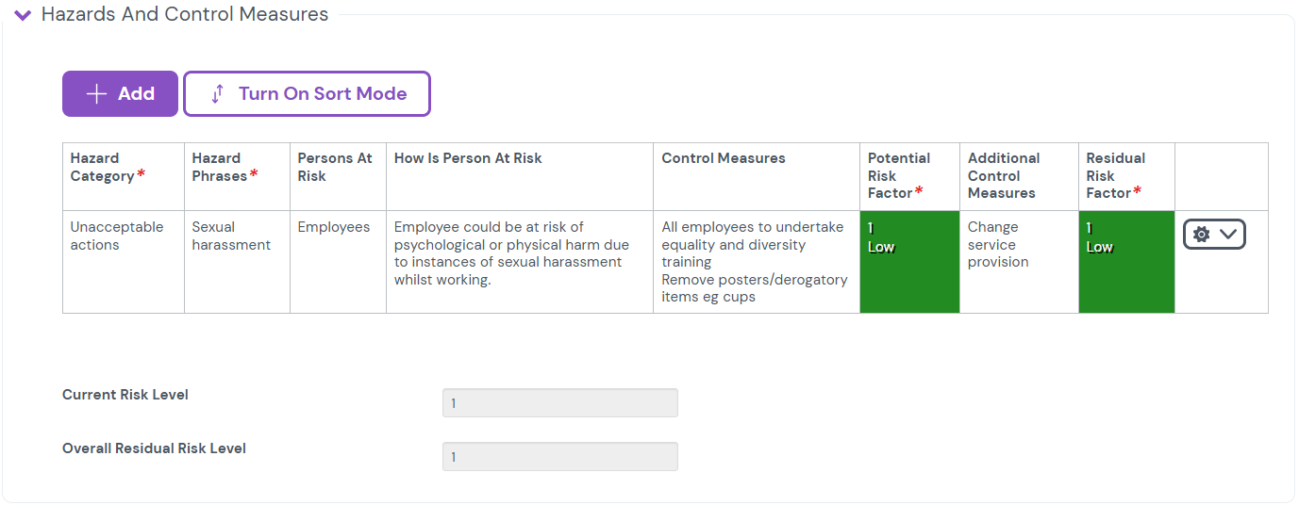
3. Control Measures should be considered and added. Appropriate control measures are available within the Control Measure to prevent sexual harassment and the following control measures are always required to be implemented:
- All employees to undertake equality and diversity training
- Remove posters/derogatory items eg cups

As a manager we should always:
- make it clear to everyone who works for you, or uses your services, that we do not tolerate harassment including sexual harassment, bullying, discrimination, or abuse in any form, and we are committed to promoting a safe and respectful workplace.
- encourage staff to report any incidents of sexual harassment
- encourage staff to report situations where they felt at risk, even if nothing happened
- set standards of behaviour for work social events

Incident Reporting & Investigation
Incident reports submitted via the EVOTIX Employee Portal now contain a field for reporting whether an incident was prejudiced based and, if so, what characteristic was involved. Where an incident report is received and it indicates a protected characteristic is involved the line manager/investigating officer should:
- Confirm with the affected employee that this is correct and if so liaise with the Service HR BP to determine the most appropriate way forward.
- If the incident was reported incorrectly as being prejudice based, the line manager/investigating officer, after confirming with the employee reporting the incident, should change the dropdown menu to ‘No’ and use the Note function in the Supporting Items of the incident report to record that this has been changed after confirming that the incident was incorrectly reported by the employee.
When recording this change in the Note, the line manager/investigating officer should cut and paste the following statement into the comment section:
This incident was incorrectly reported as being Prejudice based and has been updated following consultation with the affected employee.
