Place Services
Falkirk Stadium
4 Stadium Way
Falkirk
FK2 9EE
Director: Malcolm Bennie

Enquiries to:wasteservices@falkirk.gov.uk
Website: www.falkirk.gov.uk/recycling

Request for additional capacity for non-recyclable waste (Green bin)

Thank you for requesting additional capacity for non-recyclable waste.
Whilst we understand each individual household may have a busy lifestyle, we would appreciate it if you could take the time to complete the enclosed application form and waste audit diary.
Please complete this over a two-week period and submit your findings by visiting: Household waste and recycling: Green bin - Larger green bins - Falkirk Council.
If you don’t have access to the internet, you can call our Contact Centre on 01324 506070 between 9am and 5pm, Monday to Friday, for support.
By participating in our waste audit diary, this allows us to keep note of how much waste is being produced from your household, and it helps us identify any special requirements.
Please refer to our top tips found below, and the recycling guide overleaf, which will assist you when filling out our audit diary.

Top Tips:
- Please do not put food waste in your green bin. Your food waste can be recycled using the weekly kerbside food waste collection service. If you place food waste inside your green bin, your request for a larger green bin may be declined.
- If your household needs help with the disposal of nappies or incontinence products, why not try our Absorbent Hygiene Product service (AHP). For more information, including how to apply, please visit www.falkirk.gov.uk/ahpcollection
- Any materials that can be recycled in the burgundy bin, blue bin, brown bin or black box must not be placed in your green bin.
- Reuse plastic bags for carrying your shopping or use as a liner for your food waste caddy.
- Are the items you are placing in your bin’s reusable? Think before throwing out your old items you no longer require. Remember your waste could be another person’s treasure. Reusing materials helps to make sure that we are making the most of our waste and saves valuable natural resources.
- Retailers will take back and recycle your old electrical item when you buy a new one, regardless of brand, or whether the item being returned was bought in store, online or via mail order, for more information visit: Recycle your electricals - The retailer take back scheme
- Small electrical items and household batteries can be recycled at your nearest recycling centre

What happens next?
Once we receive your completed waste audit application, it will be reviewed, and we will let you know the outcome of your request.
If you have any questions or you require assistance with your application, please do not hesitate to contact us at wasteservices@falkirk.gov.uk

Recycling guide

To help maximise your household recycling, please refer to the guide below. If you require further information, including your bin collection days, please visit www.falkirk.gov.uk/recycling

Food Waste (Collected every week)

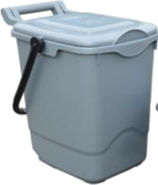
 Dairy & eggshells
Meat & Fish (including bones Fruit & vegetables
Bread, cake & pastries
Rice, pasta & beans
Teabags & coffee grounds Pizza
Pet food
Semi-liquid food
Uneaten food from your plates and dishes

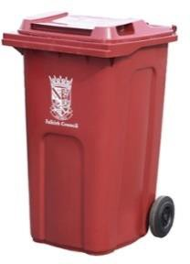
Paper, card & cardboard | (dry) | (Collected every 4 weeks)
Paper food packaging | Wrapping paper | Large & small cardboard boxes
Brochures & catalogues | Office & shredded paper | Brown corrugated boxes
Yellow pages & directories | Magazines | Toilet & kitchen roll tubes
Newspapers | Paperback books | Egg boxes
Leaflets | Letters & envelopes | Cereal boxes
Plastics, cans & cartons |  | (Collected every 4 weeks)
Food trays | Lids & bottle tops | Aluminium foil & trays
Drinks & milk bottles | Sauce bottles | Chocolate & biscuit tins

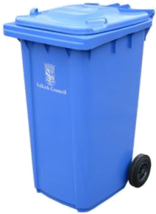

Tablet & medicine bottles Yogurt pots
Cleaning products
Garden waste
(Collected every 4 weeks)
Grass cuttings Weeds
Flowers & plants
Leaves
Prunings
Twigs & small Windfall fruit
Real Christmas trees
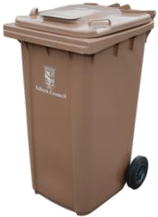
Hedge trimmings
Shampoo & hand wash bottles Drinks & food cans
Glass, small electricals & textiles
(Collected every 2 weeks)
Empty aerosol cans
Metal lids
Soup & juice cartons Other cartons

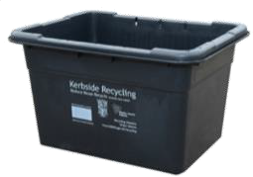
Glass bottles & jars

Non-recyclable landfill waste
(Collected every 4 weeks)
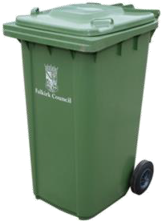

Polystyrene
Paint tins
Animal waste Vacuum dust
Plastic film & carrier bags
Plastic foil such as crisp packets and sweet wrappers Nappies & incontinence products (disposable nappies & incontinence waste can also be collected via the AHP collection service. For more information please visit www.falkirk.gov.uk/ahpcollection
Any other items not currently accepted in the kerbside recycling service

