Learning Platform User Guide

Contents
Learning Platform User Guide 1
1. Where can I find the Learning Platform? 1
2. How to sign in for the first time? 1
3. How to reset your password? 3
4. What is the Dashboard and how do I use it? 3
5. How do I launch a learning resource and check it is complete? 4
6. How do I add learning to my plan? 5
7. How do I explore available resources? 7
8. What reports can I view? 9
9. How to raise a technical issue with the system? 12

Where can I find the Learning Platform?
You can find the Learning Platform on the Council website or the quick links on the Intranet.
Tip: Add the Learning Platform to your favourites for quick access.

How to sign in for the first time?
On the login page you will see two options:
- Falkirk Council Sign In: link
Here you can sign in directly without entering any details if you have falkirk.gov.uk email address. This is the recommended option.
If you cant's sign in, please use this MS Form to register your email address and we will take care of it for you as soon as we can.
- Username & Password Sign In: link
Here you can sign in using your Username which is usually your 6 digits employee number. For the first time signing in please use the ‘Forgotten your details’ link:
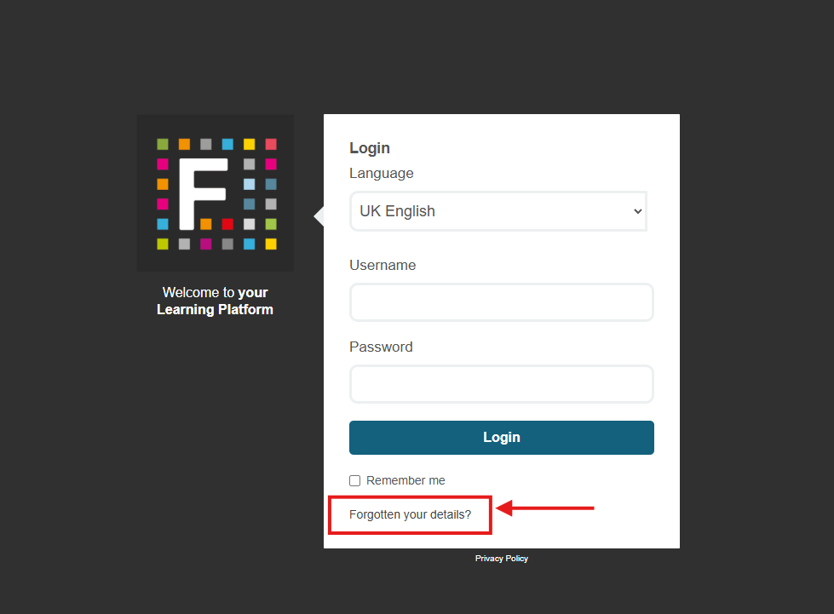

Next, please use the first option ‘Reset Your Password’. Your username in most cases is your employee number. Alternatively, please try your email address as your username.
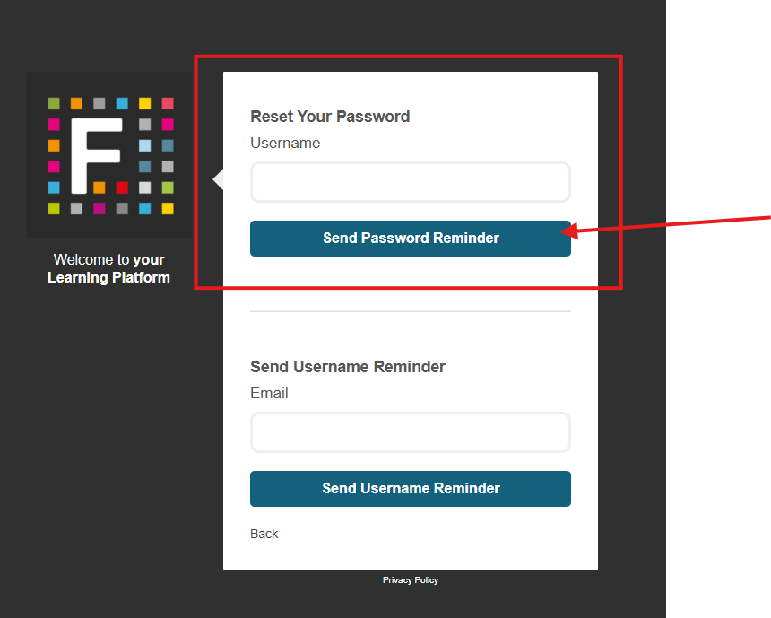
You should then receive an email from the system with a link to reset your password.

If you have any issues signing in, please contact: technicallearning@falkirk.gov.uk

How to reset your password?
On the login page, select ‘Forgotten your details’, then choose ‘Reset Your Password’.
If you are an employee, your username is your employee number. If you are a member of the team but are employed by another organisation your username is the email account that you selected.

If you have not yet done this, please register your preferred email account using this form: Learning Account Registration Form (for learners not employed by Falkirk Council)
You will then receive an email from the system with a link to reset your password.

If you have any issues signing in, please contact: technicallearning@falkirk.gov.uk

What is the Dashboard and how do I use it?
After signing in, you will see the platform landing page, known as your Dashboard.
Your Dashboard shows your assigned learning and any resources you have recently viewed:
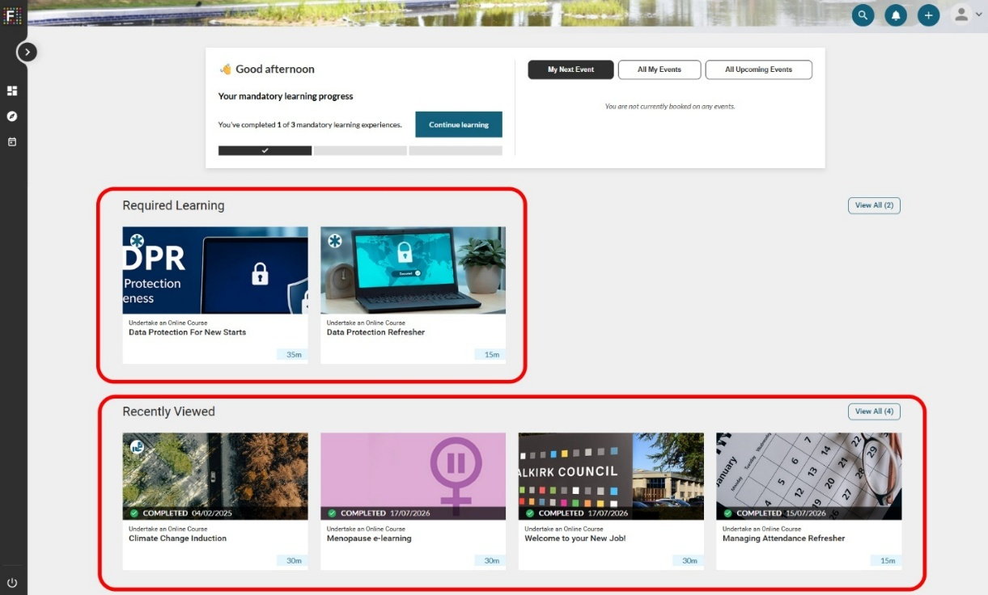
You can also view your progress towards completing required learning:
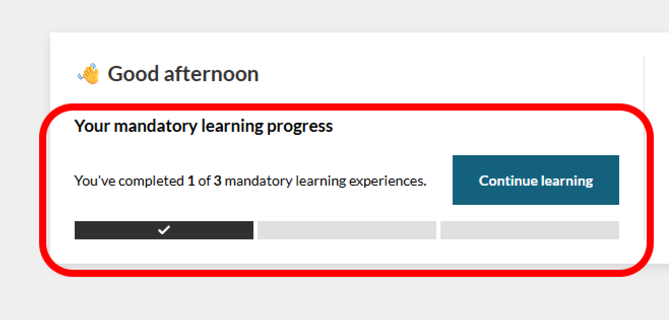

How do I launch a learning resource and check it is complete?

To start a learning resource, hover over it and select the Launch option:
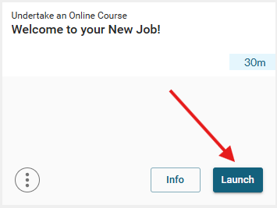
To confirm you have completed a resource, check that it is marked as completed above the course title:
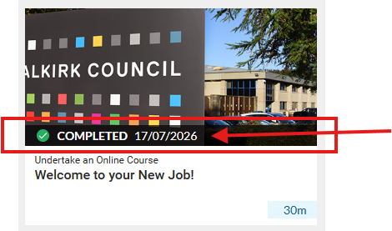
It should also be visible if you hover over the resource:
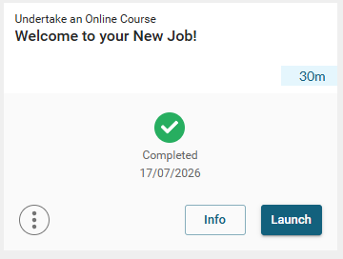

How do I add learning to my plan?
You can build your own ersonalized learning plan. Find the learning you want to add, hover over it to view more options, select the three dots in the bottom left corner, then choose ‘Add to My Plan’:
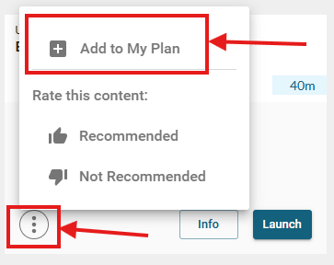
The resource will then appear in the My Plan playlist on your Dashboard:
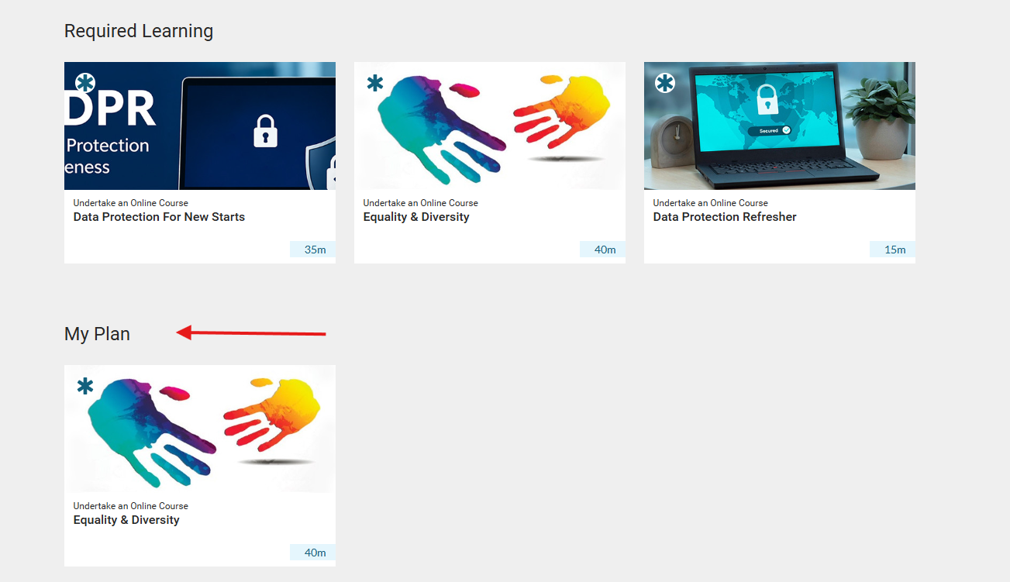
Please note: once a course is added to Your Plan, it will also appear in your Required Learning.

How do I explore available resources?

From your Dashboard, expand the left-hand side panel to view all available learning resources on the platform:
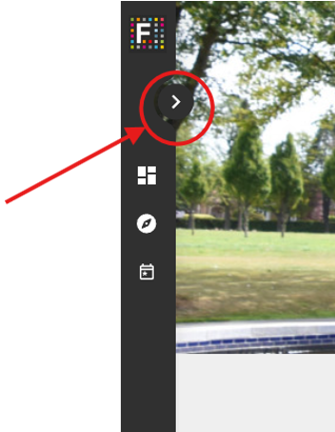
And then select the Discover option:
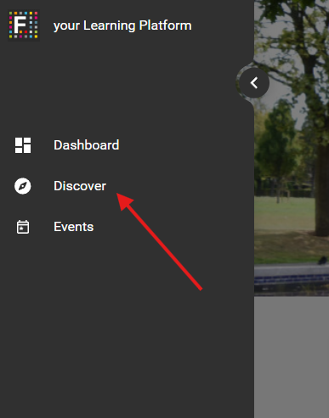
You will see all available resources there. Use the filters to find learning that interests you:
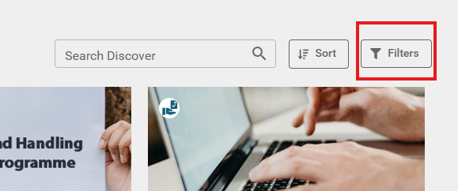

Where you can select categories and apply the filters:
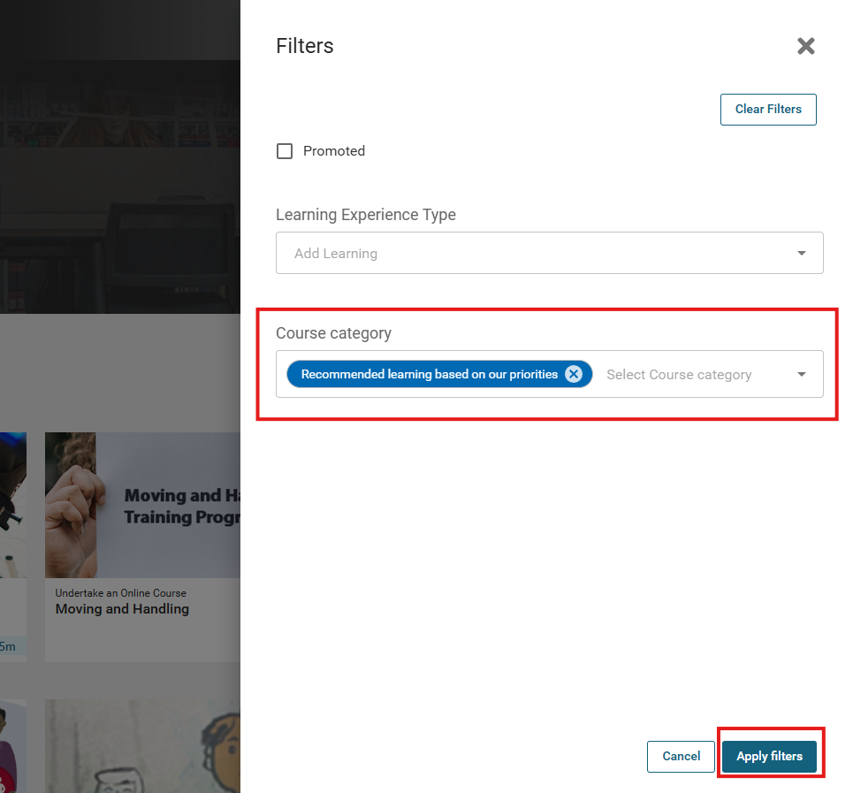

You can also use the search function to find a specific resource:
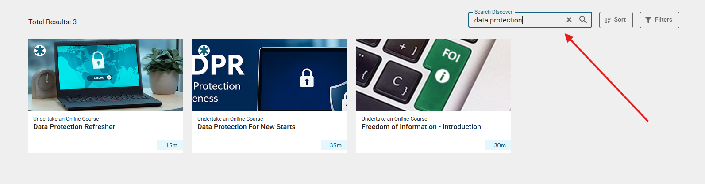

To return to your Dashboard, select the Dashboard icon on the left:
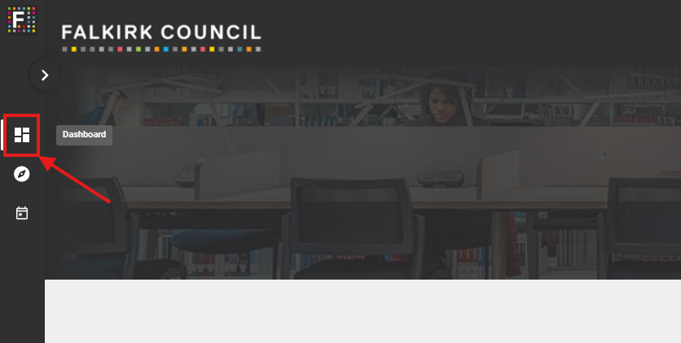

What reports can I view?
There are two report types: one for learners and one for managers. As a learner, you can view your completed learning by selecting your profile in the top-right corner, then choosing ‘My Reports’:
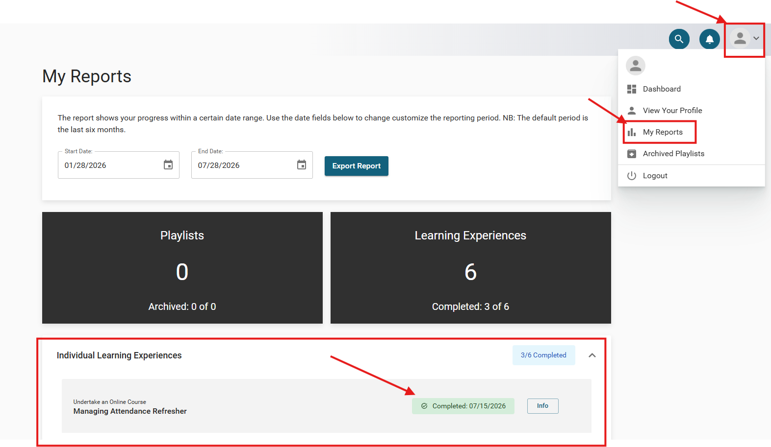
Managers can also track their team’s learning progress by selecting the ‘My Team’ option:
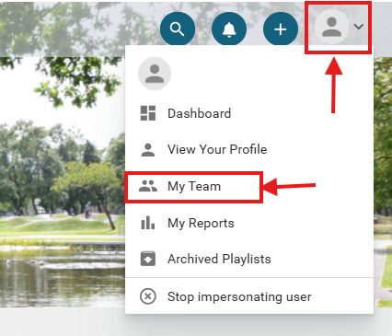

Here you can see your team members and whether they have completed their assigned learning:
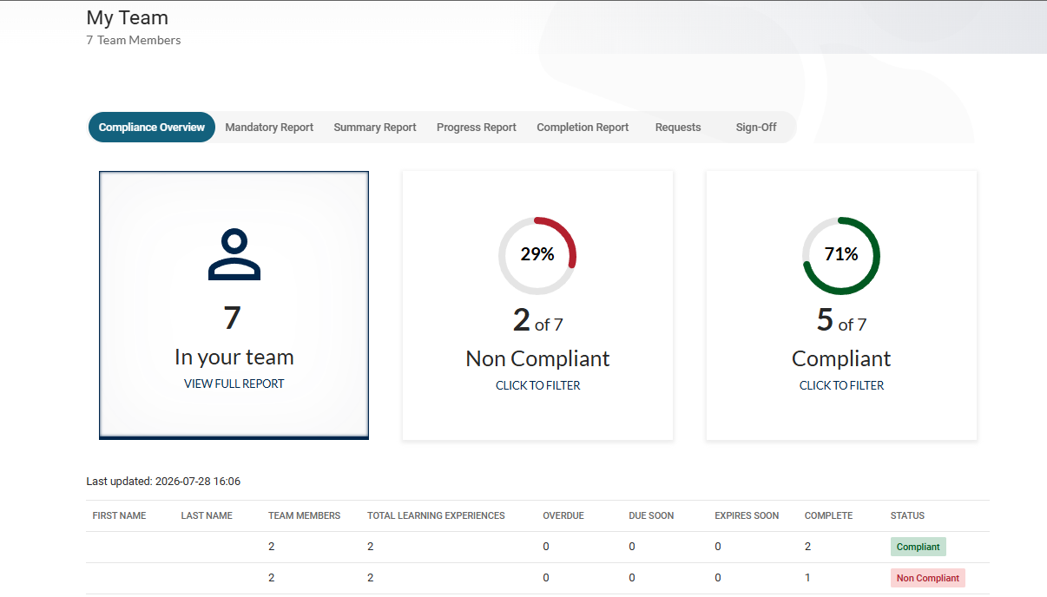

You can filter through the tabs for more details:
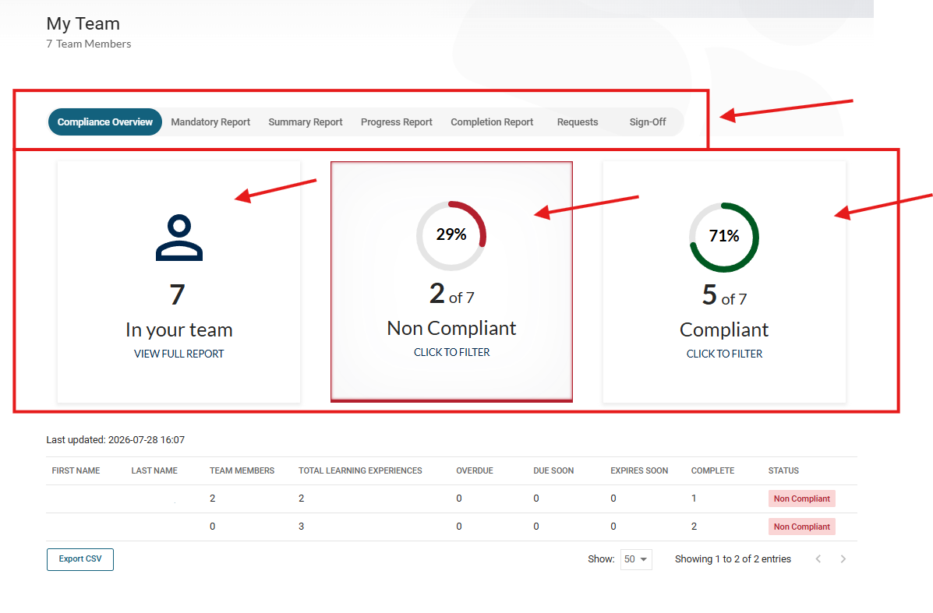

How to raise a technical issue with the system?

Please contact technicallearning@falkirk.gov.uk with any issues you may have with the platform.

