

Scottish Private Landlord Survey 2024

# Introduction

Introduction and main findings Profile of private landlords

Profile of dwellings and households The future of the Private Rented Sector Technical notes

## Introduction and main findings

Scotland’s Housing Network (SHN) is pleased to welcome you to our first report on the Scottish Private Rented Sector. This report has been informed by a national survey of landlords and letting agents who own and/or manage privately rented properties in Scotland.

Compared to other sectors, there is relatively limited information available on the functioning of the private rented sector in Scotland. Therefore the aim of the survey is to explore the characteristics and experiences of landlords and how they acquire, let, manage and maintain privately rented accommodation.

The private rented sector in Scotland has more than doubled in size since 1999, and now provides homes for around 340,000 households, a seventh of all homes in Scotland. This is due to a variety of factors including increased demand from people to live in the private rented sector, reflecting a mixture of constraints and preferences. In terms of the supply of private rented housing. The growth of buy-to-let mortgages has been a particularly important driver of growth.

A variety of regulatory controls have been introduced to the private rented sector in Scotland on an incremental basis. The Private Housing (Tenancies)(Scotland) Act 2016 introduced a new open ended private residential tenancy to supersede existing tenancy arrangements. The new tenancy includes measures to control excessive rent increases. Furthermore, it allows local authorities (with Scottish Government approval) to set up rent pressure zones in their areas where rent rises for existing tenants would be restricted. More recently, the Scottish Government introduced emergency regulations to restrict evictions and cap rents during the Covid-19 pandemic and cost of living crisis. Further new legislation for tenants in Scotland has been proposed by the Scottish Government. The Housing Bill was introduced to parliament in March 2024, and proposals include “long term rent controls for private tenancies, new rights to keep pets, decorate homes and stronger protection against eviction”. Awareness of, and the impact of these factors is explored in this report.

This report provides an overview of the private landlord population in Scotland in 2024. The first section covers the characteristics of landlords, why and how they became a landlord and how they view their current role. Section two presents an overview of landlords’ portfolios - private rented dwellings and the households living in them, including the types and location of rented homes and the types of tenants. It also explores how landlords set rents and the circumstances around how tenancies end.

The final section provides evidence regarding the likely future of the private rented sector by setting out findings about landlords’ stated future plans.

Full details of the survey sampling, weighting and reporting conventions are in the full technical notes at the end of this report. Briefly, the survey is an online survey with a responding sample of around 10,000 landlords, all of whom are registered with their local authority landlord registration scheme.

Although landlords frequently delegate the letting and management of properties to agents the survey design has allowed for the collection of information directly from the landlord. This is because the survey was looking for the motivations and aspirations of landlords entering the sector and agents cannot always provide information that would be personal or confidential to a landlord (i.e. plans for the future, qualifications and experiences etc.).

Main findings

There were 238,331 landlords registered with the landlord registration scheme in Scotland as at April 2024 (Registers of Scotland).

The survey found that around two thirds of all landlords owned one rental property, and a further 33% owned between two and five rental properties. This amounts to 91.6% owning up to five properties with the remaining 8.4% of landlords owning six or more properties.

While the majority of landlords bought their first property with the intention of letting it out, eight percent inherited or were given the property.

The most common demographic types of tenants that landlords let to were single occupants (29%), couples with no children (27%), couples with dependent children (15%), and students (9%).

Eleven percent of landlords stated that at least one of their tenants claimed housing support. Of landlords who have a tenant who receives housing support, landlords with more properties are more likely to have a higher proportion of their portfolio who receive housing support.

Landlords setting rents for new tenants were more likely to increase rent above the level at which the property was last let. For new tenancies, nearly half of landlords said they increased the rent compared to the previous tenancy, whereas 34% kept the rent at the same level and three percent decreased the rent.

Landlords who reported a tenancy ending within the last two years reported that for two thirds (64%) the tenant gave notice to end their tenancy. Around three in twenty (15%) reported that the tenant moved away. Five percent of landlords reported that they had asked the tenant to leave.

When asked about future plans for their portfolio, three in twenty planned to decrease their number of properties. Sixteen percent of landlords planned to decrease their number of properties, and a similar number planned to sell all properties and leave the business (12%). Only five percent of landlords indicated that they planned to increase their number of properties.

Acknowledgements and further queries

The authors would like to thank the landlords and agents who gave up their time to complete the survey. We are indebted to colleagues from the 32 local authorities, without whom the survey would not have been possible.

## Profile of private landlords

This section presents findings on the types and characteristic of landlords, their finances, their motivations for becoming a landlord and their perceived role as a landlord.

Landlord Types

Landlords were asked how they currently let their property. The majority (99%) let property as a private landlord, with 1% being letting agents, Figure 1.

**Figure 1: Landlord population by landlord type, 2024**

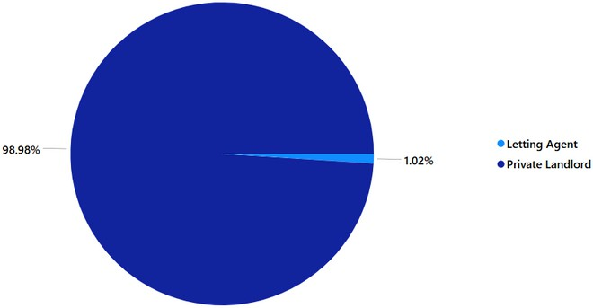

**Base: all landlords**

Landlords were asked how many rental properties they own in Scotland. More than half (59%) owned one rental property, a further 33% owned between two and five rental properties and 4% owned between six and nine rental properties. The remaining 4% of landlords owned more than ten properties, Figure 2.

**Figure 2: Portfolio size**

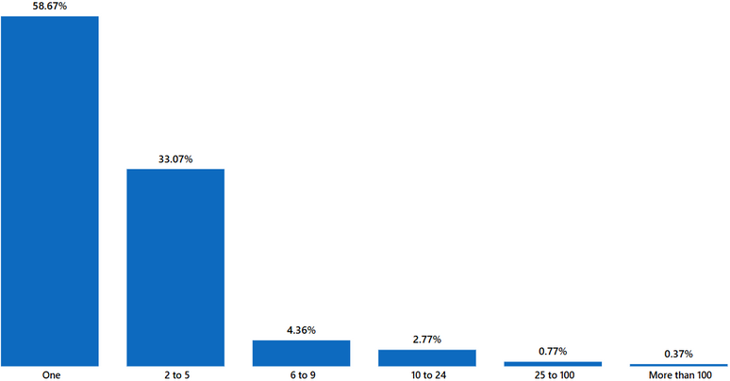

**Base: all landlords**

Landlords with Buy-to-let mortgages were more likely to have multiple properties than those who have other types of loans, or those with no debt or loans. More than half (47%) landlords with a Buy-to-Let mortgage owned one property, with 53% owning more than one property. Four in five (80%) of landlords with a conventional mortgage owned one property. For those with no debt or borrowing, 64% of landlords had one property, and 36% had more than one property.

Landlords who had been letting for longer tended to have larger portfolios. Of landlords with twenty or more years’ experience, 67% had two or more properties, compared with 22% of those who had been letting for less than three years.

Age and time spent as a landlord

Landlords were asked questions about their personal characteristics and landlord journey.

More than half (62%) of landlords were aged 55 or over in contrast to 4% of landlords who were aged from 25 to 34 years of age. In comparison, of the general population aged over 18 years of aged some 43% are aged 55 or over demonstrating that this age group is overrepresented.

**Figure 3: Landlords by age**

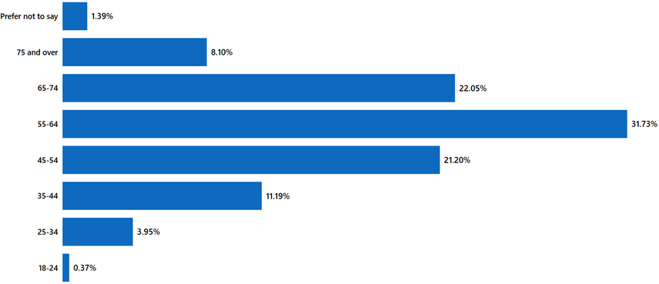

**Base: all landlords**

New landlords are defined as landlords who have been letting dwellings for one year or less. Longer term landlords are defined as landlords who have been letting properties one year or more.

 Almost half (48%) of landlords had been landlords for 10 years or less.  Less than 20% of all landlords had let for more than 20 years.

 The majority (96%) of new landlords were private landlords with one property to let.

**Figure 4: Number of years as a landlord**

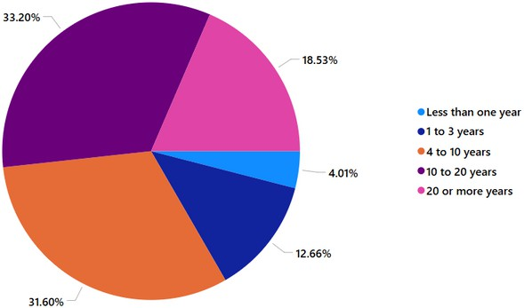

**Base: all landlords**

Becoming a landlord and perceptions of the role

Landlords were asked to select the reasons they originally became a landlord. The two most prevalent reasons were to supplement income (24%) and as a pension contribution (22%). A further 21% said they prefered to invest in property. Smaller proportions said they inherited or were given the property (8%), provide a home for a relative or friend (7%), or to let the property as a full-time business (3%). Only 1% orginally become a landlord as they could not afford the mortgage to live in the property, Figure 5.

**Figure 5: Reasons for becoming a landlord**

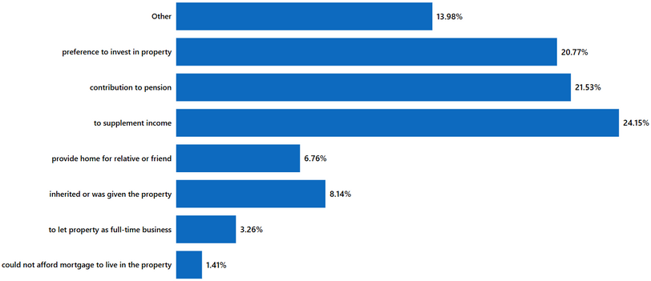

**Base: all landlords**

Landlords were asked about the sources of funding for their rental properties. More than half (50%) reported that they had no debt or borrowing. One third (36%) reported using a buy to let mortgage and 6% used a conventional mortgage. Landlords with two to four properties were equally likely to have used a buy-to-let mortgage or a conventional mortgage but landlords with portfolios of five or more properties were more likely to have used buy-to-let mortgages. Landlords with one rental property were more likely to have used a conventional repayment mortgage than landlords with multiple rental properties.

**Figure 6: Funding of rental properties**

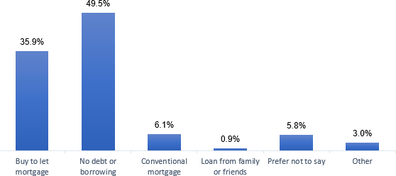

**Base: all landlords Notes:**

**1) multi-code question. Responses add up to more than 100%**

Use of agents

Landlords were asked whether they currently used an agent to let or manage their properties. More than one third (36%) said they did use a letting agent for letting services, Figure 7. Around one in five (27%) used an agent for management service. Landlords with one property were more likely to say they did use an agent (54%) compared to landlords with two to five properties (35%) or landlords with five or more properties (11%).

**Figure 7: Use of letting agents**

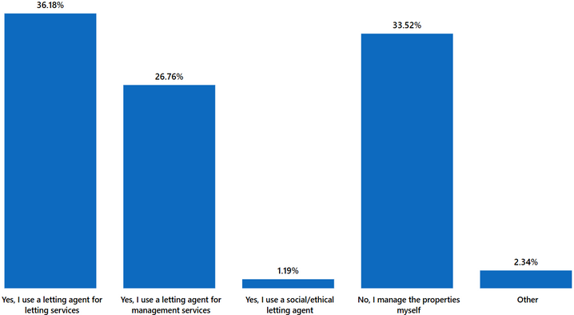

**Base: all landlords**

Membership of professional organisations

Landlords were asked if they currently or previously had belonged to one or more of the main rental related professional organisations. One third of landlords (28%) reported no membership of any organisation. Two in five (41%) landlords reported being a member of the Landlord Accrediation Scotland (LAS), one quarter (24%) of the Scottish Association of Landlords (SAL) and one percent reported membership of some other professional rental or property organisation.

## Profile of dwellings and households

This section presents findings on the types of dwellings that private landlords let and the households that live in them. It also provides findings on recent rent setting practices and the reason for ending tenancies.

Profile of Dwellings

There were 238,331 landlords registered with the landlord registration scheme as at March 2024. As noted, these do not necessarily correlate directly with the number of properties that landlord may own, as some landlords will have more than one property.

Landlords were asked to indicate any type of rental property they currently owned, let or managed across their whole portfolio.

Purpose-built flats or maisonettes were the most commonly let (69% of landlords), followed by detached houses (17%), terraced properties (14%), converted flats or maisonette (12%), semi-detached houses (11%), and bedsits, room or flatlets (3%), Figure 8.

**Figure 8: Type of rental property currently let or managed by landlords**

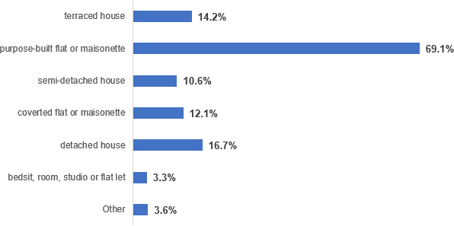

**Base: all landlords Notes:**

**1) multi-code question. Responses add up to more than 100%**

Landlords were asked to indicate the size of rental property that they currently let or manage.

Two-bed properties were the most commonly let (61% of landlords), followed by one bed properties (35%), and three bed properties (25%). In contrast, larger four and five bedroom properties (7% and 2% respectively) were less commonly let or managed by landlords, Figure 9.

**Figure 9: Size of rental property currently let or managed by landlords**

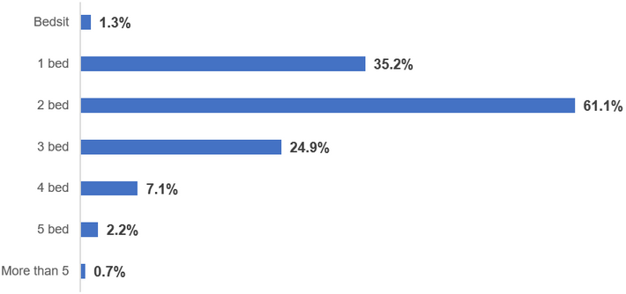

**Base: all landlords Notes:**

**1) multi-code question. Responses add up to more than 100%**

Landlords were asked to indicate if any of their properties had adaptations installed to make them more accessible for those with disabilities.

Whilst the majority of respondents (75%) indicated that no properties in their portfolio had an adaptation, the most common adaptations were wet floor/level access shower (6%), ramps (3%), and widened doorways (3%).

**Figure 10: Adaptations in rental property currently let or managed by landlords**

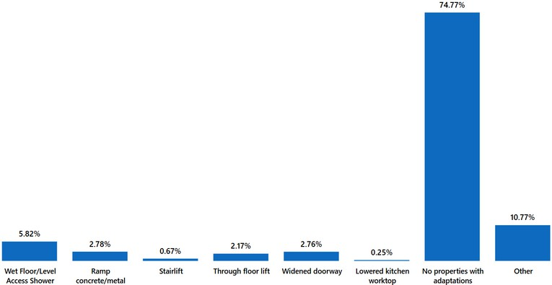

**Base: all landlords**

Profile of households

Landlords were asked to indicate which types of tenants they currently let to.

The most common demographic types of tenants that landlords let to were single occupants (44%), couples with no children (41%), couples with dependent children (24%), and students (14%). Relatively fewer landlords and agents reported letting to house sharers (13%), single parents (12%), or extended families (2%)

**Figure 11: Type of tenants landlords currently let to**

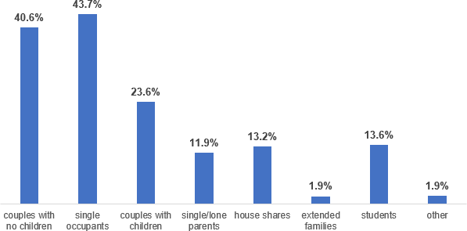

**Base: all landlords Notes:**

**1) multi-code question. Responses add up to more than 100%**

Landlords were asked whether any of their current tenants received Housing Benefit, Local Housing Allowance or Universal Credit. Eleven percent of landlords stated that at least one of their tenants claimed one of these benefits, Figure 12.

Of landlords who have a tenant in receipt of housing support, landlords with more properties are more likely to have a higher proportion of their portfolio who receive housing support. For landlords with two or more properties, 69% of tenants are in receipt of housing support. In comparison, around 31% of tenants receive housing support for landlords with only one property. Landlords with fewer properties were less likely to know whether their tenants were in receipt of benefits with 65% of landlords with one property stating that they did not know if their currents tenants receive benefits.

**Figure 12: Whether any current tenants receive benefits**

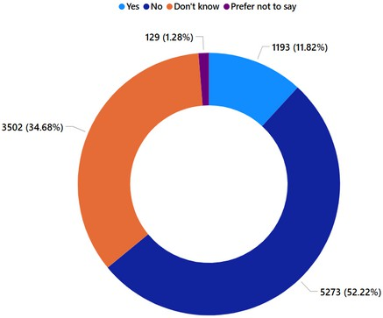

Base: all landlords

Setting rents and contracts

Landlords were asked, for their last letting to a new tenant, whether they had increased, decreased or kept the rent the same, compared to the previous tenancy. More than half (49%) had increased the rent, around one third (35%) had kept the rent the same, and 3% had decreased the rent.

**Figure 13: Setting rents for new tenants in most recent letting**

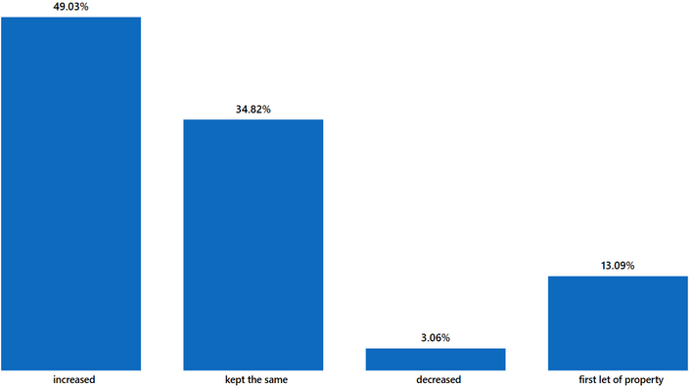

**Base: all landlords**

Tenancies that ended

Landlords who reported a tenancy ending within the last two years were asked why this tenancy (or these tenancies) had ended.

The most common reason, selected by around half (64%) of landlords was that the tenant gave notice to end their tenancy. Around three in twenty (15%) reported that the tenant moved away. Five percent of landlords reported that they had asked the tenant to leave.

Other reasons for tenancies ending included the tenant moved out before the end of tenancy (5%), tenant did not renew the tenancy (4%), tenant evicted for rent arrears (3%), tenant evicted for anti-social behaviour (1%), the landlord did not renew the tenancy (2%) and the tenant found social housing (2%).

The proportion of tenancies ending for these reasons did not vary much by different landlord type or portfolio size.

**Figure 14: Reasons tenancies ended**

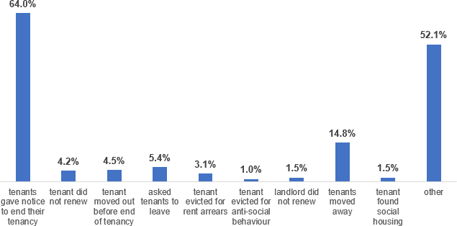

**Base: all landlords Notes:**

**1) multi-code question. Responses add up to more than 100%**

## Future of the private rented sector

This section presents findings on the future plans landlords have for their rental property portfolios and their concerns with respect to finances, legislation and tenant behaviours.

Landlords’ future plans

Landlords were asked what, if any, investment plans they had for their rental properties over the coming two years. One third 35% of landlords said that they plan to keep the number of properties the same. A further third of landlords (32%) said they had not made plans. A similar number of landlords planned to decrease their number of properties (16%), as planned to sell all properties and leave the business (12%). Only five percent of landlords indicated that they planned to increase their number of properties.

Landlords’ future plans also differ depending on their portfolio size. Overall, landlords with two or more properties were less likely to plan to keep the same number of rental properties they let out (35%) than those with one property (65%). Around one third of (37%) landlords with two or more properties reported plans to decrease the number of rental properties they own, and 17% reported plans to increase the number of rental properties they own, which were higher proportions than those with one property (4% and 13% respectively).

Landlords with buy-to-let mortgages were more likely to report plans to increase (7%) or decrease (21%) the number of properties in their portfolio compared to landlords with no debt or borrowing (4% and 12%) or a conventional mortgage (4% and 14%, respectively). They were also more likely to report intending to sell all properties and leave the business (15%) than landlords with a conventional mortgage (10%) or no debt or borrowing (10%).

**Figure 15: Length of time expected to remain in the sector**

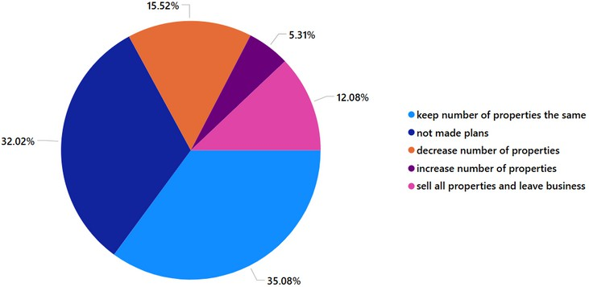

**Base: all landlords**

Landlords who planned to decrease or sell all their rental property were asked to select reasons why they were planning to do so. From the options given, government attitude towards landlords was the most commonly selected (36%), followed by recent legislative changes which was selected by 29%. A further 22 per cent of landlords also reported intending to sell or decrease their portfolio for personal reasons due to forthcoming legislative changes.

**Figure 16: Reasons for planning to decrease portfolio size or leave the sector**

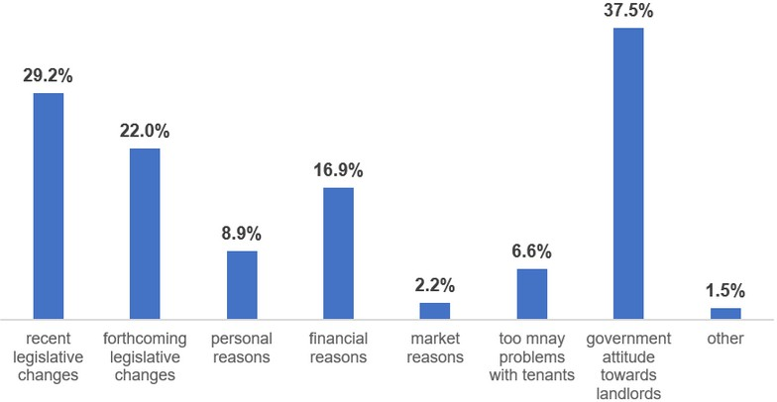

**Base: all landlords Notes:**

**1) multi-code question. Responses add up to more than 100%**

Landlords with one to five properties were more likely to report plans to decrease or sell their rental property due to financial reasons (32%) than those with six or more properties (19%) or more. Conversely, landlords with six or more properties were more likely to report planning to decrease or sell their rental property due to recent or forthcoming legislative changes (82% and 70%) than those with two to five properties (21% and 15%), or one property (18% and 10%).

Landlords who planned to increase or keep the number of their rental properties the same were also asked the reasons for doing so. From the options given, the most common reasons selected were financial (40%) and personal (31%) reasons.

**Figure 17: Reasons for planning to increase or keep portfolio size the same**

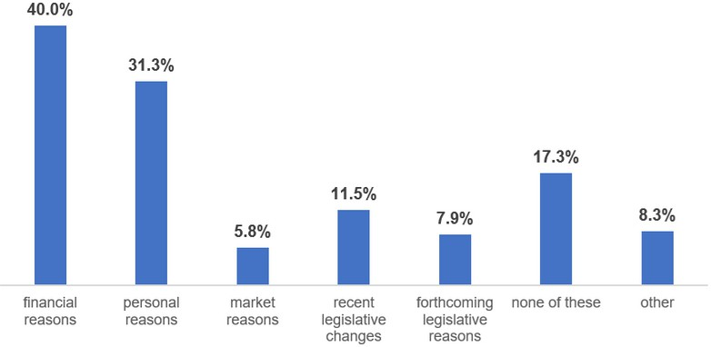

**Base: all landlords Notes:**

**1) multi-code question. Responses add up to more than 100%**

Landlords with larger portfolio sizes were more likely to select market reasons financial reasons personal reasons for increasing or keeping the same portfolio size than those with smaller portfolios.

## Technical notes

Methodology and approach

The Scottish Private Landlord Survey is an online survey of over 9,000 landlords and letting agents registered with their local authority landlord registration scheme. Since 30 April 2006 in Scotland all landlords have to be registered with their local authority landlord registration scheme. It is now an offence for anyone to own residential property in Scotland which is let, if they are not registered with the relevant local authority, or have not made a valid application to register. Anyone who owns residential property in Scotland which is let must apply to register with the local authority for the area where the property is located (exemptions do apply).

Each of the 32 local authorities in Scotland invited registered landlords and agents to take part in the survey.

There are various reasons why some of the sector would not be registered with landlord registration. While some landlords will be operating outside of the law, it is not possible to say how many.

Reporting

The base under each chart denotes the set of respondents on which the findings are presented; this is often the same as the set of respondents to whom the question was addressed.

Some questions relate to all of the respondents’ properties or lettings, whilst others relate only to the most recent letting or property. Where findings relate only to the most recent let property, this is noted.

Several survey questions were multi-coded (i.e. respondents were able to select more than one response), which means that the number of responses may add up to more than 100%. Where this is the case it is noted under the charts.

All reported comparisons were tested at the 5% significance level.

# About us

Scotland's Housing Network is Scotland's largest provider of benchmarking and data insights dedicated entirely to the Scottish social housing sector. More than two thirds of social landlords in Scotland are SHN members, which in turn represents almost 90% of the sector by stock. We've been providing benchmarking services for 29 years, continuously developing and evolving to meet our member's changing needs.

Scotland's Housing Network 5 South Charlotte Street Edinburgh

EH2 4AN

 0131 5819222

 [data@scotlandshousingnetwork.org](mailto:data@scotlandshousingnetwork.org) @ScotHousingNet

