COMMUNITY EMPOWERMENT (SCOTLAND) ACT 2015
FALKIRK COUNCIL ASSET TRANSFER REQUEST FORM
IMPORTANT NOTES:
This is an application form which can be used to make an Asset Transfer request to Falkirk Council.
Any Community Body interested in making an Asset Transfer Request is advised to contact the Asset Team on strategicpropertyreview@falkirk.gov.uk before making the request so that we can discuss your proposal.
Please complete the asset transfer request form if the property/land is owned/leased/managed by Falkirk Council.
It is essential that you read the Asset Transfer guidance provided by the Scottish Government before making a request.
When completed, this form should be emailed to strategicpropertyreview@falkirk.gov.uk or sent to
The Asset Team
Falkirk Council
4 Stadium Way
Falkirk
FK2 9EE

Section 1: Information about the Community Transfer Body (CTB) making the request
  - Name of the CTB making the asset transfer request
Denny and Dunipace Pipe Band Association
  - CTB address. This should be the registered address, if you have one.
Postal address:
REDACTED
Postcode: REDACTED
  - Contact details. Please provide the name and contact address to which correspondence in relation to this asset transfer request should be sent.
Contact name: REDACTED
Postal address: REDACTED
Postcode: REDACTED
Email: REDACTED
Telephone: REDACTED
☐ We agree that correspondence in relation to this asset transfer request may be sent by email to the email address given above. (Please tick to indicate agreement)
You can ask Falkirk Council to stop sending correspondence by email, or change the email address, by telling them at any time, as long as 5 working days’ notice is given.

  - Please mark an “X” in the relevant box to confirm the type of CTB and its official number, if it has one.
 | Company and its company number is ………….
X | Scottish Charitable Incorporated Organisation (SCIO) and its charity number is ……………….. | SC002801
 | Community Benefit Society (BenCom) and its registered number is ………………………………
 | Unincorporated organisation (no number)

Please attach a copy of the CTB’s constitution, articles of association or registered rules.
Please note that under The Community Empowerment (Scotland) Act 2015, where a CTB is seeking ownership rather than a lease, the organisation must have at least 20 members. See the Scottish Government’s Guidance for Community Transfer Bodies.
  - Has the organisation been individually designated as a community transfer body by the Scottish Ministers?
No ☐
Yes ☐
Please give the title and date of the designation order:

  - Does the organisation fall within a class of bodies which has been designated as community transfer bodies by the Scottish Ministers?
No ☐
Yes ☐
If yes what class of bodies does it fall within?
SCIO

- Information about the land and rights requested
  - Please identify the property/land to which this asset transfer request relates.
You should provide a street address or grid reference and any name by which the land or building is known. If you have identified the land on the relevant authority’s register of land, please enter the details listed there.
It may be helpful to provide one or more maps or drawings to show the boundaries of the land requested. If you are requesting part of a piece of land, you must attach a map and give a full description of the boundaries of the area to which your request relates. If you are requesting part of a building, please make clear what area you require. A drawing may be helpful.
Details of Property:
FC LOCATION PLAN
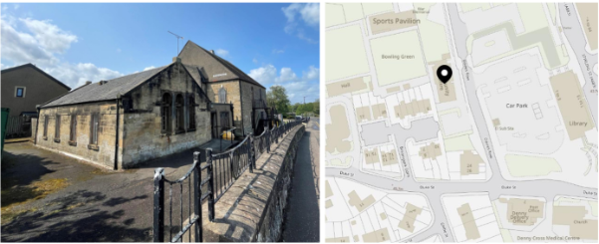
Figure 2: External and Location of Hall
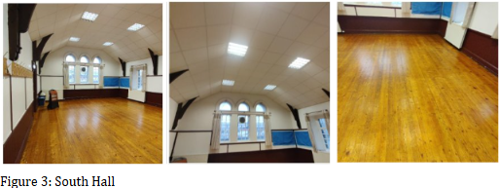
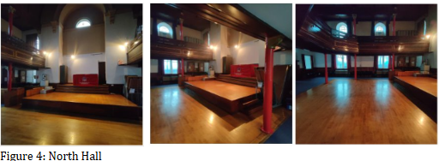
Address:
Broompark Community Hall
Davies Row
Denny
Postcode:
FK6 6NP

  - Please provide the UPRN (Unique Property Reference Number), if known.

UPRN: 136068392

- Type of request, payment and conditions
  - Please tick what type of request is being made:
 for ownership (under section 79(2)(a)) - go to section 3A

for lease (under section 79(2)(b)(i)) – go to section 3B

for other rights (section 79(2)(b)(ii)) - go to section 3C

3A – Request for Ownership
What price are you prepared to pay for the land requested?
Proposed price: £1
Please attach a note setting out any other terms and conditions you wish to apply to the request.

3B – Request for Lease

What is the length of lease you are requesting?

How much rent are you prepared to pay? Please make clear whether this is per year or per month.

Proposed rent: £ per

Please attach a note setting out any other terms and conditions you wish to be included in the lease, or to apply to the request in any other way.

3C – Request for other Rights
What are the rights you are requesting?
Car park

Do you propose to make any payment for these rights?
Yes ☐
No x☐
If yes, how much are you prepared to pay? Please make clear what period this would cover, for example per week, per month, per day?
Proposed payment: £ per

Please set out any other terms and conditions you wish to apply to the request.

- Community Proposal
  - Please set out the reasons for making the request and how the land or building will be used.
This should explain the objectives of your project, why there is a need for it, any development or changes you plan to make to the land or building, and any activities that will take place there.
4.1.1 Objectives of Project

The Denny and Dunipace Pipe Band are seeking to take asset transfer the building, to ensure that a community asset remains within community control.

The Denny and Dunipace Pipe Band was established in 1964 by [REDACTED] who became the band’s first Pipe Major. Based in the town of Denny, near Falkirk, the band quickly became a cornerstone of the local community, promoting Scottish music and culture through piping and drumming.

Today, the Denny and Dunipace Pipe Band continues to thrive. The organisation now includes a Grade 2 band led by [REDACTED] and a Grade 4A band under [REDACTED], reflecting its commitment to nurturing talent and expanding opportunities for pipers and drummers of all levels. With a proud history and a strong community presence, the band remains a vibrant part of Scotland’s musical heritage.

The Broompark Community Centre, located on Davies Row in Denny (FK6 6NP), has long served as a vital hub for local residents. Originally, the building was known as Broompark Church, a place of worship that played a central role in the spiritual and social life of the community. In the late 1980s, the site underwent a significant transformation when it was repurposed by Falkirk District Council’s Planning & Environment Department into a community centre.
This redevelopment, which took place between 1987 and 1988, marked a new chapter for the building. It shifted from a religious institution to a secular space designed to support a wide range of community activities. The centre was officially designated as a community hall, with a total area of 598 square metres, and has remained under outright ownership by the local authority.
Today, Broompark Community Centre has since ceased to operate as an important venue for local events, meetings, and social groups. However, its central location in Denny makes it easily accessible, and its historical roots as a former church add a unique character to the space.

4.1.2 Why there is a need for your Project?

Our community centre has lacked in any programme to develop and drive usage, we believe that we have the necessary skills to manage our building and get the best for our community.
By transferring ownership of the centre to the community, we aim to re-open and safeguard a vital local asset that will offer inclusive space for social connection, learning, and support.
“Our mission is to foster cultural enrichment, musical education, and community connection by providing a welcoming and accessible hall owned by Denny & Dunipace Pipe Band, through traditional music, inclusive programming, and collaborative use of the space, we aim to strengthen local identity, promote the heritage of pipe band music, and offer a venue that supports the diverse needs of our community.”

Our plans for the community ownership of the Broompark Community Centre are rooted in the pressing needs of our local population. Denny and Dunipace, together comprise an estimated 6,604 and 3,726 households (10,330 households), with a significant proportion of these households facing financial constraints due to the cost-of-living crisis. In Dunipace, 36.2% of households receive a single adult Council Tax discount, while in Denny this figure rises to 38.9%. These indicators reflect a high level of economic vulnerability and social isolation, underscoring the importance of accessible, community-led services.
The age profile of the area is mixed, with a balance of young families, working-age adults, and older residents. This diversity creates demand for a wide range of services—from youth activities and family support to adult learning and social opportunities for older people. The centre is well-positioned to meet these needs through inclusive programming and flexible space use.
Overall, the demographic and economic profile of the area clearly demonstrates the need for a community-owned facility that is responsive, inclusive, and sustainable. The centre will serve as a hub for social connection, learning, and opportunity—helping to build a stronger, more resilient community.
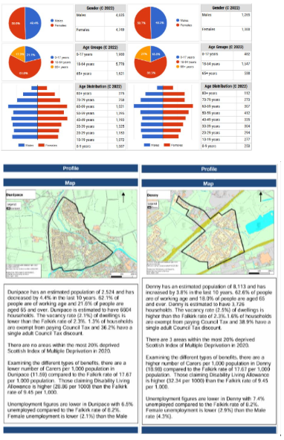

4.1.3 Will any Development/changes/modifications to the asset be required?

A range of essential developments and modifications will be required to bring the asset up to a safe, functional, and community-ready standard. These include repairs to the roof, installation of compliant fire doors, replacement or servicing of boilers, construction of partition walls, fitting of soundproof windows, implementation of a secure door entry system, and the installation of a new floor in the main hall. Due to a prolonged period of limited maintenance, we will implement a regular programme of works to ensure that the building remains safe, efficient, and fit for purpose over time.

4.1.4 What activities will take place?

We will provide space for our community to participate in the following:
Flexible Rentals: Offer hourly, half-day, or full-day rates to accommodate different community needs.
Traditional Music Nights: Host monthly traditional Scottish music evenings featuring local performers alongside your band.
Workshops for All Ages: Offer free or low-cost sessions on drumming, piping, ceilidh dancing, or heritage storytelling.
Heritage Exhibitions: Showcase the pipe band’s history and local culture through pop-up exhibits or photo displays.
Seasonal Festivals: Celebrate Hogmanay, Burns Night, or local holidays with communal events and performances.
Open House Days: Let the public explore the hall, meet the band, and learn about your mission.
Tea & Tunes Afternoons: Casual daytime socials with music, snacks, and friendly chats—especially welcoming for older residents.
Partnerships: Collaborate with schools, music tutors, or cultural groups to offer shared programmes.
Venue Hire: Rent for parties, workshops, fitness classes, or small concerts.
Pipe Band practises.

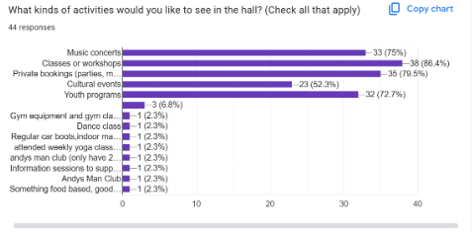
Based on our community feedback we aim to provide space for:
Classes or workshops; Private bookings (parties, meetings, etc); Music concerts; Youth programmes; Cultural events; Gym equipment and gym classes; Dance class; Regular car boots, indoor markets; Weekly yoga classes; Andy’s Man Club; information sessions to support families; Food-based activities.

4.1.5. If the asset is to be used by the public, please provide details of lettings policy and opening times.

The centre will operate daily from 10am to 10pm, offering inclusive access to the hall without discrimination. All bookings will be overseen by our Board of Trustees, with each let personally facilitated by a committee member. During this process, the terms of use are agreed upon, and both our contract of agreement and let form – which we are currently drafting – will be required to be completed and signed.

4.1.6 What provision will be provided for people with disabilities?

While Broompark Community Hall currently presents some accessibility challenges due to its age and layout – including multiple levels and staircases – efforts will be made to improve access wherever practicable. Most areas of the building are accessible, with the exception of the top landing and one room that currently requires re-entry via a separate entrance. We are committed to enhancing accessibility and will seek funding to install new disabled toilet facilities and improve access routes throughout the building. A phased approach will be taken to ensure that as much of the hall as possible is accessible to people with disabilities, aligning with inclusive community values and legal obligations.

All lets, activities, and groups hosted at the hall are open to everyone, without discrimination. We actively promote inclusive participation and will continue to work towards removing barriers to access, ensuring that all members of the community – regardless of ability – can engage fully with the services and opportunities offered at Broompark Community Hall.

4.1.7 Any other relevant information?

Benefits of the proposal
  - Please set out the benefits that you consider will arise if the request is agreed to.
Local Authorities are permitted to dispose of property at less than market value where there are wider public benefits to be gained. This is set out in the Disposal of Land by Local Authorities (Scotland) Regulations 2010. These public benefits are listed below.
In this section, please explain how the project will benefit your community, and others. Please refer to the Scottish Government guidance on how the Council will consider the benefits of a request.
Please explain how the project will benefit your community by detailing how your project will promote or improve:-

4.2.1. Economic development/income generation

ie. Please include details of any job creation or volunteering and training opportunities that will be available as a result of the Asset Transfer. Also details of how your organisation will involve the local community and of any incentives that may be available to encourage the local community to use the proposed services.

Our plans for community ownership of Broompark Community Centre will provide essential services and spaces that might otherwise be inaccessible due to the financial constraints of our local community. We plan to offer employment opportunities once the asset transfer is complete, in the form of a cleaner and a caretaker/project worker.
Moreover, the centre will serve as a platform for volunteering and skill development, enabling individuals to build experience and confidence. This is particularly valuable in areas like ours, where access to formal training and employment pathways can be limited. Through structured volunteer roles, we will support residents in enhancing their employability and personal development, helping to break cycles of disadvantage.
Income levels and employment opportunities in the area are also key considerations. Both Denny and Dunipace show signs of economic deprivation, with limited access to well-paid, stable employment. This highlights the importance of local initiatives that can offer job creation, volunteering, and skill-building opportunities. Broompark Community Centre can play a vital role in addressing these gaps.

    - Regeneration

i.e. Please include details of whether your organisation will contribute to the physical regeneration of the area, and how your proposal will impact the regeneration of the area, in terms of volunteering or employment, giving examples.

Unfortunately, due to the economic climate and the cost-of-living crisis, there has been a decline in the number of businesses, venues, and amenities in our community. The permanent closing of a vital community building would be hugely damaging to the local area. We will maintain and upgrade the facilities to a modern standard. We have plans to upgrade our space and our outdoor area, so that it can be enjoyed by our whole community. We plan to continue our community work to contribute to the local regeneration of the area.

    - Public Health

i.e. How likely is the proposal to improve the Public Health of the Community, in terms of physical and mental health, for example through volunteering, training, or taking part in activities, giving examples.

By improving the overall health of the community, our group aims to help ease the pressure on public and social services, and on other facilities. By engaging in regular social activities, our community can reduce stress, improve mood, and gain a sense of purpose. Physical activities at our centre, such as yoga classes, martial arts classes, and dance classes, help maintain physical health and mobility for all those who attend them. Together, these benefits contribute to a healthier, happier, and more connected community. When individuals have access to programmes that support their social, mental, and physical health, they are less likely to require intervention from public services. This proactive approach to community health not only benefits individuals, but also reduces the burden on public resources, allowing them to be allocated more effectively, to areas where they are needed the most.

    - Social Wellbeing

i.e. How will the proposal improve the Community's Social Well-Being and mental health, or how might it improve the learning offer and activities available in the area? Please give brief examples of these activities.

The activities and social interactions facilitated at Broompark Community Centre, will contribute significantly to both the mental and social wellbeing of our community. Our centre provides a safe space for the local community to meet and engage with each other, in a vast range of activities and events.
Pipe bands encourage teamwork, confidence, a sense of dress and discipline, fun and friendship, and they open the doors to travel too. Pipe bands are a focus of pride for schools and build positive relations with the community. And of course, the bagpipes and pipe band drums are traditional Scottish instruments, and an important part of our shared heritage and cultural future. (https://sspdt.org.uk/information/frequently-asked-questions/)
Widespread research shows that learning to play an instrument helps to develop numeracy, literacy, social and fine motor skills. Pipe bands encourage skills for life, learning and work. For example, teamwork, perseverance, camaraderie and confidence, and a sense of discipline and dress. Pipe bands build positive and respectful relationships with communities. Pipe bands strengthen communities and culture by providing new players for inter-generational pipe bands and other ensembles. Pipe bands build positive and respectful relationships with communities. Pipe bands strengthen communities and culture by providing new players for inter-generational pipe bands and other ensembles. (https://sspdt.org.uk/10-reasons-start-pipe-band/)

    - Environmental Wellbeing / Environmental Benefits

i.e. Will the proposal bring green / environmental benefits and / or have an impact on the local environment? Will it help mitigate the effects of climate change? If so please give details.

We plan to continue to work in an environmentally conscious way, and we have plans to engage with funders to make energy efficiency improvements to reduce our carbon footprint on the environment and local community by having solar panels on our south facing roof. These improvements contribute to a healthier, more attractive, and more liveable community, benefiting all who live here. Providing space for the local community will help reduce travel to other areas and therefore cut down on fuel consumption.

    - Does your project contribute to the reduction of inequalities?

i.e. Will the proposal enable the community to access activities not otherwise available; will these activities be available at an affordable rate; how will your organisation work with other local providers to reduce inequalities?

The proposed community ownership of Broompark Community Centre will enable local residents to access a wide range of activities and services that are currently unavailable or unaffordable. These include cultural events, music workshops, youth programmes, as well as health and wellbeing activities. All lets and activities will be open to everyone, without discrimination, and we will offer tiered pricing to ensure affordability—particularly for charities, youth groups, and local non-profits.
We recognise the economic challenges faced by many in our community, including high levels of financial vulnerability and social isolation. By offering inclusive programming and flexible space use, we aim to create a welcoming environment that supports people of all ages and backgrounds. Our organisation will work collaboratively with other local providers, including schools, health and social care partners, and community groups, to deliver joined-up services that address local needs.
Through community ownership, we will become a local anchor organisation, strengthening our ability to attract funding, deliver essential services, and empower residents. Our centre will also support digital inclusion, employability, and volunteering opportunities, helping to break cycles of disadvantage and build a more resilient, connected community.

4.2.7 Will local people be engaged in the use and management of the Asset?

A “community of interest” may not represent the people living near to the asset. Please provide evidence of how local people and communities will be engaged in the use and management of the asset, and how they have been consulted.

The Denny and Dunipace Pipe Band operate as a two-tier membership organisation, comprising Playing Members – who participate in musical performance and education – and Non-Playing Members, who support the band and the community centre, through volunteering, administration, and community engagement. The organisation is managed by a Board of Trustees, with broader membership open to individuals and groups from Denny, Dunipace, and the surrounding areas. All members are encouraged to participate in decision-making, including voting at Annual General Meetings.
As part of our commitment to community engagement, we have actively consulted local residents to understand what activities and services they would like to see at Broompark Community Centre. This feedback has shaped our plans, and we will continue to engage with the community to ensure the centre reflects local needs and remains a welcoming, inclusive space for all.

4.2.8 How will you monitor whether the Asset Transfer is benefiting the community?

ie. Will you survey the users / invite feedback / compare user numbers with a baseline etc

As the building has been closed for a while, we will look to use the facility for our practices for 4 hours per week on average and bring in a number of lets. We will measure the usage of the hall on a monthly, quarterly and yearly basis, against our aims to increase usage ongoing.
We will keep records of the number of people who attend our facility, our membership levels, the number of people engaging with us on social media and website users.
We will monitor our social impact by collecting information on the demographics of hall users, gathering feedback in terms of health and social benefits of users. We will keep records of feedback to measure the impact our services have on the local community.

4.2.9 Any other relevant information?

Restrictions on use of the land
  - If there are any restrictions on the use or development of the land, please explain how your project will comply with these.
Restrictions might include, amongst others, environmental designations such as a Site of Special Scientific Interest (SSI), heritage designations such as listed building status, controls on contaminated land or planning restrictions.
No known restrictions.

Negative consequences
  - What negative consequences (if any) may occur if your request is agreed to? How you propose to minimise / reduce these?
You should consider any potential negative consequences for the local economy, environment, or any group of people, and explain how you could reduce these.

We have considered potential negative consequences of the group taking over the building through Community Asset Transfer as:

- Costly repair work is required for the building we will need to fund
- Utility costs are high for the building, and we understand the risk of these increasing
- There is a risk of us not being able to attract enough business to ensure the hall is able to continue
- We understand there is a lot of volunteering work required for our proposal to work and are reliant on there being a continued involvement from the community to help with this
- Increase in the level of traffic due to increased usage of the hall
- Increase in the level of noise pollution due to the increase in usage of the hall
We see no impact on surroundings as we are addressing noise pollution, reducing this through installing much needed new windows and secure door, increased traffic, wouldn’t expect much more than now

Capacity to deliver
  - Please show how your organisation will be able to manage the project and achieve your objectives.
This could include the skills and experience of members of the organisation, any track record of previous projects, whether you intend to use professional advisers, etc.
4.5.1 Has your organisation or any of its members managed projects or owned / leased property/land prior to this?
Yes ☐
No ☐

Please provide details of:
4.5.2 Skills and experience of the members of the organisation

1. [REDACTED] I hold the position of . [REDACTED] of Denny and Dunipace Pipe Band Association. I have been associated with Pipe Bands for more than 50 years. For most of this time I have been a drummer and leading drummer in the two Grades, I also play alongside . [REDACTED] in the band. Professionally, I am a retired English teacher. With some 40 years’ experience during my teaching career, I held a few positions of teacher, assistant principal and acting principal teacher. During my teaching career I also worked as a marker for the Scottish Examination Board, latterly the Scottish Qualifications Authority. On a couple of occasions, I was invited to act as an interviewer at [REDACTED] for prospective student English teachers. On a lighter side of things in teaching, I wrote several plays to be performed at school and within pipe bands I have written two books about pipe band life with all proceeds donated to charity.
2. [REDACTED] I have been associated with pipe bands for over 40 years and within this time supported [REDACTED] the pipe bands with positions including . [REDACTED] District Pipe Band. Professionally I am a retired teacher of Business Education and Accounts. I was Principal Teacher of Business Education at [REDACTED] and ran what was statistically proved to be one of the most successful departments in Scotland.
3. [REDACTED] I hold the position of . [REDACTED] in the Pipe Band. I did have the position of Social Convenor and do still assist in this area, but we now have a team allocated for this. I have been associated with Pipe Bands for around 22 years. My professional career is with . [REDACTED].
4. [REDACTED] I bring over two decades of experience in both music and technology. I have proudly played my pipes with the Denny and Dunipace Pipe Band for 21 years. Professionally, I hold an Honours Degree in . [REDACTED] and have built a solid career in IT. I began as Desktop Services ICT Technician and now serve as the Desktop Services Manager at [REDACTED], where I lead the delivery of robust and user-focused IT support services.
5. [REDACTED] I am a former member of Denny and Dunipace Pipe Band. My major influence in the band was PM [REDACTED] who taught me from the very beginning until the time I left. Although I no longer play, I like still to follow the band progress. At present I work part time for [REDACTED] where I carry out all office work for the business. This includes assisting accountant with payroll, paying invoices, negotiating utility contracts and the pricing with various suppliers. I am happy to offer the band assistance in any way I can either with the proposed purchase and running of the premises you have in mind or any other band matter.
6. [REDACTED] I have played the bagpipes for 52 years, associated with Denny and Dunipace Pipe Band which started as a Boys Brigade band in 1964 and I joined from around 1975. I have had a few positions within the band including Secretary, Treasurer and Pipe Major, where we played and progressed from Grade 4 right up to Grade 1. In my professional career I am a . [REDACTED] I am now employed at [REDACTED] where all of my trades are useful.
7. [REDACTED] I have been associated with Pipe Bands for many years as my [REDACTED] is the bass drummer with Denny and Dunipace Pipe Band, he has also played with other local community bands and is a snare drummer with another Pipe Band. I am involved with Denny Pipe Band assisting with many engagements and events and supporting the secretary. My hobbies and interests are travelling and supporting the Pipe band, holidays, socialising and watching movies.
8. [REDACTED] I have played with Pipe Bands for 35 years, I started on the Bass Drum, then learned Tenor in 2 other local pipe bands and now back . [REDACTED] with Denny and Dunipace Pipe Band. My. [REDACTED] plays, my . [REDACTED] shares the same interests and supports the pipe bands with different events.
9. [REDACTED] I support the whole band as designated . [REDACTED]. I work in [REDACTED]
10. [REDACTED] A qualified accountant. I have been a member of the Chartered Association of Certified Accountants (ACCA) for over 30 years. I have over 30 years work experience in local government, [REDACTED] I have experience over the remits of Finance, Education, Property, Contract Management and Procurement. [REDACTED]. I have past experience of voluntary unpaid roles, e.g local authority representative on the Board of the Scottish Scientific Research and Education Centre (SSERC) for all of Scotland. I am a resident of Denny as well as a subscriber to Denny and Dunipace Pipe Band Association Grade 4, side drummer.

4.5.3 Do you intend to use professional advisors? Please provide details.
We will carry out the necessary record-keeping/book-keeping. We will engage with an accountant to complete our annual Return to OSCR as a registered SCIO.
If required, we will undertake a full survey of the building including RAAC, asbestos and cavity wall insulation. We intend to instruct a solicitor to negotiate an agreement with Falkirk Council. Our lawyers will work collaboratively with Falkirk Council to agree any remedial work it should carry out prior to any agreement of sale.
We intend to instruct surveyors, architects, building contractors, etc, as the need arises.

4.5.4 Do you currently lease/manage a property from Falkirk Council? If yes, please provide details.
We do not currently manage any property owned by Falkirk Council.
4.5.4 Please detail how you plan to manage the building?
For example opening and closing the building / managing lets / will you have staff etc?
The centre will be managed by volunteers. This will include opening and closing the building, ensuring all statutory compliance requirements are monitored and actioned, all cleaning, the taking of lets and monies, and all other relevant activities. We have plans in place to fund a facilities officer, either on a full or part-time basis, as well as a cleaner, and other staff as required.
4.5.5 Please provide any other information you think may be relevant.

- Level and nature of support
  - Please provide details of the level and nature of support for the request, from your community and, if relevant, from others.
This could include information on the proportion of your community who are involved with the request, how you have engaged with your community beyond the members of your organisation and what their response has been. You should also show how you have engaged with any other communities that may be affected by your proposals.
5.1.1. What community engagement has taken place to help develop your business plan? Please provide evidence, for example any completed surveys, questionnaires, letters of support, minutes of public meetings etc.
We have engaged with the community on multiple occasions through online surveys and speaking with potential future user groups and other local stakeholders, including the Gala Committee, and the local football team. Unfortunately, as the centre is currently closed, there are currently no user groups who use the hall. This has also meant that we have been restricted in how we have been able to gather in-person feedback.

We conducted an online survey using Google forms, posted on our own Facebook page, as well as other local Facebook groups (eg. Denny Town Page). We were able to gather over 40 responses from this survey. As the centre was closed, we asked our local community if we re-opened the centre, would they use it, and what type of events and activities they would like to see.
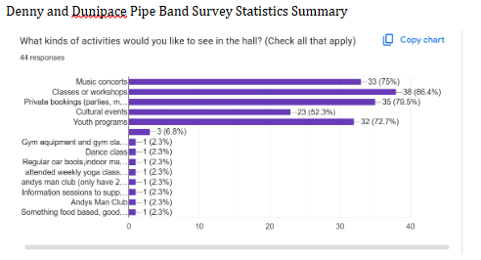

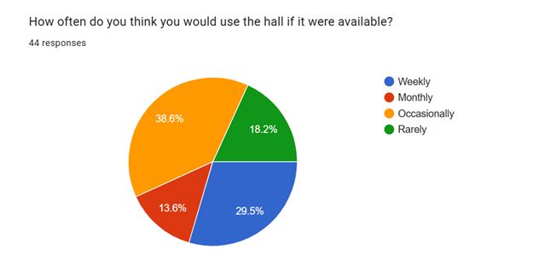
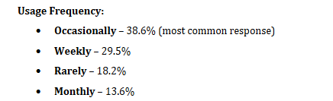
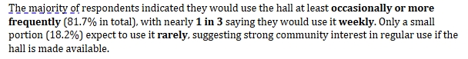
Below is a small sample of what our community is saying about our plans to take over the Broompark Community Centre.
‘The Broompark Centre is a central location for Denny & Dunipace. It will act as a hub for many community groups & be more accessible to locals.’ – local resident and volunteer.
‘I love the pipe band and fully support them taking over the hall, they could host events and then we could all enjoy the birl o’ the pipes.’ – local resident.
‘I think having lessons for beginners would benefit the band and the community’ – band member
‘Access to practices to showcase the band’ – band member
‘They have a good social media following and are a great asset to our community doing many events for our local community and for individuals.' – Founder of the Denny and Dunipace Toy Appeal

From our most recent Facebook Poll:
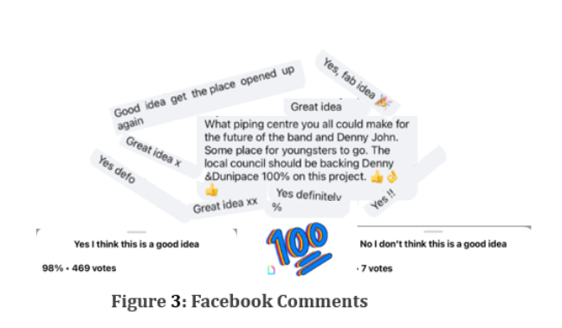
A letter of support from a local resident and former band member (other letters of support are attached.)

5.1.2 Have you consulted with other local stakeholder groups or agencies? Please provide evidence.
We have worked closely with CVS Falkirk & District. They have supported our organisation, from helping with our SCIO application, to drafting our business plan, finances, and overall governance.
We are in regular contact with the Gala Day Committee to discuss offering them appropriate lets.
We have been in touch with the local football team, who are supportive of our plans.
We recently got in contact with other groups who are going through Community Asset Transfer in the Falkirk & District Area, thanks to the Community Ownership Group that is hosted by CVS Falkirk & District.

5.1.4 Have you been in contact with any other communities or community groups
that may be affected? Please give details.
We recently attend the Community Ownership Group meetings facilitated by CVS Falkirk & District, where we made contact with other local community groups who are taking on similar buildings through Community Asset Transfer.
We are also in regular contact with other community groups within our own local area, including the local football team, the Gala committee, and the local Air Cadets.

5.1.5 Please provide any other information you think may be relevant.

- Financial Viability of Project
Your Business Plan should contain full information about the financial viability of the project, evidencing that the organisation will be able to sustain the project in the long term.
Please submit
- at least 1 year’s audited accounts to evidence your organisations financial stability (if available)
- where audited accounts are not available (for instance for new groups) please provide a bank statement.
- a projected 5 year income and expenditure account
- a cash flow forecast for the proposed asset transfer.
6.1 Please outline the Policies and Procedures your organisation has in place to govern the group’s finances
As a registered charity, we have submitted our accounts for all previous years that we have been operational to OSCR.
As a registered SCIO, we will ensure that our accounts are submitted, complete and on time, to OSCR. Our finances will be presented and scrutinised on at least, a quarterly basis at our board meetings. We will follow OSCR’s Guidance and Good Practice for Charity Trustees (oscr.org.uk) to ensure we manage our finances correctly.
The rates for each of our spaces will be set for forthcoming years at our first AGM, and these will be reviewed yearly at our AGM.

- Funding
  - Please outline how you propose to fund the price or rent you are prepared to pay for the land, and your proposed use of the land.
If you intend to apply for grants or loans you should demonstrate that your proposals are eligible for the relevant scheme, according to the guidance available for applicants.
7.1.1 Please show your calculations of the costs associated with the transfer of the land or buildings and your future use of it, including any redevelopment, ongoing, maintenance and the costs of your activities. All proposed income and investment should be identified, including volunteering and donations.

Please see our attached Cash Flow for all our planned start up, ongoing, maintenance and planned redevelopment costs. Our Cash Flow also shows all proposed income and investment.
We aim to have fundraisers on a frequent basis to help generate income for the organisation.
All proceeds from lets will be used to continue our charitable purposes.
We recognise we will require a solicitor to review and negotiate the terms of our agreement of sale with Falkirk Council.
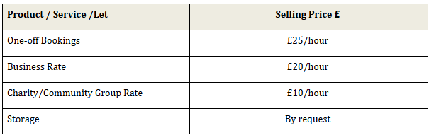

7.1.2 Please supply details of what funding you have received so far, and of any conditions attached to it.
We have successfully secured funding in the past, most recently we received £380 from the Scotmid Small Grant Scheme; £2,000 from the Falkirk Council Small Grants scheme; and £10,000 from the Kelvin Valley and Falkirk CLLD Fund 2024.

7.1.3 Please supply details of any funding you have applied for but have not yet received a response or decision. Please include timescales if known.
We currently have no outstanding funding applications.

7.1.4 Details of any other funding you will have access to? i.e. voluntary contributions, borrowing etc.
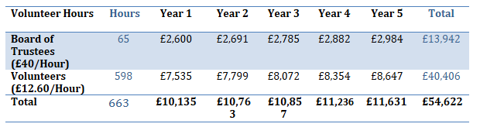
Our voluntary contributions are evidenced in the table above. General duties can include redecorating and other maintenance duties.
As a registered SCIO we will have access to overdraft and borrowing facilities with our bank.
7.1.5 Please outline your funding strategy if you have one, as well as any other relevant information.
We recognise that there is a need to continually update and upgrade our facilities, and we keep up to date with the various funding opportunities available to us, thanks to our local third sector interface, CVS Falkirk & District.

- Enablement Fund
Falkirk Council will hand the building over wind and watertight and compliant. However, this is quite light-touch and would involve (for example) patching of a leaky roof. For more significant building works, groups can apply to the Enablement Fund, to pay for capital improvements such as energy efficiency improvements or larger capital renewals which support the viability of the project going forward. Only capital items are eligible. Running repairs are revenue costs and are not eligible. You are strongly advised to email strategicpropertyreview@falkirk.gov.uk to confirm eligibility criteria before you submit this application.
Requests to the Fund must be supported by estimates / quotations from professionals which should be provided as supporting documents.
Please provide details of your request to the Enablement Fund, if applicable.
Enablement Fund request for larger capital renewals which support the viability of the CAT
Item | Estimate Provided By | Amount not more than (including VAT)
Apex Roof | [REDACTED] | £72,000
Flat Roof | [REDACTED] | £18,000
Fire Doors & Soundproof Windows | [REDACTED] | £45,753
Boilers | [REDACTED] | £72,000
Partition Walls | Awaiting Quote | ---
Secure Entry Door System | Awaiting Quote | ---
New floor for Main Hall | Awaiting Quote | ---
Toilets | [REDACTED] | £45,600
Accessible Toilets | [REDACTED] | £16,800
Total including VAT |  | £270,153+Estimate

Checklist of accompanying documents
To check that nothing is missed, please tick which additional documents are accompanying this form.
☒Section 1 – You must attach your organisation’s constitution, articles of association or registered rules
☒Section 2 – Any maps, drawings or description of the land requested
☒Section 3 – Note of any terms and conditions that are to apply to the request
☒Section 4 – Any additional evidence regarding your proposals, their benefits, any restrictions on the land or potential negative consequences, and your organisation’s capacity to deliver.
☒Section 5 – Evidence of community support
☒Section 6 – Financial – Copies of accounts, forecasts, etc
☒Section 7 – Funding – Copy of Business Case etc
☒Section 8 – Enablement Fund – copies of estimates

Declaration
Two office-bearers (board members, charity trustees or committee members) of the community transfer body must sign the form. They must provide their full names and home addresses for the purposes of prevention and detection of fraud.
This form and supporting documents will be made available online for any interested person to read and comment on. Personal information will be redacted before the form is made available.

We, the undersigned on behalf of the community transfer body as noted at Section 1, make an asset transfer request as specified in this form.
We declare that the information provided in this form and any accompanying documents is accurate to the best of our knowledge.
Name [REDACTED]
Address [REDACTED]
Date 29th August 2025
Position Secretary
Signature [REDACTED]

Name [REDACTED]
Address [REDACTED]
Date 29th August 2025
Position Chair
Signature [REDACTED]

