|  |  |
| --- | --- |
| **Management Commentary** | **2** |
|  |  |
| **Statement of Responsibilities for the Annual Accounts** | **15** |
|  |  |
| **Financial Statements** |  |
| Comprehensive Income and Expenditure Statement | 16 |
| Movement in Reserves Statement | 17 |
| Balance Sheet | 18 |
| Cash Flow Statement | 19 |
| **Supplementary Statements** |  |
| Housing Revenue Account Income and Expenditure Statement | 21 |
| Housing Revenue Account Disclosures | 22 |
| Council Tax Account | 23 |
| Non-Domestic Rates Account | 25 |
| Common Good Funds | 26 |

|  |  |
| --- | --- |
| **Notes to the Financial Statements** |  |

|  |  |  |  |  |  |
| --- | --- | --- | --- | --- | --- |
| **Note** |  | **Page** | **Note** |  | **Page** |
| 1 | General Accounting Policies | 27 | 21 | Heritage Assets | 57 |
| 2 | Accounting Standards that have been issued but have not yet been Adopted | 30 | 22 | Assets Held for Sale | 58 |
| 3 | Critical Judgements in applying Accounting Policies | 30 | 23 | Capital Expenditure and Capital Financing | 58 |
| 4 | Assumptions made about the Future and Other Major Sources of Estimation Uncertainty | 30 | 24 | Private Finance Initiative (PFI) and Similar Contracts | 59 |
| 5 | Events After the Balance Sheet Date | 33 | 25 | Contingent Assets and Liabilities | 61 |
| 6 | Expenditure and Funding Analysis | 34 | 26 | Loans Outstanding | 62 |
| 7 | Expenditure and Funding Analysis - Adjustments | 35 | 27 | Provisions | 62 |
| 8 | Expenditure & Income Analysed by Nature | 36 | 28 | Long-Term Debtors | 63 |
| 9 | Adjustments between Accounting Basis & Funding Basis Under Regulations | 37 | 29 | Inventories | 63 |
| 10 | Usable Reserves | 38 | 30 | Construction Contracts | 63 |
| 11 | Unusable Reserves | 41 | 31 | Debtors | 64 |
| 12 | Material Items of Income and Expense | 42 | 32 | Creditors | 64 |
| 13 | Related Party Transactions | 43 | 33 | Cash and Cash Equivalents | 64 |
| 14 | External Audit Fee | 44 | 34 | Trust & Third-Party Funds | 64 |
| 15 | Agency Arrangements | 44 | 35 | Government Grants and Contributions | 65 |
| 16 | Defined Benefit Pension Schemes | 44 | 36 | Financial Instruments | 66 |
| 17 | Leases | 49 | 37 | Other Long-Term Liabilities | 70 |
| 18 | Intangible Assets | 51 | 38 | Interest Payable | 70 |
| 19 | Property, Plant & Equipment | 53 | 39 | Group Accounts | 71 |
| 20 | Infrastructure Assets | 57 |  |  |  |

|  |  |
| --- | --- |
| **Other Statements ………………………………………………………………………………………………** |  |
| Annual Governance Statement……………………………………………………………………………… | 74 |
| Annual Remuneration Report………………………………………………………………………………... | 96 |
| **Independent Auditor’s Report** | **104** |

**Management Commentary**

The Management Commentary outlines the key messages about the Council’s financial and service performance for 2024/25 and looks ahead to the future challenges and risks which we will face as we strive to meet the needs of the people in the Falkirk area. The Annual Accounts report the financial performance of the Council and its Group, demonstrating the stewardship of public funds used to support delivery of the Council’s vision and key priorities. The required format and content of the Annual Accounts are set out in The Code of Practice on Local Authority Accounting in the United Kingdom (the Code).

Our report starts by outlining some key facts about the Falkirk area.

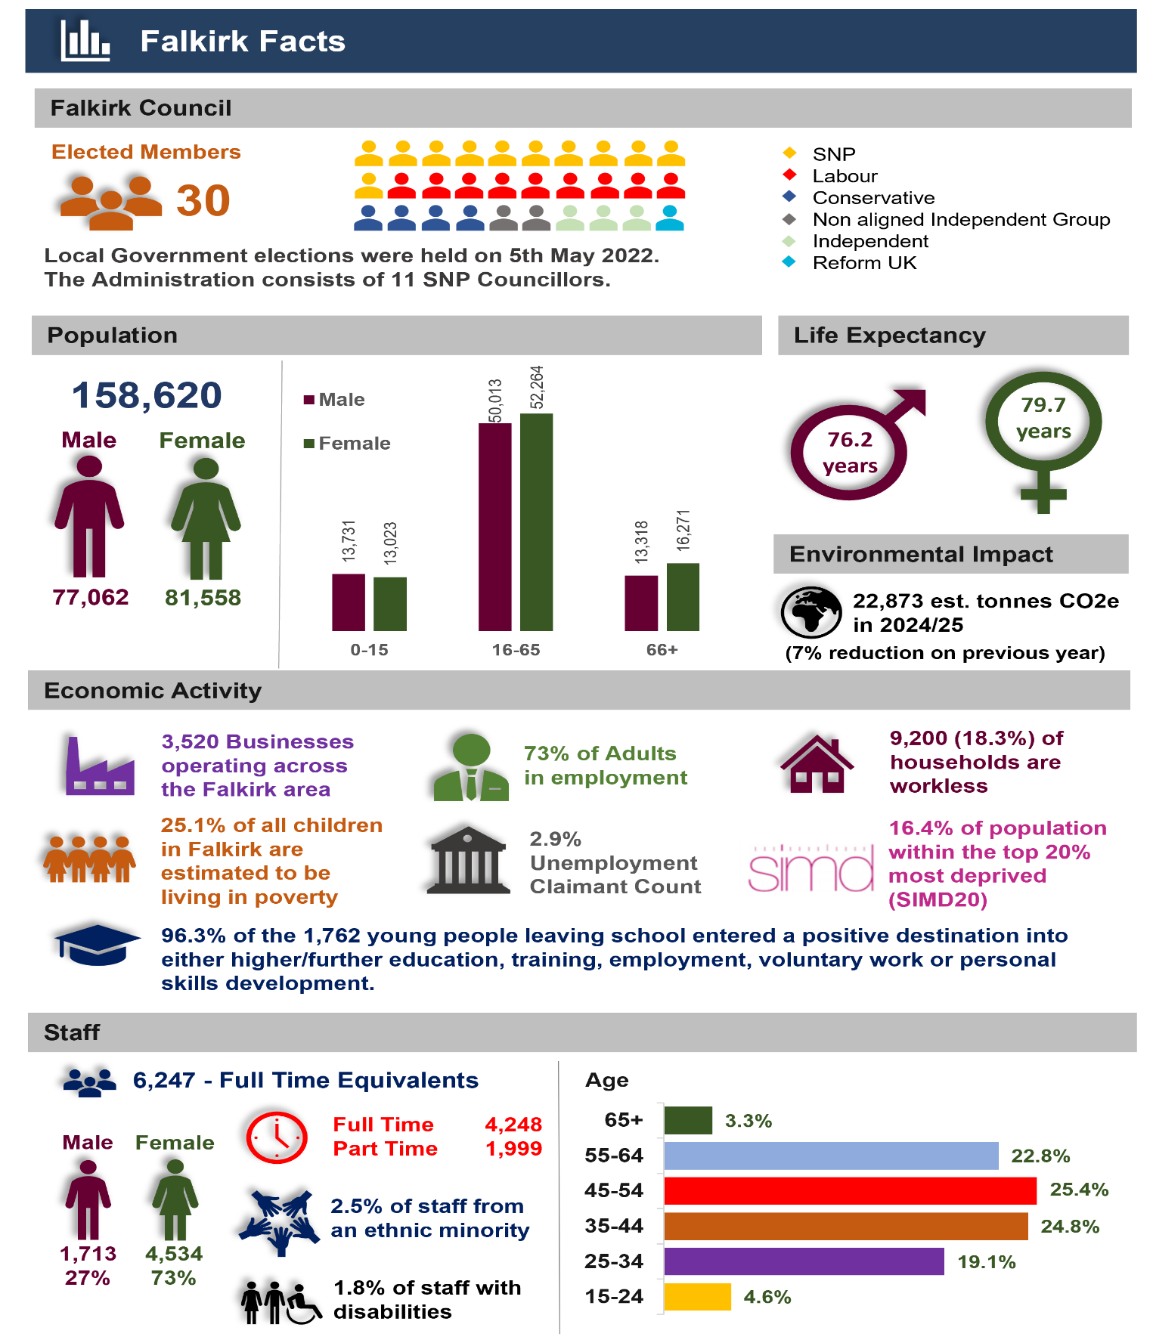

**Vision and priorities**

The Council works in close partnership with a number of other public sector partners, the Third Sector and increasingly with local communities to make Falkirk the best place we can, a place where everyone is supported to achieve their full potential. The Falkirk Plan 2021-2030 was developed by the Falkirk Community Planning Partnership and sets out 23 outcomes within the following 6 themes: working in partnership with communities, poverty, mental health, substance use, gender-based violence and economic recovery and employment. The Falkirk Plan is supported by 3 Year Delivery Plans which detail the actions and anticipated improvements.

The Falkirk Council Plan was approved in September 2023 and provides a strategic framework to deliver on the Falkirk Plan commitments. The vision and priorities within the Council Plan are:

|  |
| --- |
| **Strong communities where inequalities are reduced and lives improved** |
|  |

The Council Plan is linked to and supported by a range of strategies and plans, including the Falkirk Health and Social Care Partnership Strategic Plan, the Falkirk Council Financial Strategy, the Falkirk Economic Strategy, the Best Value Strategic Action Plan and the Falkirk Risk Management Assurance Policy and Framework.

**How are we doing?**

The performance of the Council is reported on the Falkirk Performs section of the Council’s website. This includes information on our statutory performance, important performance indicators and benchmarking to compare performance with other organisations. External scrutiny and audit reports are also used as a means of identifying best practice and securing improvement.

The Council Plan contains a number of success measures and targets, with performance measured against each target to track progress. This is reported to Elected Members every six months at both the mid-year point and the end of the year for scrutiny purposes and performance is reviewed by the Corporate Management Team on a quarterly basis.

In 2023 the Accounts Commission introduced a new structure to auditing Best Value. Best Value thematic reviews are now undertaken across all councils. Previous thematic reviews considered Leadership and Workforce Innovation. For 2024/25 the thematic review focused on Transformation with the report and findings considered by the Audit Committee in June 2025. As part of the External Audit for 2024/25, the auditors will also assess and report on whether the Council has made proper arrangements for securing Best Value, including the follow up of previous findings and recommendations. In addition, over a five year period, the Accounts Commission will receive at least one report on the Council’s performance in meeting its Best Value duties.

The chart overleaf summarises our performance trends with the Local Government Benchmarking Framework indicators. This framework reports on performance information across all 32 Councils, covering a wide range of service areas. The number of indicators in the top quartile increased from the previous year and 61% of indicators were also within quartiles 1 and 2, the highest 16 councils.

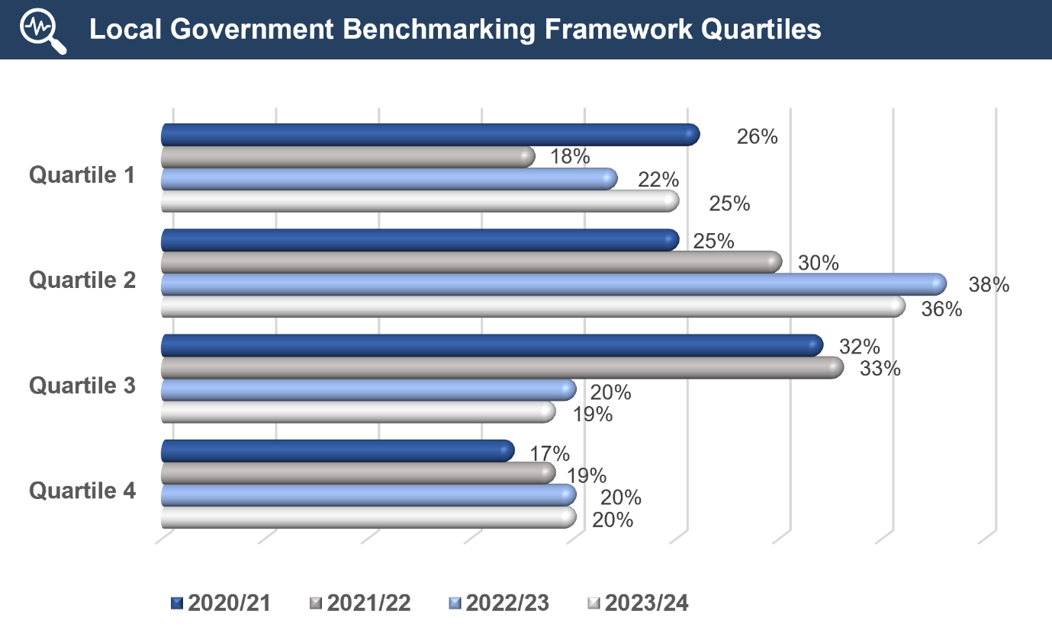

The charts below highlights some of the above performance measures against the priorities within the Council Plan.

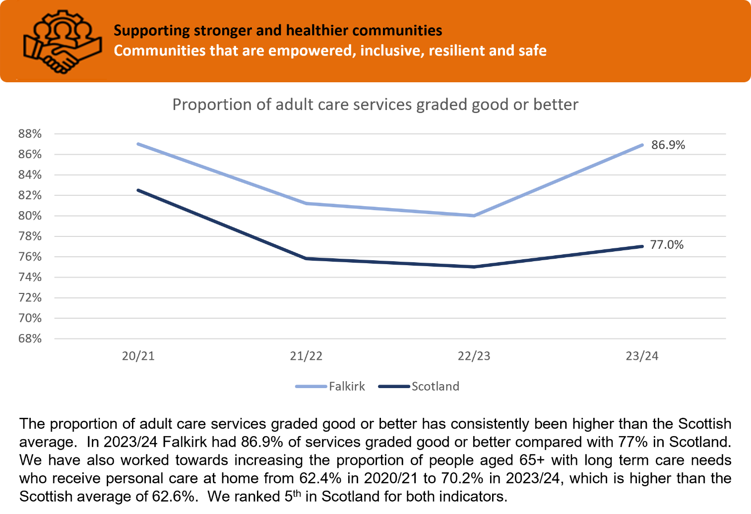

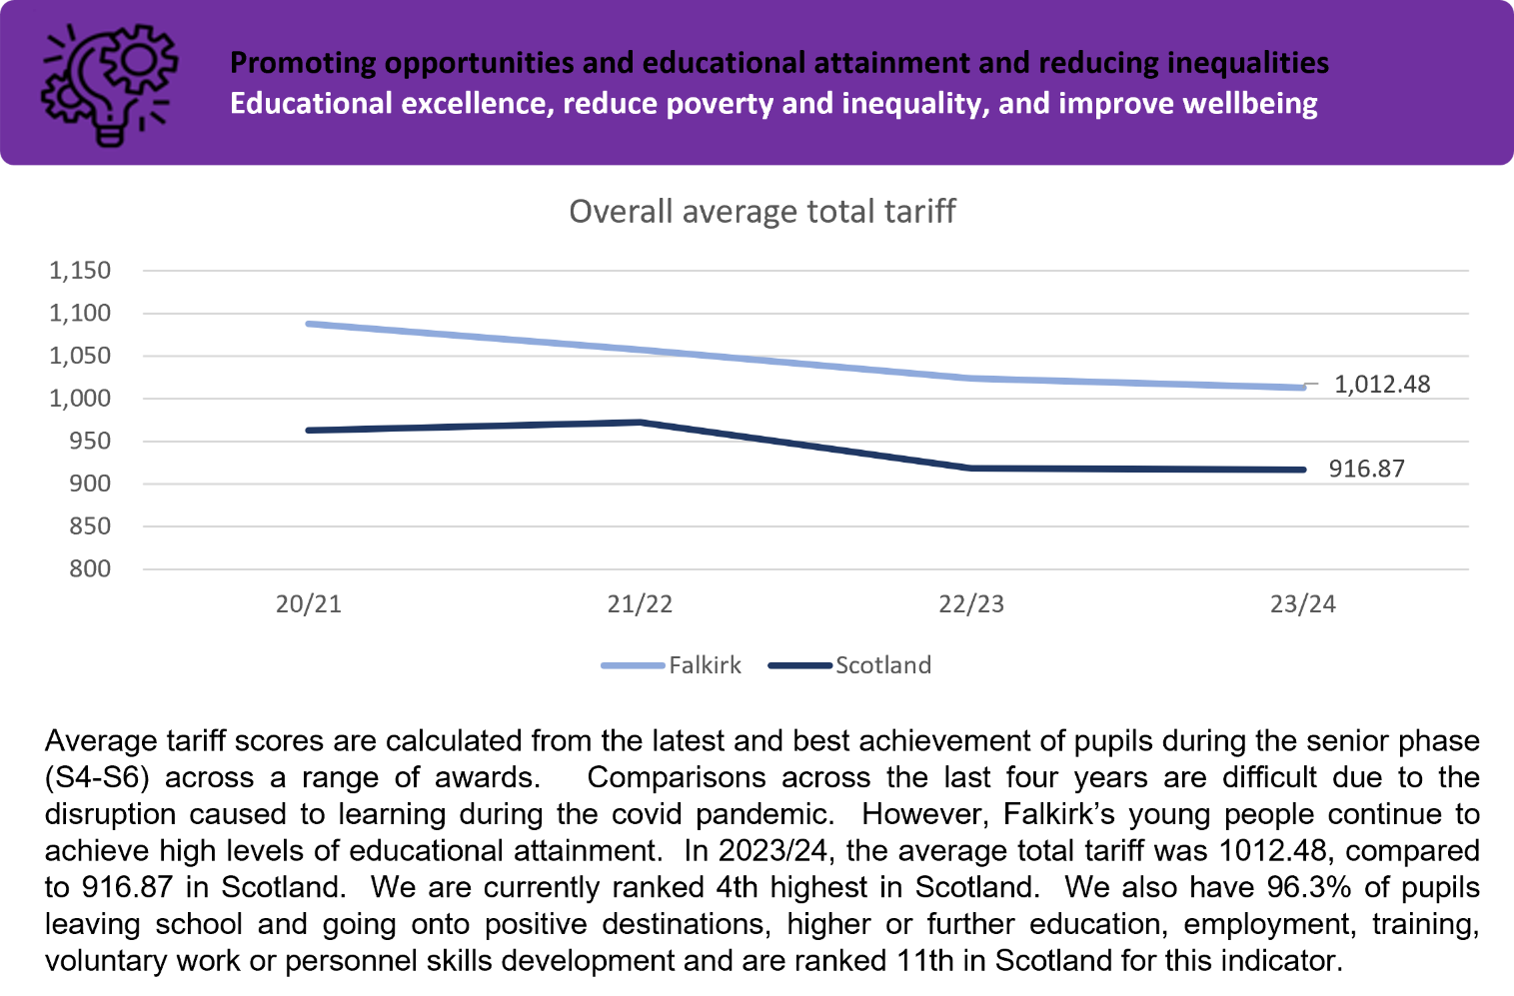

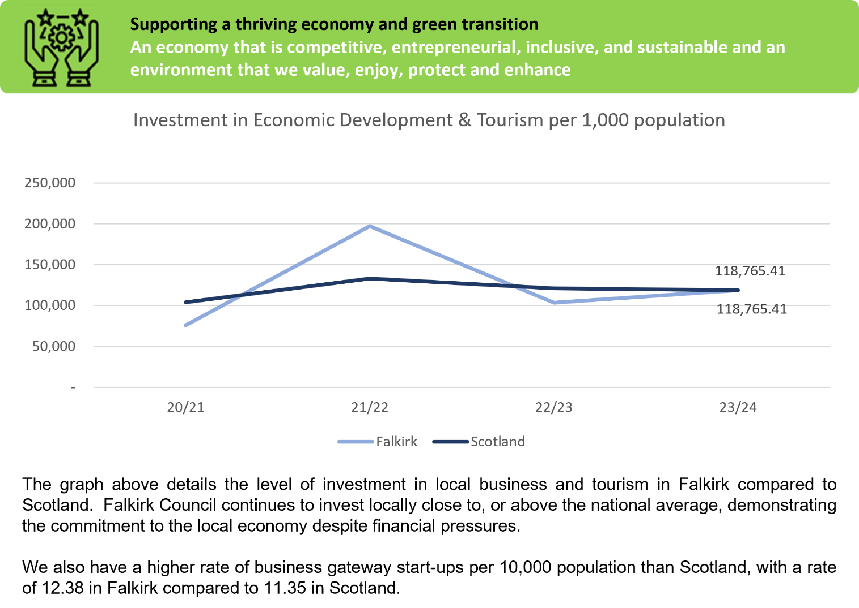

**Highlights in 2024/25**

Some of the key achievements, during a challenging financial year for the Council, are shown below:

|  |  |
| --- | --- |
| Image of coins | Falkirk has the highest uptake of the Scottish Child Payment in Scotland, with 94% of eligible low-income families receiving the benefit - above the national average of 89%. The payment, currently £26.70 per child per week, helps ease cost-of-living pressures. This success reflects joint efforts by the Council’s Community Advice Services, Advice and Support Hubs, and Citizens Advice Bureau to connect families with support. It also shows Falkirk Council’s wider commitment to tackling poverty. |
| Image of Braes High School | Braes High School has won the Climate Action Project of the Year award at the Eco-Schools Scotland Awards, jointly recognised with Leverhulme Memorial School for leadership in environmental sustainability. The award follows Braes High’s achievement of carbon neutral status for 2022/23 and its organisation of a pupil-led climate summit in September 2024, which brought together students from all Falkirk high schools. The summit led to the creation of the ‘Falkirk Agreement’ a youth-driven climate action plan shared with key policymakers. |
| Image of pupils from Bainsford Primary School | Bainsford Primary has achieved the ‘Gold’ Rights Respecting Schools Award, joining a growing number of Falkirk schools recognised for embedding the UN Convention on the Rights of the Child into daily school life. The award reflects the school’s commitment to fairness, equality, and promoting children’s rights through student leadership, policy reviews, and community projects. With visible rights messaging, active pupil involvement, and ongoing staff training, the school aims to sustain its rights-based approach and continue strengthening its links with families and local organisations. |
| Image of Leader of the Council signing the Falkirk & Grangemouth Growth Deal document with Government ministers | The Falkirk and Grangemouth Growth Deal was formally signed on 14 November 2024 by the UK and Scottish Governments and Falkirk Council. The £80 million Deal is expected to deliver up to 1,660 jobs and generate £628 million in economic benefits over the next 10 years.  Eleven projects will now move forward, including a CO₂ Utilisation Centre and Bioeconomy Pilot Plant in Grangemouth, a new Canal Centre at Lock 16 in Camelon, and a Skills Transition Centre at Forth Valley College.  Additional funding includes £10 million from the UK Government for future energy projects and £10 million from the Scottish Government for Greener Grangemouth. With contributions from Falkirk Council and Scottish Canals, total investment stands at £148.7 million. |
| Image of new Council housing development at Woodend Farm, Hallglen | Falkirk Council has completed the first phase of its £31 million social housing development at Woodend Farm, Hallglen, delivering 32 high-quality, energy-efficient homes for rent. Supported by £9 million of Scottish Government funding, the full project will provide 111 homes, including a mix of new builds and restored properties within the historic Woodend Farmhouse and Steading. Designed to high sustainability standards, the development includes solar panels, accessible layouts, and features that support biodiversity. Located near Callendar Woodland, the site offers good access to green spaces, schools, and local services, with remaining phases due by August 2025. |
| Image of boating lake at Callendar Park | A £306,000 investment from the UK Shared Prosperity Fund has delivered a range of improvements at Kinneil Estate and Callendar Park, guided by community input. At Kinneil, £176,000 funded resurfaced roads and car parks, new signage, tree planting, and biodiversity enhancements. At Callendar Park, £130,000 supported lochside landscaping, new seating, and extensive tree and bulb planting. All works were completed on time and focused on boosting access, biodiversity, and visitor experience in line with local priorities. |
| Image of refurbished gym at Grangemouth Sports Complex | Nearly £200,000 worth of improvements have been completed at Grangemouth Sports Complex over the past two years, aimed at enhancing the customer experience and building functionality. Upgrades include new gym flooring, a full range of advanced cardio equipment with smartphone casting features, a functional training area, and extra free weight benches. Additional works include a refurbished reception, upgraded changing rooms, improved lighting, combat zones, bike storage, and pool plant enhancements. The on-site café also received a £50,000 revamp, with new counters and coffee machines installed to improve the service provided. |

**Financial Planning**

|  |  |
| --- | --- |
| A robust financial framework ensures resources are targeted to our outcomes. The key financial plans are shown in diagram opposite.  Most day-to-day revenue spending and income on our services is recorded within the General Fund (pages 16 to 20), with housing revenue income and expenditure managed in the Housing Revenue Account (pages 21 to 22). In addition to day-to-day expenditure, we have capital investment in our assets, including schools, houses, and infrastructure. |  |

**Service Concession Arrangements**

In accordance with a financial flexibility approved by the Scottish Government, Falkirk Council adopted revised accounting arrangements in respect of its Private Finance Initiative (PFI) contracts, known as Service Concession Arrangements. These arrangements have allowed the Council to spread the cost of its two PFI schemes over the life of the asset rather than the life of the contract. These adjustments are time related and the overall payments to the PFI contractors remain the same. Note 24 provides further details of the revised repayment profile. For 2024/25 this has resulted in the release of a service concession adjustment of £5.7m which has been credited to an earmarked reserve within the General Fund.

In 2024/25 the Council agreed to apply service concessions of £22.5m to balance the budget. The actual service concessions applied was £16.3m. For the 2025/26 budget the Council has agreed to apply £11.5m of service concessions. Elected Members also noted proposals to set aside £46m of service concessions for capital investment. It was agreed to keep these proposals under review, recognising the need to remove the reliance on service concessions to support the revenue budget by 2026/27.

**Financial Performance**

Financial information is part of the Council’s performance framework with regular reporting to Elected Members. This section summarises our financial performance for 2024/25

**(a) General Fund Revenue Expenditure 2024/25**

The income received and expenditure incurred during 2024/25 is highlighted in the table below. The expenditure incurred was £486.4m (2023/24 £442m) which was funded from Government Grant, Council Tax, and contributions from General Fund reserves (service concessions and earmarked reserves).

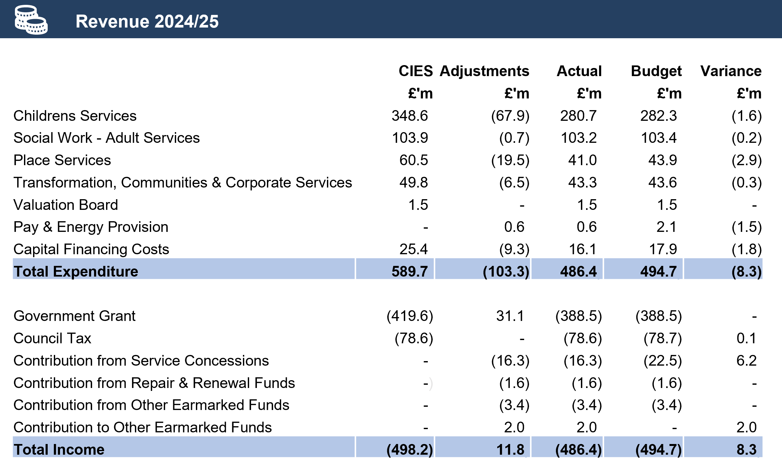

The net expenditure for each service noted above varies from the Comprehensive Income and Expenditure Statement (CIES) as a result of a number of statutory accounting adjustments. Details of these adjustments are explained in the Expenditure and Funding Analysis on page 34.

The budget was supported by General Fund reserves (Service Concessions) of £22.5m and the reliance on these non-recurring sources of funding is not a sustainable approach for the Council. However, during 2024/25 expenditure on council services was £8.3m less than budgeted, an improvement of £2.3m on the financial position reported to Members in February. This was primarily due to reduced costs within Children’s Services. The underspend reduced the contribution required by Service Concessions by £6.2m and enabled the Council to earmark £2m to offset additional costs that will arise next financial year relating to pay and conditions and other financial pressures.

In terms of the budget variations across Council Services, Children’s Services were c£1.6m under budget due to lower teaching costs and social care costs for children. Lower employee costs within Place Services largely contributed to the underspend of £2.9m and within Transformation, Communities and Corporate Services lower employee costs offset higher costs arising from computer technology and homelessness services. Capital financing costs were c£1.8m below budget reflecting lower borrowing and interest costs and the provision for pay awards and energy was £1.5m less than required.

In 2024/25 the council achieved £8.1m of approved budget savings which was c94% of the full year target and a significant improvement on the previous financial year. Of the total savings achieved, £1.5m (15%) was achieved through the Council of the Future transformation programme.

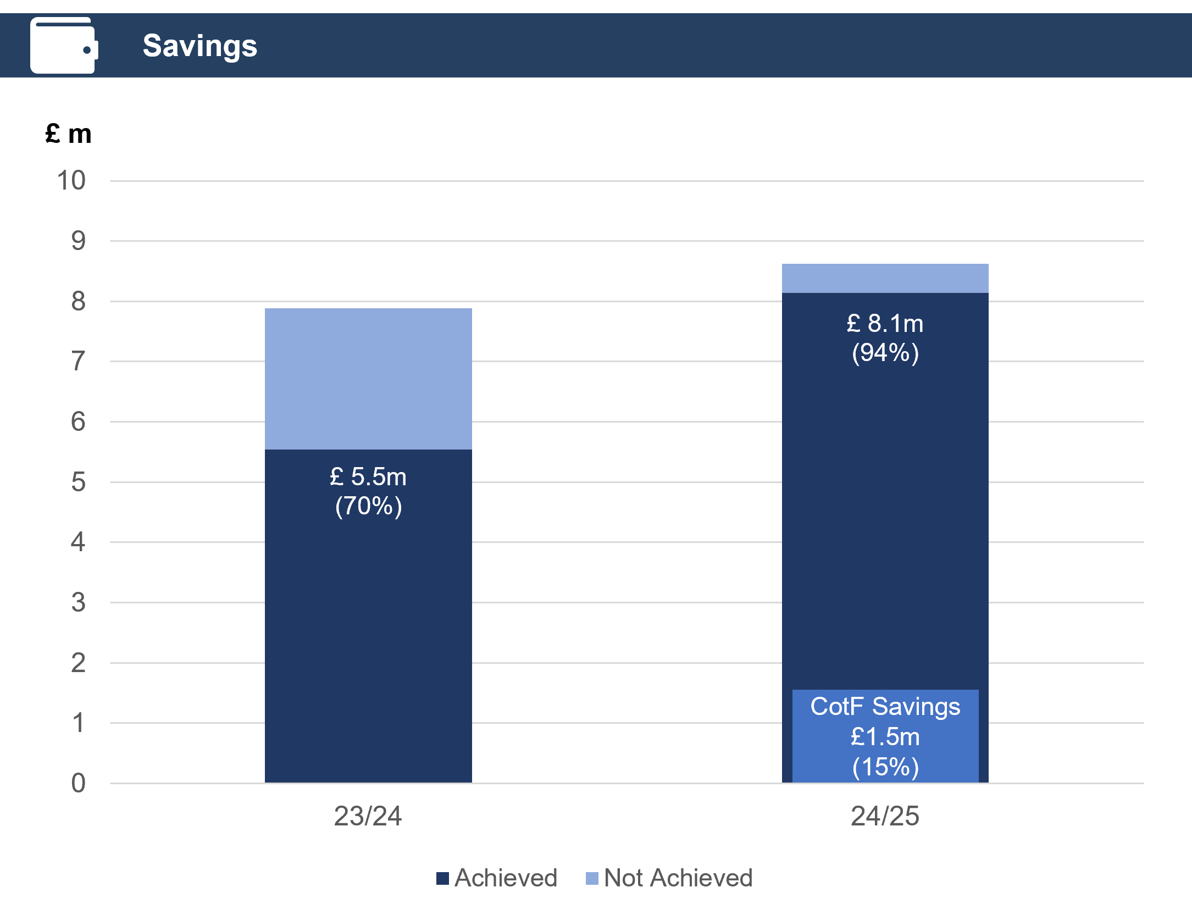

**(b) General Fund Capital Programme 2024/25**

In 2024/25 the final Council budget for General Fund capital investment was £52.5m with just over £49m (c94%) being delivered. It should be noted that the General Fund Capital Programme is part of a five-year plan and as such it is expected that there will be movement in spend across the years. Projects not delivered will be completed in forthcoming financial years. The diagrams below identify the key projects and how these were funded. Further details are provided at Note 23.

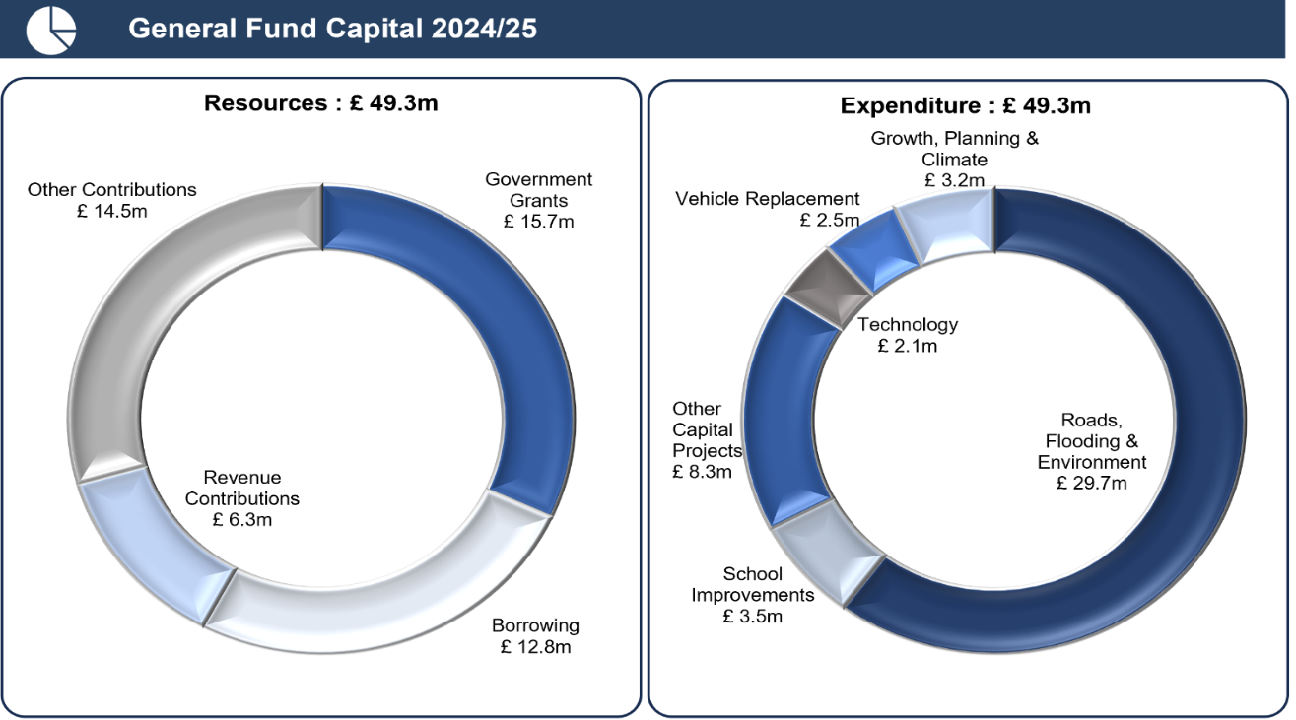

**(c) Usable Reserves**

After service concessions and transfers the Council’s overall reserves decreased from £124.5m to £109.5m. This decrease was primarily due to application of service concessions in 2024/25.

The Council’s Reserve Policy provides for 2% of annual revenue expenditure (giving a range of £9.3m - £12.4m) to be held as a contingency against unforeseen events and emergencies. The uncommitted General Fund balance of £11.8m is within the overall policy range. The financial pressures facing the Council will continue to put pressure on our reserves in 2025/26 and going forward.

The Council also has a number of earmarked and other reserves to deliver specific commitments. The most significant in terms of value includes:

* Earmarked Reserves of £92.1m, which includes £66.9m relating to Service Concessions, £15.3m for other revenue grant income, spend to save funding of £2.8m principally earmarked to cover the costs of voluntary severance and fund various initiatives to deliver council priorities and £2.4m available as a contingency to meet future revenue and capital investment requirements within the Housing Revenue Account.
* Other Statutory Reserves include an Insurance Fund of £5.1m which is available to meet outstanding claims against the Council and is subject to valuation by an independent actuary.

The diagram below summarises the movement in usable reserves, which is also detailed at Note 10 of the accounts.

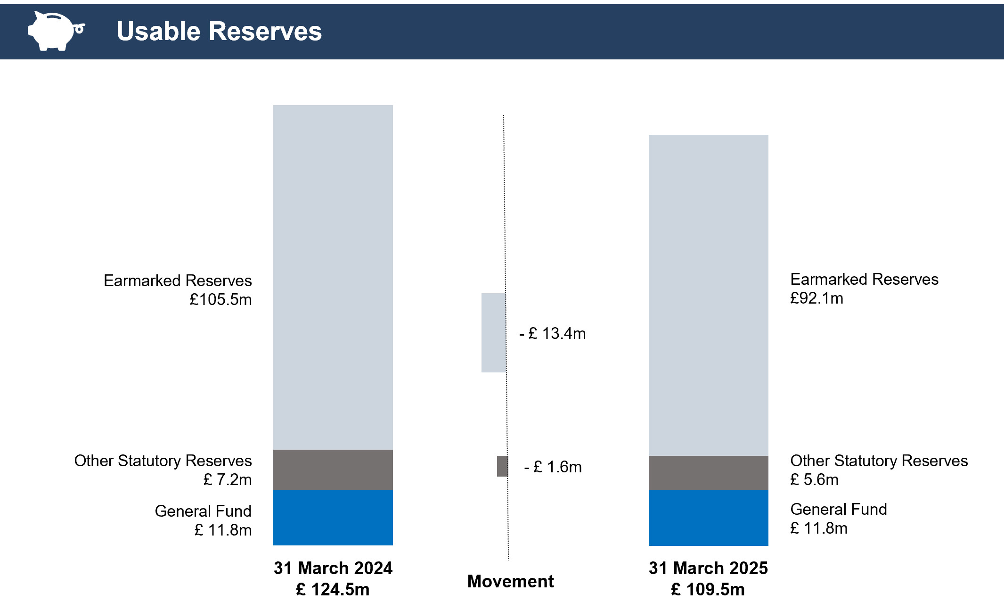

As part of the 2025/26 budget process, Elected Members agreed to apply £11.5m of earmarked reserves (Service Concessions) to help balance the budget.

**(d) Housing Revenue Account 2024/25**

For 2024/25 the Council received £78.5m of funding and spent £79.4m on Housing Revenue Services, resulting in the use of reserves of £0.9m. An analysis of funding and expenditure is provided below:

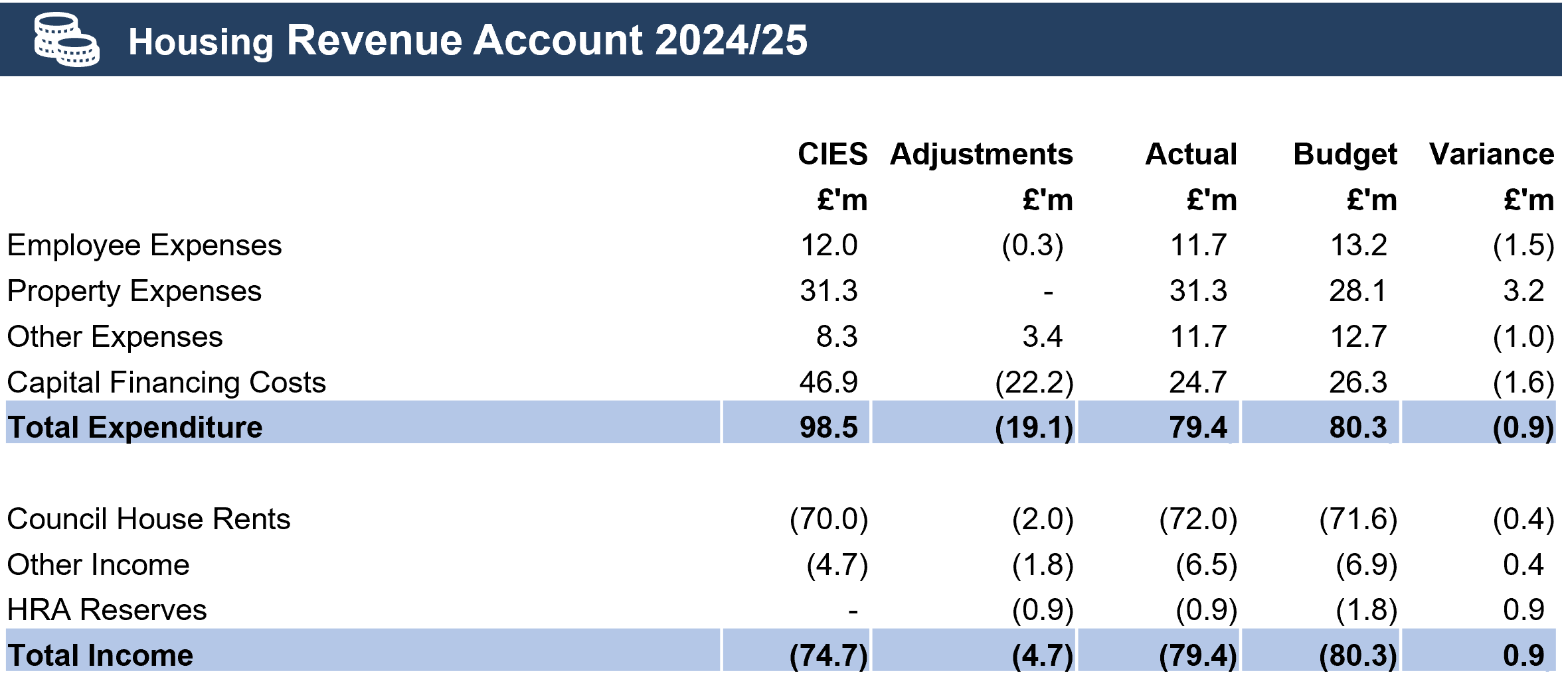

Expenditure on the Housing Revenue Account was £0.9m below budget, a significant improvement from the £3m overspend last year. An increase in property repair costs of over £3m was largely offset by underspends on employee costs, other expenses and lower capital charges reflecting reduced borrowing costs. This favourable position reduced the planned application of reserves from £1.8m to £0.9m, leaving a reserve balance of £2.4m

**(e) Housing Capital Programme 2024/25**

In 2024/25 the final Housing budget for capital investment was £58.9m against the actual capital expenditure of £53.9m. The exhibit below identifies the key projects and how these were funded.

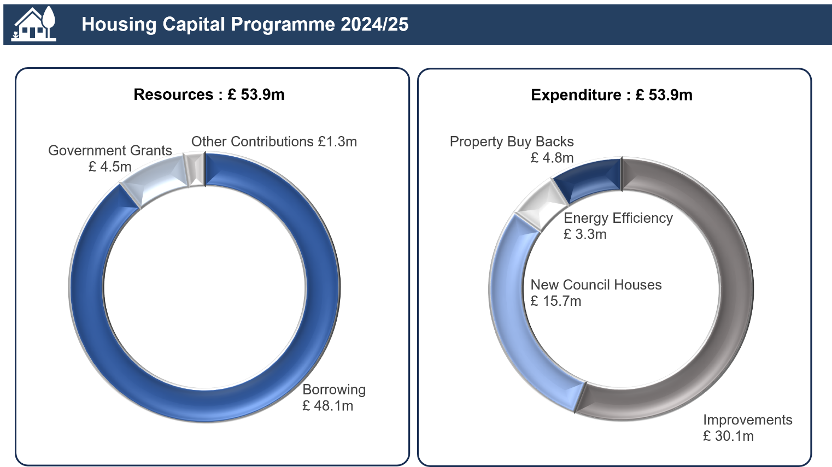

**(f) The Balance Sheet**

The diagram below summarises the Council’s Balance Sheet as at 31 March 2025, with comparatives provided for the last financial year. The Balance Sheet provides a snapshot of the Council’s financial position detailing assets, liabilities, and reserves. More information on the Balance Sheet is provided on page 18.

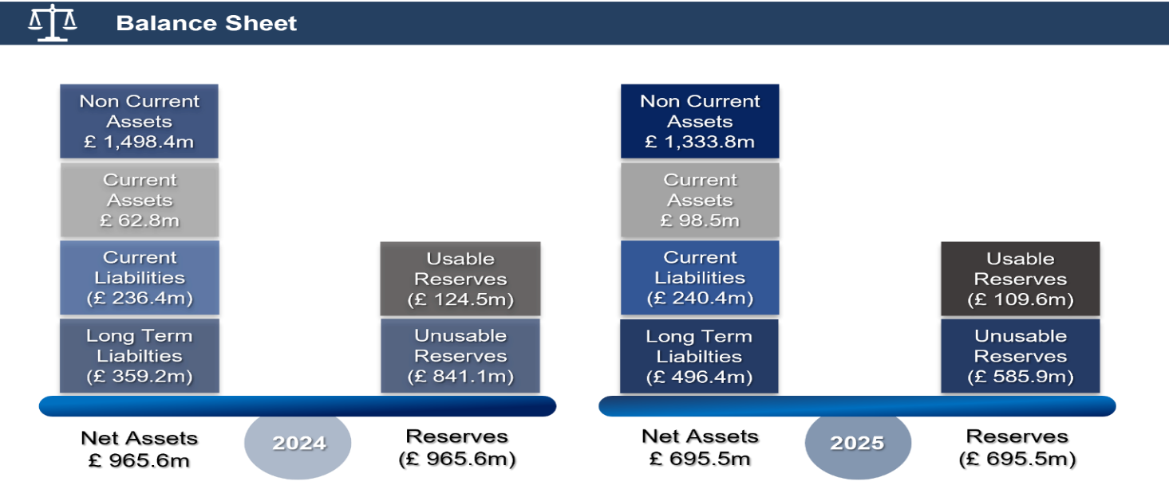

The net assets of the Council have decreased by c£270m (2023/24 net asset increase of c£7m). A number of statutory accounting adjustments, which do not impact on the Council’s Usable Reserves, have reduced the asset values for both property, plant and equipment and the defined pension scheme and increased the liabilities for finance leases, due to adopting a new financial accounting standard (IFRS16). Long term borrowing has also increased by almost £110m to fund the investment in both the general fund and housing capital programmes.

**(g) Financial Indicators**

The Chartered Institute of Public Finance and Accountancy (CIPFA) Directors of Finance Section recommends the inclusion of certain “financial ratios” in the Management Commentary to help the reader to assess the performance of Falkirk Council over the financial year and the affordability of its ongoing commitments. The following table provides these indicators with an explanation of each indicator.

|  |  |  |  |
| --- | --- | --- | --- |
| **Financial Indicator** | **Commentary** | **2023/24** | **2024/25** |
| Uncommitted general fund reserve as a % of annual net budget | Reflects the amount of funding available to manage unplanned events  (Target – 2% of Revenue Expenditure) | 2.64% | 2.39% |
| In year council tax collection | Reflects Falkirk Council’s effectiveness in collecting council tax debt  (2024/25 Scottish Average – 95.4%) | 96.7% | 96.7% |
| Actual outturn compared to budgeted expenditure | How closely expenditure compares to the budget is a reflection of the effectiveness of financial management  (Target – 98%-100%) | 98.73% | 98.31% |
| Ratio of Financing Costs to Net Revenue Stream | Shows how much of the Council’s income is committed to repaying debt arising from the capital investment (Budget 3.0%) | 2.54% | 3.0% |
| Capital Financing Requirement | The Capital Financing Requirement reflects the underlying need to borrow for Capital Investment (Budget £362.5m) | £362.1m | £367.5m |
| External Debt Levels | The actual external debt and long-term liabilities of Falkirk Council. This should never exceed Falkirk Council’s authorised limit (Budget £645m) | £645m (Limit)  £451m (Actual) | £645m (Limit)  £606m (Actual) |

**Risks**

The Council has a well embedded approach to the management of risk. This is summarised in the Annual Governance Statement (see pages 74 to 95). The Council recognises that evaluation and monitoring of corporate (strategic) and service (operational) risks is a key part of its role. Corporate Risk Updates are provided to the Executive 6-monthly, including reviews of the Corporate Risk Register and the Risk Management Improvement Plan. In addition, risk management is routinely considered by the Corporate Management Team (CMT) and the Service Management Teams (SMTs) quarterly, including CMT reviews of Corporate Risks and SMT reviews of Service Risk and Assurance Statements. The Corporate Risk Management Annual Report to the Audit Committee in June 2025 confirmed that most actions within the Risk Management Improvement Plan have been completed or embedded, and good progress has been made on embedding the remaining actions.

The table below shows four high risk areas alongside a snapshot of the mitigating actions:

|  |  |
| --- | --- |
| **Financial Sustainability** | **Public Protection** |
| * Finance Strategy * Financial Controls and Standing Orders * Financial Strategy Group | * Chief Officers’ Group governance framework * Committees, including Child and Adult Protection * Chief Officer’s Group and Committees’ Risk Registers |
| **Leadership, Governance and Decision Making** | **Equalities** |
| * Falkirk Plan and Council Plan * Collaborative Leadership Improvement Plan * Corporate Governance & Integrity Policies | * Equalities and Poverty Impact Assessments * Equalities Mainstreaming Report and Action Plan * Equalities Best Value Self-Assessment |

The Annual Governance Statement (AGS) Action Plan and Corporate Risk Register provide more details on those Corporate Risks rated ‘high’, and a link to these can be found within the AGS.

**Outlook**

As reported in previous years, Scottish local authorities continue to be faced with considerable financial challenges. This was highlighted in the recent Accounts Commission publication Local Government Budgets 2025/26. The publication highlights that local government continues to face recurring pressures such as inflation, annual pay deals, increased national insurance costs and growing demand for services. Cost pressures are expected to continue in future years.

Ongoing weak economic growth impacts on the amount generated from tax revenues which are required to fund expenditure of all public services. For local government, any reduction in overall grant funding is compounded by the protection of other public services, such as health, defence and police services and also the implementation of new policy initiatives. Increasing costs and reduced funding has a significant adverse impact on the Council’s funding gap which is currently estimated at c£42m over the next four years. The Council will therefore continue to be faced with difficult decisions to balance future budgets through increasing income, including council tax, fees and charges and reducing expenditure through savings.

While financial sustainability remains one of the biggest challenges facing the Council, there has been a significant improvement in the budget position for 2025/26. The Council has reduced the use for non-recurring reserves (service concessions) from £22.5m in 2024/25 to £11.5m in 2025/26. As noted earlier the Council also recognises the need to remove the reliance on service concessions to support the revenue budget by 2026/27. In turn this will enable the Council to use service concessions for capital investment. However, this will be dependent on increasing income and successfully identifying and approving recurring savings, including those from its Transformation Agenda.

The Council continues to regularly monitor its financial position and provide full financial updates to Corporate Management Team, the Financial Strategy Group and the Council or Executive as appropriate, including options on addressing any new budget gaps and spending pressures. A budget engagement and communication plan is being developed to effectively inform and consult with our communities and partners when deciding how council budgets should be spent.

**Supplementary Information**

**Group Accounts**

Local authorities are required to prepare Group Accounts in addition to their own Council’s accounts where they have a material interest in other organisations. Group Accounts have been prepared which consolidate the results of the Council and its interest in associated entities. The effect of the inclusion of the Council’s interests on the Group Balance Sheet is to increase both Reserves and Net Assets by £10.0m (2023/24 increase of £14.1m). This represents the Council’s share of the net liabilities in those entities.

**Pension Fund**

Falkirk Council is classed by statute as an administering authority and therefore has responsibility for operating and maintaining a pension fund for its own employees and those of constituent fund employers. Under the Council’s governance arrangements, pension fund business has been delegated to a representative Pensions Committee and is overseen by a statutory Pensions Board. The Fund produces its own Annual Report and Accounts separate from those of the Council.

The amount of pension contribution payable by the Council in respect of the Local Government Pension Scheme is set every three years following a valuation of the Pension Fund carried out by Hymans Robertson, an independent actuary. The most recent valuation was undertaken as at 31 March 2023 and set the employer pension contribution rate at 19.5% for the next three years from 1 April 2024. The next Fund valuation is scheduled to take place as at 31 March 2026 which will determine the contribution rates payable from 1 April 2027.

|  |  |  |
| --- | --- | --- |
| **Amanda Templeman, CPFA** | **Councillor Cecil Meiklejohn** | **Kenneth Lawrie** |
| **Chief Finance Officer**  **Xx xxxxxxx 2025** | **Leader of Falkirk Council**  **Xx xxxxxxx 2025** | **Chief Executive of Falkirk Council**  **Xx xxxxxxx 2025** |

**Falkirk Council Responsibilities**

The Council is required to:

* make arrangements for the proper administration of its financial affairs and to secure that the proper officer of the authority has responsibility for the administration of those affairs (section 95 of the Local Government (Scotland) Act 1973). In Falkirk Council that officer is the Chief Finance Officer
* manage its affairs to secure economic, efficient, and effective use of resources and safeguard its assets
* ensure the Annual Accounts are prepared in accordance with legislation (The Local Authority Accounts (Scotland) Regulations 2014) and, so far as is compatible with that legislation, in accordance with proper accounting practices (section 12 of the Local Government in Scotland Act 2003)
* approve the Annual Accounts for signature

I can confirm that these Annual Accounts were approved for signature by the Council at its meeting of ** ** 2025.

**Signed on behalf of Falkirk Council**

**Councillor Cecil Meiklejohn**

**Leader of Falkirk Council**

**Xx xxxxxxx 2025**

**The Chief Finance Officer Responsibilities**

The Chief Finance Officer is responsible for the preparation of the authority’s Annual Accounts in accordance with proper practices as required by legislation and as set out in the CIPFA/LASAAC Code of Practice on Local Authority Accounting in the United Kingdom (the Accounting Code).

In preparing the Annual Accounts the Chief Finance Officer has:

* selected suitable accounting policies and then applied them consistently
* made judgements and estimates that were reasonable and prudent
* complied with legislation
* complied with the Accounting Code (in so far as it is compatible with legislation).

The Chief Finance Officer has also:

* kept adequate accounting records which were up to date
* taken reasonable steps for the prevention and detection of fraud and other irregularities.

I certify that the accounts give a true and fair view of the financial position of the Council and its group as at 31 March 2025 and the transactions of the Council and its group for year ended 31 March 2025.

**Amanda Templeman, CPFA**

**Chief Finance Officer**

**27 June 2025**

**Comprehensive Income and Expenditure Statement**

This Statement shows the economic cost in the year of providing services in accordance with generally accepted accounting practices, rather than the amount to be funded from taxation. Authorities raise taxation to cover expenditure in accordance with regulations; this may be different from the accounting cost. The taxation position is shown in the Movement in Reserves Statement.

In this statement expenditure and a deficit are positive signage, income and a surplus are negative signage.

|  |  |  |  |  |  |  |  |  |
| --- | --- | --- | --- | --- | --- | --- | --- | --- |
| **Falkirk Council 2023/24** |  |  | **Group** |  | **Falkirk Council 2024/25** |  |  | **Group** |
| **Gross Expend £’000** | **Gross Income £’000** | **Net Expend £’000** | **Net Expend £’000** |  | **Gross Expend £’000** | **Gross Income £’000** | **Net Expend £’000** | **Net Expend £’000** |
| 316,292 | (31,321) | 284,971 | 284,971 | Children’s Services | 366,144 | (17,509) | 348,635 | 348,635 |
| 234,359 | (140,026) | 94,333 | 94,333 | Social Work Adult Services | 256,659 | (152,729) | 103,930 | 103,930 |
| 85,155 | (27,874) | 57,281 | 57,281 | Place Services | 91,822 | (31,268) | 60,554 | 60,554 |
| 75,277 | (33,447) | 41,830 | 41,723 | Transformation, Communities & Corporate Services | 81,235 | (31,436) | 49,799 | 49,736 |
| 77,903 | (71,238) | 6,665 | 6,665 | Housing Revenue Account | 98,204 | (74,323) | 23,881 | 23,881 |
| 1,460 | - | 1,460 | 1,460 | Valuation Joint Board | 1,548 | - | 1,548 | 1,548 |
| **790,446** | **(303,906)** | **486,540** | **486,433** | **Net Cost of Services** | **895,612** | **(307,265)** | **588,347** | **588,284** |
| **691** | **-** | **691** | **691** | **Other Operating Expenditure**  (Gains) or Losses on disposal of Non-Current and Current Assets | **2,169** | **-** | **2,169** | **2,169** |
|  |  |  |  | **Financing and Investment Income and Expenditure** |  |  |  |  |
| 33,335 | - | 33,335 | 33,335 | Interest Payable and Similar Charges (Note 38) | 32,734 | - | 32,734 | 32,734 |
| - | (6,826) | (6,826) | (6,826) | Interest & Investment Income | - | (5,769) | (5,769) | (5,769) |
| 57,445 | (57,578) | (133) | (133) | Pension interest cost & interest income on plan assets (Note 16) | 56,975 | (60,736) | (3,761) | (3,761) |
| **90,780** | **(64,404)** | **26,376** | **26,376** |  | **89,709** | **(66,505)** | **23,204** | **23,204** |
|  |  |  |  | **Taxation and Non-Specific Grant Income** |  |  |  |  |
| - | (78,331) | (78,331) | (78,331) | Council Tax | - | (78,618) | (78,618) | (78,618) |
| - | (268,191) | (268,191) | (268,191) | Government Grants (Note 35) | - | (311,948) | (311,948) | (311,948) |
| - | (31,670) | (31,670) | (31,670) | Capital Grants, Contributions & Donations (Note 35) | - | (31,093) | (31,093) | (31,093) |
| - | (75,322) | (75,322) | (75,322) | Non-Domestic Rates redistribution | - | (72,962) | (72,962) | (72,962) |
| - | (2,498) | (2,498) | (2,498) | Non-Domestic Rates – TIF | - | (3,620) | (3,620) | (3,620) |
| **-** | **(456,012)** | **(456,012)** | **(456,012)** |  |  | **(498,241)** | **(498,241)** | **(498,241)** |
|  |  |  |  |  |  |  |  |  |
| **881,917** | **(824,322)** | **57,595** | **57,488** | **(Surplus) or Deficit on Provision of Services** | **987,490** | **(872,011)** | **115,479** | **115,416** |
|  |  | **-** | **3,872** | Share of the (Surplus) or Deficit on Provision of Services by Associates & Joint Ventures |  |  | **-** | **2,628** |
|  |  |  | **61,360** | **Group (Surplus) or Deficit** |  |  |  | **118,044** |
|  |  | 40,009 | 40,009 | (Surplus) or Deficit on revaluation of non-current assets and current assets (Note 11b) |  |  | 48,655 | 48,348 |
|  |  | 863 | 863 | Remeasurements of pension assets/liabilities (Note 11c) |  |  | (172,077) | (172,077) |
|  |  | (105,770) | (105,770) | Effect of Asset Ceiling Limitation on Net Defined Benefit Asset (Note 11c) |  |  | 278,037 | 278,037 |
|  |  |  | (2,351) | Share of Other Comprehensive Income & Expenditure of Associates & Joint Ventures |  |  |  | 1,638 |
|  |  | **(64,898)** | **(67,249)** | **Other Comprehensive Income and Expenditure** |  |  | **154,615** | **155,946** |
|  |  | **(7,303)** | **(5,889)** | **Total Comprehensive Income and Expenditure** |  |  | **270,094** | **273,990** |

**Movement in Reserves Statement**

This statement shows the movement in the year on the different reserves held by the Council, analysed into “Usable Reserves” (i.e. those that can be applied to fund expenditure or reduce local taxation) and “Unusable Reserves”. The Surplus or (Deficit) on the Provision of Services line shows the true economic cost of providing the Council’s services, more details of which are shown in the Comprehensive Income and Expenditure Statement. This is different from the statutory amounts required to be charged to the General Fund Balance and the Housing Revenue Account for council tax setting and dwellings rent setting purposes.

**Movement in Reserves Statement for the year ended 31 March 2025**

|  |  |  |
| --- | --- | --- |
|  | **Falkirk Council Reserves** | **Council’s Share of Group Entity Reserves** |

|  |  |  |  |  |  |  |  |  |  |
| --- | --- | --- | --- | --- | --- | --- | --- | --- | --- |
|  | **General Fund Balance** | **HRA Balance** | **Capital & Other Reserves** | **TOTAL Usable Reserve** | **Unusable Reserve** | **TOTAL Council Reserves** | **Group Usable Reserve** | **Group Unusable Reserve** | **TOTAL Group Reserves** |
|  | **£’000** | **£’000** | **£’000** | **£’000** | **£’000** | **£’000** | **£’000** | **£’000** | **£’000** |
| **Balance at 31/03/24** | **(110,693)** | **(3,272)** | **(10,527)** | **(124,492)** | **(841,067)** | **(965,559)** | **(11,823)** | **(2,264)** | **(979,646)** |
| **Movement in reserves during 2024/25** |  |  |  |  |  |  |  |  |  |
| Total Comprehensive Income and Expenditure | 82,873 | 32,606 | - | **115,479** | 154,615 | 270,094 | 2,565 | 1,331 | **273,990** |
| Adjustments between accounting basis and funding basis under regulations (Note 9) | (49,989) | (11,673) | 435 | **(61,227)** | 61,227 | - | 41 | (41) | - |
| Adjustments to usable reserves permitted by accounting standards | (19,270) | (20,041) | - | **(39,311)** | 39,311 | - | - | - | - |
| Transfers (to)/from Other Statutory Reserves | (1,506) | - | 1,506 | **-** | - | - | - | - | - |
| **(Increase)/Decrease in 2024/25** | **12,108** | **892** | **1,941** | **14,941** | **255,153** | **270,094** | **2,606** | **1,290** | **273,990** |
| **Balance at 31/03/25** | **(98,585)** | **(2,380)** | **(8,586)** | **(109,551)** | **(585,914)** | **(695,465)** | **(9,217)** | **(974)** | **(705,656)** |

**Movement in Reserves Statement for the year ended 31 March 2024**

|  |  |
| --- | --- |
| **Falkirk Council Reserves** | **Council’s Share of Group Entity Reserves** |

|  |  |  |  |  |  |  |  |  |  |
| --- | --- | --- | --- | --- | --- | --- | --- | --- | --- |
|  | **General Fund Balance** | **HRA Balance** | **Capital & Other Reserves** | **TOTAL Usable Reserve** | **Unusable Reserve** | **TOTAL Council Reserves** | **Group Usable Reserve** | **Group Unusable Reserve** | **TOTAL Group Reserves** |
|  | **£’000** | **£’000** | **£’000** | **£’000** | **£’000** | **£’000** | **£’000** | **£’000** | **£’000** |
| **Balance at 31/03/23** | **(49,700)** | **(6,617)** | **(10,633)** | **(66,950)** | **(891,306)** | **(958,256)** | **(15,492)** | **(9)** | **(973,757)** |
| **Movement in reserves during 2023/24** |  |  |  |  |  |  |  |  |  |
| Total Comprehensive Income and Expenditure | 49,505 | 8,090 | - | **57,595** | (64,898) | (7,303) | 3,765 | (2,351) | **(5,889)** |
| Adjustments between accounting basis and funding basis under regulations (Note 9) | (87,972) | 13,875 | (1,785) | **(75,882)** | 75,882 | - | (96) | 96 | - |
| Adjustments to usable reserves permitted by accounting standards | (20,393) | (18,862) | - | **(39,255)** | 39,255 | - |  |  | - |
| Transfers (to)/from Other Statutory Reserves | (2,133) | 242 | 1,891 | **-** |  | - |  |  | - |
| **(Increase)/Decrease in 2023/24** | **(60,993)** | **3,345** | **106** | **(57,542)** | **50,239** | **(7,303)** | **3,669** | **(2,255)** | **(5,889)** |
| **Balance at 31/3/24** | **(110,693)** | **(3,272)** | **(10.527)** | **(124,492)** | **(841,067)** | **(956,559)** | **(11,823)** | **(2,264)** | **(979,646)** |

**Balance Sheet**

The Balance Sheet shows the value as at the Balance Sheet date of the asset and liabilities recognised by the Council. The net assets of the Council (assets less liabilities) are matched by the reserves held by the Council. Reserves are reported in two categories. The first category of reserves is usable reserves, i.e. those reserves that the Council may use to provide services, subject to the need to maintain a prudent level of reserves and any statutory limitations on their use (for example the capital receipts reserve that may only be used to fund capital expenditure or repay debt). The second category of reserves is those that the Council is not able to use to provide services. This category of reserves includes reserves that hold unrealised gains and losses (for example the revaluation reserve), where amounts would only become available to provide services if the assets are sold; and reserves that hold timing differences shown in the Movement in Reserves Statement line “Adjustments between accounting basis and funding basis under regulations”.

|  |  |  |  |  |  |
| --- | --- | --- | --- | --- | --- |
| **Council 2023/24** | **Group 2023/24** |  | **Council 2024/25** | **Group 2024/25** | **Note** |
| **£’000** | **£’000** |  | **£’000** | **£’000** |  |
|  |  | **Non-Current Assets** |  |  |  |
| 1,225,163 | 1,225,891 | Property, Plant & Equipment | 1,147,006 | 1,147,722 | 19 |
| - | - | Right of Use Assets | 4,952 | 4,952 | 19 |
| 159,932 | 159,932 | Infrastructure Assets | 177,972 | 177,972 | 20 |
| 266 | 266 | Heritage Assets | 275 | 275 | 21 |
| 464 | 464 | Intangible Assets | 659 | 659 | 18 |
| 109,335 | 109,335 | Defined Benefit Pension Scheme Asset | - | - | 16 |
| 3,286 | 3,286 | Long Term Debtors | 2,895 | 2,895 | 28 |
| **1,498,446** | **1,499,174** |  | **1,333,759** | **1,334,475** |  |
|  |  | **Current Assets** |  |  |  |
| 403 | 403 | Inventories | 317 | 317 | 29 |
| 43,423 | 43,423 | Short Term Debtors | 58,306 | 58,306 | 31 |
| 10,920 | 10,920 | Cash and Cash Equivalents | 33,339 | 33,339 | 33 |
| 7,946 | 8,043 | Assets Held for Sale | 6,533 | 6,958 | 22 |
| **62,692** | **62,789** |  | **98,495** | **98,920** |  |
|  |  | **Current Liabilities** |  |  |  |
| - | - | Deferred Liabilities | (3,734) | (3,734) | 17 |
| (141,977) | (140,922) | Short Term Borrowing | (145,053) | (143,944) | 26 |
| (94,375) | (94,375) | Creditors (including provisions) | (91,631) | (91,631) | 32 |
| **(236,352)** | **(235,297)** |  | **(240,418)** | **(239,309)** |  |
|  |  | **Long Term Liabilities** |  |  |  |
| (251,665) | (251,670) | Long Term Borrowing | (361,497) | (361,497) | 26 |
| (29,942) | (29,942) | Defined Benefit Pension Scheme Liability | (24,656) | (24,656) | 16 |
| (58,802) | (58,802) | Other Long-Term Liabilities | (96,890) | (96,890) | 37 |
| (18,818) | (18,818) | Capital Grants and Receipts Received in Advance | (13,328) | (13,328) | 35 |
| - | 12,212 | Liabilities in Associates and Joint Ventures | - | 7,941 |  |
| **(359,227)** | **(347,020)** |  | **(496,371)** | **(488,430)** |  |
| **965,559** | **979,646** | **Net Assets** | **695,465** | **705,656** |  |
| (124,492) | (124,492) | **Usable Reserves** | (109,551) | (109,551) | 10 |
|  | (11,823) | Group Entities | - | (9,217) | 39 |
| **(124,492)** | **(136,315)** |  | **(109,551)** | **(118,768)** |  |
| (841,067) | (841,067) | **Unusable Reserves** | (585,914) | (585,914) | 11 |
|  | (2,264) | Group Entities | - | (974) | 39 |
| **(841,067)** | **(843,331)** |  | **(585,914)** | **(586,888)** |  |
| **(965,559)** | **(979,646)** | **Total Reserves** | **(695,495)** | **(705,656)** |  |

The unaudited accounts were issued on 27 June 2025.

**Amanda Templeman, CPFA**

**Chief Finance Officer**

**27 June 2025**

**Cash Flow Statement**

The Cash Flow Statement shows the changes in cash and cash equivalents of the Council during the reporting period. The statement shows how the Council generates and uses cash and cash equivalents by classifying cash flows as: operating, investing, and financing activities. The amount of net cash flows arising from operating activities is a key indicator of the extent to which the operations of the Council are funded by way of taxation and grant income or from the recipients of services provided by the Council. Investing activities represent the extent to which cash outflows have been made for resources which are intended to contribute to the Council’s future service delivery. Cash flows arising from financing activities are useful in predicting claims on future cash flows by providers of capital (i.e. borrowing) to the Council.

|  |  |  |  |  |
| --- | --- | --- | --- | --- |
| **Council**  **2023/24 £’000** | **Group**  **2023/24 £’000** |  | **Council 2024/25 £’000** | **Group 2024/25 £’000** |
|  |  | **Operating Activities** |  |  |
| 57,595 | 61,360 | Net (surplus) or deficit on the provision of services | 115,479 | 118,044 |
| (32,424) | (36,189) | Adjust net surplus or deficit on the provision of services for non-cash movements | (97,455) | (100,020) |
| 31,670 | 31,670 | Adjust for items included in the net surplus or deficit on the provision of services that are investing and financing activities | 31,093 | 31,093 |
| **56,841** | **56,841** | **Net cash flows from operating activities** | **49,117** | **49,117** |
|  |  | **Investing Activities** |  |  |
| 93,085 | 93,085 | Purchase of property, plant & equipment, investment property and intangible assets | 89,085 | 89,085 |
| (608) | (608) | Proceeds from the sale of property, plant & equipment, investment property and intangible assets | (2,787) | (2,787) |
| (38,952) | (38,952) | Other receipts and investing activities | (31,627) | (31,627) |
| **53,525** | **53,525** | **Net cash flows from investing activities** | **54,671** | **54,671** |
|  |  | **Financing Activities** |  |  |
| (121,702) | (121,702) | Cash receipts of short and long-term borrowing | (285,437) | (285,437) |
| 8,423 | 8,423 | Cash payments for the reduction of the outstanding liabilities relating to finance leases and on-balance sheet PFI contracts | 15,172 | 15,172 |
| 23,055 | 23,055 | Repayments of short and long-term borrowing | 144,058 | 144,058 |
| **(90,224)** | **(90,224)** | **Net cash flows from financing activities** | **(126,207)** | **(126,207)** |
| **20,142** | **20,142** | **Net (increase) or decrease in cash and cash equivalents** | **(22,419)** | **(22,419)** |
|  |  |  |  |  |
| **(31,062)** | **(31,062)** | **Cash and cash equivalents at the beginning of the reporting period** | **(10,920)** | **(10,920)** |
|  |  | **Cash and cash equivalents at the end of the reporting period** |  |  |
| (58) | (58) | Cash held by Officers | (54) | (54) |
| 1,597 | 1,597 | Bank Current Accounts | 5,602 | 5,602 |
| (12,459) | (12,459) | Short-term deposits | (38,887) | (38,887) |
| **(10,920)** | **(10,920)** |  | **(33,339)** | **(33,339)** |

The cash flows for operating activities include interest paid of £32.7m (2023/24 £33.3m) and interest received of £5.8m (2023/24 £6.8m).

**Adjust net surplus or deficit on the provision of services for non-cash movements:**

|  |  |  |
| --- | --- | --- |
| **Council 2023/24** |  | **Council 2024/25** |
| **£’000** |  | **£’000** |
| (691) | Net Gain/(Loss) | (2,169) |
| (358) | Amortisation of Intangible Assets | (324) |
| (50,146) | Depreciation & Impairment of Fixed Assets | (71,222) |
| (4,879) | Net Charges for Retirement Benefits | 1,911 |
| - | IFRS16 Impact | (52,492) |
| 8,142 | Increase / (Decrease) in Debtors | 14,492 |
| 15,542 | (Increase) / Decrease in Creditors | 3,169 |
| (34) | Increase / (Decrease) in Stock | (86) |
| - | Other Non-Cash Movements | 9,266 |
| **(32,424)** |  | **(97,455)** |

**Adjust for items included in the net surplus or deficit on the provision of services that are investing and financing activities:**

|  |  |  |  |
| --- | --- | --- | --- |
| 21,729 |  | Capital Grants General Fund | 25,290 |
| 9,941 |  | Capital Grants HRA | 5,803 |
| **31,670** |  |  | **31,093** |

**Housing Revenue Account Income and Expenditure Statement**

This account reflects the statutory requirement to account separately for Council Housing and it shows the major elements of housing revenue expenditure and capital financing costs and how these are met by rents, housing support grant and other income.

|  |  |  |
| --- | --- | --- |
| **2023/24 £’000** |  | **2024/25 £’000** |
| (65,863) | Dwelling Rents | (70,009) |
| (1,364) | Non-Dwelling Rents | (1,356) |
| (4,011) | Other Income | (3,332) |
| **(71,238)** | **Total Income** | **(74,697)** |
| 34,340 | Repairs and Maintenance | 29,559 |
| 19,494 | Supervision and Management | 19,971 |
| 22,974 | Depreciation and Impairment of Non-Current Assets | 46,906 |
| 955 | Rent, Rates, Taxes & Other Charges | 971 |
| 452 | Other Expenditure | 1,229 |
| (312) | Increase/(Decrease) in Bad Debts Provision | (58) |
| **77,903** | **Total Expenditure** | **98,578** |
| **6,665** | **Net Expenditure of HRA Services as included in the Comprehensive Income and Expenditure Statement** | **23,881** |
|  |  |  |
| 247 | HRA Services Share of Corporate and Democratic Core | 294 |
| **6,912** | **Net Expenditure of HRA Services** | **24,175** |
|  |  |  |
|  | **HRA Share of Operating Income and Expenditure included in the Comprehensive Income and Expenditure Statement:** |  |
| 1 | (Gain)/Loss on Sale of HRA Non-Current Assets | 100 |
| 11,988 | Interest Payable and similar charges | 15,008 |
| (863) | Interest and Investment Income | (664) |
| (7) | Pensions Interest Cost and Expected Return on Pension Assets | (210) |
| (9,941) | Recognised Capital Grant Income | (5,803) |
| **8,090** | **(Surplus)/Deficit for the Year** | **32,606** |

**Movement on the Housing Revenue Account Statement**

|  |  |  |
| --- | --- | --- |
| **2023/24 £’000** |  | **2024/25 £’000** |
| **(6,617)** | **Balance on the HRA at the end of the previous year** | **(3,272)** |
| 8,090 | (Surplus) or Deficit for the year on HRA Income and Expenditure Statement | 32,606 |
| 13,875 | Adjustments between Accounting Basis and Funding Basis under Statute | (11,673) |
| (18,862) | Adjustment to Usable Reserves permitted by Accounting Standards | (20,041) |
| **3,103** | **Net (Increase) or Decrease before transfers to or from Reserves** | **892** |
| 242 | Transfers to or (from) Reserves | - |
| **3,345** | **(Increase) or Decrease in Year on the HRA** | **892** |
| **(3,272)** | **Balance on the HRA at the end of the Current Year** | **(2,380)** |

**Housing Revenue Account Disclosures**

**Adjustments between Accounting Basis and Funding Basis under Statute**

|  |  |  |
| --- | --- | --- |
| **2023/24**  **£’000** |  | **2024/25 £’000** |
| (1) | Gain or (loss) on sale of HRA non-current assets | (100) |
| (4,112) | Depreciation and Impairment | (26,864) |
| 7,652 | Statutory Repayment of Debt (Loans Fund Advances) | 9,594 |
| 349 | HRA share of contributions to or from the Pensions Reserve | (172) |
| (18) | Accumulated Absences Account | 8 |
| 64 | Difference between any other item of income and expenditure determined in accordance with the Code and statutory HRA requirements | 58 |
| 9,941 | Recognised Capital Grant Income | 5,803 |
| **13,875** | **Total** | **(11,673)** |

**Housing Stock**

The Council Housing Stock at 31 March 2025 was 16,999 properties in the following categories.

|  |  |  |
| --- | --- | --- |
| **2023/24 Number** |  | **2024/25 Number** |
| 2,757 | One bedroom and under | 2,798 |
| 9,044 | Two bedrooms | 9,117 |
| 4,546 | Three bedrooms | 4,568 |
| 490 | Four bedrooms | 497 |
| 19 | Five bedrooms and larger | 19 |
| **16,856** | **Total** | **16,999** |
| **£74.92** | **Average Weekly rent (52-week basis)** | **£78.67** |

The increase in housing stock numbers is a combination of the new build activity that the Council has been undertaking and the buy-back programme where the Council buys back Council houses that had previously been sold.

**Rent Arrears**

Rent Arrears at 31 March 2025 were £9,543,568 (£8,409,364 in 2023/24).

**Bad Debt Provision**

An impairment of £4.922m (£4.974m in 2023/24) has been provided in the Balance Sheet for irrecoverable rents, a decrease of £0.052m from the provision in 2023/24

**Losses on Void Properties**

|  |  |  |
| --- | --- | --- |
| **2023/24 £’000** |  | **2024/25 £’000** |
| 1,453 | Dwelling Rents | 1,212 |
| 435 | Non-Dwelling Rents | 466 |
| **1,888** | **Total** | **1,678** |

**Council Tax Income Account**

The council tax income account (Scotland) shows the gross income raised from council taxes levied and deductions made under statute. The resultant net income is transferred to the Comprehensive Income and Expenditure Statement of the authority.

|  |  |  |
| --- | --- | --- |
| **2023/24 £’000** |  | **2024/25 £’000** |
| (101,247) | Gross Council Tax Levied | (101,722) |
| 195 | Prior Year Adjustments | 153 |
| **(101,052)** | **Total Income** | **(101,569)** |
| 9,897 | Council Tax Reduction | 10,058 |
| 957 | Provisions Against Bad and Doubtful Debts | 1,066 |
| 11,867 | Other Discounts and Reductions | 11,827 |
| **22,721** | **Total Expenditure** | **22,951** |
| **(78,331)** | **Net Council Tax Income transferred to General Fund** | **(78,618)** |

**The Council Tax Charge**

The actual Council Tax is levied according to the Base Band ‘D’ charge and weighted in accordance with ratios detailed above. The charges set for each Band for 2024/25 are as follows:

|  |  |
| --- | --- |
| **Band** | **£ per Dwelling** |
| A* | £757.68 |
| A | £909.21 |
| B | £1,060.75 |
| C | £1,212.28 |
| D | £1,363.82 |
| E | £1,791.91 |
| F | £2,216.21 |
| G | £2,670.81 |
| H | £3,341.36 |

* Band ‘A’ with Disabled Persons Relief

**Calculation of the Council Tax Base per 2024/25 Budget**

|  |  |  |  |  |  |  |  |  |  |  |
| --- | --- | --- | --- | --- | --- | --- | --- | --- | --- | --- |
|  | **Band A\*** | **Band A** | **Band B** | **Band**  **C** | **Band D** | **Band E** | **Band F** | **Band G** | **Band H** | **Total** |
| No. of Dwellings | N/A | 22,233 | 19,472 | 7,180 | 9,474 | 9,265 | 6,139 | 3,097 | 82 | **76,942** |
| Exempt Dwellings | N/A | 1,031 | 499 | 201 | 173 | 119 | 47 | 31 | 2 | **2,103** |
| Chargeable Dwellings | N/A | 21,202 | 18,973 | 6,979 | 9,301 | 9,146 | 6,092 | 3,066 | 80 | **74,839** |
| Disabled Reduction | N/A | 80 | 110 | 58 | 70 | 100 | 70 | 34 | - | **522** |
| Adjusted Chargeable Dwellings | 80 | 21,232 | 18,921 | 6,991 | 9,331 | 9,116 | 6,056 | 3,032 | 80 | **74,839** |
| Discounts (25%) | 39 | 13,122 | 8,033 | 3,299 | 3,156 | 2,107 | 888 | 306 | 9 | **30,959** |
| Discounts (due to being second homes) | - | 21 | 26 | 20 | 12 | 17 | 25 | 3 | - | **124** |
| Discount (long term empty properties) | - | 233 | 121 | 55 | 63 | 40 | 18 | 14 | 1 | **545** |
| Discount (occupied by disregarded adults) | - | 6 | 3 | 1 | 4 | 1 | 2 | 1 | - | **18** |
| Not entitled to discount | 41 | 7,850 | 10,738 | 3,616 | 6,096 | 6,951 | 5,123 | 2,708 | 70 | **43,193** |
| Effective Dwellings | 70 | 18,033 | 16,963 | 6,197 | 8,563 | 8,610 | 5,844 | 2,961 | 79 | **67,320** |
| Ratio to Band D | 5/9 | 2/3 | 7/9 | 8/9 | 1 | 1 1/3 | 1 5/8 | 2 | 2 4/9 |  |
| No. of Band D Equivalents | 39 | 12,022 | 13,193 | 5,509 | 8,563 | 11,313 | 9,496 | 5,789 | 193 | **66,117** |

­­­

|  |  |
| --- | --- |
| Add: Estimated Growth in tax base | **61** |
| Less: Dwellings for which collection of Council Tax is considered to be doubtful – 98.12% collection offset by prior year collection | **1,104** |
| Council Tax (£’000) | **88,749** |
| Less: Impact of Council Tax Reduction Scheme (£’000) | **(10,058)** |
| **Budgeted Council Tax Base (£’000)** | **78,691** |

**Non-Domestic Rates Account**

The non-domestic rate account reflects the statutory obligation for billing authorities to maintain a separate non-domestic rate account. The statement shows the gross income from the rates and deductions made under statute. The net income is paid to the Scottish Government as a contribution to the national non-domestic rate pool.

|  |  |  |
| --- | --- | --- |
| **2023/24 £’000** |  | **2024/25 £’000** |
| (97,652) | Rate Levied (including large Business Supplement) | 104,333 |
|  | **Less:** |  |
| 12,151 | Reliefs and Other Deductions | (13,764) |
| 2,162 | Write-Off of Uncollectable Debts and Allowance for Impairment | (1,674) |
| **(83,339)** | **Net Non-Domestic Rate Income** | **88,895** |
| 9,407 | Adjustments to previous years National Non-Domestic Rates | (2,141) |
| 2,498 | Non-Domestic Rate Income Retained by Authority (TIF) | (3,620) |
| **(71,434)** | **Contribution to Non-Domestic Rate Pool** | **83,134** |
|  |  |  |
| (75,322) | Distribution from Non-Domestic Rate Pool | 72,962 |
| **(75,322)** | **Income Credited to the Comprehensive Income and Expenditure Statement** | **72,962** |

**Rate Poundage**

The Non-Domestic Rates (NDR) charge for each property is determined by the rateable value placed upon it by the Assessor, multiplied by the National Rate Poundage which is set by Scottish Ministers. For 2024/25 the Rate Poundage was set at 49.8 pence for properties with a rateable value up to £51,000; an intermediate rate of 54.5 pence for properties with rateable values from £51,001 to £100,000; and a higher rate of 55.9 pence for properties with rateable values more than £100,000.

**Empty Property Relief**

From the 1 April 2023, Empty Property Relief was devolved to local authorities. Expenditure on Empty Property Relief was £1.707m in 2024/25.

**Analysis of Rateable Values as at 1 April 2024**

|  |  |  |  |
| --- | --- | --- | --- |
|  | **No. of Premises** | **Rateable Value £’000** | **%** |
| Shops | 1,393 | 31,583 | 16.0 |
| Hotels and Public Houses | 114 | 5,181 | 2.6 |
| Offices | 940 | 12,557 | 6.4 |
| Industrial – Factories, Warehouses, Stores and Workshops | 1,471 | 53,204 | 27.0 |
| Sports, Leisure, Cultural, Entertainment, Caravans, Holiday Sites | 436 | 6,579 | 3.3 |
| Garages and Petrol Stations | 63 | 2,627 | 1.3 |
| Education and Training | 78 | 14,309 | 7.3 |
| Public Service Subjects | 150 | 8,554 | 4.3 |
| Quarries and Mines | 18 | 1,521 | 0.8 |
| Petrochemical | 15 | 33,948 | 17.2 |
| Religious | 110 | 1,746 | 0.9 |
| Health/Medical and Care Facilities | 149 | 14,176 | 7.2 |
| Undertaking | 41 | 9,166 | 4.6 |
| Communications, Advertising and Other | 384 | 2,207 | 1.1 |
| **Total** | **5,362** | **197,358** | **100.0** |

**Common Good Funds**

Common Good Funds were inherited from the former burgh authorities of Bo’ness, Denny, Grangemouth, and Falkirk in 1975 and are used solely for the benefit of the residents of these areas. Kilns House is part of the former Falkirk Town Council and was revalued at 1 April 2016.

|  |  |  |  |  |  |  |
| --- | --- | --- | --- | --- | --- | --- |
| **Total 2023/24**  **£’000** |  | **Former Bo’ness Town Council 2024/25 £’000** | **Former Denny Town Council 2024/25 £’000** | **Former Grangemouth Town Council 2024/25 £’000** | **Former Falkirk Town Council 2024/25 £’000** | **Total**  **2024/25**  **£’000** |
|  | **Income and Expenditure Account** |  |  |  |  |  |
|  | **Income** |  |  |  |  |  |
| **(144)** | Revaluation Gain | - | (112) | - | (226) | **(338)** |
| **(245)** | Asset Sale | - | - | - | - | **-** |
| **-** | Rents Received | - | - | - | - | **-** |
| **(48)** | Interest | (3) | - | (1) | (49) | **(53)** |
| **(437)** | **Total Income** | **(3)** | **(112)** | **(1)** | **(275)** | **(391)** |
|  | **Expenditure** |  |  |  |  |  |
| **15** | Depreciation | - | - | - | 34 | **34** |
| **-** | Other | - | - | - | (42) | **(42)** |
| **315** | Revaluation Impairment | - | - | - | 31 | **31** |
| **330** | **Total Expenditure** | **-** | **-** | **-** | **23** | **23** |
| **(107)** | **(Surplus)/Deficit for Year** | **(3)** | **(112)** | **(1)** | **(252)** | **(368)** |
|  | **Balance Sheet** |  |  |  |  |  |
| **826** | Fixed Assets | 7 | 279 | - | 855 | **1,141** |
| **1,055** | Investments | 62 | 7 | 26 | 1,014 | **1,109** |
| **1,881** | **Net Assets** | **69** | **286** | **26** | **1,869** | **2,250** |
|  | **Financed by:** |  |  |  |  |  |
| **168** | Asset Revaluation Reserve | 5 | 156 | - | 336 | **497** |
| **658** | Capital Adjustment Account | 2 | 123 | - | 519 | **644** |
| **1,055** | Revenue Reserve | 62 | 7 | 26 | 1,014 | **1,109** |
| **1,881** |  | **69** | **286** | **26** | **1,869** | **2,250** |

**Amanda Templeman, CPFA**

**Chief Finance Officer**

**Xx xxxxx 2025**

**Note 1: General Accounting Policies**

**General Principles and Accounting Concepts**

The Annual Accounts summarise the Council’s transactions for the 2024/25 financial year and its position at the year-end of 31 March 2025. The Council is required to prepare Annual Accounts by the Local Authority Accounts (Scotland) Regulations 2014. Section 12 of the Local Government in Scotland Act 2003 requires that the accounts are prepared in accordance with proper accounting practices. The Accounts have been prepared in accordance with the Code of Practice on Local Authority Accounting in the United Kingdom 2024/25 (the Code) and the Service Reporting Code of Practice 2024/25 (SERCOP), supported by International Financial Reporting Standards (IFRS).

The Code of Practice on Local authority Accounting is issued by the Chartered Institute of Public Finance and Accountancy (CIPFA) and the Local Authority (Scotland) Accounts Advisory Committee (LA(S) AAC).

The Accounts are designed to illustrate the financial performance in the year as well as the position of the Council as at 31 March 2025. Comparative figures for the previous financial year are also provided.

In accordance with IAS 8: Accounting Policies, the Council regularly reviews its accounting specific policies to ensure that they remain the most appropriate. The Code defines accounting policies as “the principles, bases, conventions, rules and practices applied by an authority in preparing and presenting accounts.”

The accounting concepts of ‘materiality’, ‘accruals’, ‘going concern’ and ‘primacy of legislative requirements’ have been considered in the application of accounting policies. In this regard the materiality concept means that information is included where it is of such significance as to justify its inclusion. The accruals concept requires the non-cash effects of transactions to be included in the accounts for the year in which they occur, not in the period in which payment is made or income received. The going concern concept assumes that the Council will not significantly curtail the scale of its operation. In cases where accounting principles and legislative requirements conflict, the latter will apply.

The selection of accounting policies can have a significant impact on the figures shown in the accounts and as such they are required to be disclosed in these accounts. The policies shown in Notes 1 to 5 in general impact on the accounts as a whole. More specific accounting policies are also disclosed against the relevant notes to the accounts.

Any departures from the above Codes of Practice are stated in the notes to the financial statements. In addition, these accounts have been prepared under the historic cost convention, other than changes resulting from the revaluation of certain categories of non-current assets.

As noted in the management commentary by the Chief Finance Officer, Group Accounts have been prepared which reflect the Council’s interest in the Central Scotland Valuation Joint Board, Common Good Funds and Falkirk Integration Joint Board (IJB).

**Basis of Preparation**

The Council’s financial statements for 2024/25 have been prepared on a going concern basis. The concept of a going concern assumes that an authority’s functions and services will continue in operational existence for the foreseeable future. The provisions in respect of going concern reporting requirements reflect the economic and statutory environment in which local authorities operate. These provisions confirm that, as authorities cannot be created or dissolved without statutory prescription, they must prepare their financial statements on a going concern basis of accounting. In accordance with the CIPFA Code of Local Government Accounting (2024/25), the Council is required to prepare its financial statements on a going concern basis unless informed by the relevant national body of the intention for dissolution without transfer of services or function to another entity. The accounts are prepared on the assumption that the Council will continue in operational existence for the foreseeable future.

Falkirk Council considered the Revenue Budget and Financial Strategy for 2025/26 at its meeting on 6 March 2025. In order to maintain a balanced budget for 2025/26, the Council was required to bridge a budget gap of £33.8m which included £11.5m of service concessions and service savings of £11.2m. The Council continues to face unprecedented challenges in delivering essential services whilst resources are constrained. The latest projections show the Council has a budget gap of c£20.1m in 2026/27. In addition to known costs, there remains a risk that further costs will continue to be incurred. Going forward work will continue to develop the Financial Strategy, and further updates and savings options will be considered by the Council. Measures available to the Council include the use of service concessions, reprioritisation of earmarked reserves and balances, revisions to service delivery or service standards and identification of additional saving measures.

The Council has established a minimum uncommitted general fund target of £9.3m. The uncommitted general fund balance at 31 March 2025 is £11.8m. Should additional cost pressures exceed the remaining general reserve balance, the Council will consider a range of options to balance the budget, as outlined above.

The Council’s Treasury Management Strategy ensures that there is sufficient cash available to meet its requirements. Falkirk Council has a high level of balances of cash short term investments, totalling £39.6m at 31 March 2025. Normally when investments mature, they are reinvested for periods up to a year. Typically, cash has been invested in highly liquid instruments, such as the overnight bank account or money market funds, to ensure that the funds are available as required.  The Council’s cash flow is monitored daily by management and the Council does not forecast any cash flow shortage.  The Council has ready access to cash through the money market and borrowing with the PWLB (Public Works Loan Board) and issues with access to cash are therefore a low risk for the Council.

On this basis, the Council is satisfied that it has sufficient reserves and liquidity to continue as a going concern for a period of at least 12 months from authorisation of the financial statements.

**Accrual of Income and Expenditure**

Activity is accounted for in the year that it takes place, not simply when cash payments are made or received. In particular:

* revenue from the sale of goods is recognised when the Council transfers the significant risks and rewards of ownership to the purchaser, and it is probable that economic benefits or service potential associated with the transaction will flow to the Council.
* revenue from the provision of services is recognised when the Council can reliably measure the percentage of completion of the transaction, and it is probable that economic benefits or service potential associated with the transaction will flow to the Council.
* supplies are recorded as expenditure when they are consumed – where there is a gap between the date supplies are received and their consumption, they are carried as inventories on the Balance Sheet.
* expenses in relation to services received (including those rendered by employees) are recorded as expenditure when the services are received, rather than when payments are made.
* interest payable on borrowings and receivable on investments is accounted for on the basis of the effective interest rate for the relevant financial instrument rather than the cash flows fixed or determined by the contract.
* where revenue and expenditure have been recognised but cash has not been received or paid, a debtor or creditor for the relevant amount is recorded in the Balance Sheet. Where there is evidence that debts are unlikely to be settled, the balance of debtors is written down and a charge made to revenue for the income that might not be collected.

**Prior Period Adjustments, Changes in Accounting Policies and Estimates and Errors**

Changes in accounting policies are only made when required by proper accounting practices or the change provides more reliable or relevant information about the effect of transactions, other events and conditions on the Council’s financial position or financial performance. Where a change is made, it is applied retrospectively by adjusting opening balances and comparative amounts for the prior period as if the new policy had always been applied.

Changes in accounting estimates are accounted for prospectively i.e. in the current and future years affected by the change.

Material errors discovered in prior period figures are corrected retrospectively by amending opening balances and comparative amounts for the prior period.

**Cash and Cash Equivalents**

Cash is represented by cash in hand and deposits with financial institutions repayable without penalty on notice of not more than 24 hours. Cash equivalents are investments that mature in three months or less from the date of acquisition and that are readily convertible to known amounts of cash with insignificant risk of change in value.

In the Balance Sheet and Cash Flow Statement, cash and cash equivalents are shown net of bank overdrafts that are repayable on demand and form an integral part of the Council’s cash management.

**Charges to Revenue for Non-Current Assets**

Service revenue accounts, support services and the trading accounts are debited with the following amounts to record the real cost of holding non-current assets during the year:

* depreciation attributable to the assets used by the relevant service.
* revaluation and impairment losses attributable to the clear consumption of economic benefits on tangible non-current assets used by the service where there are no accumulated gains in the Revaluation Reserve against which the losses can be written off.
* amortisation of intangible non-current assets attributable to the service.

The Council is not required to raise council tax to cover depreciation, impairment losses, revaluation losses, or amortisations. However, it is required to make an annual contribution from general fund balances to reduce its overall borrowing requirement. Depreciation, impairment losses, revaluation losses, and amortisations are therefore substituted by a funding contribution in the General Fund Balance, by way of an adjusting transaction with the Capital Adjustment Account in the Movement in Reserves Statement for the difference between the two. More information on the accounting for and disclosure around infrastructure assets held by the Council can be found at Note 20.

**Value Added Tax**

Income and expenditure exclude any amounts related to VAT, as all VAT collected is payable to Her Majesty’s Revenue & Customs (HMRC) and all VAT paid is recoverable from HMRC.

**Revenue Expenditure Funded from Capital Under Statute**

Expenditure incurred during the year that may be capitalised under statutory provisions but does not result in the creation of a non-current asset has been charged as expenditure to the relevant service in the Comprehensive Income & Expenditure Statement in the year. Where the Council has determined to meet the cost of this expenditure from existing capital resources or by borrowing, a transfer in the Movement in Reserves Statement from the General Fund Balance to the Capital Adjustment Account then reverses out the amounts charged so that there is no impact on the level of council tax.

**Overheads and Support Services**

Changes to the 2016/17 Code for Telling the Story removed the requirement to report services in the Comprehensive Income and Expenditure Statement in accordance with the specifications in the Service Reporting Code of Practice (SERCOP). As a result, the costs of Central Support Services are no longer allocated out to all Services.

**International Financial Reporting Standard 16 (IFRS 16)**

In 2024/2025, the Authority has applied IFRS 16 Leases as adopted by the Code of Accounting Practice. The main impact of the new requirements is that, for arrangements previously accounted for as operating leases (i.e. without recognising the leased property as an asset and future rents as liability), a right-of-use asset and a lease liability are to be brought into the Balance Sheet at 1 April 2024. Leases for items of low value and leases that expire on or before 31 March 2025 are exempt from the new arrangements.

IFRS 16 has been applied retrospectively, but with the cumulative effect recognised at 1 April 2024. This means that right-of-use assets and lease liabilities have been calculated as if IFRS 16 had always applied but recognised in 2024/2025 and not by adjusting prior year figures.

**Note 2: Accounting Standards that have been issued but have not yet been adopted**

The following standards have been adopted in the 2025/26 Code and will therefore be applicable to local authorities for the 2025/26 financial year reporting:

* **The Effects of Changes in Foreign Exchange Rate (Lack of Exchangeability) (Amendments to IAS 21)**

This amendment clarifies how an entity should assess whether a currency is exchangeable and how it should determine a spot exchange rate when exchangeability is lacking, as well as require the disclosure of information that enables users of financial statements to understand the impact of a currency not being exchangeable.

* **Insurance Contracts (IFRS 17 replaces IFRS 4)**

This amendment sets out principles for recognition, measurement, presentation and disclosure of insurance contracts.

* **The Measurement of Non-investment Assets (Adaptations of IAS 16 and IAS 38)**

These amendments set out three revaluation processes for operational property, plant and equipment, requiring indexation for tangible non-investment assets and a requirement to value intangible assets using the historical cost approach.

**Note 3: Critical Judgements in Applying Accounting Policies**

In applying these accounting policies, the Council has had to make certain judgements about complex transactions or those involving uncertainty about future events. The critical judgements made in the Annual Accounts are:

* There is a high degree of uncertainty about future levels of funding for local government. A funding gap of c£62m has been estimated over the next five years. The Council’s financial strategy will continue to ensure that resources are targeted at key priorities. The Council has therefore determined that uncertainty over future funding is not yet sufficient to provide an indication that the assets of the Council might be impaired as a result of a need to close facilities and reduce levels of service provision.
* The Council is deemed to control the services provided under the Private Finance Initiative agreements for the provision of school buildings, maintenance, and other facilities (Class 98 and Falkirk Schools Gateway Ltd). The accounting policies for Private Finance Initiatives have been applied to these arrangements and the schools (valued at net book value of £257.9m at 31 March 2024) are recognised as Property, Plant and Equipment on the Council’s Balance Sheet.
* Acting as a principal or agent in financial transactions – the Council has applied a judgement in determining the recognition of income and expenditure related to Scottish Government grants where it may be considered to be either an agent or the principal in receiving and distributing funds.

**Note 4: Assumptions Made about the Future and Other Major Sources of Estimation Uncertainty**

The Annual Accounts contain estimated figures that are based on assumptions made by the Council about the future or that are otherwise uncertain. Estimates are made taking into account historical experience, current trends, and other relevant factors. However, because balances cannot be determined with certainty, actual results could be materially different from the assumptions and estimates.

The items in the Council’s Balance Sheet as at 31 March 2025 for which there is a significant risk of material adjustment in the forthcoming financial years are as follows:

**Provisions**

The Council has made a provision for the settlement of claims for back pay arising from Equal Pay and Holiday Pay. However, uncertainty remains as settlement negotiations are ongoing.

**Pensions Liability**

Estimation of the net liability to pay pensions depends on a number of complex judgements relating to the discount rate used, the rate at which earnings are projected to increase, changes in retirement ages, mortality rates and expected returns on pension fund assets. Hymans Robertson LLP, a firm of consulting actuaries, are engaged to provide the Council with expert advice about the assumptions to be applied.

The actuarial inputs into the pension liability valuation are subject to annual review and have a significant impact on the potential valuation. Historically it is common for small changes in the discount rate, salary assumption rate and pension rate to have material impacts on the year end valuations on a year-to-year basis. The potential impact of future changes is outlined below. The valuation of pension fund assets and liabilities as at 31 March 2025 is £1,317m and £943m respectively.

More information on the key assumptions used in the actuarial valuation of the estimates is available in Note 17 to the accounts, including information on the key assumptions, risks, and sensitivities. An update is also included in this note on the latest development around a number of equalisation adjustments to pension liabilities which have occurred in LGPS and may continue to materially impact the valuation of the Council’s liability going forward.

**Guaranteed Minimum Pension (GMP)**

GMP was accrued by members of the Local Government Pension Scheme (LGPS) between 6 April 1978 and 5 April 1997. The value of GMP is inherently unequal between males and females, however overall equality of benefits was achieved for public service schemes through the interaction between scheme pensions and the Second State Pension. The introduction of the new Single State Pension in April 2016 disrupted this arrangement and brought uncertainty over the ongoing indexation of GMPs, which could lead to inequalities between men and women’s benefits. The fund’s actuary has carried out calculations in order to estimate the impact that the GMP indexation changes will have on the liabilities of the Council for financial reporting purposes. The estimate assumes that the permanent solution eventually agreed will be equivalent in cost to extending the interim solution to all members reaching state pension age from 6 April 2016 onwards. This increased liability has been reflected in the annual accounts as a past service cost in 2019/20 and no further impact assessed at 31 March 2025.

**Effect if Actual Results Differ from Assumptions**

The effects on the net pension liability to changes in individual assumptions can be measured. The following table shows the sensitivity of the results to the changes in the principal assumptions used to measure the scheme liabilities:

|  |  |  |
| --- | --- | --- |
| **Sensitivities at 31 March 2025** | **Approx % Increase to Employer Liability** | **Approx monetary amount £’000** |
| 0.1% decrease in Real Discount Rate | 2 | 16,124 |
| 0.1% increase in the Salary Increase Rate | 0 | 1,047 |
| 0.1% increase in the Pension Increase Rate | 2 | 15,512 |

In addition, the actuary has estimated that a one-year increase in life expectancy would approximately increase the Employers Defined Benefit Obligation by around 4%.

**Property, Plant and Equipment**

Assets are depreciated over useful lives that are dependent on a number of assumptions including the level of repairs and maintenance that will be incurred in relation to individual assets. The current economic climate makes it uncertain that the Council will be able to sustain its current spending on repairs and maintenance. Significant changes to the assumptions on spend for repairs and maintenance for example, could impact on the useful lives of the assets.

**Effect if Actual Results Differ from Assumptions**

If the useful life of the asset is reduced, depreciation increases and the carrying amount of the asset falls. It is estimated that the annual depreciation charge would increase.

**Property Valuations**

In 2024/25, the valuation of the following assets was reviewed as at 31 March 2025:

* Education properties – the review was carried out by Graham & Sibbald and led to a valuation decrease of £3.5m on the previous year totalling £435.4m. Education properties are valued on an EUV basis using a market value comparison (EUV-MV) and where assets are considered specialised e.g. primary schools depreciated replacement cost on a modern equivalent basis where appropriate (DRC/MEA).
* Housing stock – the desktop impairment review, carried out by the District Valuer, resulted in a valuation of £512.1m which represents a decrease of £69.1m on the previous year. Housing Stock is valued on an EUV basis for Social Rent (EUV-SH).
* Non-Operational Assets – these were revalued by Ryden to £52.3m, an increase of £3.5m. Non-Operational assets were valued on a Market Value basis.
* Operational Assets – these were valued by Ryden with no material change.

As noted above – these valuations were undertaken to ensure that the carrying value is not materially different from the current value.

The changes in valuation in assets in 2024/25, compared to 2023/24, represent updated information around the assets since the most recent full valuation, in particular the cost of replacing assets based on RICS indices for the changes in market value of housing properties and adjustments for social rent discounts for housing stock.

**Effect if Actual Results Differ from Assumptions**

The net book value of all Council property, plant, and equipment subject to revaluation through the 5-year revaluation cycle is £1.330 billion. All property assets were subject to an impairment review of revaluation in 2024/25. The impact of a 5% change in valuation of these would be £66.5m, either resulting in an increase or decrease in the Council’s revaluation reserve or an additional impairment charge. There would be no impact on the Council’s general fund.

**Arrears**

As at 31 March 2025 the Council has Council Tax debt due of £17.4m, housing rents of £9.5m and sundry debtors of £8.6m. Management reviewed these balances at 31 March and determined that an allowance for doubtful debts of £14.7m, £4.9m and £2.3m was appropriate for the respective balances based upon historical assessment of recoverability/review of individual balances and correspondence with third parties/ageing analysis at year end. However, it is recognised that in the current economic climate and taking into account the impact of COVID-19 there is increased uncertainty around the recoverability of debtor balances. Management has continued to review all material outstanding balances at the year-end subsequent to 31 March and has not determined any further allowance is required based on recovery to date.

An increase of 5% in the value of the above provisions would amount to c.£0.733m, c.£0.246m and c.£0.113m respectively.

**Note 5: Events After the Balance Sheet Date**

Events after the Balance Sheet date are those events, both favourable and unfavourable, that occur between the balance sheet date and the date when the Annual Accounts are authorised for issue. Two types of events can be identified:

* those that provide evidence of conditions that existed at the end of the reporting period – the Annual Accounts are adjusted to reflect such events.
* those that are indicative of conditions that arose after the reporting period – the Annual Accounts are not adjusted to reflect such events, but where a category of events would have a material effect, disclosure is made in the notes of the nature of the events and their estimated financial effect.

There have been no such events up to the date of authorisation.

Events taking place after the date of authorisation for issue are not reflected in the Annual Accounts.

**Note 6: Expenditure and Funding Analysis**

The Expenditure and Funding Analysis shows how annual expenditure is used and funded from resources (government grants, rents, council tax and business rates) by the Council in comparison with those resources consumed or earned by the Council in accordance with generally accepted accounting practices. It also shows how this expenditure is allocated between the Council’s services. Income and expenditure accounted for under generally accepted accounting practices is presented more fully in the Comprehensive Income and Expenditure Statement.

|  |  |  |
| --- | --- | --- |
| **2023/24** |  | **2024/25** |

|  |  |  |  |  |  |  |
| --- | --- | --- | --- | --- | --- | --- |
| **Net Expenditure Chargeable to the General Fund and HRA Balances £’000** | **Adjustments between the Funding and Accounting Basis (Note 7) £’000** | **Net Expenditure in the Comprehensive Income and Expenditure Statement  £’000** |  | **Net Expenditure Chargeable to the General Fund and HRA Balances £’000** | **Adjustments between the Funding and Accounting Basis (Note 7) £’000** | **Net Expenditure in the Comprehensive Income and Expenditure Statement  £’000** |
| 261,310 | 23,661 | 284,971 | Children’s Services | 280,705 | 67,930 | 348,635 |
| 94,443 | (110) | 94,333 | Social Work Adult Services | 103,162 | 768 | 103,930 |
| 41,943 | 15,338 | 57,281 | Place Services | 41,015 | 19,539 | 60,554 |
| 40,282 | 1,548 | 41,830 | Transformation, Communities & Corporate Services | 43,341 | 6,458 | 49,799 |
| (2,245) | 2,245 | - | Pay and Energy Provisions | 600 | (600) | - |
| 3,103 | 3,562 | 6,665 | Housing Revenue Account | (23,046) | 46,927 | 23,881 |
| 1,460 | - | 1,460 | Valuation Joint Board | 1,548 | - | 1,548 |
| **440,296** | **46,244** | **486,540** | **Net Cost of Services** | **447,325** | **141,022** | **588,347** |
| 4,793 | 22,274 | 27,067 | Other Income and Expenditure | 40,432 | (15,059) | 25,373 |
| (424,342) | (31,670) | (456,012) | Taxation and Non-Specific Grant Income | (467,148) | (31,093) | (498,241) |
| **(419,549)** | **(9,396)** | **(428,945)** | **Total Other Income and Expenditure** | **(426,716)** | **(46,152)** | **(472,868)** |
| **20,747** | **36,848** | **57,595** | **(Surplus) or Deficit** | **20,609** | **94,870** | **115,479** |
| (56,317) | - | - | Opening General Fund & HRA Balance at 1st April | (113,965) | - | - |
| 20,747 | - | - | Less/(Add) Deficit or Surplus on General Fund and HRA Balance in Year | 20,609 | - | - |
| (1,891) | - | - | Transfers to/(from) Other Statutory Reserves | (1,506) | - | - |
| (76,504) | - | - | Service Concessions | (6,103) | - | - |
| **(113,965)** |  |  | **Closing General Fund and HRA Balance at 31 March** | **(100,965)** |  |  |

For a split of this balance between the General Fund and the HRA – see the Movement in Reserves Statement.

**Note 7: Expenditure and Funding Analysis – Adjustments**

**Adjustments between Funding and Accounting Basis 2024/25**

|  |  |  |  |  |
| --- | --- | --- | --- | --- |
| **Adjustments from General Fund to arrive at the Comprehensive Income and Expenditure Statement amounts** | **Adjustments for Capital Purposes (Note 1) £’000** | **Net change for the Pensions Adjustments (Note 2) £’000** | **Other Differences (Note 3)**  **£’000** | **Total Adjustments**  **£’000** |
| Children’s Services | 67,026 | 784 | 120 | 67,930 |
| Social Work – Adult Services | 585 | 369 | (186) | 768 |
| Place Services | 19,116 | 433 | (10) | 19,539 |
| Transformation, Communities & Corporate Services | 6,903 | (118) | (327) | 6,458 |
| Pay and Energy Provisions | - | - | (600) | (600) |
| Housing Revenue Account | 46,847 | 382 | (302) | 46,927 |
| **Net Cost of Services** | **140,477** | **1,850** | **(1,305)** | **141,022** |
| **Other Income and Expenditure from the Expenditure and Funding Analysis** | **(42,391)** | **(3,761)** | **-** | **(46,152)** |
| **Difference between General Fund surplus or deficit and Comprehensive Income and Expenditure Statements Surplus or Deficit on the Provision of Services** | **98,086** | **(1,911)** | **(1,305)** | **94,870** |

**Adjustments between Funding and Accounting Basis 2023/24**

|  |  |  |  |  |
| --- | --- | --- | --- | --- |
| **Adjustments from General Fund to arrive at the Comprehensive Income and Expenditure Statement amounts** | **Adjustments for Capital Purposes (Note 1) £’000** | **Net change for the Pensions Adjustments (Note 2)**  **£’000** | **Other Differences (Note 3)**  **£’000** | **Total Adjustments**  **£’000** |
| Children’s Services | 25,106 | (1,155) | (290) | 23,661 |
| Social Work – Adult Services | 353 | (528) | 65 | (110) |
| Place Services | 15,918 | (659) | 79 | 15,338 |
| Transformation, Communities & Corporate Services | 3,273 | (2,062) | 337 | 1,548 |
| Housing Revenue Account | - | - | 2,245 | 2,245 |
| **Net Cost of Services** | 4,133 | (342) | (229) | 3,562 |
| **Other Income and Expenditure from the Expenditure and Funding Analysis** | **48,783** | **(4,746)** | **2,207** | **46,244** |
| **Difference between General Fund surplus or deficit and Comprehensive Income and Expenditure Statements Surplus or Deficit on the Provision of Services** | **(9,263)** | **(133)** | **-** | **(9,396)** |
|  | **39,520** | **(4,879)** | **2,207** | **36,848** |

1. **Adjustments for Capital Purposes**

This column includes depreciation and impairment of non-current assets, amortisation of intangible assets, capital grants and contributions which have been applied to capital financing, gains, and losses on the disposal of non-current assets, statutory charges for the financing of capital investment, capital expenditure charged against the General Fund and HRA balances and any adjustments involving the Capital Fund.

**(2) Net Change for the Pensions Adjustments**

Net change for the removal of pension contributions and the addition of IAS 19 Employee Benefits pension related expenditure and income. This represents the removal of the employer pension contributions made by the authority as allowed by statute and the replacement with current service costs and past service costs; and the net interest on the defined benefit.

**(3) Other Differences**

Other differences between amounts debited/credited to the Comprehensive Income and Expenditure Statement and amounts payable/receivable to be recognised under statute include the amount by which finance costs charged to the CIES are different from finance costs chargeable in the year in accordance with statutory requirements, the amount by which officer remuneration charged to the CIES on an accruals basis is different from remuneration chargeable in the year in accordance with statutory requirements and the removal of the impact of internal recharges in accordance with Code requirements. Pay and Energy provision has also been adjusted to align with the Council’s Management Accounts.

**Note 8: Expenditure and Income Analysed by Nature**

The authority’s expenditure and income are analysed as follows:

|  |  |  |
| --- | --- | --- |
| **2023/24 £’000** |  | **2024/25 £’000** |
|  | **Expenditure** |  |
| 325,522 | Employee benefits expenses | 339,488 |
| 375,166 | Other services expenses | 392,773 |
| 89,758 | Depreciation, amortisation, impairment | 163,351 |
| 33,335 | Interest payments | 32,734 |
| 57,313 | Pensions interest cost | 56,975 |
| 691 | Loss on the disposal of assets | 2,169 |
| **881,785** | **Total Expenditure** | **987,490** |
|  | **Income** |  |
| (303,906) | Fees, charges, and other service income | (307,265) |
| (6,826) | Interest & investment income | (5,769) |
| (57,446) | Pensions interest income on plan assets | (60,736) |
| (156,151) | Income from council tax, non-domestic rates | (155,200) |
| (299,861) | Government grants and contributions | (343,041) |
| **(824,190)** | **Total Income** | **(872,011)** |
| **57,595** | **(Surplus) or Deficit on the Provision of Services** | **115,479** |

**Note 9: Adjustments between Accounting Basis and Funding Basis Under Regulations 2024/25**

This Note details the adjustments that are made to the total Comprehensive Income and Expenditure recognised by the Council in the year in accordance with proper accounting practice to the resources that are specified by statutory provisions as being available to the Council to meet future capital and revenue expenditure.

|  |  |  |  |  |  |
| --- | --- | --- | --- | --- | --- |
|  | **General Fund Balance £’000** | **HRA Balance £’000** | **Capital Reserves £’000** | **Total Usable Reserves £’000** | **Unusable Reserves £’000** |
| Depreciation, impairment, and downward revaluation of non-current assets | (42,376) | (26,864) | - | **(69,240)** | 69,240 |
| PFI Lease Liability (IFRS16) | (52,726) | - | - | **(52,726)** | 52,726 |
| Right of Use Assets | 234 | - | - | **234** | (234) |
| Amortisation of Intangible Assets | (324) | - | - | **(324)** | 324 |
| Statutory Repayment of Debt (Loans Fund Advances) | 3,612 | 9,594 | - | **13,206** | (13,206) |
| Revenue expenditure funded from capital under statute | (1,982) | - | - | **(1,982)** | 1,982 |
| Capital expenditure charged to the General Fund Balance (CFCR) | 7,661 | - | - | **7,661** | (7,661) |
| Statutory Repayment of Debt (PFI) | 15,172 | - | - | **15,172** | (15,172) |
| Capital Grants Received | 25,290 | 5,803 | - | **31,093** | (31,093) |
| Capital Receipts Received | - | - | (2,787) | **(2,787)** | 2,787 |
| Capital Receipts applied to fund Capital Expenditure | - | - | 3,222 | **3,222** | (3,222) |
| Net (Gain)/Loss on Sale of Assets | (2,069) | (100) | - | **(2,169)** | 2,169 |
| Amount by which pension costs calculated in accordance with the Code (i.e., in accordance with IAS 19) are different from the contributions due under the pension scheme regulations | 2,083 | (172) | - | **1,911** | (1,911) |
| Net transfer to or from the Accumulated Absences account required by legislation | 1,297 | 8 | - | **1,305** | (1,305) |
| Amount by which finance costs calculated in accordance with the Code are different from the amount of finance costs calculated in accordance with statutory requirements | 242 | 58 | - | **300** | (300) |
| Application of Service Concessions | (6,103) | - | - | **(6,103)** | 6,103 |
| **Total Adjustments** | **(49,989)** | **(11,673)** | **435** | **(61,227)** | **61,227** |

Movements in Usable and Unusable reserves are set out in more detail in Notes 10 and 11 respectively.

**Adjustments between accounting basis and funding basis under regulations 2023/24**

|  |  |  |  |  |  |
| --- | --- | --- | --- | --- | --- |
|  | **General Fund Balance £’000** | **HRA Balance £’000** | **Capital & Other Reserves £’000** | **Total Usable Reserves £’000** | **Unusable Reserves £’000** |
| Depreciation, impairment, and downward revaluation of non-current assets | (46,034) | (4,112) | - | **(50,146)** | 50,146 |
| Amortisation of intangible assets | (358) | - | - | **(358)** | 358 |
| Statutory Repayment of Debt (Loans Fund Advances) | 2,854 | 7,652 | - | **10,506** | (10,506) |
| Statutory Repayment of Debt (PFI) | 8,423 | - | - | **8,423** | (8,423) |
| Capital Receipts applied to fund Capital Expenditure | - | - | 813 | **813** | (813) |
| Capital Grant used for Pay Award |  | - | (1,990) | **(1,990)** | 1,990 |
| Capital Grants Received | 21,729 | 9,941 | - | **31,670** | (31,670) |
| Capital Receipts Received |  |  | (608) | **(608)** | 608 |
| Amount by which pension costs calculated in accordance with the Code (i.e., in accordance with IAS 19) are different from the contributions due under the pension scheme regulations | 4,530 | 349 | - | **4,879** | (4,879) |
| Net transfer to or from the Accumulated Absences account required by legislation | (2,189) | (18) | - | **(2,207)** | 2,207 |
| Amount by which finance costs calculated in accordance with the Code are different from the amount of finance costs calculated in accordance with statutory requirements | 266 | 64 | - | **330** | (330) |
| Net Loss/(Gain) on Sale of Assets | (689) | (1) | - | **(690)** | 690 |
| Application of Service Concessions | (76,504) | - | - | **(76,504)** | 76,504 |
| **Total Adjustments** | **(87,972)** | **13,875** | **(1,785)** | **(75,882)** | **75,882** |

Movements in Usable and Unusable reserves are set out in more detail in Notes 10 and 11 respectively.

**Note 10: Usable Reserves**

Reserves are amounts set aside for specific purposes outwith the definition of provisions. They are created by appropriating amounts out of the General Fund Balance in the Movement in Reserves Statement. When expenditure to be financed from a reserve is incurred, it is charged to the appropriate service revenue account in that year and included within the Net Cost of Services in the Comprehensive Income & Expenditure Statement. The reserve is then appropriated back into the General Fund Balance in the Movement in Reserves Statement so that there is no net charge against council tax for the expenditure in that year.

Section 93 of the Local Government (Scotland) Act 1973 requires the Council to have a General Fund. Schedule 3 to the Local Government (Scotland) Act 1975 also allows local authorities to establish a Repairs and Renewals Fund, an Insurance Fund, and a Capital Fund. Other reserves have also been established to meet the accounting requirements of the Code.

|  |  |  |
| --- | --- | --- |
| **2023/24**  **£’000** | **Usable Reserves** | **2024/25 £’000** |
| (113,965) | General Fund | (100,965) |
| (5,132) | Insurance Fund | (5,132) |
| (2,043) | Repairs & Renewals | (537) |
| (3,146) | Capital Receipts Reserve | (2,720) |
| (206) | Capital Grants and Receipts Unapplied Account | (197) |
| **(124,492)** | **Total** | **(109,551)** |

1. **General Fund**

|  |  |  |  |  |
| --- | --- | --- | --- | --- |
|  | **Balance at 1 April 2024 £’000** | **Balance at 31 March 2025 £’000** | **Movement £’000** | **Purpose of Reserve** |
| General Fund (Unearmarked) | (11,821) | (11,821) | - | Council’s reserve strategy is to provide for 2% of annual revenue expenditure (currently £9.3m- £12.4m) to be held as a contingency against unforeseen events and emergencies. |
| HRA | (3,272) | (2,380) | 892 | HRA reserve to meet future revenue and capital investment. |
| Grants | (17,724) | (15,331) | 2,393 | Carry forward of grant funding not yet utilised. |
| Devolved School Management | (1,207) | (1,458) | (251) | The Devolved School Management Reserve enables schools to carry forward balances to be utilised in future years. |
| Spend to Save | (3,087) | (2,847) | 240 | Earmarked to cover the costs of Voluntary Severance, funding spend-to-save initiatives and supporting enabler projects to deliver Council priorities. |
| Central Energy Efficiency Fund | (1,089) | (530) | 559 | This fund allows for energy efficiency works to be completed. Savings generated are paid back into the fund for the delivery of future projects. |
| Place Services | (1,613) | (4,138) | (2,525) | Place Services have three funds split across the three operational areas of Invest Falkirk, Growth Planning and Climate and Environment & Operations. |
| COVID-19 Grants | (2,242) | (2,096) | 146 | Carry forward of COVID-19 grant funding not yet utilised. |
| Earmarked Reserves | (2,775) | (1,106) | 1,669 | The Council approved a number of earmarked reserves on 1 March 2023. The balance remaining includes £0.4m for Children & Families, £0.2m for climate change initiatives, and £0.5m for 20mph speed zones. |
| TIF Reserve | (1,315) | - | 1,315 | Non-domestic rate income from Tax Incremental Financing (TIF) is ringfenced and specifically used to fund various infrastructure projects in 2024/25. |
| Empty Property Relief | (899) | (899) | - | Empty property relief for non-domestic properties was devolved to local authorities. This fund will be used to mitigate exceptional costs arising from properties becoming vacant. |
| Budgetary Pressures | - | (2,000) | (2,000) | £2m has been allocated to meet expected costs in the new year relating to pay and conditions. |
| Service Concessions | (66,921) | (56,359) | 10,562 | Service Concession Arrangements released a further £6m, with £16.6m applied in 2024/25. As part of the budget for 2025/26 Members noted proposals to set aside £46m of service concessions for capital investment. It was agreed to keep these proposals under review, recognising the need to remove the reliance on service concessions to support the budget by 2026/27. |
| **Total** | **(113,965)** | **(100,965)** | **13,000** |  |

**(b) Insurance Fund**

An updated independent actuarial valuation of the Insurance Fund was undertaken in March 2024. This has established that there are sufficient funds to meet its outstanding liabilities in respect of Property, Liability and Motor Insurance claims. There is no material risk which remains unfunded. The balance of the Fund as at 31 March 2025 is £5.132m (£5.132m as at 31 March 2024).

**(c) Repairs & Renewals**

The Repairs and Renewals Fund is used to finance repairs, maintenance, replacement, or renewal of fixed assets.

|  |  |  |
| --- | --- | --- |
| **2023/24 £’000** | **Repairs & Renewals Fund** | **2024/25 £’000** |
| (1,980) | Balance at 1 April | (2,043) |
| (63) | Appropriation to/(from) General Fund | 1,506 |
| - | Application of Fund | - |
| **(2,043)** | **Balance at 31 March** | **(537)** |

**(d) Capital Receipts Reserve**

The Capital Receipts Reserve holds proceeds from the sale of assets which have been set aside to use for a specific purpose at a future date.

|  |  |  |
| --- | --- | --- |
| **2023/24 £’000** | **Capital Receipts Reserve** | **2024/25 £’000** |
| (3,218) | Balance at 1 April | (3,146) |
| (608) | Capital Receipts received in year | (2,787) |
| 680 | Capital Receipts applied to fund Capital Expenditure | 3,213 |
| **(3,146)** | **Balance at 31 March** | **(2,720)** |

**(e) Capital Grants and Receipts Unapplied Account**

This reserve comprises Section 75 contributions from developers and capital grants/contributions for which conditions often apply. The movement on this reserve is as follows:

|  |  |  |
| --- | --- | --- |
| **2023/24 £’000** | **Analysis of the Capital Grants & Receipts Unapplied Account** | **2024/25 £’000** |
| (339) | Balance at 1 April | (206) |
| 133 | Movement in Capital Grants & Contributions held for standard use | 9 |
| **(206)** | **Balance at 31 March** | **(197)** |

**(f) Capital Fund**

Schedule 3 of the Local Government (Scotland) Act 1975 permits a local authority to establish a Capital Fund.  In 2023/24 councils agreed to accept General Capital Grant in place of General Revenue Grant. Statutory Guidance (Local Government Finance Circular 6/2023) allowed the grant to be transferred to the capital fund.  This grant has then been used to repay loans principal.

|  |  |  |
| --- | --- | --- |
| **2023/24 £’000** | **Capital Fund** | **2024/25 £’000** |
| - | Balance at 1 April | - |
| (1,990) | Capital Grant received in year | - |
| 1,990 | Capital Grant applied to repay loans principal | - |
| **-** | **Balance at 31 March** | **-** |

**Note 11: Unusable Reserves**

Certain reserves are kept to manage the accounting processes for non-current assets and financial instruments as well as retirement benefits and do not represent usable resources for the Council.

|  |  |  |
| --- | --- | --- |
| **2023/24**  **£’000** | **Unusable Reserves** | **2024/25**  **£’000** |
| (277,890) | Capital Adjustment Account | (216,010) |
| (496,223) | Revaluation Reserve | (405,394) |
| 9,719 | Accumulated Absences Account | 8,414 |
| (79,393) | Pension Reserve | 24,656 |
| 2,720 | Financial Instruments Adjustment Account | 2,420 |
| **(841,067)** | **Total** | **(585,914)** |

1. **Capital Adjustment Account**

The Capital Adjustment Account contains the difference between amounts provided for depreciation and amounts that require to be charged to revenue to repay the principal element of external loans. It also contains the amount of impairment charged to revenue to the extent that the revaluation reserve does not contain a revaluation gain relevant to a specific asset.

|  |  |  |
| --- | --- | --- |
| **2023/24 £’000** |  | **2024/25 £’000** |
| **(356,774)** | **Balance at 1 April** | **(277,890)** |
| 91,259 | Depreciation/ impairment and downward revaluation of non-current assets | 108,551 |
| (133) | Liability for the PFI Schemes | 52,726 |
| - | Right of Use Assets recognised under IFRS 16 | (234) |
| 358 | Amortisation of intangible assets | 324 |
| (10,506) | Statutory Repayment of Debt (Loans Fund Advances) | (13,206) |
| - | Revenue expenditure funded from capital under statute | 1,982 |
| - | Capital expenditure charged to the General Fund Balance (CFCR) | (7,661) |
| (8,290) | Statutory Repayment of Debt (PFI) | (15,172) |
| (31,670) | Capital Grants Applied to Fund Capital Expenditure | (31,093) |
| (680) | Capital Receipts Applied to Fund Capital Expenditure | (3,216) |
| 1,297 | Net Book Value of Asset Disposals | 2,087 |
| 76,504 | Service Concessions | 6,103 |
| (39,255) | Adjustment between CAA and Revaluation Reserve for depreciation that is related to the revaluation balance rather than Historic Cost | (39,311) |
| **(277,890)** | **Balance at 31 March** | **(216,010)** |

**(b) Revaluation Reserve**

The Revaluation Reserve records the increase in value of non-current assets as a result of revaluation. These increases are offset by the depreciation charge incurred as a result of the revaluation of each asset. On disposal of an asset, the reserve is reduced by any balance it may hold in relation to that asset. Any downward revaluations will be processed through the revaluation reserve up to the value of any previous credits which may exist. The balance in the revaluation reserve represents an increase in the net worth of the Council. However, these gains would only be recognised if the assets were sold, and a capital receipt generated.

|  |  |  |
| --- | --- | --- |
| **2023/24 £’000** |  | **2024/25 £’000** |
| **(575,487)** | **Balance at 1 April** | **(496,223)** |
| - | Net Book Value of Assets Disposals | 2,863 |
| 40,009 | Loss/(Gain) on Revaluation of Non-Current Assets | 48,655 |
| 39,255 | Adjustment between CAA and Revaluation Reserve for depreciation that is related to the revaluation balance rather than Historic Cost | 39,311 |
| **(496,223)** | **Balance at 31 March** | **(405,394)** |

**(c) Pension Reserve**

The Pensions Reserve absorbs the timing differences arising from the different arrangements for accounting for post-employment benefits and for funding benefits in accordance with statutory provisions. The credit balance on the Pensions Reserve currently shows that resources are sufficient to meet the benefits earned by past and future employees. Statutory arrangements continue to ensure that adequate funding is available to meet pension benefits that are due to be paid.

|  |  |  |
| --- | --- | --- |
| **2023/24**  **Restated £’000** |  | **2024/25 £’000** |
| **30,393** | **Balance at 1 April** | **(79,393)** |
| 863 | Remeasurements of Pension Assets/Liabilities | (172,077) |
| (4,879) | Amount by which pension costs calculated in accordance with the Code (i.e. in accordance with IAS 19) are different from the contribution due under the pension scheme regulations | (1,911) |
| (105,770) | Effect of Asset Ceiling Limitation on net defined benefit Asset | 278,037 |
| **(79,393)** | **Balance at 31 March** | **24,656** |

**(d) Accumulated Absences Account**

The Accumulated Absences Account absorbs the differences that would otherwise arise on the General Fund Balance from accruing for compensated absences earned but not taken in the year. Statutory arrangements require that the impact on the General Fund Balance is neutralised by transfers to or from the Account.

|  |  |  |
| --- | --- | --- |
| **2023/24 £’000** |  | **2024/25 £’000** |
| **7,512** | **Balance at 1 April** | **9,719** |
| 2,207 | Net transfer to or (from) earmarked reserves required by legislation | (1,305) |
| **9,719** | **Balance at 31 March** | **8,414** |

**(e) Financial Instruments Adjustment Account**

The Financial Instruments Adjustment Account absorbs the timing differences arising from the different arrangements for accounting for income and expenses relating to certain financial instruments and for bearing losses or benefiting from gains per statutory provisions. The Council uses the Account to manage premiums paid on the early redemption of loans. Premiums are debited to the Comprehensive Income and Expenditure Statement when they are incurred but reversed out of the General Fund Balance to the Account in the Movement in Reserves Statement. Over time, the expense is posted back to the General Fund Balance in accordance with statutory arrangements for spreading the burden on council tax. In the Council’s case, this period is the unexpired term that was outstanding on the loans when they were redeemed. As a result, the balance on the Account at 31 March 2025 will be charged to the General Fund over the next 30 years.

|  |  |  |
| --- | --- | --- |
| **2023/24 £’000** |  | **2024/25 £’000** |
| **3,050** | **Balance at 1 April** | **2,720** |
| (330) | Amount by which finance costs calculated in accordance with the Code are different from the amount of finance costs calculated in accordance with statutory requirements | (300) |
| **2,720** | **Balance at 31 March** | **2,420** |

**Note 12: Material Items of Income and Expense**

When items of income and expense are material, their nature and amount is disclosed separately, either on the face of the Comprehensive Income and Expenditure Statement or in the notes to the accounts, depending on how significant the items are to an understanding of the Council’s financial performance. There were no material items requiring additional disclosure in 2024/25.

**Note 13: Related Party Transactions**

The Council is required to disclose material transactions with related parties – that is bodies or individuals that have potential to control or influence the Council or to be controlled or influenced by the Council.

**Scottish Government**

The Scottish Government is a related party as it exerts significant influence through legislation and funding.

**Members**

Members of the Council have direct control over the Council’s financial and operating policies. The total of members’ remuneration, allowances and expenses paid in 2024/25 is shown in the Annual Remuneration Report.

**Other Public Bodies**

The Council undertakes material transactions with Central Scotland Valuation Joint Board and Falkirk Integration Joint Board, which are detailed in the tables below. Falkirk Integration Joint Board is a formal partnership between NHS Forth Valley and Falkirk Council as established under the Public Bodies (Joint Working) (Scotland) Act 2014 to lead the integration, strategic planning and commissioning of adult health and social care services in the Falkirk area.

**Entities Controlled or Significantly Influenced by Falkirk Council**

The Council has significant interests in the following organisations:

* Falkirk Schools Gateway Ltd operate four schools for Falkirk Council under a NPDO arrangement. Falkirk Council has representation on the Board of Falkirk Schools Gateway Ltd
* Falkirk Community Justice Partnership consists of statutory partners and is currently chaired by the Service Manager for Justice Services
* Family Centres – Falkirk Council has a Service Level Agreement with Aberlour (Langlees Family Centre) and One Parent Families whereby an agreed level of service is provided for an agreed fee.
* Falkirk Towns Ltd is a company limited by guarantee initially established by Falkirk Council and is funded by BID Levy that Falkirk Council collects on their behalf. The Council has a representative that sits on the Board of Directors
* Central Scotland Green Network Trust is a partnership body funded mainly by Scottish Government. Falkirk Council is one of the partner bodies.
* Committed to Ending Abuse (CEA) Ltd is a limited company and registered Scottish Charity committed to ending all forms of abuse which receives funding from Falkirk Council.
* Forth Green Freeport Operating Company Ltd is a wholly owned subsidiary of Forth Green Freeport Ltd. Falkirk Council Chief Finance Officer and one Falkirk Council Councillor sit on the Board of Forth Green Freeport Ltd. In line with the Forth Green Freeport FBC, Falkirk Council (along with Fife Council and City of Edinburgh Council) contributes a proportion of retained NDR from Forth Green Freeport Tax Sites towards the operating costs of Forth Green Freeport Operating Company Ltd.

Other material transactions with related parties were as follows:

|  |  |  |  |  |
| --- | --- | --- | --- | --- |
| **Income 2023/24** | **Expenditure 2023/24** |  | **Income 2024/25** | **Expenditure 2024/25** |
| **£’000** | **£’000** |  | **£’000** | **£’000** |
|  |  | **Other Public Bodies** |  |  |
| 98,794 | 92,567 | Falkirk Integration Joint Board | 110,674 | 100,874 |
| 19 | 1,460 | Central Scotland Valuation Joint Board | 19 | 1,548 |
| 120 | - | Falkirk Council Pension Fund | 120 | - |
|  |  | **Entities Controlled or Significantly Influenced by Falkirk Council** |  |  |
| - | 7,324 | Falkirk Schools Gateway Ltd | - | 7,767 |
| 253 | - | Falkirk Community Justice Partnership | 253 | - |
| - | 193 | Family Centres | - | 243 |
| - | 286 | Falkirk Towns Ltd | - | 355 |
| - | 184 | Committed to Ending Abuse (CEA Ltd) | - | 151 |
| - | 344 | Central Scotland Green Network Trust | - | 148 |
| - | - | Forth Green Freeport Operating Co Ltd | - | 71 |
| **99,186** | **102,358** | **TOTAL** | **111,066** | **111,157** |

Outstanding balances for related parties were as follows:

|  |  |  |  |  |
| --- | --- | --- | --- | --- |
| **2023/24 Debtor £’000** | **2023/24 Creditor £’000** |  | **2024/25 Debtor £’000** | **2024/25 Creditor £’000** |
|  |  | **Other Public Bodies** |  |  |
| - | 10,434 | Falkirk Integration Joint Board | 2,404 | 634 |
| 12 | - | Central Scotland Valuation Joint Board | 7 | - |
|  |  | **Entities Controlled or Significantly Influenced by Falkirk Council** |  |  |
| 225 | (545) | Falkirk Schools Gateway | 627 | 8 |
| - | 91 | Family Centres | 1 | 21 |
| - | 271 | Falkirk Towns Ltd | - | 117 |
| - | 45 | Committed to Ending Abuse (CEA Ltd) | - | - |
| - | 122 | Central Scotland Green Network Trust | - | - |
| - | - | Forth Green Freeport Operating Co Ltd | - | 71 |
| **237** | **10,418** | **TOTAL** | **3,039** | **851** |

**Note 14: External Audit Fee**

The agreed external audit fee for Falkirk Council for 2024/25 was £406,120 (£393,834 in 2023/24). Audit Scotland will also charge £2,600 for the audit of the Temperance Trust (£2,600 in 2023/24). These fees were for work undertaken in accordance with the Code of Audit Practice. No non-audit services were provided by Audit Scotland.

**Note 15: Agency Arrangements**

The Council has an agreement with Scottish Water whereby it collects water and waste charges in conjunction with collection of Council Tax. The income received from this service in 2024/25 was £604,047 (£583,027 in 2023/24).

**Note 16: Defined Benefit Pension Schemes**

As part of the terms and conditions of employment, the Council offers retirement benefits to its employees. Although these benefits will not actually be payable until employees retire, the Council has a commitment to make the payments that need to be disclosed at the time that employees earn their future pension entitlement.

The Council participates in two pension schemes, the rules of which are made under the terms of the Public Services Pensions Act 2013.

**The Local Government Pension Scheme**

The scheme provides defined benefits for non-teaching employees and is administered locally by the Council. The scheme is funded which means that the Council and the scheme members pay contributions into a fund, calculated at a level that is intended to balance the pensions liabilities with investment assets. The contribution rate of employees is tiered between 5.5% and 12% depending on the level of members’ salary.

The fund is used to pay pension and lump sum benefits to scheme members and their dependants. Contributions to the fund are made by active members and by participating employers. Income also flows into the fund through its investments which include equities, property and bonds.

The assets and liabilities of the Council’s pension arrangements as at 31 March 2025 have been calculated by Hymans Robertson, a firm of independent Consulting Actuaries.

The principal risks of the Council’s participation in the Local Government Pension Scheme are diverse economic cycles, varying levels of investment return and changes in mortality rates. All of these are factors which could impact on the Council’s cash flow position as they could require the actuary to set a revised employer contribution rate having undertaken the three-yearly valuation of the pension fund.

Whilst there is always an element of uncertainty as to the extent of any change in the contribution rate, the actuary is obliged to have regard to the Fund’s Funding Strategy which is to take a prudent long- term view of liabilities and maintain as constant an employer contribution rate as possible.

Around 20 employers currently participate in the Falkirk Council Pension Fund. If any Fund employer were to be wound up and unable to pay its share of any fund deficit, that liability would fall on the employers remaining in the Fund, including Falkirk Council.

The Council is itself a guarantor of the pension liabilities of Haven Products Ltd. There was no requirement for the guarantor role to be activated during 2024/25.

Falkirk Council has delegated pension fund business to its Pensions Committee which comprises six elected members from Falkirk Council and three co-opted members representing Trade Unions, Pensioners and Other Fund employers. The work of the Pensions Committee is overseen by a statutory Pension Board which consists of four trade union representatives and four employer representatives.

In accordance with the requirements of International Accounting Standard 19 “Employee Benefits” (IAS 19), the Council is required to disclose certain information concerning assets, liabilities, income, and expenditure related to Pension Schemes for its employees.

Regulation 55 of the Local Government Pension Scheme (Scotland) Regulations 2014 requires that an Administering Authority must prepare a pension fund annual report. Statutory guidance issued by the Scottish Government and contained in the Local Government Finance Circular No. 1/2011 requires that the annual report is to be published separately from the Council’s accounts and is to be subject to a separate audit opinion.

The annual report of the Falkirk Council Pension Fund in respect of year 2024/25 can be inspected online at www.falkirkpensionfund.org by following the links to local government pension scheme.

**The Teachers’ Pension Scheme**

The scheme is administered by the Scottish Public Pensions Agency (SPPA) and provides defined benefits for teaching employees. The employee contribution rate ranges from 7.35% to 12.14% depending on the level of teachers’ salary. The Council contributes towards the costs of the scheme by making contributions based on a percentage of members’ pensionable salaries.

In addition to both of the schemes above, the Council has powers to grant additional benefits under Discretionary Payments Regulations relating to teaching and non-teaching employees. On occasion, benefits under the regulations may be awarded by the Council where an employee leaves in the interests of the efficiency of the service or on the grounds of redundancy. These are unfunded schemes meaning that there are no investment assets built up to meet the pension liabilities. These benefits have been accounted for on a defined benefit basis.

The cost of retirement benefits in the Net Cost of services is recognised when employees earn them, rather than when the benefits are eventually paid as pensions. The following information is in relation to the Comprehensive Income and Expenditure Statement.

**Comprehensive Income and Expenditure Statement**

|  |  |  |
| --- | --- | --- |
| **31/03/24  £’000** |  | **31/03/25  £’000** |
| 30,814 | Current Service Cost | 32,841 |
| 47,414 | Interest Cost | 51,434 |
| 10,031 | Interest on Effect of Asset Ceiling | 5,541 |
| (57,578) | Interest Income on Plan Assets | (60,736) |
| 1,016 | Past Service Costs/(Gains) | 2,184 |
| **31,697** | **Total** | **31,264** |

**Reconciliation of present value of defined benefit obligation**

|  |  |  |
| --- | --- | --- |
| **31/03/24  £’000** |  | **31/03/25  £’000** |
| **996,741** | **Opening Defined Benefit Obligation** | **1,069,952** |
| 30,814 | Current Service Cost | 32,841 |
| 47,414 | Interest Cost | 51,434 |
| 8,631 | Contributions by Members | 8,983 |
|  | **Remeasurements:** |  |
| (23,711) | Change in demographic assumptions | (1,788) |
| (41,037) | Change in financial assumption | (168,705) |
| 91,850 | Other experience | (12,621) |
| 1,016 | Past Service Cost | 2,184 |
| (39,254) | Benefits paid | (36,732) |
| (2,512) | Unfunded Benefits Paid | (2,526) |
| **1,069,952** | **Closing Defined Benefit Obligation** | **943,022** |

**Reconciliation of the movements in the fair value of plan assets**

|  |  |  |
| --- | --- | --- |
| **31/03/24 £’000** |  | **31/03/25 £’000** |
| **1,207,916** | **Opening Fair Value of Plan Assets** | **1,264,781** |
| 57,578 | Interest Income on Plan Assets | 60,736 |
|  | **Remeasurements:** |  |
| (47,607) | Other Experience | - |
| 43,453 | Return on Plan Assets excluding the amount included in net interest | (11,037) |
| 34,064 | Contributions by Employer | 30,649 |
| 8,631 | Contributions by Members | 8,983 |
| 2,512 | Contributions in respect of unfunded benefits | 2,526 |
| (39,254) | Benefits Paid | (36,732) |
| (2,512) | Unfunded Benefits Paid | (2,526) |
| **1,264,781** | **Closing Fair Value of Plan Assets** | **1,317,380** |

**Disclosure of Net Pensions Asset/Liability**

***Local Government Pension Schemes***

The underlying assets and liabilities for retirement benefits attributable to the Council at 31 March 2025 are as follows:

|  |  |  |
| --- | --- | --- |
| **31/03/24**  **(Restated) £’000** |  | **31/03/25 £’000** |
| (29,942) | Net Liability | (24,656) |
| 224,771 | Net Asset | 399,014 |
| (115,436) | Effect of Asset Ceiling Limitation on Net Defined Benefit Asset | (399,014) |
| **79,393** | **Closing Net Asset / (Liability)** | **(24,656)** |

The net position above includes the sum of £24.7m for year ended 31 March 2025 (£29.9m for 31 March 2024) being unfunded liabilities related to the award of discretionary benefits.

The net defined benefit asset at 31 March 2025 has been measured to the lower of the surplus in the defined benefit plan and the asset ceiling.

In deriving the asset ceiling, assumptions have been made on the present value of the economic benefits available in the form of refunds from the plan and reductions in future contributions to the plan. No economic benefit has been recognised with regards to a refund as it is an entitlement which is not wholly within the Council’s control. The economic benefit associated with a reduction in future contributions, recognising a minimum funding requirement for future service, has been estimated as the present value of employer future service costs less the present value of future employer contributions. This economic benefit, however, cannot be reduced below zero where the present value of future employer contributions exceed the present value of future service costs.

Using assumptions consistent with those used to determine the defined benefit obligation at 31 March 2025, the asset ceiling has been valued at £399m, recognising the following:

* Net present value of employer future service costs: £1,010 million
* Net present value of employer future contributions: £1,276 million.

Actuaries have recognised the weighted average duration of the benefit obligation which takes account of the average time until payment of all expected future discounted cash flows, based on membership and the financial and demographic assumptions. Falkirk has been allocated into a Medium category with a weighted average duration of 15.3 years

***Fair Value of Employer Assets***

The assets held by the Pensions Fund are primarily a mixture of equities, bonds and property and an expected rate of return has been set equal to the discount rate of 5.8% (4.8% for year ended 31 March 2024).

|  |  |  |  |  |  |  |
| --- | --- | --- | --- | --- | --- | --- |
| **Quoted Prices in Active Markets 31/03/24 £’000** | **Prices not Quoted in Active Markets 31/03/24 £’000** | **Total 31/03/24 £’000** |  | **Quoted Prices in Active Markets 31/03/25 £’000** | **Prices not Quoted in Active Markets 31/03/25 £’000** | **Total 31/03/25 £’000** |
|  |  |  | **Equity Securities** |  |  |  |
| 93,114 | - | 93,114 | Consumer | 123,527 | - | 123,527 |
| 102,764 | - | 102,764 | Manufacturing | 105,155 | - | 105,155 |
| 51,652 | - | 51,652 | Energy and Utilities | 62,401 | - | 62,401 |
| 92,941 | - | 92,941 | Financial Institutions | 92,048 | - | 92,048 |
| 53,320 | - | 53,320 | Health & Care | 46,696 | - | 46,696 |
| 84,901 | - | 84,901 | Information Technology | 69,046 | - | 69,046 |
| 9,966 | - | 9,966 | Other | 10,555 | - | 10,555 |
| **488,658** | **-** | **488,658** |  | **509,428** | **-** | **509,428** |
|  |  |  | **Debt Securities** |  |  |  |
| 133,617 | - | 133,617 | UK Government | 184,005 | - | 184,005 |
| 16,811 | - | 16,811 | Other | 17,047 | - | 17,047 |
| **150,428** | **-** | **150,428** |  | **201,052** | **-** | **201,052** |
|  |  |  | **Private Equity** |  |  |  |
| **-** | **11,553** | **11,553** |  | **-** | **4,518** | **4,518** |
|  |  |  | **Real Estate** |  |  |  |
| - | 69,362 | 69,362 | UK Property | - | 71,294 | 71,294 |
| - | 5 | 5 | Overseas Property | - | - | - |
| **-** | **69,367** | **69,367** |  | **-** | **71,294** | **71,294** |
|  |  |  | **Investment Funds and Unit Trusts** |  |  |  |
| 235,251 | - | 235,251 | Equities | 200,979 | - | 200,979 |
| 57,537 | - | 57,537 | Bonds | 21,016 | - | 21,016 |
| - | 187,449 | 187,449 | Infrastructure | - | 192,364 | 192,364 |
| - | 29,229 | 29,229 | Other | - | 22,676 | 22,676 |
| **292,788** | **216,678** | **509,466** |  | **221,995** | **215,040** | **437,035** |
|  |  |  | **Cash and Cash Equivalents** |  |  |  |
| **35,309** | **-** | **35,309** |  | **94,053** | **-** | **94,053** |
| **967,183** | **297,598** | **1,264,781** | **Total** | **1,026,528** | **290,852** | **1,317,380** |

A substantial portion of employer assets are invested in global financial markets. Valuations can therefore be affected by the strength of local currency against sterling.

The main assumptions used in the calculations have been:

|  |  |  |
| --- | --- | --- |
| **31/03/24 % p.a.** |  | **31/03/25 % p.a.** |
| 2.80 | Pension Increase Rate | 2.80 |
| 3.30 | Salary Increase Rate | 3.30 |
| 4.80 | Discount Rate | 5.80 |

***Investment Returns***

The return on the fund in market value terms for the period to 31 March 2025 is estimated based on actual fund returns and index returns where necessary. Details are given below:

|  |  |
| --- | --- |
| **Actual Returns from 1 April 2024 to 31 March 2025** | 3.9% |
| **Total Returns from 1 April 2024 to 31 March 2025** | 3.9% |

***Demographic assumptions – Mortality***

Average future life expectancy calculated by the Pension Fund Actuary at age 65 are summarised below:

|  |  |  |
| --- | --- | --- |
|  | **Males** | **Females** |
| Current Pensioners | 19.7 years | 22.8 years |
| Future Pensioners | 20.7 years | 24.6 years |

***Commutation***

An allowance is included for future retirements to elect to take 50% of the maximum additional tax-free cash up to HMRC limits for pre-April 2009 service and 75% for post-April 2009 service.

***Projected pension expense for the year to 31 March 2026***

The following table sets out the estimation of the pension cost for 2025/26, based on the assumptions as at 31 March 2025 (the start of the period).

**Analysis of projected amount to be charged to operating profit for the year to 31 March 2026**

|  |  |
| --- | --- |
| **Year Ended** | **£’000** |
| Projected Current Service Cost | 24,459 |
| Interest on Obligation | 54,517 |
| Interest Income on Plan Assets | (76,452) |
| Past Service Cost | - |
| **Total** | **2,524** |

The estimated Employer’s contributions for the year to 31 March 2026 will be approximately £29.65m.

The pension fund’s approach to meeting its obligations is set out in its Funding Strategy Statement. The funding policy is to achieve a funding level of 100% of liabilities. At present, while the fund is showing a positive overall balance of £374m, the underlying strategy is to require employers to make up any deficit contributions over periods of up to 20 years, but also maintain contribution levels at as stable a rate as possible.

In order to achieve the desired stability, Falkirk Council’s contribution rate has been determined as part of a pooled group, including Clackmannanshire and Stirling Councils.

***Teachers’ Pension Scheme***

During the year, the Council paid £23.188m (£21.026m in 2023/24) to the Scottish Government in respect of teachers’ pension costs and this was based on 23% of teachers’ pensionable pay.

The Council is also required to meet the costs of benefits arising from compensatory added years, as well as the costs arising from the early release of benefits in the Teachers’ Pension Scheme. In 2024/25, these amounted to £1.210m, representing 1.36% of pensionable pay (£1.110m, representing 1.46% of pensionable pay in 2023/24).

With regard to the Teachers’ Pension Scheme, there were no contributions outstanding at the year end.

**Note 17: Leases**

**International Financial Reporting Standard 16 (IFRS 16)**

In 2024/2025, the Council has applied IFRS 16 Leases as adopted by the Code of Accounting Practice. The main impact of the new requirements is that, for arrangements previously accounted for as operating leases (i.e. without recognising the leased property as an asset and future rents as liability), a right-of-use asset and a lease liability are to be brought into the balance sheet at 1 April 2024. Leases for items of low value (below £10,000 when new) and leases that expire on or before 31 March 2024 are exempt from the new arrangements.

IFRS 16 has been applied retrospectively, but with the cumulative effect recognised at 1 April 2024. This means that right-of-use assets and lease liabilities have been calculated as if IFRS 16 had always applied but recognised in 2024/2025 and not by adjusting prior year figures. The details of the changes in accounting policies and transitional provisions are disclosed below.

**A. Definition of a lease**

On transition to IFRS 16, the Council elected to apply the practical expedient not to reassess whether a contract is, or contains, a lease at 1 April 2024, except in relation to leases for nil consideration and housing tenancies. It has applied IFRS 16 only to contracts that were previously identified as leases under IAS 17 and IFRIC 4.

**(a) The Council as Lessee**

**Right of Use Assets**

As a lessee, the Council previously classified leases as operating or finance leases based on its assessment of whether the lease transferred significantly all of the risks and rewards incidental to ownership of the underlying asset to the Authority. Under IFRS 16, the Council recognises right-of-use assets and lease liabilities for most leases – i.e. these leases are on-balance sheet.

The Council decided to apply recognition exemptions to short-term leases and has elected not to recognise right-of-use assets and lease liabilities for short term leases that have a term of 12 months or less and leases of low value assets (below £10,000 when new). The Council recognises the lease payments associated with these leases as an expense on a straight-line basis over the lease term.

***Leases classified as operating leases under IAS 17***

The Council used the following practical expedients when applying IFRS 16 to leases previously classified as operating leases under IAS 17.

* Lease liabilities are measured at the present value of the remaining lease payments at 1 April 2024, discounted by the Council’s incremental borrowing rate at that date
* A single discount rate has been applied to portfolios of leases with reasonably similar characteristics
* The weighted average of the incremental borrowing rates used to discount liabilities was 5.14 %
* Right-of use assets are measured at the amount of the lease liability, adjusted for any prepaid or accrued lease payments that were in the balance sheet on 31 March 2024 – any initial direct costs have been excluded
* All leases were assessed as to whether they were onerous at 31 March 2024, so right-of-use assets have not been subject to an impairment review – carrying amounts have been reduced by any provisions for onerous contracts that were in the 31 March 2024 balance sheet
* For right-of-use assets for peppercorn or nominal lease payments a right-of use asset has been recognised at fair value on 1 April 2024 with the between that fair value and the lease liability credited as a gain in the surplus/deficit on the provision of services.

Application of the Code’s adaptation of IFRS16 has resulted in the following additions to theBalance Sheet at 1 April 2024:

* £1,324,934.34 Property, Plant and Equipment – land and buildings (right-of-use assets)
* £328,088.38 Non-current creditors (lease liabilities)
* £890,020.06 Current creditors (lease liabilities)

The additions of £1.324m above include £0.107m in relation to valuing peppercorn leases at commercial market rates. The newly recognised leases liabilities of £1.218m compare with the operating lease commitments of £1.025m at 31 March 2024, disclosed in the notes to the 31 March 2024 financial statements.

The table below shows the change in the value of right-of-use assets held under leases by the authority:

|  |  |  |  |
| --- | --- | --- | --- |
|  | **Land and Buildings** | **Vehicles, Plant and Equipment** | **Total** |
|  | **£’000** | **£’000** | **£’000** |
| **Balance as at 1 April 2024** | **-** | **-** | **-** |
| IFRS 16 Implementation Impact | 999 | 326 | **1,325** |
| Additions | 1,724 | 2,666 | **4,390** |
| Revaluations | - | - | **-** |
| Depreciation & Amortisation | (453) | (310) | **(763)** |
| Disposals | - | - | **-** |
| **Balance as at 31 March 2025** | **2,270** | **2,682** | **4,952** |

The Council incurred the following expenses and cash flows in relation to leases:

|  |  |  |
| --- | --- | --- |
| **As at 31 March 2024** |  | **As at 31 March 2025** |
| **£’000** |  | **£’000** |
|  | **Comprehensive Income & Expenditure Statement** |  |
| - | Interest Expense of lease liability | 140 |
| - | Expense relating to Short-Term Leases | - |
| - | Expense relating to exempt leases of low-value items | - |
|  | **Cash Flow Statement** |  |
| 314 | Total cashflow for leases | 1,030 |
| - | Cash payments for Interest portion of lease liabilities | 140 |
| - | Short-term lease payments where exemptions taken | - |
| - | Low value lease payments where exemptions taken | - |

The lease liabilities are due to be settled over the following time bands (measured at the undiscounted amounts of expected payments):

|  |  |  |
| --- | --- | --- |
| **As at 31 March 2024** |  | **As at 31 March 2025** |
| **£’000** |  | **£’000** |
| 280 | Not Later than one year | 984 |
| 452 | Later than one year and not later than five years | 2,972 |
| 293 | Later than five years | 762 |
| **1,025** | **Total** | **4,718** |

**(b) The Council as Lessor**

***Finance Leases***

The Council leases out Northfield Quarry to Tillicoultry Quarries Ltd on a finance lease with a remaining term of 3 years.

The Council has a gross investment in the lease, made up of the minimum lease payments expected to be received over the remaining term. The gross investment is made up of the following amounts:

|  |  |  |
| --- | --- | --- |
| **31/03/24 £’000** |  | **31/03/25 £’000** |
|  | Finance lease debtor (net present value of minimum lease payments): |  |
| 82 | Current | 89 |
| 320 | Non-Current | 231 |
| 55 | Unearned finance income | 32 |
| **457** | **Gross investment in the lease** | **352** |

The gross investment in the lease and the minimum lease payments will be received over the following periods:

|  |  |  |  |  |
| --- | --- | --- | --- | --- |
| **Gross Investment in the Lease 31/03/24 £’000** | **Minimum Lease Payment 31/03/24 £’000** |  | **Gross Investment in the Lease 31/03/25 £’000** | **Minimum Lease Payment 31/03/25 £’000** |
| 105 | 82 | Not later than one year | 106 | 89 |
| 352 | 320 | Later than one year and not later than 5 years | 246 | 231 |
| **457** | **402** | **Total** | **352** | **320** |

***Operating Leases***

The Council leases out land and buildings to provide suitable affordable accommodation for local businesses in the interests of economic development.

The future minimum lease payments receivable under non-cancellable leases in future years are:

|  |  |  |
| --- | --- | --- |
| **31/03/24**  **£’000** |  | **31/03/25**  **£’000** |
| 3,669 | Not later than one year | 3,421 |
| 7,185 | Later than one year and not later than five years | 7,318 |
| 16,102 | Later than five years | 18,838 |
| **26,956** | **Total** | **29,577** |

**Note 18: Intangible Assets**

Intangible assets are assets that do not have physical substance but are identifiable and controlled by the Council (e.g. software licences). These assets will bring benefits to the Council for more than one financial year.

Intangible assets have been initially valued at cost and are then amortised on a straight-line basis to the Comprehensive Income and Expenditure Statement over the economic life of the investment from the year after the year of purchase. Accounting treatment of intangible assets is the same as Property, Plant and Equipment. However, intangible assets are not revalued, as the fair value of the assets held by the Council cannot be determined by reference to an active market.

The Council accounts for its software as intangible assets, to the extent that the software is not an integral part of a particular IT system and accounted for as part of the hardware item of Property, Plant and Equipment. The intangible assets include both purchased licenses and software.

All software is given a finite useful life, based on assessments of the period that the software is expected to be of use to the Council. The useful lives assigned to the major software suites used by the Council is 5 years.

The largest single intangible asset for the Council Office 365 Backup and Cloud Storage which has a carrying value of £0.338m as at 31 March 2025.

The movement on intangible asset balances during the year is as follows:

|  |  |  |
| --- | --- | --- |
| **Other Assets 2023/24 £’000** |  | **Other Assets 2024/25 £’000** |
|  | **Balance at start of year:** |  |
| 6,027 | Gross carrying amounts | 6,238 |
| (5,416) | Accumulated amortisation | (5,774) |
| **611** | **Net carrying amount at start of year** | **464** |
|  | **Additions:** |  |
| 211 | Purchases | 519 |
| (358) | Amortisation for the period | (324) |
| **464** | **Net carrying amount at end of year** | **659** |
|  | **Comprising:** |  |
| 6,238 | Gross carrying amounts | 6,757 |
| (5,774) | Accumulated amortisation | (6,098) |
| **464** |  | **659** |

**Note 19: Property, Plant and Equipment**

This note details the movement in Property, Plant and Equipment (PPE) during 2024/25. The valuation bases, useful lives and depreciation methods are described below.

**Property, Plant & Equipment Movements in 2024/25**

|  |  |  |  |  |  |  |  |  |
| --- | --- | --- | --- | --- | --- | --- | --- | --- |
|  | **Council Dwellings £’000** | **Other Land and Buildings £’000** | **Vehicles, Plant and Equipment £’000** | **Community Assets £’000** | **Assets under Construction £’000** | **Surplus Assets £’000** | **Right of Use Assets**  **£’000** | **Total £’000** |
| **Cost or Valuation as at 1 April 2024** | **805,940** | **1,150,615** | **67,207** | **25,068** | **72,945** | **10,462** | **-** | **2,132,237** |
| IFRS 16 Implementation |  |  |  |  |  |  | 1,325 | **1,325** |
| Additions | 38,318 | 7,576 | 4,660 | 1,510 | 30,787 | - | 4,390 | **87,241** |
| **Revaluations:** |  |  |  |  |  |  |  |  |
| Recognised in Revaluation Reserve | - | 3,622 | - | - | - | - | - | **3,622** |
| Recognised in Provision of Services | - | 9,134 | - | - | - | - | - | **9,134** |
| **De-recognition:** |  |  |  |  |  |  |  |  |
| Disposals | - | (3,394) | (1,211) | - | - | (100) | - | **(4,705)** |
| Assets reclassified to/from Held for Sale | - | (14) | - | - | - | (430) | - | **(444)** |
| Other Movements in Cost or Valuation | 47,665 | 10,462 | 73 | - | (67,911) | - | - | **(9,711)** |
| **As at 31 March 2025** | **891,923** | **1,178,001** | **70,729** | **26,578** | **35,821** | **9,932** | **5,715** | **2,218,699** |
| **Accumulated Depreciation & Impairment as at 1 April 2024** | **275,206** | **564,093** | **52,293** | **7,492** | **1,151** | **6,839** | **-** | **907,074** |
| **Depreciation:** |  |  |  |  |  |  |  |  |
| Charge for Year | 25,397 | 30,710 | 6,496 | 856 | - | - | 763 | **64,222** |
| **Impairment Losses/(Reversals):** |  |  |  |  |  |  |  |  |
| Recognised in Revaluation Reserve | 55,293 | 5,702 | - | - | - | 55 | - | **61,050** |
| Recognised in Provision of Services | 20,742 | 15,106 | - | - | 647 | - | - | **36,495** |
| **De-recognition:** |  |  |  |  |  |  |  |  |
| Disposals | - | (988) | (1,112) | - | - | - | - | **(2,100)** |
| **As at 31 March 2025** | **376,638** | **614,623** | **57,677** | **8,348** | **1,798** | **6,894** | **763** | **1,066,741** |
| Net Book Value |  |  |  |  |  |  |  |  |
| 31 March 2024 | 530,734 | 586,522 | 14,914 | 17,576 | 71,794 | 3,623 | - | **1,225,163** |
| 31 March 2025 | 515,285 | 563,378 | 13,052 | 18,230 | 34,023 | 3,038 | 4,952 | **1,151,958** |

**Property, Plant & Equipment Movements in 2023/24**

|  |  |  |  |  |  |  |  |
| --- | --- | --- | --- | --- | --- | --- | --- |
|  | **Council Dwellings £’000** | **Other Land and Buildings £’000** | **Vehicles, Plant and Equipment £’000** | **Community Assets £’000** | **Assets under Construction £’000** | **Surplus Assets £’000** | **Total £’000** |
| **Cost or Valuation as at 1 April 2023** | **749,073** | **1,042,414** | **62,727** | **22,037** | **54,127** | **14,729** | **1,945,107** |
| Additions | 41,313 | 5,696 | 5,829 | 1,612 | 44,032 | - | **98,482** |
| **Revaluations:** |  |  |  |  |  |  |  |
| Recognised in Revaluation Reserve | - | 94,525 | - | - | - | - | **94,525** |
| Recognised in Provision of Services | - | 4,458 | - | - | - | - | **4,458** |
| **De-recognition:** |  |  |  |  |  |  |  |
| Disposals | - | (912) | (1,681) | - | - | - | **(2,593)** |
| Assets reclassified to/from Held for Sale | - | (1,031) | - | - | - | (4,267) | **(5,298)** |
| Other Movements in Cost or Valuation | 15,554 | 5,465 | 332 | 1,419 | (25,214) | - | **(2,444)** |
| **As at 31 March 2024** | **805,940** | **1,150,615** | **67,207** | **25,068** | **72,945** | **10,462** | **2,132,237** |
| **Accumulated Depreciation & Impairment as at 1 April 2023** | **228,525** | **409,502** | **47,142** | **6,689** | **1,151** | **6,086** | **699,095** |
| **Depreciation:** |  |  |  |  |  |  |  |
| Charge for Year | 22,520 | 32,845 | 6,698 | 803 |  |  | **62,866** |
| **Impairment Losses/(Reversals):** |  |  |  |  |  |  |  |
| Recognised in Revaluation Reserve | 24,161 | 98,545 |  |  |  | 553 | **123,259** |
| Recognised in Provision of Services |  | 23,207 |  |  |  | 200 | **23,407** |
| **De-recognition:** |  |  |  |  |  |  |  |
| Disposals |  | (6) | (1,547) |  |  |  | **(1,553)** |
| **As at 31 March 2024** | **275,206** | **564,093** | **52,293** | **7,492** | **1,151** | **6,839** | **907,074** |
| Net Book Value |  |  |  |  |  |  |  |
| 31 March 2023 | 520,548 | 632,912 | 15,585 | 15,348 | 52,976 | 8,643 | **1,246,012** |
| 31 March 2024 | 530,734 | 586,522 | 14,914 | 17,576 | 71,794 | 3,623 | **1,225,163** |

**Recognition**

Expenditure on the acquisition, creation or enhancement of Property, Plant and Equipment is capitalised on an accruals basis, provided that it is probable that the future economic benefits or service potential associated with the item will flow to the Council and the cost of the item can be measured reliably. Expenditure that maintains but does not add to an asset’s potential to deliver future economic benefits or service potential (i.e., repairs and maintenance) is charged as an expense when it is incurred.

**Measurement**

Assets are initially measured at cost, comprising:

* the purchase price
* any costs attributable to bringing the asset to the location and condition necessary for it to be capable of operating in the manner intended by management.

Assets are carried in the Balance Sheet using the following measurement bases:

* Council dwellings – current value, determined using the basis of existing use value (Social Housing – Beacon Method)
* infrastructure, community assets and assets under construction – historical cost
* surplus assets – fair value, estimated at highest and best use from a market participant’s perspective
* all other assets – current value, determined as the amount that would be paid for the asset in its existing use (existing use value – EUV, except where there is no market-based evidence of fair value).

Where there is no market-based evidence of fair value because of the specialist nature of an asset, depreciated replacement cost (DRC) is used as an estimate of fair value.

**Disposals and Non-Current Assets Held for Sale**

When it becomes probable that the carrying amount of an asset will be recovered principally through a sale transaction rather than through its continuing use, it is reclassified as an Asset Held for Sale.  The asset is revalued immediately before reclassification and then carried at the lower of this amount and fair value less costs to sell.  Depreciation is not charged on Assets Held for Sale.

If assets no longer meet the criteria to be classified as Assets Held for Sale, they are reclassified back to non-current assets and valued at the lower of their carrying amount before they were classified as Assets Held for Sale and their recoverable amount at the date of the decision not to sell.

The written-off value of disposals is not a charge against council tax, as the cost of non-current assets is fully provided for under separate arrangements for capital financing.

**Depreciation**

Depreciation is provided by a straight-line allocation of depreciable amounts over useful lives. Depreciation is charged in the year of acquisition, but no depreciation is charged in the year of disposal. An exception is made for assets without a determinable finite useful life (i.e., freehold land and certain Community Assets) and assets that are not yet available for use (i.e., assets under construction). Typical useful lives are determined by the valuer:

|  |  |
| --- | --- |
|  | **Typical Lives** |
| Buildings | 10-50 years |
| Council Dwellings | 21-25 years |
| Vehicles, Plant & Equipment | 5-25 years |
| I.T. Equipment | 3-5 years |
| Infrastructure | 10-50 years |

If building assets are depreciated over lease terms the life may be lower than 10 years. Where an item of Property, Plant and Equipment has a valuation in excess of £1m and has major components whose cost is significant in relation to the total cost of the item, the components are depreciated separately.

**Revaluation & Impairment**

The Council's annual rolling valuation programme, undertaken by external valuers, ensures assets requiring valuation are valued at least every 5 years. This ensures that the values in the Balance Sheet are not materially different from an assets fair value at the year-end. Increases in valuations are matched by credits to the Revaluation Reserve to recognise unrealised gains. However, gains might be credited to the Comprehensive Income and Expenditure Statement where they arise from the reversal of a loss previously charged to a service.

The Revaluation Reserve contains revaluation gains recognised since 1 April 2007 only, the date of its formal implementation. Gains arising before that date have been consolidated into the Capital Adjustment Account.

Assets are assessed at each year-end to determine if there is any indication that an asset may be impaired. For the 2024/25 accounts, this assessment has been performed by external valuers. Where indications exist and any possible differences are estimated to be material, the recoverable amount of the asset is estimated and, where this is less than the carrying amount of the asset, an impairment loss is recognised for the shortfall.

Where impairment losses are identified, they are accounted for as follows:

* where there is a balance of revaluation gains for the asset in the revaluation reserve, the carrying amount of the asset is written down against that balance (up to the amount of the accumulated gains); or
* where there is no balance in the revaluation reserve, or an insufficient balance, the excess value is written down against the relevant service line(s) in the Comprehensive Income and Expenditure Statement.

**Valuation Disclosure**

All of the Council’s land and buildings are subject to a rolling programme of revaluation. This effectively means that each asset has to be revalued at least once within a five-year period, always as at 31 March of the year. The revaluations are performed externally by the District Valuer or external property surveyors.

The valuation of operational Land and Building assets has been split by category as updated in the table below:

|  |  |  |
| --- | --- | --- |
| **Category** | **Last/Next Full Valuation** | **Valuation Basis** |
| Education - Primary & Secondary Schools  Education – Other | 31 March 2024/  31 March 2029  31 March 2024/ 31 March 2029 | Where the assets were considered to be non-specialised e.g., Nurseries, these were valued on the basis of an Existing Use Value using a Market Value comparable.  Where the assets were considered to be specialised e.g., primary schools, these were valued on the basis of Depreciated Replacement Cost based on a modern equivalent asset basis where appropriate. |
| Non-Operational Assets | 31 March 2023 / 31 March 2028 | Market Value |
| HRA – Other non-specialised Operational | 31 March 2023 /  31 March 2028 | Existing Use Value |
| Other, including Community Asset and some Offices | 31 March 2023 /  31 March 2028 | Open Market Value for Existing Use or where recognised as specialised, Depreciated Replacement Cost |
| Social Work | 31 March 2022 /  31 March 2027 | Open Market Value for Existing Use |
| HRA - Council Dwellings | 31 March 2021 /  31 March 2026 | Existing Use Value – Social Housing (EUV-SH) |
| Vehicles, Plant & Equipment | Not applicable | Historical Cost |
| Infrastructure Assets | Not applicable | Historic Cost |
| Assets Under Construction | Not Applicable | Cost |
| Surplus Assets | Not applicable | Fair value equivalent to market Value |

Annually, outwith the 5-year full valuation rolling programme, a desktop review is carried out for the following asset categories:

1. Council Dwellings
2. Education Assets
3. Non-Operational Assets

Desktop impairment reviews were carried out with the following results:

* Education Properties – the review led to a valuation decrease of £3.5m compared to 2023/24
* Housing Stock – the review led to a decrease of £69.1m compared to 2023/24
* Non-Operational Assets – the review led to an increase of £3.5m compared to 2023/24
* Operational Assets – no material change

The sources of information and assumptions made in producing the various valuations are set out in a valuation certificate and report.

**Capital Commitments**

As at 31 March 2025, the Council has entered into a number of contracts for the construction, enhancement or purchase of Property, Plant and Equipment in 2024/25 and future years, budgeted to cost £42.4m. Commitments at 31 March 2024 were £51.7m. The major commitments are:

|  |  |
| --- | --- |
| **Project** | **£’m** |
| Replacement Windows and Doors 4-year contract (Housing) | 2.4 |
| New Build Housing | 4.0 |
| Heating & Gas Infrastructure (Housing) | 0.4 |
| Energy, Efficiency & Climate Change | 3.1 |
| External Fabric Improvements (Housing) | 6.0 |
| TIF | 25.1 |
| Other Housing Contracts | 0.2 |
| Various / Misc. Contracts | 1.2 |
| **Total** | **42.4** |

**Note 20: Infrastructure Assets**

|  |  |  |
| --- | --- | --- |
| **2023/24  £’000** |  | **2024/25  £’000** |
| **151,761** | **Net carrying amount at 1 April** | **159,932** |
| (8,294) | Depreciation | (9,228) |
| 16,465 | Additions | 27,268 |
| **159,932** | **Balance outstanding at 31 March** | **177,972** |

In June 2024, the Scottish Government confirmed in Local Government Finance Circular 08/2024 that it has provided a temporary statutory override to the accounting and disclosure requirements related to infrastructure assets in local government financial statements, whilst more permanent updates are developed within the CIPFA/LASAAC Code of Practice for Local Authority Accounting (“the Code”). The allowed changes are applicable for the 2021/22 financial year through to the 31 March 2025 financial year.

The Council has applied available statutory override for infrastructure assets:

Statutory override 1 of LGFC08/2024 permits local authorities in Scotland not to disclose gross cost and accumulated depreciation. This applies for accounting periods commencing from 1 April 2021 until 31 March 2025.

**Note 21: Heritage Assets**

Heritage Assets are defined as assets which have historical, artistic, scientific, technological, or environmental qualities and are held and maintained principally for their contribution to knowledge and culture. It is a distinct asset class which is reported separately from Property, Plant and Equipment and Intangible Assets.

Heritage Assets are recognised where cost or valuation information is available. Where the cost or value is not available, and the cost of obtaining the information is disproportionate in terms of the benefit derived, the Code does not require the assets to be recognised on the Balance Sheet. Where valuation is available, this is based on insurance valuation. Any increases in valuation are accounted for in accordance with the Council’s general policies on revaluation.

Heritage Assets are reviewed periodically where there is evidence of physical deterioration or breakage. Where impairment losses are identified, they are accounted for in accordance with the Council’s general policies on impairment. The Council does not consider it appropriate to charge depreciation in respect of Heritage Assets due to the undetermined lives and high residual values.

With the exception of Civic Regalia and one item of art, the Council does not consider that reliable cost or valuation information can be obtained and consequently there is limited recognition of Heritage Assets on the Balance Sheet.

|  |  |  |
| --- | --- | --- |
| **2023/24  £’000** |  | **2024/25  £’000** |
| **266** | **Cost or Valuation as at 1 April** | **266** |
| - | Movements | 9 |
| **266** | **As at 31 March** | **275** |
| **-** | **Accumulated Depreciation and Impairment as at 1 April** | **-** |
| - | Movements | - |
| **-** | **As at 31 March** | - |
| **266** | **Net Book Value as at 31 March** | **275** |

The total net book value of Heritage Assets at 31 March 2024 is £0.266m, of which £0.211m relates to Civic Regalia.

Heritage Assets were initially recognised in the Balance Sheet in 2011/12. The initial recognition was via the Revaluation Reserve. Thereafter, in 2013/14, £0.048m was added for Town Centre Sculptures, with a further £0.007m added in 2016/17 for a memorial statue. In 2024/25 a further £0.009m was added for a memorial statue.

**Note 22: Assets held for Sale**

|  |  |  |  |  |
| --- | --- | --- | --- | --- |
| **Current 2023/24 £’000** | **Non-Current 2023/24 £’000** |  | **Current 2024/25 £’000** | **Non-Current 2024/25 £’000** |
| **2,248** | **-** | **Balance at 1 April** | **7,946** | **-** |
| 5,726 | - | Assets Newly Classified as Held for Sale | 444 | - |
|  |  | **Revaluation losses**: |  |  |
| (1,222) | - | Recognised in Revaluation Reserve | (540) | - |
| (339) | - | Recognised in Provision of Services | (251) | - |
|  |  | **Revaluation gains**: |  |  |
| 1,792 | - | Recognised in Revaluation Reserve | 1,278 | - |
| 1 | - | Recognised in Provision of Services | - | - |
| (260) | - | Assets sold | (2,344) | - |
| **7,946** | **-** | **Balance outstanding 31 March** | **6,533** | **-** |

**Note 23: Capital Expenditure and Capital Financing**

The total amount of capital expenditure incurred in the year is shown in the table below (including the value of assets acquired under finance leases and PFI/PPP contracts), together with the resources that have been used to finance it. Where capital expenditure is to be financed in future years by charges to revenue as assets are used by the Council, the expenditure results in an increase in the Capital Financing Requirement (CFR), a measure of the capital expenditure incurred historically by the Council that has yet to be financed. The CFR is analysed in the second part of this note.

|  |  |  |
| --- | --- | --- |
| **2023/24 (Restated)  £’000** |  | **2024/25**  **£’000** |
| **466,184** | **Opening Capital Financing Requirement** | **619,657** |
| 2,472 | Alignment of historical CFCR | - |
|  | **Capital Investment:** |  |
| 125,570 | Property, Plant and Equipment | 102,692 |
| 211 | Intangible Assets | 519 |
| - | Heritage Assets | 9 |
| 327 | Revenue Expenditure Funded from Capital under Statute | 327 |
|  | **IFRS 16:** |  |
| - | Right of Use Assts – Liability | 4,718 |
| - | PFI Schemes Uplift | 37,692 |
|  | **Service Concession Arrangements:** |  |
| 76,503 | Service Concession Adoption | - |
| - | In-Year increase for Class 98 Schools | 5,109 |
| - | In-Year increase for NPDO Schools | 994 |
|  | **Sources of Finance**: |  |
| (680) | Capital receipts | (3,213) |
| (32,001) | Government grants and other contributions | (33,085) |
|  | **Sums set aside from revenue:** |  |
| - | Direct revenue contributions | (6,304) |
| (10,506) | Loans Fund Principal | (12,880) |
| - | Loans Fund Principal – Service Concessions | (326) |
| (8,423) | Assets acquired under PFI / PPP contracts | - |
| - | Service Concessions Applied | (16,338) |
| **619,657** | **Closing Capital Financing Requirement** | **699,571** |
|  | **Explanation of movements in year:** |  |
| 93,427 | Increase in underlying need to borrow (unsupported by government financial assistance) | 60,945 |
| - | Increase in Liability for IFRS 16 | 42,410 |
| 76,503 | Service Concessions – In-Year increase | 6,103 |
| (10,506) | Loans Fund Principal | (12,880) |
| - | Loans Fund Principal – SCA’s | (326) |
| (8,423) | PFI / PPP contract unitary charge payment | - |
| - | Service Concessions applied | (16,338) |
| **151,001** | **Increase / (Decrease) in Capital Financing Requirements** | **79,914** |

**Note 24: Private Finance Initiative (PFI) and Similar Contracts**

PFI contracts are agreements to receive services, where the responsibility for making available the assets needed to provide the services passes to the PFI contractor. If the Council is deemed to control the services that are provided under its PFI schemes and if ownership of the assets will pass to the Council at the end of the contracts for no additional charge, the Council should carry the assets used under the contracts on its Balance Sheet, as part of Property, Plant and Equipment.

Under the revised accounting arrangements for PFI that were introduced for 2009/10 by the 2009 SORP, the criteria for asset recognition moved from risk and reward to issues about the control of service provision as well as control over the residual value of the asset. An exercise was carried out which concluded that the two PFI schemes operated by Falkirk Council would result in the assets being recognised on the Balance Sheet.

The two PFI Schemes operated by Falkirk Council are:

* Class 98 Ltd, for the provision of 5 schools with payments due from August 2000 and terminating in August 2025. In June 2022 the Council agreed to take all necessary administrative, technical and contractual steps to bring the contract to an end in August 2025 and transfer the schools back to the Council.
* Falkirk Schools Gateway Ltd for the provision of 4 schools with payments due from January 2009 and terminating in March 2040.

The Code requires that when these assets are recognised an equal and opposite entry is made to credit a finance lease liability. The asset is depreciated in line with normal Council policy and the finance lease liability is written down annually by the apportioned element of the PFI unitary charge.

The amounts payable to the PFI operators each year are analysed into five elements:

* Fair value of the services received during the year – debited to the relevant service in the Comprehensive Income & Expenditure Statement
* Finance cost – an interest charge on the outstanding Balance Sheet liability, debited to the Financing and Investment Income and Expenditure line in the Comprehensive Income and Expenditure Statement
* Contingent rent – increases in the amount to be paid for the property arising during the contract, debited to the Financing and Investment Income and Expenditure line in the Comprehensive Income and Expenditure Statement
* Payment towards liability – applied to write down the Balance Sheet liability towards the PFI operator (the profile of write-downs is calculated using the same principles as for a finance lease)
* Lifecycle replacement costs – proportion of the amount payable is posted to the Balance Sheet as a prepayment and then recognised as additions to Property, Plant and Equipment when the relevant works are eventually carried out.

As the above scenario would result in a reduction in the total sum charged to the Comprehensive Income and Expenditure Account as compared to previous accounting arrangements, statutory intervention has been agreed with the Scottish Government (Finance Circular 4/2010) the intention of which is as far as possible, to put local authorities in a neutral finance position as compared to the previous accounting treatment of PFI arrangements. Two statutory charges have therefore been created:

* Statutory Charge for the Repayment of Debt (for the element of the Unitary Payment designated for the repayment of the finance lease liability)
* Capital Expenditure Charged to General Fund (for the element of the Unitary Payment designated for lifecycle replacement costs).

The inclusion of these two Statutory Charges within the Movement in Reserves Statement should ensure that there is no effect on the General Fund Balance.

**(a) Movement in Assets**

|  |  |  |  |
| --- | --- | --- | --- |
|  | **Class 98 £’000** | **Falkirk Schools Gateway Ltd £’000** | **TOTAL £’000** |
| **Balance as at 1 April 2024** | **130,280** | **127,642** | **257,922** |
| Net Additions during year | 419 | 2,537 | **2,956** |
| Revaluation | 6,531 | 2,261 | **8,792** |
| Depreciation | (7,947) | (5,023) | **(12,970)** |
| **Net Book Value 31 March 2025** | **129,283** | **127,417** | **256,700** |

**(b)** **Movement in Liabilities**

|  |  |  |  |
| --- | --- | --- | --- |
|  | **Class 98 £’000** | **Falkirk Schools Gateway Ltd £’000** | **TOTAL**  **£’000** |
| **Balance as at 1 April 2024** | **8,822** | **58,746** | **67,568** |
| Remeasurement due to IFRS16 | 5,421 | 47,305 | **52,726** |
| **Restated Balance as at 1 April 2024** | **14,243** | **106,051** | **120,294** |
| Repaid during year | (10,594) | (4,440) | **(15,034)** |
| **Balance as at 31 March 2025** | **3,649** | **101,611** | **105,260** |
| of which: |  |  |  |
| Current | 3,649 | 4,864 | **8,513** |
| Long Term | - | 96,747 | **96,747** |
| **Total** | **3,649** | **101,611** | **105,260** |

**(c) Estimated Future Unitary Payment Obligations**

|  |  |  |  |  |
| --- | --- | --- | --- | --- |
| **Basic Annual Payments – Class 98** | **Service Charges £’000** | **Interest £’000** | **Finance Lease Repayment £’000** | **2024/25 £’000** |
| Within one year | 991 | 372 | 3,649 | **5,012** |
| **Total** | **991** | **372** | **3,649** | **5,012** |

The figures shown above for the Basic Annual Payment assume an indexation rate of 0% on a fixed part of the Basic Annual Payment with the balance indexed at 4.5% per annum as per the operator’s financial model.

|  |  |  |  |  |
| --- | --- | --- | --- | --- |
| **Basic Annual Payments – Falkirk Schools Gateway Ltd.** | **Service Charges £’000** | **Interest £’000** | **Finance Lease Repayment £’000** | **2024/25 £’000** |
| Within one year | 8,073 | 5,940 | 4,864 | **18,877** |
| In the second to fifth years inclusive | 38,945 | 20,757 | 20,644 | **80,346** |
| In the sixth to tenth years inclusive | 63,842 | 18,688 | 29,732 | **112,262** |
| In the eleventh to fifteenth years inclusive | 55,743 | 7,118 | 46,371 | **109,232** |
| **Total** | **166,603** | **52,503** | **101,611** | **320,717** |

The figures shown above for the Basic Annual Payment assume an indexation rate of 6.0% as per the operator’s financial model.

**Service Concession Arrangements**

Within the Local Government Finance Circular 10/2022 – Finance Leases and Service Concession Arrangements, the Scottish Government has outlined a provision for financial flexibility which allows local authorities to apply a retrospective recalculation of the annual charges to the General Fund in relation to the principal capital repayment element of service concession arrangements for PFI contracts. The application of this flexibility makes no change to the actual payments to the contractor.

The adjustments are time related and the overall repayments charged to the General Fund will remain unchanged. Falkirk Council has approved the application of this flexibility and the adoption of the resultant revised accounting arrangements in respect of its PFI contracts and the capital repayment element of the contracts have been reviewed and adjusted in a manner consistent with the accounting of other fixed assets. Under the revised accounting arrangements, an annuity-based repayment schedule has been identified as prudent, sustainable, affordable and reflecting the anticipated flow of benefits from the assets. This has resulted in the rescheduling of charges to the General Fund over a 40-year useful economic life of the assets rather than the current contract terms and reprofiling of the costs to 2053.

|  |  |  |  |
| --- | --- | --- | --- |
|  | **Current Payment Profile** | **Revised Payment Profile** | **Service Concession Adjustment** |
|  | **£’000** | **£’000** | **£’000** |
| Prior Years | 84,641 | 8,137 | (76,504) |
| Payable 2024/25 | 9,048 | 3,271 | (5,777) |
| Payable within 2-5 years | 13,539 | 15,638 | 2,099 |
| Payable within 6-10 years | 15,654 | 26,931 | 11,277 |
| Payable within 11-15 years | 26,979 | 38,551 | 11,572 |
| Payable within 16-20 years | 2,349 | 29,022 | 26,673 |
| Payable within 21-25 years |  | 25,604 | 25,604 |
| Payable within 26-30 years |  | 5,056 | 5,056 |
|  | **152,210** | **152,210** | **-** |

**Note 25: Contingent Assets and Liabilities**

A contingent asset or liability arises where an event has taken place that gives the Council a possible asset or obligation whose existence will only be confirmed by the occurrence or otherwise of uncertain future events not wholly within the control of the Council. Contingent liabilities also arise in circumstances where a provision would otherwise be made but either it is not probable that an outflow of resources will be required, or the amount of the obligation cannot be measured reliably. Contingent assets and liabilities are not recognised in the Balance Sheet but disclosed in a note to the accounts.

**(a) Contingent Assets**

There are no contingent assets.

**(b) Contingent Liabilities**

1. Falkirk Schools Project – Falkirk Council has entered into a Public Private Partnership with Class 98 Ltd to provide five schools. In terms of the Project Agreement, the Council is liable for outstanding senior debt following termination of a Class 98 Ltd event of default. At 31 March 2025, this totalled £2.5m (£4.8m as at March 2024).
2. The Limitation (Childhood Abuse) (Scotland) Act 2017 removed the three-year time limit on claims for child abuse. Historic claims are therefore likely against Falkirk Council and its predecessors. Whilst the Scottish Government has put in place a Redress Scheme for survivors of historical child abuse in care, individuals have the option to progress via this route for a capped pre-determined amount (funded by various organisations, including all 32 Scottish Councils) or to pursue a claim against Falkirk Council directly.

**Note 26: Loans Outstanding**

These loans were raised to finance the capital expenditure of the Council. The source of these loans as at 31 March 2024 was as follows:

|  |  |  |
| --- | --- | --- |
| **2023/24 £’000** | **Short & Long Term Borrowing** | **2024/25 £’000** |
|  | **Short Term Borrowing** |  |
| (60,000) | Temporary Borrowing | (89,500) |
| (75,836) | Public Works Loans Board | (48,127) |
| (4,611) | Accrued Interest | (5,990) |
| **(140,447)** | **Total Short Term Borrowing** | **(143,617)** |
|  | **Long Term Borrowing** |  |
| (214,400) | Public Works Loan Board | (322,274) |
| (26,000) | Market Bonds | (26,000) |
| (10,000) | Temporary Borrowing | (12,000) |
| (1,265) | Accrued Interest | (1,223) |
| **(251,665)** | **Total Long Term Borrowing** | **(361,497)** |

Short-Term Borrowing per the Balance Sheet is £145.053m. This figure includes temporary borrowing of £143.617m and £1.436m in respect of Third-Party balances which are invested in the Loans Fund as at 31 March 2025.

**Note 27: Provisions**

Provisions are made where an event has taken place that gives the Council a legal or constructive obligation that probably requires settlement by a transfer of economic benefits or service potential and a reliable estimate can be made of the obligation. Provisions are charged as an expense to the appropriate service revenue account in the Comprehensive Income and Expenditure Statement in the year that the Council becomes aware of the obligation, based on the best estimate of the likely settlement. When payments are eventually made, they are charged to the provision set up in the Balance Sheet. Estimated settlements are reviewed at the end of each financial year and appropriate adjustments made to the level of provision. The provisions are included in the accounts in accordance with IAS37.

**(a) Equal Pay & Holiday Pay Claims**

Employment Tribunal proceedings have been raised against the Council by a number of staff relating to Equal Pay and Holiday Pay. The information usually required by International Accounting Standard 37 (Provisions, Contingent Liabilities and Contingent Assets) is not disclosed in respect of this provision on the grounds that it can be expected to prejudice seriously the outcome of the proceedings.

**(b) Insurance Claims**

1. Prior to local government reorganisation in 1996 the extant councils, Central Regional Council and Falkirk District Council, entered into a solvent run-off arrangement with their insurer, MMI, with the aim of having sufficient assets to meet outstanding insurance claims. This essentially means that liabilities, as they arise, can be met from available resources. The outcome of litigation has created a financial liability for Falkirk Council as successor Council. Consequently, a provision of £0.720m was created. This provision has been drawn down by £0.578m up to 31 March 2024, with a further draw down of £0.023 in 2024/25. The balance on the provision at 31 March 2025 is £0.119m, (£0.142m as at 31 March 2024).
2. The Council has received a number of historic child abuse claims. A provision of £0.200m has been made to reflect new legislation extending the period in which claims could be made. Historic insurance policies have been traced however there remains the policy excess to be funded. The public redress scheme may not have an effect on these numbers as there is a larger financial incentive to pursue claims against the local authority directly.

**Note 28: Long Term Debtors**

|  |  |  |  |  |
| --- | --- | --- | --- | --- |
| **Balance 31/03/24 £’000** |  | **Advanced 2024/25 £’000** | **Repaid 2024/25 £’000** | **Balance 31/03/25 £’000** |
| 402 | Northfield Quarry | 23 | (105) | 320 |
| 48 | Owner Occupiers | - | - | 48 |
| 2,499 | Scottish Fire Service | - | (282) | 2,217 |
| 117 | Social Work Deferred Payments | 12 | (19) | 110 |
| 220 | Redding Park Development | - | (20) | 200 |
| **3,286** | **Total** | **35** | **(426)** | **2,895** |

The outstanding debt in respect of the Scottish Fire Service is shown on the Council’s balance sheet as a long-term debtor. The balance will be written down over the life of the loans on payment of an annual account raised to Scottish Fire Service.

**Note 29: Inventories**

Consumable Closing Stocks are valued at average cost.

The value of stocks as at 31 March 2025 is shown below:

|  |  |  |  |  |  |
| --- | --- | --- | --- | --- | --- |
|  | **2024/25 Opening Stock £’000** | **Purchases / Additions £’000** | **Stock Write Downs £’000** | **Recognition as an expense £’000** | **2024/25 Closing Stock £’000** |
| Stocks | **403** | 1,437 | (7) | (1,516) | **317** |

**Note 30: Construction Contracts**

Work in progress under construction contracts is accounted for using the percentage of completion method. Contract revenue is matched with contract costs incurred in reaching the state of completion at the Balance Sheet date.

As at 31 March 2025, the Council’s Building Maintenance Division had several construction contracts in progress. The income derived from the value of work completed at 31 March 2025 was established using a stage of completion methodology based on architects’ certificates obtained at the year end. There were no sums due as at 31 March 2025.

**Note 31: Debtors**

|  |  |  |
| --- | --- | --- |
| **2023/24  £’000** |  | **2024/25 £’000** |
| 22,840 | Central government bodies | 20,239 |
| 1,989 | Other local authorities | 2,314 |
| 2,890 | NHS Bodies | 1,795 |
| 38,928 | Other entities and individuals | 55,005 |
| - | Falkirk IJB | 2,404 |
| **66,647** |  | **81,757** |
| (23,224) | Provision for Bad Debt | (23,451) |
| **43,423** | **Total Debtors** | **58,306** |

**Note 32: Creditors**

|  |  |  |
| --- | --- | --- |
| **2023/24** |  | **2024/25** |
| **£’000** |  | **£’000** |
| (2,459) | Central government bodies | (3,039) |
| (516) | Other local authorities | (818) |
| (587) | NHS Bodies | (945) |
| (78,732) | Other entities and individuals | (83,791) |
| (12,081) | Falkirk IJB | (3,038) |
| **(94,375)** | **Total Creditors** | **(91,631)** |

**Note 33: Cash and Cash Equivalents**

|  |  |  |
| --- | --- | --- |
| **2023/24**  **£’000** |  | **2024/25 £’000** |
| (1,539) | Bank Current Accounts | (5,547) |
| 12,459 | Deposits with UK Banks, Building Societies & Local Authorities | 38,886 |
| **10,920** | **Total** | **33,339** |

**Note 34: Trust and Third-Party Funds**

The Council administers and acts as trustees, where applicable, to a number of third-party funds none of which are registered as a Charity under the Charities and Trustee Investment (Scotland) Act 2005. Whilst each fund has specific objectives and conditions, most were gifted into the trust of the Council to provide assistance to the poor and needy and to pay for the maintenance and upkeep of lairs. The Council acts as the sole trustee for all funds except one.

**The purposes of the largest General Trust Funds held by Falkirk Council are:**

**Funds for which the Council Acts as Sole Trustee:**

* Provost’s Fund for Necessitous Poor (£63,825)- to provide donations to residents of the former Burgh of Falkirk at the sole discretion of the Provost.
* Shank’s Bequest (£29,405)- to provide donations to the needy of Denny.
* Candyend Trust (£90,788)- to provide donations to specific organisations assisting the elderly in the Muiravonside area.
* Alexander Douglas King Bequest (£20,912)– bequest for the promotion and advancement of education of art at Bo’ness Academy.
* McNair Bequest (£10,671)– bequest for the benefit of Bo’ness Academy.

**Fund for which the Council is not Sole Trustee**

* Odenwald Trust (£25,040)- to foster twinning exchanges between the Council and the Odenwald region in Germany. The Fund is managed by the three successor Councils of Central Regional Council who previously administered it. Each of the Councils from Stirling, Falkirk and Clackmannanshire has appointed one Trustee along with one appointed from the Odenwald Association.

**Temperance Trust**

The Temperance Trust is a registered charity (SC001904) administered by Falkirk Council. As at 31 March 2025 there are two trustees of the Trust – Provost Robert Bissett and Councillor Sarah Patrick. Temperance Trust funds are available to assist mainly organisations operating within Falkirk dealing with alcohol abuse and other forms of substance addiction. As at 31 March 2025 the Trust had available funds of £171,103*.* The funds do not represent assets of the Council and are not included in the Council’s Balance Sheet. Annual Report and Accounts are available for the Temperance Trust.

|  |  |  |  |  |
| --- | --- | --- | --- | --- |
| **General 2023/24 £’000** | **Temperance 2023/24 £’000** |  | **General 2024/25 £’000** | **Temperance 2024/25 £’000** |
|  |  | **Income** |  |  |
| (15) | (4) | Investment Income | (17) | (5) |
|  |  | **Expenditure** |  |  |
| - | - | Awards and Other Expenses | 1 | - |
| **(15)** | **(4)** | **Deficit / (Surplus) for the Year** | **(16)** | **(5)** |
|  |  |  |  |  |
|  |  |  |  |  |
|  |  | **Fixed Assets** |  |  |
| 3 | 166 | External Investments | 3 | 171 |
| 317 | - | Internal Investments | 333 | - |
| **320** | **166** | **Net Assets** | **336** | **171** |
| (305) | (162) | Fund Balance at 1 April | (320) | (166) |
| (15) | (4) | Deficit/(Surplus) for Year | (16) | (5) |
| **(320)** | **(166)** | **Fund Balance at 31 March** | **(336)** | **(171)** |

**Note 35: Government Grants and Contributions**

Whether paid on account, by instalments or in arrears, government grants and third-party contributions and donations are recognised as due to the Council when there is reasonable assurance that:

* the Council will comply with the conditions attached to the payments
* the grants or contributions will be received.

Amounts recognised as due to the Council are not credited to the Comprehensive Income and Expenditure Statement until conditions attached to the grant or contribution have been satisfied. Conditions are stipulations that specify that the future economic benefits or service potential embodied in the asset acquired using the grant or contribution are required to be consumed by the recipient as specified, or future economic benefits or service potential must be returned to the transferor.

Monies advanced as grants and contributions for which conditions have not been satisfied are carried in the Balance Sheet as creditors. When conditions are satisfied, the grant or contribution is credited to the relevant service line (attributable revenue grants/contributions) or Taxation and Non-Specific Grant Income (non-ring-fenced revenue grants and all capital grants) in the Comprehensive Income and Expenditure Statement.

Where capital grants are credited to the Comprehensive Income and Expenditure Statement, they are reversed out of the General Fund Balance in the Movement in Reserves Statement. Where the grant has yet to be used to finance capital expenditure, it is posted to the Capital Grants and Receipts Unapplied Account. Where it has been applied, it is posted to the Capital Adjustment Account. Amounts in the Capital Grants and Receipts Unapplied reserve are transferred to the Capital Adjustment Account once they have been applied to fund capital expenditure.

The Council credited the following grants, contributions and donations to the Comprehensive Income and Expenditure Statement during the year.

|  |  |  |
| --- | --- | --- |
| **2023/24 £’000** | **Credited to Services** | **2024/25 £’000** |
| (3,961) | Criminal Justice | (4,214) |
| (26,760) | Housing DWP Subsidy | (25,817) |
| (385) | Education Maintenance Allowances | (371) |
| (1,605) | ETU Programmes | (1,426) |
| (1,430) | Home Insulation Scheme | (478) |
| (11,151) | Integration Fund | (10,486) |
| (3,962) | Pupil Equity Fund | (5,283) |
| (16,151) | Early Years Expansion | - |
| (1,747) | Resettlement | (1,474) |
| (1,614) | Shared Prosperity Fund | (3,626) |
| (3,181) | Other Grants | (2,796) |
| **(71,947)** | **Total** | **(55,971)** |

|  |  |  |
| --- | --- | --- |
| **2023/24 £’000** | **Credited to Taxation and Non-Specific Grant Income** | **2024/25 £’000** |
| (10,299) | Scottish Government – General Capital Grant | (12,937) |
| (4,677) | Scottish Government – Specific Capital Grants | (1,905) |
| (9,844) | Scottish Government – Other Grants | (4,481) |
| (5,614) | Other Grants | (8,252) |
| (285) | Developers Contributions | (1,602) |
| (951) | Other Contributions | (1,916) |
| **(31,670)** | **Capital Grants, Contributions and Donations** | **(31,093)** |
| (268,191) | Revenue Support Grant | (311,948) |
| **(268,191)** | **Government Grants** | **(311,948)** |

**Capital Grants Received in Advance**

The Council has received a number of grants, contributions and donations that have yet to be recognised as income as they have conditions attached to them which require the monies to be returned to the giver. The balances at the year-end are as follows:

|  |  |  |
| --- | --- | --- |
| **2023/24 £’000** | **Capital Grants and Receipts Received in Advance** | **2024/25 £’000** |
| (874) | Scottish Government | (601) |
| (10,128) | Developers Contributions | (11,999) |
| (7,816) | Other Contributions | (728) |
| **(18,818)** | **Total** | **(13,328)** |

**Note 36: Financial Instruments**

A financial instrument is any contract that gives rise to a financial asset of one entity and a financial liability of another. The term ‘financial instrument’ covers both financial liabilities and financial assets. Financial instruments are initially measured at fair value and are carried at their amortised cost. Where no reliable measurement exists, they will be measured at cost. Fair Value is defined as the price that would be received to sell an asset or paid to transfer a liability in an orderly transaction between market participants at the measurement date. The valuation technique used to measure the fair value of financial instruments depends on where they sit in the fair value hierarchy (level 1, 2 or 3). There were no changes to the valuation techniques used in 2024/25 for financial instruments.

The Council has no financial instruments measured at Fair Value through Comprehensive Income.

**Categories of Financial Instruments in the Balance Sheet**

|  |  |  |  |  |
| --- | --- | --- | --- | --- |
| **Long Term 31/03/24 £’000** | **Current 31/03/24 £’000** |  | **Long Term 31/03/25 £’000** | **Current 31/03/25 £’000** |
|  |  | **Investments** |  |  |
| **-** | **-** | Long Term Investments | **-** | **-** |
|  |  | **Other Financial Assets** |  |  |
| - | 14,403 | Temporary Deposits | - | 39,646 |
| 2,206 | 283 | Loan Debt – Central Scotland Fire & Rescue Service | 1,926 | 282 |
| 1,536 | 45 | Other Loans & Receivables | 1,492 | 44 |
| - | 43,423 | Trade Debtors | - | 58,306 |
| **3,742** | **58,154** |  | **3,418** | **98,278** |
|  |  | **Borrowings** |  |  |
| (214,401) | (75,836) | PWLB Debt | (322,274) | (48,127) |
| (26,000) | - | Non PWLB Debt | (26,000) | - |
| (10,000) | (60,000) | Temporary Short-Term Loans | (12,000) | (89,500) |
| **(250,401)** | **(135,836)** |  | **(360,274)** | **(137,627)** |
|  |  | **Other Financial Liabilities** |  |  |
| **-** | **(94,375)** | Trade Creditors |  | **(91,631)** |

**Investments**

The Council does not have any investments.

**Other Financial Assets**

The Council has loan debt due from Scottish Fire and Rescue Service, recognised in 2013 when the services were transferred from the Council and repayable annually until 2042.

The Council does not have any soft loans.

The majority of financial assets held are with other local authorities and banks and the Council’s policy is to invest in approved counterparties for no more than 12 months. Local authorities are excluded from an impairment loss calculation. Deposits with other counterparties mature in less than 12 months and the credit risk is extremely low, consequently no credit losses are anticipated and therefore an impairment loss has not been calculated.

**Borrowings**

The Council has a significant long term loan portfolio with the Public Works Loan Board (PWLB) as well as four money market loans. These are all held on the Balance Sheet at amortised cost. Interest on these borrowings is charged to the Comprehensive Income & Expenditure Statement (CIES).

The fair value of these borrowings can be assessed under Fair Value hierarchy Level 2, using net present values of cash flows expected over the remaining life of the debt to estimate the value of future payments. This will be higher than amortised cost as the Council’s portfolios of loans includes fixed rate loans where interest payable is higher than rates available on similar loans in the market at the balance sheet date.

|  |  |  |  |  |
| --- | --- | --- | --- | --- |
| **Carrying Amount 31/03/24 £’000** | **Fair value 31/03/24 £’000** |  | **Carrying Amount 31/03/25 £’000** | **Fair value 31/03/25 £’000** |
| 290,237 | 277,394 | PWLB Debt | 370,401 | 346,572 |
| 26,000 | 24,677 | Non-PWLB Debt | 26,000 | 22,661 |
| 70,000 | 70,797 | Temporary Loans | 101,500 | 101,778 |
| **386,237** | **372,868** | **Total Debt** | **497,901** | **471,011** |

For most of the borrowings that the Council has, this means that the amount presented in the Balance Sheet is the outstanding principal repayable (plus accrued interest); and interest charged to the CIES is the amount payable for the year according to the loan agreement.

In previous years, the Council has modified its Loan Debt and the costs of this restructuring are added to amortised cost as an Effective Interest Rate (EIR) liability written down over the life of the debt. The impact on balances is spread over the life of the debt by an annual transfer between the CIES and the Financial Instruments Adjustment Account (FIAA).

**Other Financial Liabilities**

Other Financial Liabilities include Trade Creditors. There is no difference between the carrying amount and the Fair Value of Trade Creditors.

**Nature and Extent of Risk Arising from Financial Instruments**

**Key Risks**

The Council’s activities expose it to a variety of financial risks. The key risks are:

* Credit risk – the possibility that other parties might fail to pay amounts due to the Council
* Liquidity risk – the possibility that the Council might not have funds available to meet its commitments to make payments
* Re-financing risk – the possibility that the Council might be required to renew a financial instrument on maturity at disadvantageous interest rates or terms
* Market risk – the possibility that financial loss might arise for the Council as a result of changes in such measures as interest rates movements

**Overall Procedures for Managing Risk**

The Council’s treasury management practices operate to minimise exposure to the unpredictability of financial markets and aim to protect the financial resources available to fund services. The Council has formally adopted the requirements of the CIPFA Treasury Management Code of Practice.

The Treasury Management Strategy for the forthcoming year is approved annually by Council. This Strategy sets out criteria for both borrowing and investing and selecting investment counterparties in compliance with the Government Regulations

Risk Management is carried out by Treasury Management staff, under policies approved by the Council in the Annual Treasury Management Strategy. The Council maintains written principles for overall risk management, as well as written policies covering specific areas, such as interest rate risk, credit risk, and the investment of surplus cash through Treasury Management Practices (TMPs). These TMPs are a requirement of the Code of Practice and are reviewed periodically.

In accordance with the Prudential Code for Capital Finance in Local Authorities, the Council sets Prudential, and Treasury Indicators for the following five years as part of its annual budget report approved by full Council. Reports are submitted annually to Council providing a mid-year update and, after the year end, reporting on the actual performance against Treasury and Prudential Indicators.

**Credit Risk**

Credit risk arises from deposits with banks and financial institutions, as well as credit exposures to the Council’s customers. Deposits are not made with financial institutions unless they meet identified minimum credit criteria set out in the Council’s Treasury Management Strategy which is based on leading Credit Reference Agency ratings. The Annual Treasury Management Strategy also imposes maximum amounts and time limits in respect of each financial institution.

The Council also lends to other Local Authorities. To minimise the risks involved, lending is limited to £10m per Local Authority.

The Council does not generally allow credit for its trade debtors and £4.5m of the £8.9m balance is past its due date for payment. The past due amount can be analysed by age as follows:

|  |  |
| --- | --- |
|  | **£’000** |
| Less than 28 days | 878 |
| 29 – 56 days | 92 |
| 57 – 84 days | 76 |
| More than 85 days | 3,441 |
| **Total** | **4,487** |

The Council initiates a deferred charge on property in circumstances where clients, requiring the assistance of Social Work Services, are unable to meet their immediate financial liabilities. The total collateral at 31 March 2025 was £0.57m.

**Liquidity Risk**

The Council manages its liquidity position through the risk management procedures above (the setting and approval of prudential indicators and the approval of the treasury and investment strategy reports), as well as through cash flow management procedures required by the Code of Practice.

The Council has ready access to borrowings from the Money Markets to cover any day-to-day cash flow need, and whilst the PWLB provides access to longer term funds, it also acts as a lender of last resort to councils (although it will not provide funding to a council whose actions are unlawful). The Council is also required to provide a balanced budget through the Local Government Finance Act 1992, which ensures sufficient monies are raised to cover annual expenditure. There is therefore no significant risk that it will be unable to raise finance to meet its commitments under financial instruments.

**Re-financing and Maturity Risk**

The approved treasury indicator limits for the maturity structure of debt are the key parameters used to address re-financing and maturity risk. The Council approved treasury and investment strategies address the main risks and the central treasury team address the operational risks within the approved parameters. The team will monitor the maturity profile of financial liabilities and amend the profile through either new borrowing or the rescheduling of the existing debt. They will also monitor the maturity profile of investments to ensure sufficient liquidity is available for the Council’s day to day cash flow needs. The maturity analysis of financial liabilities is as follows:

|  |  |  |  |  |
| --- | --- | --- | --- | --- |
| **31/03/24** |  | **Approved** | **Maximum Limits** | **31/03/25** |
| **£’000** |  | **%** | **£’000** | **£’000** |
| 135,836 | Less than one year | 35 | 177,265 | 137,626 |
| 34,210 | Between one and two years | 20 | 99,580 | 97,408 |
| 56,825 | Between two and five years | 20 | 99,580 | 84,750 |
| 11,667 | Between five and ten years | 30 | 149,370 | 30,417 |
| 49,381 | Between ten and twenty years | 30 | 149,370 | 49,381 |
| 31,000 | Between twenty and thirty years | 30 | 149,370 | 31,000 |
| 28,318 | Between thirty and forty years | 30 | 149,370 | 32,318 |
| 39,000 | Between forty and fifty years | 40 | 199,160 | 35,000 |
| **386,237** | **Total** |  |  | **497,900** |

**Market Risk**

**Interest rate risk** - the Council is exposed to interest rate movements on its borrowings and investments and rate changes have a direct impact on the CIES and General Fund or HRA balances. Movements in interest rates have a complex impact on the Council, depending on how variable and fixed interest rates move across differing financial instrument periods. An increase in short term interest rates would increase the amount payable on short term borrowings (if variable rate) and potentially increase the amount receivable for investments.

Borrowings are held in the Balance Sheet at amortised cost rather than fair value, so any gains and losses to fair value as a result of a change in interest rates will not have an impact on the Balance Sheet.

The Council has a number of strategies for managing interest rate risk. The Annual Treasury Management Strategy draws on the Council’s prudential and treasury indicators and its expected treasury operations, including an expectation of interest rate movements. From this Strategy a treasury indicator is set which provides maximum limits for fixed and variable interest rate exposure. The central treasury team will monitor market and forecast interest rates within the year to adjust exposures appropriately.

If all interest rates had been 1% higher with all other variables held constant, the financial effect would be:

|  |  |
| --- | --- |
|  | **£’000** |
| Increase in interest payable on variable rate borrowings | - |
| Increase in interest receivable on variable rate investments | (396) |
| **Impact on Other Comprehensive Income and Expenditure** | **(396)** |
| Share of overall impact credited to the HRA | (236) |
| **Decrease in fair value of fixed rate borrowings liabilities (no impact on the Surplus or Deficit on the Provision of Services or Other Comprehensive Income and Expenditure)** | **(18,871)** |

The approximate impact of a 1% fall in interest rates would be as above but with the movements being reversed.

**Price Risk and Foreign Exchange risk** - The Council does not invest in equity shares and consequently is not exposed to gains or losses arising from movements in the prices of shares. The Council does not lend or borrow in foreign currencies and has no exposure to gains or losses arising from movements in exchange rates.

**Note 37: Other Long-Term Liabilities**

|  |  |  |
| --- | --- | --- |
| **2023/24 £’000** |  | **2024/25 £’000** |
| (58,520) | PFI Finance Lease Liabilities | (96,747) |
| (281) | PFI Deferred Income | (143) |
| **(58,801)** | **Total** | **(96,890)** |

**Note 38: Interest Payable**

|  |  |  |
| --- | --- | --- |
| **2024/25 £’000** |  | **2024/25 £’000** |
| 19,624 | Interest Paid | 25,093 |
| 13,711 | Finance Lease Interest PFI / NPDO | 7,641 |
| **33,335** | **Total** | **32,734** |

**Note 39: Group Accounts**

**1. Group Accounting Policies**

The Group Accounting policies are those specified for the single entity accounts. The accounting policies of all group members are materially the same as those of the single entity.

**Disclosure of Interest in Other Entities**

The Council has adopted the recommendations of Chapter 9 of the Code, which requires local authorities to consider their interest in all types of entity to incorporate into Group Accounts.

A full set of Group Accounts, in addition to the Council’s Accounts has been prepared which incorporates material balances from identified bodies.

**Nature of Combination**

The Council has accounted for its interest in its Associates and Joint Ventures by the equity method of accounting.

With regard to Central Scotland Valuation Joint Board, the Council's interest reflects the requisition share paid by the Council. Goodwill has not arisen as no consideration was paid for such interests.

All intra-group transactions have been eliminated from the Group Accounts as part of the consolidation process.

**2. Financial Impact of Consolidation**

By including the Subsidiary and Associate bodies (details of which are shown in Notes 4 and 5 below), the effect on the Group Balance Sheet is an increase in Reserves of £10.191m. This represents the Council’s share of the net liabilities in those entities.

**3. Combining Entities**

Falkirk Council administers the Common Good Funds for the four former Town Councils of Bo'ness, Grangemouth, Falkirk and Denny. These funds can only be used for a limited range of purposes. They are not assets of the Council and are not included in the Council's Balance Sheet, however, they have been included in the Group Account Statements and consolidated in full.

The accounting period end for all entities is 31 March 2025. Copies of the most recent audited accounts of the group entities are available from the Chief Finance Officer, Falkirk Council.

**Subsidiaries**

Falkirk Council no longer has any subsidiaries.

**Associate**

***Central Scotland Valuation Joint Board***

This Board is jointly administered by the Councils of Clackmannanshire, Falkirk and Stirling and appoints an Assessor for the valuation area who also acts as Electoral Registration Officer. Falkirk Council is requisitioned for 49.5% of expenditure, based on adjusted population.

**Joint Ventures**

***Falkirk Integration Joint Board***

Falkirk Integration Joint Board (IJB) is a statutory body established to integrate health and social care services between Falkirk Council and NHS Forth Valley. The contribution provided by Falkirk Council in 2024/25 was £100.9m (£92.6m in 2023/24), consisting of both General Fund and HRA elements. The IJB Board comprises 6 voting members consisting of 3 elected members from Falkirk Council and 3 non-executive Health Board members.

**4. Group Income and Expenditure of Associates and Joint Ventures**

**Share of the (Surplus) or Deficit on Provision of Services by Associates and Joint Ventures**

|  |  |  |
| --- | --- | --- |
| **2023/24** |  | **2024/25** |
| **£’000** |  | **£’000** |
| 88 | Central Scotland Valuation Joint Board | (145) |
| 3,784 | Falkirk Integration Joint Board | 2,773 |
| **3,872** | **Total** | **2,628** |

**Share of Other Comprehensive Income & Expenditure of Associates and Joint Ventures**

|  |  |  |
| --- | --- | --- |
| **2023/24**  **£’000** |  | **2024/25 £’000** |
| (2,351) | Central Scotland Valuation Joint Board | 1,638 |
| **(2,351)** | **Total** | **1,638** |

**5. Group Entities Reserves**

|  |  |  |  |  |  |
| --- | --- | --- | --- | --- | --- |
| **2023/24  Total £’000** | **Reserves** | **Central Scotland Valuation Joint Board £’000** | **Common Good Funds £’000** | **Falkirk Integration Joint Board £’000** | **2024/25 Total £’000** |
| **(11,823)** | Usable | (250) | (1,109) | (7,858) | **(9,217)** |
| **(2,264)** | Unusable | 167 | (1,141) | - | **(974)** |
| **(14,087)** | **Total** | **(83)** | **(2,250)** | **(7,858)** | **(10,191)** |

**6. Non-Consolidation Interests in Other Entities**

The Council has a relationship with the following entities which have been set up for specific purposes but have not been consolidated into the Group.

* Trust Funds - Although administered by Falkirk Council, these have been excluded under the quantitative assessment of materiality.
* The Hub Initiative - This was established to aid the delivery of capital investment projects across Scotland. Equity and working capital is split amongst the private sector (60%), the 17 public sector bodies (30%) and the Scottish Futures Trust (10%). Falkirk Council has no particular control or influence and, therefore, their interest is immaterial.
* Community Schools 2008 Charity – This was established to receive and disburse monies contractually received from the NPDO Schools project holding company to voluntary groups and organisations providing recreational facilities in the Council area. Falkirk Council has no significant influence.
* Forth Green Freeport – Falkirk Council was one of the partners in a successful bid to operate a Green Freeport in Scotland – the Forth Green Freeport.  The successful bid was submitted by a consortium of public and private organisations, including Falkirk Council, City of Edinburgh Council, Fife Council, Babcock, CalaChem, Forth Ports, Ineos and others.  The aims of the project include:
* To support delivery of a just transition to net zero
* To attract inward investment
* To build international trade and export capability
* To create high quality and well-paid jobs

The project is overseen by the Forth Green Freeport Board.  Falkirk Council also has a role as Accountable Body which primarily means that the Council will oversee the Seed Capital funding and ensure it is spent in accordance with the appropriate terms and conditions. The Council is represented on the Board by one councillor – Councillor Alan Nimmo - and the Chief Finance Officer as the Accountable Body representative.  The Freeport will see the creation of a number of tax sites and the overall delivery and management of these will be co-ordinated by an Operating Company.  Councillor Alan Nimmo and the Chief Finance Officer are both Directors of this Operating Company.   The Forth Green Freeport Operating Company was incorporated in February 2024.

**Annual Governance Statement 2024/25**

As specified in the Local Authority Accounts (Scotland) Regulations 2014, the Council is required to conduct a review of the effectiveness of its internal control systems at least once in each financial year. The Council must also include an Annual Governance Statement (AGS) as part of the Annual Accounts. This is consistent with the Code of Practice on Local Authority Accounting in the United Kingdom and guidance developed by the Chartered Institute of Public Finance and Accountancy (CIPFA) entitled “Delivering Good Governance in Local Government: A Framework”.

The AGS includes the following:

* Section 1: Purpose of the AGS and the meaning of Good Governance;
* Section 2: The Council’s Governance Framework and Internal Control System;
* Section 3: Assurance on the adequacy and effectiveness of the Governance Framework;
* Section 4: AGS Action Plan 2024/25; and
* Section 5: Conclusion and Opinion on Assurance

**Section 1: Purpose of the AGS and the meaning of Good Governance**

The CIPFA / SOLACE Framework 2016 includes seven principles for good governance, and the AGS Action Plan (at Section 4) sets out how we meet our commitments, presenting the primary sources of assurance against each principle. The principles are:

* Principle A: Behaving with integrity, demonstrating strong commitment to ethical values, and respecting the rule of law.
* Principle B: Ensuring openness and comprehensive stakeholder engagement.
* Principle C: Defining outcomes in terms of sustainable economic, social, and environmental benefits.
* Principle D: Determining the interventions necessary to optimise the achievement of the intended outcomes.
* Principle E: Developing the entity’s capacity, including the capability of its leadership and the individuals within it.
* Principle F: Managing risks and performance through robust internal control and strong public financial management.
* Principle G: Implementing good practices in transparency, reporting, and audit, to deliver effective accountability.

The purpose of this Statement is to report publicly on the extent to which Falkirk Council complies with its governance arrangements on an annual basis, including how the Council has monitored and evaluated its effectiveness, as well as any planned changes in the coming period. The process of preparing the AGS itself adds value to the effectiveness of the governance and internal control framework.

The CIPFA / SOLACE Framework is clear that governance is about how local government bodies ensure that they are doing the right things, in the right way, for the right people, in a timely, inclusive, open, honest, and accountable manner. The governance framework comprises the systems and processes, and cultures and values, by which local government bodies are directed and controlled.

Good governance leads to good management, good performance, good stewardship of public money, good public engagement and, ultimately, good outcomes for the Falkirk area’s citizens and service users.

**Section 2: The Council’s Governance Framework and Internal Control System**

This AGS relates to the governance framework in place within the Council for the year ended 31 March 2025 and up to the date of signature of the Council’s Annual Accounts for 2024/25.

The Council’s governance framework and internal control system is built upon the structure, systems, and processes as described within the following key documents:

* + - The [Falkirk Plan 2021 - 2031](https://www.falkirk.gov.uk/coins/submissiondocuments.asp?submissionid=19009) and [The Council Plan 2022 - 2](https://www.falkirk.gov.uk/policies-and-strategies/council-plan-2022-2027)7;
    - [Code of Conduct for Employees](https://www.falkirk.gov.uk/coins/viewSelectedDocument.asp?c=e%97%9Dc%92i%7C%8F) and [Statutory Code of Conduct for Councillors](https://www.bing.com/ck/a?!&&p=43ed0c30bb5bad0bJmltdHM9MTcwNDkzMTIwMCZpZ3VpZD0zOWQxZTVhNy1mYTNmLTY4NmUtM2Y5My1mN2VjZmUzZjZlM2EmaW5zaWQ9NTY5MA&ptn=3&ver=2&hsh=3&fclid=39d1e5a7-fa3f-686e-3f93-f7ecfe3f6e3a&psq=statutory%2BCode%2Bof%2BConduct%2Bfor%2BCouncillors%2Bscotland&u=a1aHR0cHM6Ly93d3cuc3RhbmRhcmRzY29tbWlzc2lvbnNjb3RsYW5kLm9yZy51ay9jb2Rlcy1vZi1jb25kdWN0L2NvdW5jaWxsb3JzLWNvZGUtb2YtY29uZHVjdA&ntb=1);
    - [Contract Standing Orders](https://www.falkirk.gov.uk/coins/submissiondocuments.asp?submissionid=18835) (reviewed in 2021);
    - [Financial Regulations](https://www.falkirk.gov.uk/coins/submissiondocuments.asp?submissionid=18836) (reviewed in 2021);
    - [Financial Strategy 2025/26 to 2029/30](https://coins.falkirk.gov.uk/submissiondocuments.asp?submissionid=22041);
    - [Treasury Management Strategy 2024/25](https://coins.falkirk.gov.uk/viewSelectedDocument.asp?c=e%97%9Dc%92o%7B%89); and
    - [Whistleblowing Policy, Anti-Fraud and Corruption Strategy, and Procedure for the](https://www.falkirk.gov.uk/coins/submissiondocuments.asp?submissionid=18912) [Investigation of Corporate Fraud Referrals](https://www.falkirk.gov.uk/coins/submissiondocuments.asp?submissionid=18912) (reviewed in 2021).

The Council’s [Standing Orders](https://coins.falkirk.gov.uk/submissiondocuments.asp?submissionid=21782) (reviewed in June 2024) set out the Council’s governance and decision making structures, including the roles of Committees and Elected Members. In addition, the Council’s system of internal control is highlighted within the [Risk Management Assurance](https://www.falkirk.gov.uk/services/council-democracy/policies-strategies/docs/corporate-risk/Risk%20Management%20Assurance%20Policy%20and%20Framework.docx?v=202210031513) [Policy and Framework](https://www.falkirk.gov.uk/services/council-democracy/policies-strategies/docs/corporate-risk/Risk%20Management%20Assurance%20Policy%20and%20Framework.docx?v=202210031513); and an assessment of the Council’s key risks, internal controls, and assurance sources is contained within the Corporate Risk Register (CRR), which is included in the Corporate Risk updates to the Executive (6 monthly) and the Audit Committee (annually).

The governance framework is based on internal controls, including management and financial information, compliance with Financial Regulations, administration, supervision, and delegation. During 2024/25 this included regular Committee reports on the following:

* Best value, financial, and strategy reports to Council, Executive and / or Audit Committee;
* Internal Audit, Corporate Risk, and Corporate Fraud reports to the Audit Committee; and
* Performance reports by Council Services and Partners to the Scrutiny Committee.

The system of internal control is a significant part of our governance framework and is designed to manage risk to a reasonable level. It cannot eliminate all risk of failure to achieve policies, aims and objectives, or comply with controls, and can, therefore, only provide reasonable and not absolute assurance of effectiveness. It is based on an ongoing process designed to:

* evaluate the likelihood of those risks occurring and the impact should they occur;
* identify and prioritise the risks to the achievement of the Council’s priorities; and
* manage those risks efficiently, effectively, and economically.

Assurance on the effectiveness of the Council’s governance framework and internal control system comes from a variety of sources, including the ‘three lines of assurance’ graphic overleaf. The graphic has been enhanced by showing some of the key Partnerships and Governance Groups (Groups) that have an important role in managing and scrutinising the risks to delivering the themes within the Falkirk Plan and the Council Plan. The external Partnerships have independent Boards, with some representatives from the Council, and they provide assurance to the Scrutiny Committee and / or CMT. The internal Groups include Council Officers who are Subject Experts and /or Service Leads on specific subjects; and these report to CMT. The outcomes from each Groups’ annual self-assessments feed into the AGS Action Plan (at Section 4), and their remits are attached as a background paper to the Annual Risk Report.

**The Council’s Risk and Assurance Framework**

Note: This forms part of the [Risk Management Assurance Policy and Framework](https://www.falkirk.gov.uk/services/council-democracy/policies-strategies/docs/corporate-risk/Risk%20Management%20Assurance%20Policy%20and%20Framework.docx?v=202210031513), and these sources feed into ongoing AGS Action Plan and Corporate Risk Register Reviews

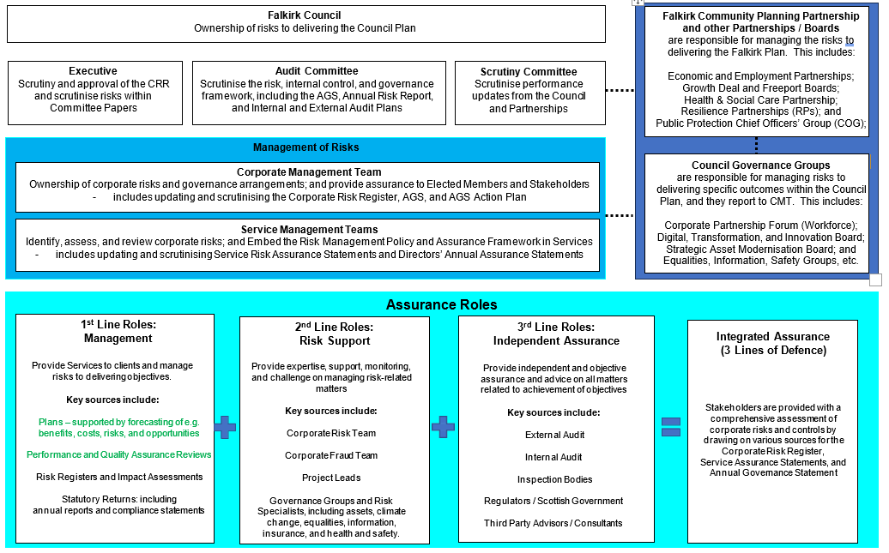

**Section 3: Adequacy and Effectiveness of the Governance Framework**

This section provides assurance on the following elements of the governance framework:

* + Audit Committee and Executive;
  + Best Value and Performance;
  + Standing Orders and Scrutiny;
  + Fraud and Corruption;
  + Internal Audit;
  + Risk Management;
  + Legal Compliance; and
  + External Audits and Inspections.

**Audit Committee and Executive Assurance**

The Audit Committee was held five times throughout 2024/25 (including the meeting in April 2025), and they were responsible for reviewing the effectiveness of the assurance functions in place, including Internal Audit. This included a range of reports produced throughout the year by the Internal Audit, Risk, and Corporate Fraud Manager on Internal Audit progress and Corporate Fraud work. This included a Mid-Year 2023/24 AGS Action Plan update in March 2025; and regular updates on Internal Audit and Corporate Fraud.

The Executive received Corporate Risk Management updates in October 2024 and March 2025 (and the latter included an update on corporate risks to 31 March 2025). Briefings were held in advance of most of these meetings, which allowed for scrutiny and questioning of Officers to take place; and enabled Elected Members to seek assurance that any weaknesses or gaps that were identified in the risk management assurance reports were being addressed.

The Audit Committee and Executive will continue to receive regular updates during 2025/26, and briefings will be held with the Executive in advance of each 6-monthly CRM Update. More formal risk management and assurance training will be organised as needed. In addition, Elected Members received reports and / or briefings from Subject Experts on most subjects within the CRR and AGS Action Plan during 2024/25. These updates allow Officers to set out the risks and challenges to delivering on specific Council Plan outcomes and strategies; so that Elected Members can decide whether to adjust the Council’s priorities or resources or accept the risks. For example, Elected Members receive briefings, including consideration of risks, on Equalities, Financial Sustainability, and areas of Transformational Change.

**Best Value, Performance, and Transformational Change Assurance**

The Corporate Management Team continues to monitor and provide updates to Elected Members on the improvements identified in previous Best Value reports, including equalities, financial sustainability, leadership and culture, and performance.

The Council Plan was reviewed by the Executive in September 2023. To support this, the Executive also undertook a Horizon Scanning Workshop to identify risks to delivering the Council Plan, and any significant changes and emerging risks are captured in the CRR.

The Council Plan is supported by a range of thematic strategies, including Assets, Digital, Finance, and Workforce Strategies. To ensure these strategies are implemented effectively, action plans are continuously reviewed; and a summary of progress is included within the AGS Action Plan (at Section 4). Each thematic strategy / plan includes a review of the significant challenges to delivering them, including horizon scanning of medium-term trends including demand and e.g. asset, funding, and workforce requirements.

Service Directorate Plans were developed further during 2024, and they are now updated annually and published thereafter. These include specific actions and performance indicators to support the Council Plan priorities; and CMT review these quarterly. In addition, Performance on the Council Plan is reviewed by the Scrutiny Committee every 6 months. The performance reports includes progress on key Council of the Future (COTF) Transformation Projects.

**Standing Orders and Scrutiny Committee Assurance**

A Standing Orders Review Group was established during 2023/24 and the revised Standing Orders were considered and agreed by Council in June 2024 and implemented thereafter. The changes included streamlining Committee structures, including merging the Executive and Children and Young People’s Executive, and also merging the Scrutiny Committee and External Scrutiny Committee into one; and improving Committee papers so that Elected Members receive more robust information when making decisions and scrutinising implications relating to climate change, equalities, resources, and risks.

The Scrutiny Committee’s reviews during 2024/25 included reports on the Council’s Contact Centre performance, Curriculum for Excellence, and Health and Wellbeing. The Scrutiny Committee also receive regular updates on the performance of Community Planning Partners, including the Falkirk Health and Social Care Partnership, Local Police and Fire Services’ Area Plans, and Third Sector organisations who receive Council funding. This includes the Following the Public Pound reports, which provide assurance on the outcomes from the Council’s funding to third sector organisations to support the Falkirk Plan.

**Fraud and Corruption Assurance**

Falkirk Council is determined to protect itself and the public from fraud and corruption, and, therefore, has a zero-tolerance approach. This approach includes a Corporate Fraud Team which is committed to the rigorous maintenance of the [Whistleblowing Policy and Anti-Fraud and Corruption Strategy and Procedure for Investigation of Corporate Fraud Referrals](https://www.falkirk.gov.uk/coins/submissiondocuments.asp?submissionid=18912) (last updated in November 2021) which provides a framework for:

* encouraging fraud deterrence and prevention;
* raising awareness of fraud and corruption and promoting detection and zero tolerance;
* performing investigations and facilitating recovery;
* working with Human Resources to invoke disciplinary proceedings when required;
* referral to the Police and / or the Procurator Fiscal when appropriate; and
* monitoring, publicising, and updating the policy, strategy and related procedures.

The Anti-Fraud and Corruption Strategy will be reviewed in Quarter 2 – 3 of 2025; and it will be submitted to the Audit Committee thereafter.

Corporate Fraud Team (CFT) Updates are provided twice yearly to Audit Committee, and this includes an update on the Corporate Fraud Action Plan and the response to emerging risks, as well as lessons learned. The CFT has considered ways to increase prevention measures in line with the aims of new legislation; and their reviews are informed by the emerging threats identified in e.g. Audit Scotland’s quarterly Technical Bulletins and the Scottish Local Authority Chief Internal Auditors Group meetings. During 2025/26, the CFT will also consider whether the National Audit Fraud Network (NAFN)’s threat bulletins can be used as an additional source; and the CFT will work in collaboration with the Corporate Risk Co-ordinator to establish a Fraud Risk Assessment template / toolkit to allow Services to effectively identify and mitigate emerging fraud risks.

The Chief Finance Officer, Chief Governance Officer / Monitoring Officer, and Director of Transformation, Communities, and Corporate Services meet quarterly with the Internal Audit, Risk, and Corporate Fraud Manager to discuss and review any significant corporate fraud investigations and lessons that could be learned corporately. The also consider any emerging themes from internal or external sources.

The Council’s mitigations to address fraud and irregularity include:

* + - All Directors provided completed Annual Assurance Statements to the Internal Audit, Risk, and Corporate Fraud Manager in April 2025. Most Directors confirmed that fraud risk controls are working effectively; except for the Director of Education Services who identified the improvement actions at section 3.37;
    - All Council Services record fraud risks and mitigations within their Quarterly Service Risk Assurance Statements; although these need to be improved during 2025/26, to improve the links to the Corporate Fraud Action Plan and intelligence sources;
    - Children’s Services have controls in place to validate all applications for e.g. Clothing Grants, Education Maintenance Allowance (EMA), Free School Meals, and school admissions / placing requests;
    - Place Services have specialists trained Officers to detect, deter, and disrupt breaches of environmental health, licensing, and trading standards regulations; they collaborate with community planning and economic partnerships and regulators to raise awareness amongst businesses and the public within the Falkirk area;
    - Health and Social Care Partnership have controls in place to mitigate harm and tackle exploitation of vulnerable adults and children; fraud by care service providers e.g. private care homes, and checking applications for individual packages of care; and assurance on fraud risks feeds into the Integration Joint Board (IJB)’s Annual Governance Statement; and
    - Transformation, Communities, and Corporate Services (TCCS) have controls in place to mitigate Financial Controls, Procurement, Recruitment, Housing, and Benefits Fraud; and TCCS also lead on Resilience Partnerships and Counter-Terrorism (CONTEST).

The risks rated as Medium Risk and Substantial Assurance on the Corporate Risk Register, except CONTEST, which is rated as High Risk and Limited Assurance. CMT have agreed an improvement action to address this in 2025/26.

Services’ fraud risk reviews also take into account the key risks and controls identified in [Scotland’s Serious Organised Crime Taskforce Strategy](https://www.gov.scot/publications/serious-organised-crime-strategy/) (SOC Strategy). This includes mitigation actions which contribute to the following Council Plan priorities:

|  |  |
| --- | --- |
| **Priority: Supporting stronger and healthier communities:**   * Form stronger ties with our communities and partners to improve the lives of our most vulnerable; and * Ensure people feel safe within their community and live in high-quality housing. | **Priority: Supporting a thriving economy and green transition**   * Support sustainable economic recovery that benefits everyone; and * Reimagine our town centres, making them vibrant places to live, meet, eat, shop, and do business. |

The SOC Strategy is also embedded into various Council Governance Groups, including:

* Falkirk Community Planning Board lead on the Falkirk Plan, which includes actions to embed the national objectives relating to Communities and Enterprise above;
* Falkirk Economic Partnerships share information with business and Police Scotland to help detect, deter, and disrupt fraud and crime in Town Centres;
* Local and Regional Resilience Planning Partnership lead on Counter-Terrorism risks, including assessing risks and developing response plans to emergencies; and
* Public Protection Chief Officers Group (COG) lead on the Community Justice and Community Safety Partnerships, including risk of harm to adult and children.

The COG agreed (as part of their annual risk review in March 2025) that the link between Public Protection, Resilience, and CONTEST risks and governance structures needs a more detailed review by the COG, HSCP, and Resilience Partnerships during 2025/26.

**Internal Audit Assurance**

The Internal Audit team provide services to Clackmannanshire Council via a separate Internal Audit Plan. This includes audit work for Clackmannanshire and Stirling Integration Joint Board and Central Scotland Valuation Joint Board. Falkirk Council received an income for this work during 2024/25, as well as income for the provision of an Internal Audit service to Strathcarron Hospice. The completion of the Falkirk Council Internal Audit Plan for 2024/25 (including a separate Plan for the Pensions Committee and Board) has been impacted by unforeseen changes to the workload commitments at Clackmannanshire Council and time taken to undertake this work. Resources at Clackmannanshire Council will be increased during 2025/26, which we anticipate will resolve these challenges.

The completion of the Falkirk Council Internal Audit Plan for 2024/25 has also been impacted by two additional audit review requests by Falkirk Council Chief Officers in 2023/24. In April 2025, the Internal Audit, Risk, and Corporate Fraud Manager reported that the 2023/24 Internal Audit Plan was now completed and that two audits from the 2024/25 Internal Audit Plan needed to be deferred into 2025/26. The Audit Committee have been provided with regular updates throughout 2024/25 regarding resourcing issues. There is an internal review underway looking at the resourcing of the additional workstreams to ensure that the team continue to have capacity to undertake Falkirk Council’s internal audit programme. Part of the requirement for this review is to ensure that Internal Audit, via the work undertaken, are able to provide an annual audit opinion.

In June 2025 the Internal Audit, Risk, and Corporate Fraud Manager will provide the Audit Committee with an Annual Assurance Report on the adequacy and effectiveness of the Council’s framework of governance, risk management, and control for the year ending 31 March 2025. The report will provide details of the position relating to the audits contained within the 2024/25 Internal Audit Plan and will highlight whether all recommendations made have been accepted by management, and once fully implemented will improve the Council’s internal control environment.

Having taken all factors into consideration substantial assurance can be placed on the adequacy and effectiveness of the Council’s internal control system in the year to 31 March 2025. The Annual Assurance Report will also confirm the organisational independence of Internal Audit.

For 2024/25, Internal Audit operates in accordance with the Public Sector Internal Audit Standards 2017 (PSIAS) which apply to Local Government. The Internal Audit team undertake annual self assessments and are subject to an independent evaluation of their compliance with PSIAS every 5 years. This external review is ongoing, and the results will be reported to the Audit Committee during 2025/26, however, this review was delayed and has gone outwith the five-year period.

Performance of Internal Audit was consistent with the Internal Audit Charter which sets out the purpose, authority, and responsibility of the internal audit activity in compliance with the Definition of Internal Auditing, the Code of Ethics, and the Standards. The Charter was approved by the Audit Committee on 29 October 2024.

The Standards were in place until 31 March 2025. From 1 April 2025 the Institute of Internal Auditors (IIA) Global Internal Audit Standards 2024 (GIAS) apply. GIAS is supplemented by the Application Note: Global Internal Audit Standards in the UK Public Sector issued by relevant standards setters for the UK public sector including CIPFA. The new GIAS continues to mandate that Internal Audit maintains a Quality Assurance and Improvement Programme (QAIP), therefore, over the next 12 months the Internal Audit, Risk, and Corporate Fraud Manager will be assessing the team against the new GIAS.

**Risk Management Assurance**

Corporate Risk Management updates are provided to the CMT (quarterly), the Executive (6-monthly), and the Audit Committee (annually). This includes a review of the CRR and 2023-25 Risk Management Improvement Plan (RMIP), and (by exception) service risks. Good progress has been made on most corporate risk actions on the RMIP during 2024/25, including clearer actions and target risk (appetite) on corporate risks. Other improvements to be implemented during 2025/26 include linking risks to Council Plans and Directorate Plans, so that there is a clear link with performance information; and improving the risk section in Committee reports, so that Elected Members can more effectively scrutinise and agree whether to accept or tolerate risks.

Service Management Teams (SMTs) maintain quarterly Service Risk Assurance Statements (SRASs), which assess the risks to delivering their Directorate Plans. Any significant actions feed into the Corporate Risk updates to the Executive and the AGS Action Plan (at Section 4). These show that improvements need to be implemented

during Quarter 2-3 2025 in how Education and Places Services monitor risks.

The Risk Management Internal Audit review undertaken by West Lothian Council during 2023/24 provided ‘Reasonable Assurance’ on the effectiveness of risk management arrangements. This continues to be the assurance provided by CMT and most Services; although Education Services are continuing to review and improve their approach to risk.

Council Partnerships and Governance Groups provide Annual Self-Assessments, which include a review of their remit and effectiveness. The outcomes from these feed into the AGS Action Plan (at Section 4) and CMT also scrutinise their remits and self- assessments.

The Community Planning Partnership (CPP) lead on the Falkirk Plan outcomes relating to e.g. the Employment and Training, Housing, and Poverty; and the CPP receive regular updates on those strategies and the risks to delivering them. In addition, other external partnerships - including the Falkirk Growth Deal, Forth Green Freeport, and Falkirk Health and Social Care Partnership - have a Risk Management Strategy, Improvement Plan, and Risk Registers; and these are monitored by their Boards.

**Statutory Officers’ Assurance**

The Chief Finance Officer (CFO), Chief Governance Officer (CGO), and Chief Social Work Officer (CSWO) each have independent roles in monitoring the Council’s compliance with regulations and standards in their respective areas; and they provide Annual Assurance Statements (in addition to Directors’ Annual Assurance Statements).

The Chief Finance Officer (CFO) has overall responsibility for the Council’s financial arrangements and is professionally qualified and suitably experienced to lead the Council’s finance function and staff; and they feed into the Risk Management reviews outlined above. The CFO can confirm that the Council complies with the requirements of CIPFA’s statement on ‘The Role of the CFO in Local Government’.

The CGO provides CMT with assurance on e.g. Health and Safety, Information Governance, and Procurement risks (including compliance with timescales on responses to Freedom of Information requests). The AGS Action Plan (at Section 4) shows a mixture of substantial and limited assurance on these areas.

The CSWO provides an annual report to the Scottish Government and ongoing updates to both the Council and IJB; and these provide substantial assurance on public protection arrangements. In addition, Social Work inspections are reported to the Falkirk IJB’s Performance, Audit, and Assurance Committee (PAAC), and either the Council’s Scrutiny Committee and / or Executive, as appropriate. In addition, the PAAC have similar arrangements in place for the monitoring of inspections relating to the Falkirk Health and Social Care Partnership (HSCP).

**Directors’ Annual Assurance Statements**

Directors provide the Internal Audit, Risk, and Corporate Fraud Manager with Annual Assurance Statements confirming that Services have complied with the Financial Regulations and the Code of Practice on Local Authority Accounting in relation to 'Related Party Transactions’ (such as Chief Officer appointments to independent Boards). No significant issues have been identified as part of the completion of these statements during 2024/25; except for the improvement actions identified below.

The Director of Education Services has confirmed that the following improvements to internal control processes will be implemented during 2025/26:

* + - Communications will be issued to all Heads of Establishment and Managers on the Council’s Contract Standing Orders and Financial Regulations to ensure that all staff are aware of these documents and their requirement to comply with them;
    - A review of all Service specific policies and procedures is currently being carried out. This involves ensuring that all our policies and procedures are current and relevant. The target date for completion of the review is August 2026. As part of the review a framework for regular review and monitoring of implementation will be established; and
    - An annual checklist and assurance statement will be developed for all Heads of Establishment and Managers

to confirm that they have ensured that their teams comply with all legislation and council policies and procedures.

Directors have identified no new significant incidents or legal breaches during 2024/25; and all actions arising from Health and Safety Execute (HSE) improvement notices have been completed. The CRR also provides assurance on compliance with legal duties such as Community Empowerment, Equalities, and Operators Licences e.g. Fleet and Waste.

**External Audits and Inspections Assurance**

The Council provides a range of assurance reports to the Scottish Government and / or regulators. This includes the annual reports by the Chief Social Work Officer and the annual reports on Climate Change, Housing, and Procurement. These reports are communicated to Elected Members through either Committees and / or Information Bulletins, and any significant outcomes and actions are also included in the AGS Action Plan (at Section 4).

There continues to be ongoing reviews by the Care Inspectorate and Education Scotland. These inspections have provided positive assurance outcomes on a range of areas, including some Schools and Care Homes being rated as very good or excellent. The actions from all inspections continue to be monitored by CMT and the outcomes are reviewed by Committees, including Council’s Scrutiny Committee and IJB PAAC.

**Section 4: AGS Action Plan**

The AGS Action Plan for 2024/25 shown on the following pages includes a summary of how well the Council implement the 7 CIPFA Principles of Good Governance, and these are grouped into the Council’s High and Medium corporate risks. The AGS Action Plan also includes a list of improvement actions for High corporate risks.

The AGS Action Plan includes outstanding actions carried forward from the 2023/24 AGS Action Plan, which were reviewed by the Audit Committee in February 2025, as well as any significant additional actions identified in the 2024/25 year-end assurance reports:

* + - 1st Line Management Assurance: including e.g. annual reports and action plans;
    - 2nd Line Specialists Assurance: including Governance Group Self-Assessments; and
    - 3rd Line Independent Assurance: including reviews by Internal Audit and External Audit.

In addition, the [CRR Details](https://www.falkirk.gov.uk/services/council-democracy/policies-strategies/corporate-risk.aspx) include an overview of key assurance sources for each risk.

A mid-year AGS Action Plan update will be submitted to the Audit Committee in Quarter 4 of 2025, to assess progress on the actions in line with June 2025 implementation dates.

**AGS Action Plan**

**Key**

|  |
| --- |
| **CIPFA Good Governance Principles** |
| **Principle A:** Behaving with integrity, demonstrating strong commitment to ethical values, and respecting the rule of law. |
| **Principle B:** Ensuring openness and comprehensive stakeholder engagement |
| **Principle C:** Defining outcomes in terms of sustainable economic, social, and environmental benefits |
| **Principle D:** Determining the interventions necessary to optimise the achievement of the intended outcomes |
| **Principle E:** Developing the entity’s capacity, including the capability of its leadership and the individuals within it |
| **Principle F:** Managing risks and performance through robust internal control and strong public financial management |
| **Principle G:** Implementing good practices in transparency, reporting, and audit, to deliver effective accountability |

|  |  |
| --- | --- |
| **Council Plan – Our Communities’ Priorities** | |
| **STR** | Supporting stronger and healthier communities: Communities that are empowered, inclusive, resilient,  and safe |
| **PRO** | Promoting opportunities and educational attainment and reducing inequalities: Educational excellence,  reduce poverty and inequality, and improve wellbeing |
| **EGT** | Supporting a thriving economy and green transition: An economy that is competitive, entrepreneurial,  inclusive, and sustainable and an environment that we value, enjoy, protect and enhance |
| **ENA** | Our Enablers: Valued Sustainable Workforce, Transformation and Improvement, and Financial  Sustainability |

|  |  |  |  |  |  |  |
| --- | --- | --- | --- | --- | --- | --- |
|  | **Status – Assurance Rating** |  | **Status – Action Progress** |  | **Change In Year** | |
|  | No Assurance: Significant weakness  in controls and / or framework | Significant delay or shortfall on outcomes. |  | No change |
|  | Limited Assurance: Some weaknesses  in controls and / or framework | Minor delay or shortfall on outcomes. |  | Improved |
|  | Substantial: Controls are working  effectively (or only minor weaknesses) | Actions are completed or expected to meet  timescales and outcomes. |  | Deteriorated |
|  | More information required  – needs assessed. | More information required –  needs assessed – or action not yet started |  |  |

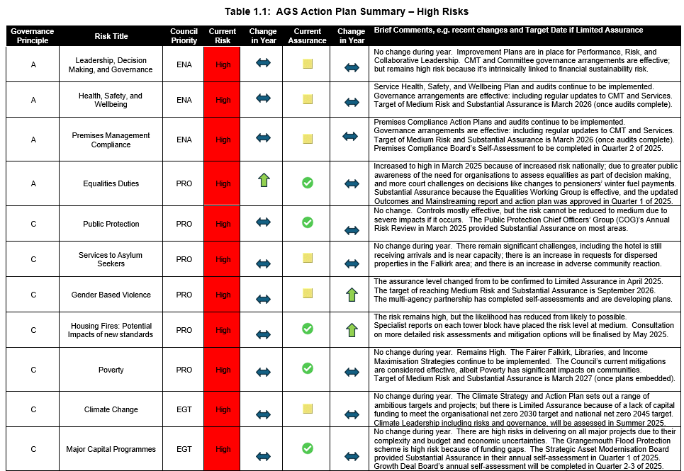

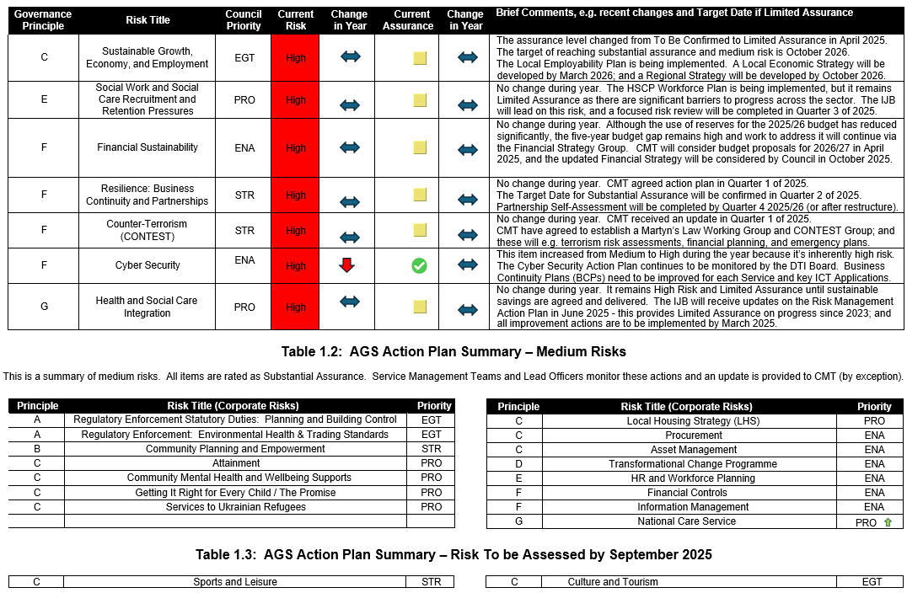

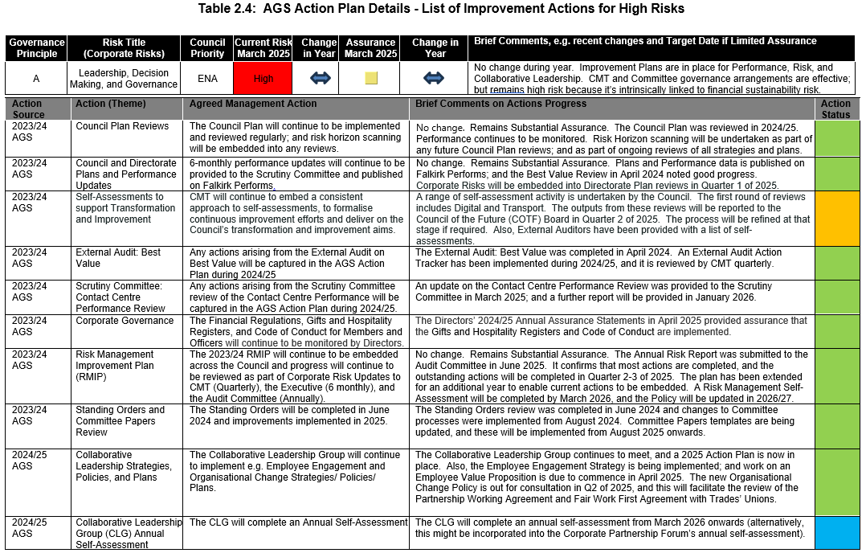

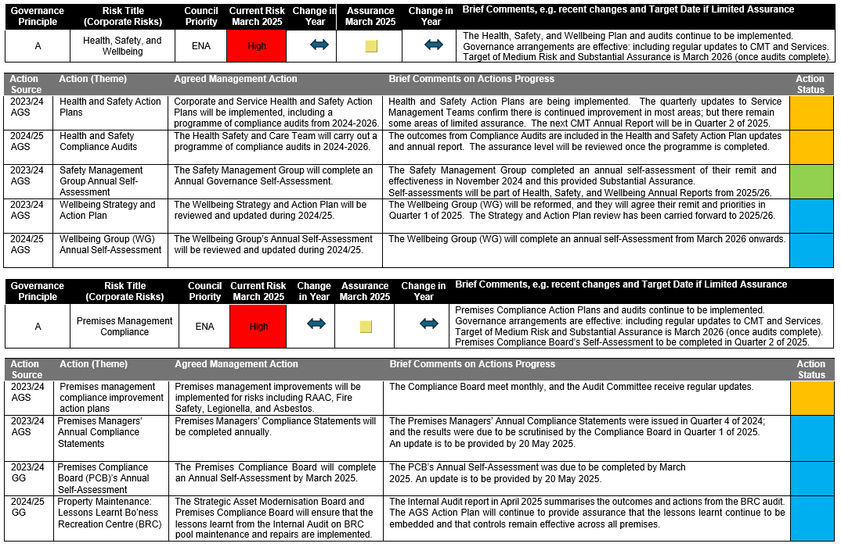

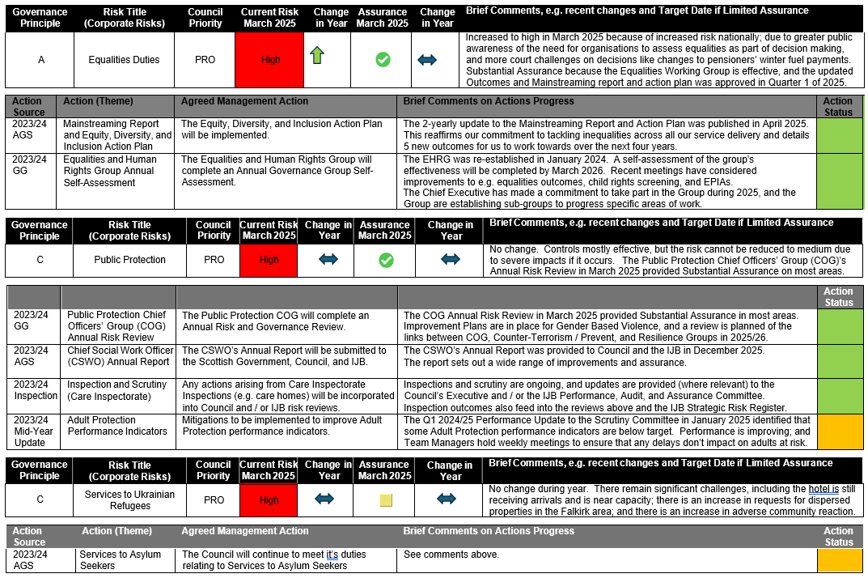

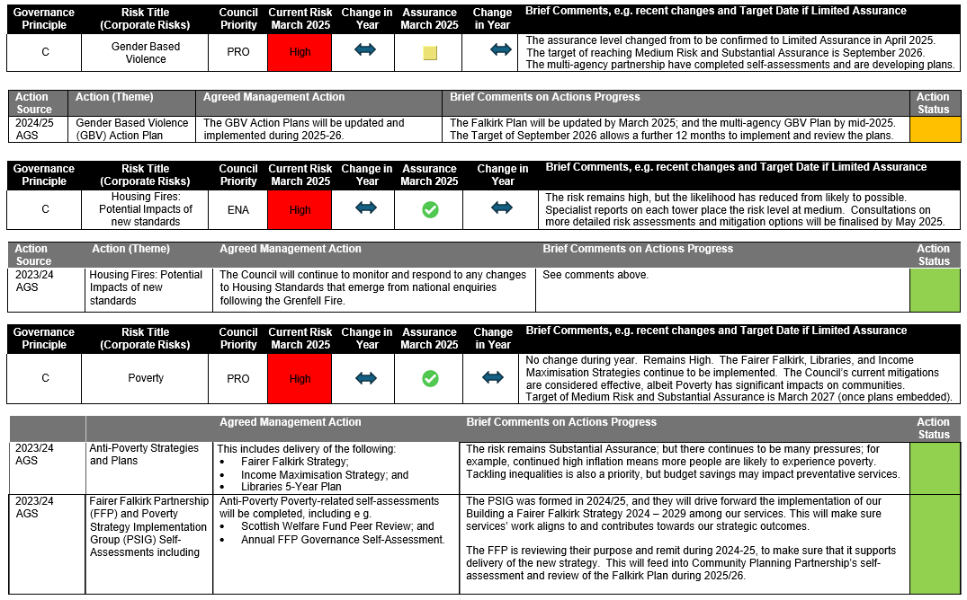

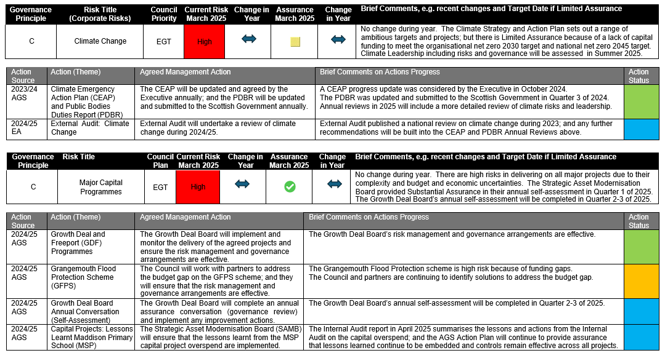y

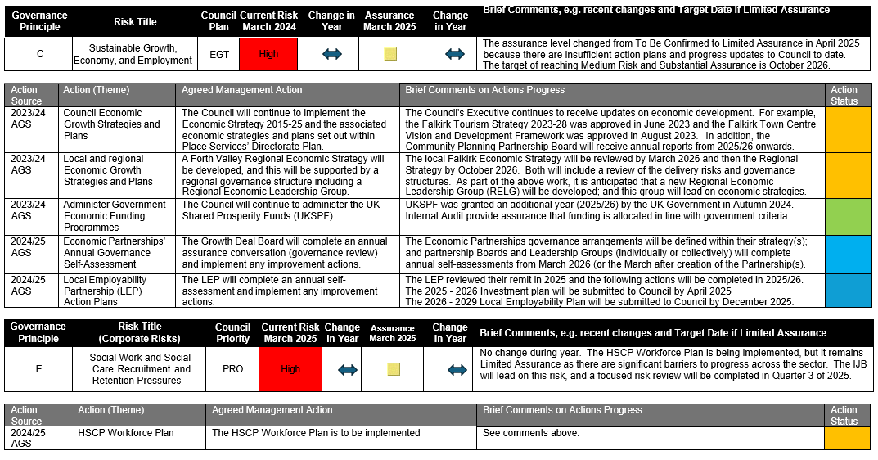

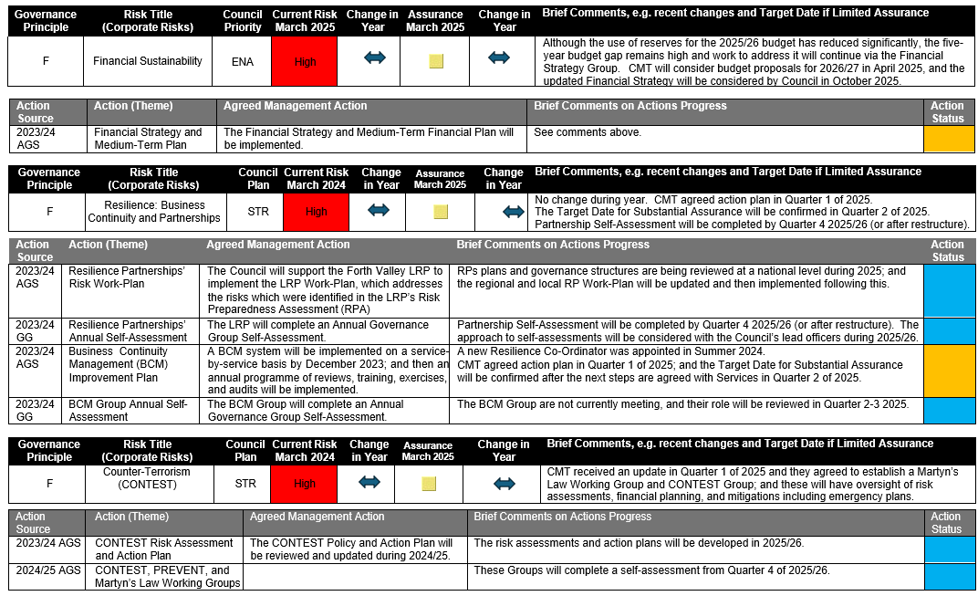

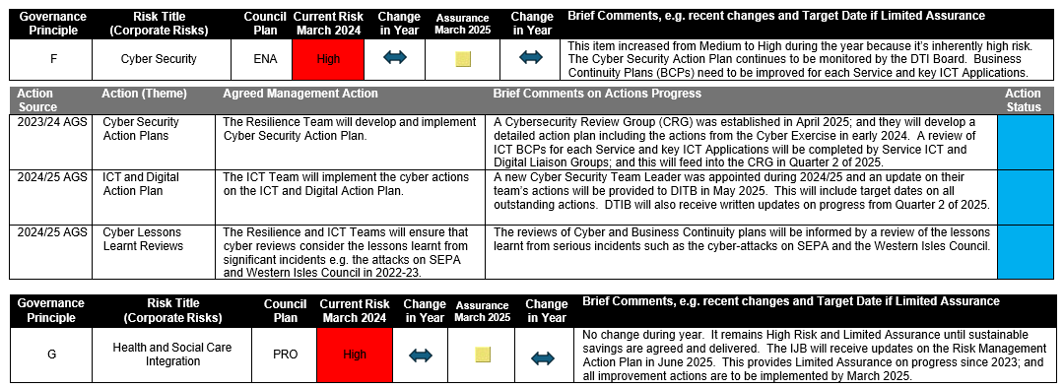

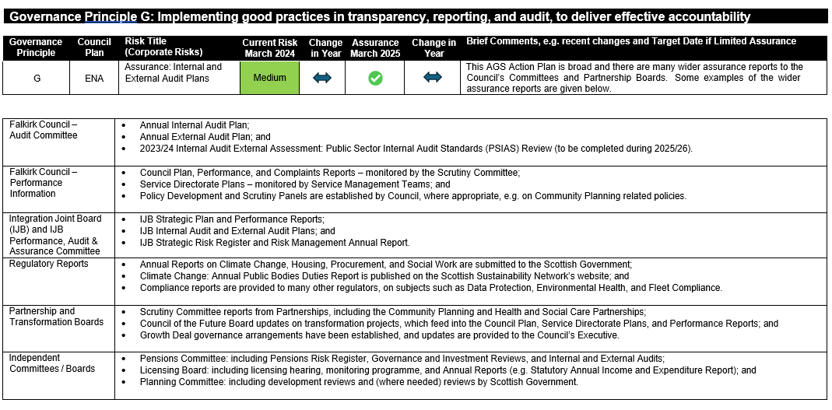

**Section 5: Conclusion and Opinion on Assurance**

The Leader of the Council and Chief Executive both recognise the importance of having a solid foundation of good governance and sound financial management. The Council has a strong record of financial management, as evidenced in the [2023/24 Annual Accounts](https://www.falkirk.gov.uk/budgets-spending-and-performance/annual-accounts) [and 2023/24 External Audit Annual Report](https://www.falkirk.gov.uk/budgets-spending-and-performance/annual-accounts). This includes an unqualified opinion on the 2023/24 Annual Accounts.

The Council undertook a review of the [Standing Orders](https://www.falkirk.gov.uk/coins/submissiondocuments.asp?submissionid=19249) in 2023/24, and the agreed changes to decision-making arrangements were implemented during 2024/25.

This Statement is an objective appraisal of our governance framework and demonstrates that largely satisfactory risk, control, and governance systems are in place within Falkirk Council. This Statement also demonstrates that we have met our legal and statutory obligations to our residents; and we are committed to completing the actions identified in 2025/26 (at Section 4 above).

The Council is a complex organisation with interests in other organisations. This statement covers our relationships with the organisations included in the Council’s Group Accounts for 2024/25. The Falkirk Integration Joint Board (IJB) have produced their own annual accounts and AGS; and these are due to be considered by the IJB’s Performance, Audit, and Assurance Committee (PAAC) in June 2025.

**Signed on behalf of Falkirk Council**

|  |  |
| --- | --- |
| **Councillor Cecil Meiklejohn** | **Kenneth Lawrie** |
| **Leader of Falkirk Council** | **Chief Executive of Falkirk Council** |
|  |  |
| **Xx xxxxx 2025** | **Xx xxxxxx 2025** |

**Annual Remuneration Report 2024/25**

The Local Authority Accounts (Scotland) Regulations 2014 require the annual accounts of the Council to contain a Remuneration Report. This Report for the financial year 2024/25 contains the information specified in the Schedule to the above Regulations.

All information disclosed in the tables below will be audited by Audit Scotland. The other sections of this Report will be reviewed by Audit Scotland to ensure that they are consistent with the accounts.

**Senior Councillors’ Remuneration Arrangements**

The remuneration of Councillors is regulated by the Local Governance (Scotland) Act 2004 (Remuneration) Regulations 2007, as amended by the Local Governance (Scotland) Act 2004 (Remuneration and Severance Payments) Amendment Regulations 2023. The Regulations provide for the grading of Councillors for the purposes of remuneration arrangements, as either the Leader of the Council, the Civic Head - who is the Provost, Senior Councillors or Councillors. The Leader of the Council and the Civic Head cannot be the same person for the purposes of payment of remuneration. A Senior Councillor is a Councillor who holds a significant position of responsibility in the Council’s political management structure.

The salary that is to be paid to the Leader of the Council is set out in the Regulations. For 2024/25 the salary for the Leader of Falkirk Council is £42,698. The Regulations permit the Council to remunerate one Civic Head. The Regulations set out the maximum salary that may be paid to that Civic Head as £32,024.

The Regulations also set out the remuneration that may be paid to Senior Councillors and the total number of Senior Councillors the Council may have. The maximum yearly amount that may be paid to a Senior Councillor is 75% of the total yearly amount payable to the Leader of the Council (£32,024). The total yearly amount payable by the Council for remuneration of all its Senior Councillors, excluding the Leader of the Council, the Provost, and the Convener, is specified by the above Regulations and shall not exceed £373,580. The Council can exercise local flexibility in the determination of the precise number of Senior Councillors and their salary within these maximum limits.

In 2024/25, Falkirk Council had 12 Senior Councillors for just over three months and 11 Senior Councillors for the remainder of the financial year. One Councillor moved from a level 3 to a level 2 responsibility halfway through 24/25. The basic salary of these totalled £297,583 (23/24 - £302,388). In 2023/24, there were 12 Senior Councillors. The Regulations permit the Council to pay contributions or other payments as required to the Local Government Pension Scheme in respect of those Councillors who elect to become Councillor members of the pension scheme.

In addition to the Senior Councillors of the Council the Regulations also set out the remuneration payable to Councillors with responsibility of a Convener or Vice-Convener of a Joint Board, such as a Joint Valuation Board. The Regulations specify the remuneration to be paid by the Council of which the Convener or Vice-Convener (as the case may be) is a member. The Council is also required to pay any pension contributions arising from the Convener or Vice-Convener being a member of the Local Government Pension Scheme.

The Council is reimbursed by the Joint Board for any additional remuneration paid to the member from being a Convener or Vice-Convener.

**Senior Employees’ Remuneration Arrangements**

The salary of senior employees is set by reference to national arrangements and local benchmarking. The Scottish Joint Negotiating Committee (SJNC) for Local Authority Services sets the salaries for the Chief Executives of Scottish Local Authorities. Industrial Relations Circular 10-24b sets the amount of salary for the Chief Executive of Falkirk Council for the period 2024/25.

The salaries for Chief Officers are evaluated using the Hays Grading Scheme.

**General Disclosure by Pay Band**

The number of employees whose remuneration was £50,000 or more in 2024/25 is as follows:

|  |  |  |  |  |  |  |  |  |
| --- | --- | --- | --- | --- | --- | --- | --- | --- |
| **Remuneration** | **Employees** |  | **Chief** | **Officers** | **Teachers** |  | **SJC Employees** |  |
| **Bands** | **2023/24** | **2024/25** | **2023/24** | **2024/25** | **2023/24** | **2024/25** | **2023/24** | **2024/25** |
| £50,000 - £54,999 | 696 | 312 | - | - | 584 | 161 | 112 | 151 |
| £55,000 - £59,999 | 172 | 145 | - | - | 115 | 74 | 57 | 71 |
| £60,000 - £64,999 | 95 | 86 | - | 1 | 58 | 54 | 37 | 31 |
| £65,000 - £69.999 | 79 | 101 | - | 2 | 70 | 78 | 9 | 21 |
| £70,000 - £74,999 | 62 | 82 | - | - | 51 | 65 | 11 | 17 |
| £75,000 - £79,999 | 42 | 32 | - | - | 41 | 27 | 1 | 5 |
| £80,000 - £84,999 | 20 | 23 | - | - | 13 | 13 | 7 | 10 |
| £85,000 - £89,999 | 5 | 3 | - | 2 | 2 | 1 | 3 | - |
| £90,000 - £94,999 | 1 | 1 | 1 | 1 | - | - | - | - |
| £95,000 - £99,999 | 6 | 3 | 4 | 1 | 2 | 2 | - | - |
| £100,000 - £104,999 | 3 | 5 | 1 | 3 | 2 | 2 | - | - |
| £105,000 - £109,999 | 7 | 6 | 5 | 1 | 2 | 4 | - | 1 |
| £110,000 - £114,999 | 2 | 2 | - | 2 | 1 | - | 1 | - |
| £115,000 - £119,999 | 1 | - | - | - | 1 | - | - | - |
| £120,000 - £124,999 | 2 | - | 2 | - | - | - | - | - |
| £125,000 - £129,999 | 1 | 2 | 1 | 2 | - | - | - | - |
| £130,000 - £134,999 | - | 2 | - | 1 | - | - | - | 1 |
| £135,000 - £139,999 | - | 1 | - | 1 | - | - | - | - |
| £145,000 - £149,999 | 1 | - | 1 | - | - | - | - | - |
| £160,000 - £164,999 | 1 | - | 1 | - | - | - | - | - |
| £165,000 - £169,999 | - | 1 | - | 1 | - | - | - | - |
| **Total** | **1,196** | **807** | **16** | **18** | **942** | **481** | **238** | **308** |

# *There is a significant decrease in the number of teachers over £50k due to the 2023/24 figures including payment of back-dated pay award for 2022/23 being made in April 2023, along with the pay award for 2023/24.

**Disclosure of Remuneration for Relevant Persons**

The Regulations require that the report shows, in tabular form, the total amounts against the post held and name of each relevant person, whether received or receivable, by each relevant person from Falkirk Council.

The information is provided in separate tables as follows:

**Remuneration paid to Falkirk Council’s Senior Councillors**

|  |  |  |  |
| --- | --- | --- | --- |
| **Name** | **Position(s)** | **Salary, Fees and Allowances**  **2024/25 £** | **Salary, Fees and Allowances**  **2023/24 * £** |
| David Balfour | Depute Provost | 23,986 | 22,586 |
| Robert Bissett | Provost | 32,243 | 30,356 |
| Gary Bouse | Portfolio Holder, Housing and Communities | 28,613 | 26,943 |
| William Buchanan | Planning Committee Convener | 25,646 | 24,304 |
| Fiona Collie | Portfolio Holder, Health and Social Care | 28,613 | 26,943 |
| Stacey Devine | Portfolio Holder, Public Protection | 28,613 | 26,943 |
| Paul Garner | Portfolio Holder, Economic Development | 28,613 | 26,943 |
| James Kerr | Leader of the Opposition (Conservative) to 02/10/24 and Convener of Civic Licensing from 03/10/24 | 24,807 | 22,586 |
| Cecil Meiklejohn | Leader of the Council | 42,698 | 40,205 |
| Iain Sinclair | Portfolio Holder, Education | 28,613 | 26,943 |
| Alan Nimmo | Convener Central Scotland Valuation Joint Board | 27,062 | 25,297 |
| Anne Hannah | Leader of the Opposition (Labour) | 25,646 | 24,149 |
| Lorna Binnie | Pensions Committee Convener | 24,270 | 22,895 |
| Euan Stainbank | Civic Licensing Committee Convener to 05/07/24 | 1,549 | 24,149 |
| Bryan Deakin | Portfolio Holder, Climate Change | 28,613 | 25,745 |
| **Total** |  | **399,585** | **396,987** |

* *2023/24 figures restated to remove Councillors who left in the prior year*

The amount recharged to Central Scotland Valuation Joint Board in 2024/25 was £7,200 (2023/24 £6,929).

There were taxable expenses of £878 (2023/24 £896) and no non-cash expenses and benefits in kind in 2024/25 (2023/24 Nil).

**Remuneration paid to all Members in 2024/25 was:**

|  |  |  |
| --- | --- | --- |
| 2023/24 £’000 |  | 2024/25 £’000 |
| 699 | Salaries | 729 |
| 1 | Allowances (Mileage) | 2 |
| 2 | Expenses | 2 |
| 702 |  | 733 |

The annual return of Councillors’ salaries and expenses for 2024/25 is available for any member of the public to view at all Council libraries and public offices during normal working hours and is also available on the Council’s website at www.falkirk.gov.uk. Please follow the “Councillors” quick link on the Council’s website.

**Remuneration of Senior Employees of Falkirk Council**

|  |  |  |  |  |  |
| --- | --- | --- | --- | --- | --- |
| **Name** | **Post Title** | **Salary, Fees, and Allowances £** | **Other Amounts £** | **Total Remuneration 2024/25 £** | **Total Remuneration 2023/24 £** |
| **K Lawrie** | Chief Executive | 166,528 | 2,035 | 168,563 | 160,741 |
| **M Bennie** | Director of Place Services | 128,738 | 504 | 129,242 | 124,372 |
| **K Algie** | Director of Transformation, Communities and Corporate Services; Acting Director of Children’s Services to 12/05/24 | 133,338 | 166 | 133,504 | 124.372 |
| **J Reid** | Director of Children’s Services from 13/05/24 | 115,463 (full year equivalent 130,526) | 270 | 115,733 | 108,307 |
| **A Templeman** | Chief Finance Officer (Section 95 Officer) | 113,932 | - | 113,932 | 109,973 |
| **S Lacey** | Head of Social Work Children’s Services (CSWO) | 106,933 (full year cost 113,932) | 245 | 107,178 | 109,973 |

There were no payments to senior employees by way of bonuses, taxable expenses or benefits other than in cash.

The “Other Amounts” value above covers election duties and related fees taking place (2023/24 Nil). These payments are reimbursed by either the Scottish Government or the Government of the United Kingdom.

The senior employees included in the table above include any local authority employee:

* who has responsibility for management of the local authority to the extent that the person has power to direct or control the major activities of the authority (including activities involving the expenditure of money), during the year to which the Report relates, whether solely or collectively with other persons,
* who holds a post that is politically restricted by reason of section 2(1) (a), (b) or (c) of the Local Government and Housing Act 1989(a),
* whose annual remuneration, including any remuneration from a local authority subsidiary body, is £150,000 or more.

**Pension Benefits**

Pension benefits for councillors and local government employees are provided through the Local Government Pension Scheme (LGPS).

Before 1 April 2015 the scheme provided final salary benefits that were calculated by reference to a member’s salary and their number of years of membership in the scheme. For employees the best of the last three final years of salary is used to determine the benefit accrued whereas for Councillors it is their career average pay that is used.

Career average pay is worked out by taking the Councillor’s pay for each year or part year ending 31 March (other than the pay in the final year commencing 1 April) which is then revalued to reflect the cost of living, as measured by the appropriate index (or indices) between the end of that year and the last day of the month in which scheme membership ends. The total of the revalued pay is then divided by the period of membership to calculate the career average pay.

Benefits that are built up after 31 March 2015 build up on a CARE basis for both employees and Councillors. Under CARE, pension is built up annually and then revalued to reflect the cost of living, as measured by the Consumer Prices Index.

At retirement scheme members may opt to give up (commute) pension for lump sum up to the limit set by the Finance Act 2004. The normal retirement age for both Councillors and employees is State Pension age or age 65 if later. However, benefits that were built before 1 April 2015 retain a normal retirement age of 65.

The LGPS operates a five-tier contribution system with contributions from scheme members being based on how much of their actual pay falls into each tier. To drive an efficient payroll these tiers are converted into steps of 0.1% to which pay ranges are attached. The pay ranges are then revalued each year to reflect the cost of living. This is designed to give more equality between the cost and benefits of scheme membership.

The steps and members contribution rates for 2024/25 were as follows:

|  |  |  |  |  |  |
| --- | --- | --- | --- | --- | --- |
| **Contribution**  **Rate** | **Actual Pay**  **Min** | **Actual Pay**  **Max** | **Contribution**  **Rate** | **Actual Pay**  **Min** | **Actual Pay**  **Max** |
| 5.5% | Up to | £28,308 | 8.4% | £79,377 | £81,612 |
| 5.6% | £28,309 | £30,078 | 8.5% | £81,613 | £83,978 |
| 5.7% | £38,079 | £32,083 | 8.6% | £83,979 | £86,485 |
| 5.8% | £32,084 | £34,009 | 8.7% | £86,486 | £89,146 |
| 5.9% | £34,010 | £35,343 | 8.8% | £89,147 | £91,976 |
| 6.0% | £35,344 | £36,785 | 8.9% | £91,977 | £94,991 |
| 6.1% | £36,786 | £38,351 | 9.0% | £94,992 | £98,211 |
| 6.2% | £38,352 | £40,055 | 9.1% | £98,212 | £101,657 |
| 6.3% | £40,056 | £41,918 | 9.2% | £101,658 | £105,354 |
| 6.4% | £41,919 | £43,963 | 9.3% | £105,355 | 109,330 |
| 6.5% | £43,964 | £46,177 | 9.4% | £109,331 | £113,617 |
| 6.6% | £46,178 | £47,798 | 9.5% | £113,618 | £118,255 |
| 6.7% | £47,799 | £49,536 | 9.6% | £118,256 | £123,287 |
| 6.8% | £49,537 | £51,405 | 9.7% | £123,288 | £128,766 |
| 6.9% | £51,406 | £53,421 | 9.8% | £128,767 | £134,755 |
| 7.0% | £53,422 | £55,602 | 9.9% | £134,756 | £141,329 |
| 7.1% | £55,603 | £57,968 | 10.0% | £141,330 | £148,576 |
| 7.2% | £57,969 | £60,544 | 10.1% | £148,577 | £156,608 |
| 7.3% | £60,545 | £62,306 | 10.2% | £156,609 | £165,557 |
| 7.4% | £62,307 | £63,675 | 10.3% | £165,558 | £175,590 |
| 7.5% | £63,676 | £65,106 | 10.4% | £175,591 | £186,919 |
| 7.6% | £65,107 | £66,603 | 10.5% | £186,920 | £199,810 |
| 7.7% | £66,604 | £68,170 | 10.6% | £199,811 | £214,611 |
| 7.8% | £68,171 | £69,813 | 10.7% | £214,612 | £231,780 |
| 7.9% | £69,814 | £71,537 | 10.8% | £231,781 | £251,934 |
| 8.0% | £71,538 | £73,348 | 10.9% | £251,935 | £275,928 |
| 8.1% | £73,349 | £75,253 | 11.0% | £275,929 | £304,973 |
| 8.2% | £75,254 | £77,260 | 11.1% | £304,974 | £340,852 |
| 8.3% | £77,261 | £79,376 | 11.2% | £340,853 | and above* |

The value of the accrued benefits has been calculated by reference to the member’s age on the basis they have reached the age at which they are entitled to receive a full unreduced benefit on retirement; without exercising any option to commute pension into a lump sum; and without any adjustment for the effects of future inflation.

The benefits and accrual rates for each year of service are:

* **Before 1 April 2009**

A pension of 1/80th x pensionable pay*

A lump sum of 3/80th x pensionable pay*

* **Between 1 April 2009 and 31 March 2015**

A pension of 1/60th x pensionable pay*

* **From 1 April 2015**

A pension of 1/49th x pensionable pay*

*Pensionable pay is the relevant final pay, career average pay or career average revalued earnings.

The pension figures shown relate to the benefits that the person has accrued as consequence of their total pensionable service, which may include service derived from other employments, and not just their current appointment. The pension figures shown must be rounded to the nearest £1,000.

**Pension Rights of Senior Councillors of Falkirk Council**

The pension entitlements for Senior Councillors for the year to 31 March 2025 are shown in the table below, together with the contribution made by the Council to each Senior Councillor’s pension during the year.

|  |
| --- |
| Accrued Pension Benefits |

|  |  |  |  |  |  |
| --- | --- | --- | --- | --- | --- |
| **Name** | **In-Year Pension Contributions for year to 31/03/2025 £** | **As at 31/03/2025 Pension £** | **As at 31/03/2025 Lump Sum £** | **Difference from 31/03/2024 Pension £** | **Difference from 31/03/2024 Lump Sum £** |
| David Balfour | 4,677 | 7,000 | - | 1,000 | **-** |
| Robert Bissett | 6,245 | 4,000 | - | - | **-** |
| Alan Nimmo | 5,204 | 7,000 | - | 1,000 | - |
| Gary Bouse | 5,580 | 5,000 | - | 1,000 | **-** |
| Fiona Collie | 5,580 | 5,000 | - | 1,000 | **-** |
| Paul Garner | 5,580 | 6,000 | - | 1,000 | **-** |
| Lorna Binnie | 4,677 | 4,000 | - | 1,000 | - |
| James Kerr | 4,837 | 4,000 | - | 1,000 | **-** |
| Cecil Meiklejohn | 8,326 | 13,000 | - | 1,000 | **-** |
| Bryan Deakin | 5,580 | 2,000 | - | 1,000 | **-** |
| Euan Stainbank | 1,606 | 1,000 | - | - | - |
| Stacey Devine | 5,580 | 2,000 | - | 1,000 | - |
| Anne Hannah | 5,001 | 2,000 | - | 1,000 | - |
| Iain Sinclair | 5,580 | 2,000 | - | 1,000 | - |
| **Total** | **74,053** | **64,000** | **-** | **12,000** | **-** |

The pension benefits shown relate to the benefits that the individual has accrued as a consequence of their total pensionable service in the Scheme, and not just their current appointment.

**Pension Rights of Senior Employees of Falkirk Council**

The pension entitlements of Senior Employees for the year to 31 March 2025 are shown in the table below, together with the contribution made by the Council to each Senior Employee’s pension during the year.

|  |
| --- |
| Accrued Pension Benefits |

|  |  |  |  |  |  |  |
| --- | --- | --- | --- | --- | --- | --- |
| Name | Post Title | In-Year Pension Contributions for year to 31/03/2025 £ | As at 31/03/2025 Pension £ | As at 31/03/2025  Lump Sum £ | Difference from 31/03/2024  Pension £ | Difference from 31/03/2024  Lump Sum £ |
| S Lacey | Head of Social Work, Children’s Services (CSWO) | 22,217 | 21,000 | - | 4,000 | - |
| K Lawrie | Chief Executive | 32,473 | 80,000 | 90,000 | 7,000 | 3,000 |
| K Lawrie | Returning Officer | 391 | 1,000 | - | - | - |
| J Reid | Director of Children’s Services | 22,510 | 2,000 | - | 2,000 | - |
| K Algie | Director of Transformation, Communities and Corporate Services | 25,453 | 65,000 | 86,000 | 6,000 | 3,000 |
| M Bennie | Director of Place Services | 25,453 | 33,000 | - | 4,000 | - |
| A Templeman | Chief Finance Officer (Section 95 Officer) | 22,217 | 30,000 | 20,000 | 4,000 | 1,000 |
| Total |  | 150,714 | 232,000 | 196,000 | 27,000 | 7,000 |

The pension benefits shown relate to the benefits that the individual has accrued as a consequence of their total pensionable service in the Scheme, and not just their current appointment.

**Exit Packages**

The Local Authority Accounts (Scotland) Regulations 2014 require a local authority to disclose the number of exit packages agreed in the financial year in bands as disclosed in the table below.

The total cost shown in the following tables is for exit packages that have been agreed, accrued for, and charged to the Comprehensive Income and Expenditure Statement or equivalent statements in 2024/25.

The costs in respect of compensatory and pension fund payments have been converted to capital values using factors agreed by the LGPS sub-committee of the Association of Consulting Actuaries in 1998 and published in November 1998, uprated to 2009 values as advised by the actuary to the Falkirk Council Pension Fund. These factors have also been used to arrive at capital values for the equivalent costs in the Teachers’ Pension Scheme.

There were no compulsory redundancies in either 2024/25 or 2023/24

**Exit Packages agreed with former employees of Falkirk Council**

|  |  |  |  |  |
| --- | --- | --- | --- | --- |
| **Bands** | **2023/24 No.** | **Total Payments £** | **2024/25 No.** | **Total Payments £** |
| Up to £20k | 3 | 29,292 | 34 | 279,839 |
| Over £20k up to £40k | 3 | 98,072 | 11 | 309,300 |
| Over £40k up to £60k | 2 | 90,983 | 11 | 528,551 |
| Over £60k up to £80k | 1 | 76,606 | 5 | 373,812 |
| Over £80k up to £100k | - | - | 5 | 428,440 |
| Over £100k up to £150k | 3 | 439,276 | 7 | 792,613 |
| Over £150k | - | - | 5 | 902,583 |
| **Number of Packages** | 12 | **734,229** | **78** | **3,615,138** |
|  |  |  |  |  |

**Trade Union Facility Time**

In accordance with the provisions of the Trade Union (Facility Time Publication Requirements) Regulations 2017, Falkirk Council is now required to report annually on the amount of time-off granted to Trade Union representatives and the associated costs. It is a requirement of the legislation that information relating to employees of the authority’s education function is reported separately.

**Falkirk Council – Facility Time Report for 1 April 2024 – 31 March 2025**

|  |  |  |  |  |
| --- | --- | --- | --- | --- |
| **Education**  **2023/24** | **Other**  **2023/24** |  | **Education**  **2024/25** | **Other**  **2024/25** |
| 20 | 24 | Number of employees who were relevant union officials during the relevant period | 22 | 24 |
| 18.46 | 18.14 | Number of full-time equivalent employees | 20.38 | 22.42 |
| 6  13  -  1 | 4  15  1  4 | Number of employees analysed by % of time spent on Facility Time   * 0% * 1%-50% * 51%-99% * 100% | 5  15  1  1 | 5  17  -  2 |
| £124,597 | £181,601 | Total cost of Facility Time | £130,474 | £137,666 |
| 0.08% | 0.15% | % of Total pay bill spent on Facility Time | 0.08% | 0.11% |
| 18.92% | 8.77% | % Time spent on paid trade union activities as % of total paid facility hours | 17.65% | 8.91% |

|  |  |
| --- | --- |
| **Councillor Cecil Meiklejohn**  **Leader of Falkirk Council**  **Xx xxxxx 2025** | **Kenneth Lawrie**  **Chief Executive of Falkirk Council**  **Xx xxxxx 2025** |