Council Plan Mid-Year Performance Report 2025/26 | 

Supporting Stronger & Healthier Communities

Communities that are empowered, inclusive, resilient and safe

Reference | Performance Indicator | 2024/25 | Q1 2025/26 | Q2 2025/26 | Mid-Year 2025/26 |  |  | Annual Target 2025/26
Reference | Performance Indicator | Value | Value | Value | Value | Target | Status | Annual Target 2025/26
LPI 03 | Total homeless presentations | 1,058 | 258 | 314 | 572 | Data only |  | -
LPI 01 | Total Housing Advice Interviews | 731 | 175 | 212 | 387 | Data only |  | -
COM 01.02a | Undertake Organisational Health checks to increase capacity and resilience of community groups | 55 | 6 | 24 | 30 | 25 |  | 50
COM 01.02b | Number of people from Community Groups attending training/development courses | 239 | 52 | 34 | 86 | 60 |  | 120
COM 01.04.02b | Number of engagements hosted on Participate+ | 37 | 27 | 14 | 41 | 20 |  | 40
COM 01.04b | Total value of grants distributed to community groups (UK Shared Prosperity Fund (UKSPF) and Community Choices) |  | £216,758 | £316,959 | £533,717 | £250,000 |  | £500,000
COM 01.04c | Number of community groups receiving support through Community Benefit contributions via Council procurement |  | 5 | 5 | 10 | 10 |  | 20
COM 01.06b | Percentage of children on the child protection register with a protection plan in place | 100% | 100% | 100% | 100% | 100% |  | 100%
COM 01.06c | Percentage of Child Protection Planning Meetings held within 28 days | 75.56% | 62.5% | 76% | 69.25% | 75% |  | 75%
HSN 01.10b | Number of additional affordable homes – Council Buy Back scheme | 50 | 17 | 23 | 40 | 22.5 |  | 45
LPI 11 | Home Seeker as a percentage of applicants housed | 40.3% | 35.9% | 44.9% | 40.2% | 40.0% |  | 40.0%
S&L 01 | Satisfaction rating for customers using the Sport & Leisure provision | 76 | 73 | 73 | 73 | 70 |  | 70
S&L 01.01 | Participation with our Sport & Leisure provision | 1.71m | 0.35m | 0.42m | 0.77m | 0.70m |  | 1.40m
S&L 03.07a | Total Income from our Sport & Leisure provision | £6.02m | £1.59m | £1.57m | £3.16m | £3.05m |  | £6.09m
S&L 01.03 | 'GoCard Plus' uptake within the Sport and Leisure service | 15,888 | 3,575 | 3,626 | 7,201 | 7,500 |  | 15,000
COM 01.07e | Percentage of adult support and protection referrals received by the health and social care partnership that are screened within 24 hours | 69% | 70% | 68% | 68% | 90% |  | 90%
CP22 01.07f | Percentage of multiagency inquiries (adult support and protection referrals) completed within 5 working days | 73% | 72% | 64% | 64% | 85% |  | 85%
CP22 01.07g | Percentage of reports of harm investigated (including visits, interviews, medical examinations, and the examination of records) within 10 working days | 59% | 64% | 45% | 45% | 75% |  | 75%
GGV 7 | Average length of time taken to relet properties in the last year (days) | 81.21 | 68.42 | 56.9 | 62.85 | 36 |  | 36

Exceptions

S&L 01.03 'GoCard Plus' uptake within the Sport and Leisure service
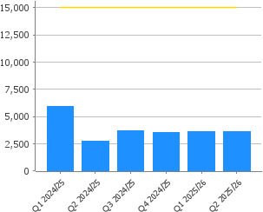 | Figure of 3,626 added 09.10.2025 to reflect Number of Go Cards ISSUED - report from Sisense. This is an increase of 51 from Q1 this year, using same report methodology to produce figure (hence comparable to previous quarter).
 | Figure of 3,575 added 24.07.2025 to reflect Number of Go Cards ISSUED - report from Sisense. This is a reduction from Q1 last year due to previously noted inaccuracies that included some dormant GoCards in the total number of GoCards. This has now been resolved with the figure of 3,575 being accurate.

COM 01.07e Percentage of adult support and protection referrals received by the health and social care partnership that are screened within 24 hours
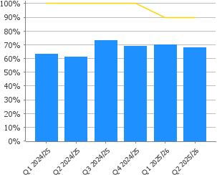 | In addition to the improvement work set out in last quarters notes we are also strengthening individual team accountability by revising the agenda for our ASP Team Managers Meeting. Each team manager will be required to attend, present their performance across all indicators and outline their work plan to achieve high performance. It is anticipated that this improved individual reporting will allow their managers (HSCP Leads) to consider more fully systemic factors such as duty processes and resource allocation and review as necessary.  We are performing 20% below our target when combining the performance of all teams. We are drilling down to understand more what the specific challenges are for teams individually. One of our locality teams meets the 90% target, one is just below it and our largest locality team with 25+ referrals per council officer per quarter has poor performance. A basic analysis of high workload resulting in poor performance is relevant but not the only factor. Those under pressure and with moderate workload still meet the target or are close to it. Our specialist teams under perform despite low workload indicating that systemic, skill related or complexity challenges are a factor. We have improved the tools our team managers have to monitor performance. They now have access to a TEAMS channel with live Power BI data that they can monitor and respond to. We expect this will assist them to have good oversight and present data to their teams to motivate higher performance. This will take time to bed in and team managers gaining the skill and confidence to use the digital tools.  Another factor is that a number of lower level incidents are being reported through our Adult Support and Protection (ASP) pathway, most commonly from care homes, we are working closely with the sector and our Care Home Assurance and Review Team (CHART) to strengthen our incident reporting pathway to prevent over reporting through the ASP pathway, pressure on teams and poor performance as lower level referrals will not be provided the same priority and targets whilst teams focus on priority tasks. We expect that if our mitigating work will become effective and be observed in improved performance in Q4 and Q1 of 26.27 - this work takes time as there are several stakeholders to work with to bring about the systemic improvement.

CP22 01.07f Percentage of multiagency inquiries (adult support and protection referrals) completed within 5 working days
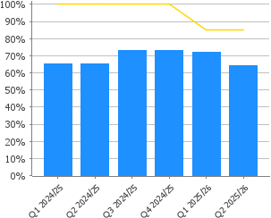 | Our second largest locality team is performing above our target in this quarter, collectively we are nearing our target. As detailed fully in COM 01.07e note (screening within 24 hrs) we are attempting to unpick further specific challenges individual teams have, increase their accountability and reporting of these and thereafter increase senior manager understanding and overview to allow consideration of mitigation towards systemic factors including resource allocation, team duty processes etc.

CP22 01.07g Percentage of reports of harm investigated (including visits, interviews, medical examinations, and the examination of records) within 10 working days
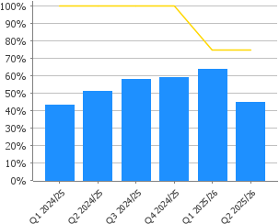 | The partnership undertook a Large Scale Investigation in one of our registered care services during this quarter - this activity was complex and we required more time to carry out the investigatory activity. Timescales were not met but for good reason. Aside from this our largest locality with the greatest workload only managed to meet this target 50% of the time. These two factors combined resulted in poor performance. Priority work is required with our largest locality to support better performance.

GGV 7 Average length of time taken to relet properties in the last year (days)
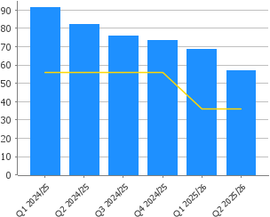 | Void performance is continually monitored to reduce relet times and ensure those in most housing need can access secure accommodation as quickly and efficiently as possible. We are continuing to review and improve performance thorough our void working group which meets regularly to ensure the action plan of change is delivered. Performance for Q2 is 56.9 days, improving from 68.4 days. Performance along with levels of customer satisfaction will continue to be monitored.

Promoting opportunities and educational attainment and reducing inequalities

Educational excellence, reduce poverty and inequality and improve wellbeing

Reference | Performance Indicator | 2024/25 | Q1 2025/26 | Q2 2025/26 | Mid-Year 2025/26 |  |  | Annual Target 2025/26
Reference | Performance Indicator | Value | Value | Value | Value | Target | Status | Annual Target 2025/26
CP22 02.05c | Care Inspectorate Inspection Report Score of good or better | 100% | N/A* | 100% | 100% | 100% |  | 100%
ES 02.05a | HMIe Inspection Report Score of good or better | 100% | 100% | N/A* | 100% | 100% |  | 100%
EQ 02.11a | All decision-making reports to the Council and Executive are supported by an Equality & Poverty Impact Assessment (EPIA) | 100% | 100% | 100% | 100% | 100% |  | 100%
LIB 02.01 | Number of individuals accessing IT support in libraries (support) | 224 | 384 | 882 | 1,266 | 750 |  | 1,500
LIB 02.02 | Number of individuals accessing IT support in libraries (connectivity) | 88,032 | 25,175 | 21,341 | 46,516 | 37,500 |  | 75,000
LIB 02.03 | Number of attendees at programmed events and activities offered by libraries | 28,101 | 7,473 | 7,212 | 14,685 | 12,500 |  | 25,000
POV 02.02g | Number of households provided with internet connectivity through our digital inclusion projects |  | 17 | 24 | 41 | 30 |  | 60
CP22 02.04a | Increase the number of new foster care placements | 6 | 1 | 1 | 2 | 3 |  | 6

*No inspections held in this quarter
CP22 02.04a Increase the number of new foster care placements
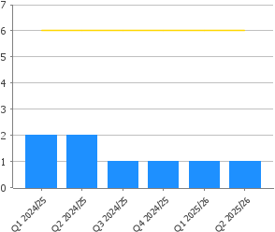 | There has been 1 new fostering family in the last quarter and they are approved as short break carers. This is below the target of 2 families we had predicted.  Recruitment of new foster carers is a national as well as local challenge and we are continuing in efforts to identify new carers and we have an active recruitment campaign including advertising online.

Supporting a thriving economy and green transition

An economy that is competitive, entrepreneurial, inclusive and sustainable and an environment that we value, enjoy, protect and enhance

Reference | Performance Indicator | 2024/25 | Q1 2025/26 | Q2  2025/26 | Mid-Year 2025/26 |  |  | Annual Target  2025/26
Reference | Performance Indicator | Value | Value | Value | Value | Target | Status | Annual Target  2025/26
ETU NOMIS04 | Employment Rate | 72.30% | 74.40% | 74.40% | 74.40% | Data only |  | -
ENV 03.06a | Percentage of our vehicle fleet that are zero emission vehicles | 35% | 40% | 42% | 42% | 33% |  | 33%
ASM 03.05 | Percentage of business properties leased by the council that are occupied | 91.9% | 91% | 91% | 91% | 96% |  | 96%

Exceptions
ASM 03.05 Percentage of business properties leased by the council that are occupied
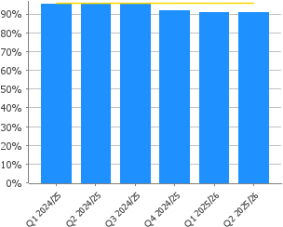 | The downturn in the national and local economy including the impact of decisions made by large local companies to close operations has a direct impact on the local commercial property market. The current downturn in the occupancy of the Council’s commercial portfolio reflects these difficult market conditions.

Financial sustainability

Reference | Performance Indicator | 2024/25 | Q1 2025/26 | Q2 2025/26 | Mid-Year 2025/26 |  |  | Annual Target 2025/26
Reference | Performance Indicator | Value | Value | Value | Value | Target | Status | Annual Target 2025/26
FIN 04.02e | Healthy and efficient use of reserves – maintain reserves within the range of the general fund reserves policy | 2.4% | 2.3% | 2.3% | 2.3% | 2% |  | 2%
FIN 04.02f | Percentage of savings delivered in year | 97.4% | 100% | 100% | 100% | 95% |  | 95%
FIN 04.02c | Bridging the budget gap – at least 90% of savings identified over the five year period of the financial strategy | 48.2% | 36.0% | 36.0% | 36.0% | 90.0% |  | 90.0%
FIN 04.02d | Reducing reliance on non-recurring reserves to balance the budget gap over the period of the financial strategy | 3.99% | 4.68% | 5.37% | 5.03% | 0.5% |  | 0.5%

Exceptions

FIN 04.02c Bridging the budget gap – at least 90% of savings identified over the five year period of the financial strategy
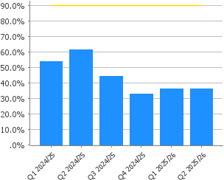 | According to the Financial Strategy presented to Council in October 2025, the budget gap over the five-year period from 2026/27 to 2030/31 is currently estimated at £43.9m, with savings totalling £16m identified to date.

FIN 04.02d Reducing reliance on non-recurring reserves to balance the budget gap over the five year period of the financial strategy
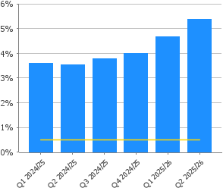 | The Council’s General Fund Budget for 2025/26 is balanced by £11.5m of service concessions. However, the use of non-recurring funding to balance the budget is unsustainable in the long term. Q2 projections indicate that this full £11.5m will be needed.  The recent Financial Strategy noted that the funding gap for the next 5 years is c£44m which requires to be addressed by a combination of recurring savings and income.

COTF – Transformation and Improvements

Reference | Performance Indicator | 2024/25 | Q1 2025/26 | Q2 2025/26 | Mid-Year 2025/26 |  |  | Annual Target 2025/26
Reference | Performance Indicator | Value | Value | Value | Value | Target | Status | Annual Target 2025/26
CTF 05.01a | Percentage of Council of the Future projects that have clear benefits which can be measured | 100% | 100% | 100% | 100% | 100% |  | 100%
CTF 05.01b | Percentage of Council of the Future projects monitored and reported | 100% | 100% | 100% | 100% | 100% |  | 100%
CTF 05.01c | Percentage of Council of the Future projects delivered on time and on budget | 48.25% | 36% | 44% | 40% | 80% |  | 80%

Exceptions
CTF 05.01c Percentage of Council of the Future projects delivered on time and on budget
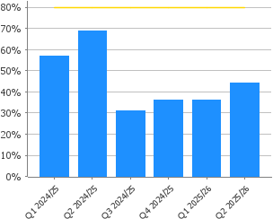 | At the mid-year, there were 9 projects in the COTF programme with the overall performance level is at 44% (4 projects) with milestones on track and financial status above 80%. However, 67% of projects are on track and delivering according to milestone plans. The overall performance levels are impacted by the potential risks in savings delivery, which the Council of the Future (COTF) Board actively monitors and are managing mitigations. From the current 9 projects in the COTF programme:  • 4 projects, Sport & Leisure, SPR (Strategic Property Review), Learning & Employability, and PPP (Public Private Partnership) Contracts are performing as 'green - on track' against both milestone and financial status.  • 1 project, the Facilities Review, is 'green - on track' against milestones but 'amber – 50-80%' for financial status, with financial risks currently being mitigated.  • 1 project, Environment and Operations, is 'amber – attention needed' against milestones and 'amber – 50-80%' for financial status, with ongoing efforts to finalise project resources and mitigate financial risks.  • 2 projects financials have to be confirmed, with the milestones for one, ASN (additional Support Needs) Service Review, on track and the Council Wide Transport Review with attention needed.  • The Ward-based Budgeting project is transitioning to an Improvement Project.  All projects are reported to the COTF Board for scrutiny.

Valued sustainable workforce

Reference | Performance Indicator | 2024/25 | Q1 2025/26 | Q2 2025/26 | Mid-Year 2025/26 |  |  | Annual Target 2025/26
Reference | Performance Indicator | Value | Value | Value | Value | Target | Status | Annual Target 2025/26
CP22 06.01c | Staff turnover rate | 9.60% | 2.07% | 2.99% | 5.06% | 10.00% |  | 10.00%
CP22 06.01b | Sickness absence percentage for teaching staff | 3.96% | 3.66% | 2.76% | 2.76% | 4% |  | 4%
CP22 06.01a | Sickness absence percentage EXCLUDING teachers | 7.78% | 7.26% | 6.98% | 6.98% | 4% |  | 4%

Exceptions - Quarterly Performance Indicators

CP22 06.01a Sickness absence percentage EXCLUDING teachers
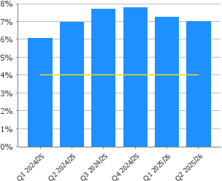 | Absence has decreased in Q2 compared to Q1 and remains above target. A report was submitted to Corporate Management Team in October 2024 and February 2025 to consider a range of actions being taken to address absence levels across Services. A Human Resources Officer is focussing on the top 5 cases in each service. Face to face training has been introduced for managers on absence management. The Absence Management Policy has been reviewed and agreed. This is now available online.

