COMMUNITY EMPOWERMENT (SCOTLAND) ACT 2015

FALKIRK COUNCIL ASSET TRANSFER REQUEST FORM
IMPORTANT NOTES:
This is an application form which can be used to make an Asset Transfer request to Falkirk Council.
Any Community Body interested in making an Asset Transfer Request is advised to contact the Asset Team on strategicpropertyreview@falkirk.gov.uk before making the request so that we can discuss your proposal.
Please complete the asset transfer request form if the property/land is owned/leased/managed by Falkirk Council.
It is essential that you read the Asset Transfer guidance provided by the Scottish Government before making a request.
When completed, this form should be emailed to strategicpropertyreview@falkirk.gov.uk or sent to
The Asset Team
Falkirk Council
4 Stadium Way
Falkirk
FK2 9EE

Section 1: Information about the Community Transfer Body (CTB) making the request
  - Name of the CTB making the asset transfer request
Stenhousemuir Gymnastics Club
  - CTB address. This should be the registered address, if you have one.
Postal address: Carron Gymnastics Centre 2 Carronlea Drive, Falkirk
Postcode: FK2 8DN.

  - Contact details. Please provide the name and contact address to which correspondence in relation to this asset transfer request should be sent.
Contact name: [REDACTED]
Postal address: [REDACTED]
Grangemouth
Postcode: [REDACTED]
Email: [REDACTED]
Telephone: [REDACTED]
X We agree that correspondence in relation to this asset transfer request may be sent by email to the email address given above. (Please tick to indicate agreement)
You can ask Falkirk Council to stop sending correspondence by email, or change the email address, by telling them at any time, as long as 5 working days’ notice is given.

  - Please mark an “X” in the relevant box to confirm the type of CTB and its official number, if it has one.
 | Company and its company number is ………….
 | Scottish Charitable Incorporated Organisation (SCIO) and its charity number is ……………….. | SC054406
 | Community Benefit Society (BenCom) and its registered number is ………………………………
 | Unincorporated organisation (no number)

Please attach a copy of the CTB’s constitution, articles of association or registered rules.
Please note that under The Community Empowerment (Scotland) Act 2015, where a CTB is seeking ownership rather than a lease, the organisation must have at least 20 members. See the Scottish Government’s Guidance for Community Transfer Bodies.
  - Has the organisation been individually designated as a community transfer body by the Scottish Ministers?
No ☐x
Yes ☐
Please give the title and date of the designation order:

  - Does the organisation fall within a class of bodies which has been designated as community transfer bodies by the Scottish Ministers?
No ☐
Yes ☐x
If yes what class of bodies does it fall within?
Section 80(1)(b) it is a Scottish charitable incorporated organisation the constitution of which includes provision that the organisation must have not fewer than 20 members.

- Information about the land and rights requested
  - Please identify the property/land to which this asset transfer request relates.
You should provide a street address or grid reference and any name by which the land or building is known. If you have identified the land on the relevant authority’s register of land, please enter the details listed there.
It may be helpful to provide one or more maps or drawings to show the boundaries of the land requested. If you are requesting part of a piece of land, you must attach a map and give a full description of the boundaries of the area to which your request relates. If you are requesting part of a building, please make clear what area you require. A drawing may be helpful.
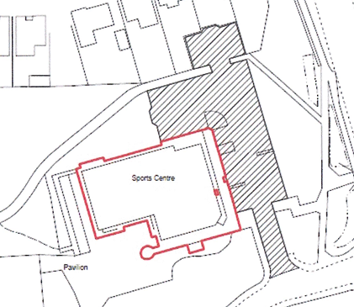
Details of Property:

Carron Gymnastics Centre, Carronlea Dr, Carron, Falkirk FK2 8DN.
UPRN: 136023577

Address: 2 Carronlea Drive, Falkirk
Postcode: FK2 8DN.

  - Please provide the UPRN (Unique Property Reference Number), if known.

UPRN: 136023577

- Type of request, payment and conditions
  - Please tick what type of request is being made:
X
for ownership (under section 79(2)(a)) - go to section 3A

for lease (under section 79(2)(b)(i)) – go to section 3B

for other rights (section 79(2)(b)(ii)) - go to section 3C

3A – Request for Ownership
What price are you prepared to pay for the land requested?
Proposed price: £1
Please attach a note setting out any other terms and conditions you wish to apply to the request.
Car Park access

3B – Request for Lease

What is the length of lease you are requesting?

How much rent are you prepared to pay? Please make clear whether this is per year or per month.

Proposed rent: £ per

Please attach a note setting out any other terms and conditions you wish to be included in the lease, or to apply to the request in any other way.

3C – Request for other Rights
What are the rights you are requesting?
Car park access / use

Do you propose to make any payment for these rights?
Yes ☐
No x
If yes, how much are you prepared to pay? Please make clear what period this would cover, for example per week, per month, per day?
Proposed payment: £ per

Please set out any other terms and conditions you wish to apply to the request.

- Community Proposal
  - Please set out the reasons for making the request and how the land or building will be used.
This should explain the objectives of your project, why there is a need for it, any development or changes you plan to make to the land or building, and any activities that will take place there.
4.1.1 Objectives of Project

We currently run our gymnastics programme from the Carron Gymnastics Centre, where we train gymnasts to a high level. We offer the opportunity for our gymnasts to gain coaching experience and qualifications
We work with the community, for the community. We will continue to develop partnerships with local organisations, service providers and community groups.
Our vision is to provide a community led space that helps deliver long-term, social, economic, sustainable and environmental benefits to the local community.

Our values are based on:
- Working in an inclusive and respectful manner, not discriminating against anyone
- Being a not-for-profit organisation and investing any surplus in the advancement of our facilities for our local community
- Being community led
- Intergenerational approach to serving all age ranges in the community
- Innovative and proactive approach to local people’s needs

Our key objectives are:
- To offer the people of Falkirk and District, a quality gymnastics service and to build a successful community gymnastics hub giving it a financially secure future.
- To improve health and wellbeing of our community
- Provide increased social benefits
- Empower our community, families, and gymnasts
- Provide opportunity to gain coaching qualifications and experience
- Provide a space for children to help alleviate child poverty in the area

4.1.2 Why there is a need for your Project?

The centre is purpose built for gymnasts. Set up as a gymnastics centre in 2019. Currently providing good quality facilities at all levels, from birth to adults and also people with ASN needs. The centre has potential to provide even more classes and disciplines to a wider audience as well as support other organisation to provide a safe space for play etc.
Our mission is to empower individuals of all ages and abilities through gymnastics by providing affordable, high-quality coaching in a safe, fun, and inclusive environment. We strive to foster personal development, promote physical health, and strengthen community engagement. As we look to the future, we aim to take community ownership of our facilities, expand our outreach, and enhance our program offerings to ensure long-term sustainability and growth.

4.1.3 Will any Development/changes/modifications to the asset be required?

We plan on upgrading the facility as when needed so we can provide everyone access to our facilities.

4.1.4 What activities will take place?

Gymnastics and associated activities within the large gym space.

Our plan would be to introduce a Gym/ Fitness Studio. This would be in our small hall which could be converted to a gym which would again benefit our gymnasts training. The gym could also be utilised by community for a membership fee.

4.1.5. If the asset is to be used by the public, please provide details of lettings policy and opening times.

We will aim to provide a space for fitness and associated activities. We will develop policies and procedures as and when needed.

The centre is available to book 7 days a week, from 9am until 10pm, with various classes taking place throughout the week and weekend.

4.1.6 What provision will be provided for people with disabilities?

We look to seek funding to make the facility fully accessible as we want to provide gymnastics and associated activities for all abilities. Funding will help us to build out our offering for people with additional support needs of all types.

4.1.7 Any other relevant information?

Benefits of the proposal
  - Please set out the benefits that you consider will arise if the request is agreed to.
Local Authorities are permitted to dispose of property at less than market value where there are wider public benefits to be gained. This is set out in the Disposal of Land by Local Authorities (Scotland) Regulations 2010. These public benefits are listed below.
In this section, please explain how the project will benefit your community, and others. Please refer to the Scottish Government guidance on how the Council will consider the benefits of a request.
Please explain how the project will benefit your community by detailing how your project will promote or improve: -

4.2.1. Economic development/income generation

ie. Please include details of any job creation or volunteering and training opportunities that will be available as a result of the Asset Transfer. Also details of how your organisation will involve the local community and of any incentives that may be available to encourage the local community to use the proposed services.

Our Gymnastics Club provides essential services that might otherwise be inaccessible due to the financial constraints of our local community. We are a volunteer-run club, and the opportunities we provide to volunteers help residents develop new skills and gain valuable work experience. Volunteering can serve as a stepping stone to future employment, enhancing the employability of individuals and contributing to the overall skill level of the community. Offering educational and training programmes can help bridge the gap for those who are not in full-time education or employment.
We also give young people the chance to work towards their coaching certificates, providing them with a structured pathway to develop their skills and gain formal qualifications. This not only enhances their personal development but also contributes to the sustainability of our club by nurturing future coaches and leaders within the community.
Our Gymnastics Club fosters social cohesion and well-being, which are essential for a thriving economy.

    - Regeneration

i.e. Please include details of whether your organisation will contribute to the physical regeneration of the area, and how your proposal will impact the regeneration of the area, in terms of volunteering or employment, giving examples.

By taking community ownership of the Gymnastics Centre, we will look to regularly maintain the interior and exterior of the facility. We will paint the exterior to improve the aesthetic of the centre. This initiative will ensure that the building does not become derelict and neglected, which can be an eyesore and a safety concern in the middle of a residential area. By keeping the Gymnastics Centre well-maintained, we will contribute to the overall appearance and safety of the neighbourhood, fostering a sense of pride and community among residents.

    - Public Health

i.e. How likely is the proposal to improve the Public Health of the Community, in terms of physical and mental health, for example through volunteering, training, or taking part in activities, giving examples.

By improving the overall health of our community, our Gymnastics Club aims to help ease the pressure on public and social services, and on other facilities. The physical activities we provide for children of different age groups help maintain physical health and mobility for all those who attend them. Together, these benefits contribute to a healthier, happier, and more connected community. When individuals have access to programmes that support their physical and mental health, they are less likely to require intervention from public services. This proactive approach to community health not only benefits individuals, but also reduces the burden on public resources, allowing them to be allocated more effectively to areas where they are needed the most.
Regular physical activity can reduce stress, improve mood, and provide a sense of purpose, which can decrease the reliance on health services.

Previous research undertaken by British Gymnastics shows that many children drop out of the sport by age eight or nine with only 15% of total participants remaining active by the age of 16.
We are currently looking at how we can encourage gymnasts to either continue with the sport or look at other pathways such as volunteering.
We aim to work with and encourage our older gymnasts to volunteer and help support the younger gymnasts, gain qualification and experience while still training, or towards the end of their training. All our volunteers are encouraged to register their volunteer hours with Saltire awards.

    - Social Wellbeing

i.e. How will the proposal improve the Community's Social Well-Being and mental health, or how might it improve the learning offer and activities available in the area? Please give brief examples of these activities.

The activities and social interactions facilitated by our Gymnastics Club will contribute significantly to both the mental and social wellbeing of our community. We provide a safe space for the local community to meet and engage with each other through our training sessions, activities, and events. Offering volunteer opportunities within the Gymnastics Club can enhance social cohesion and provide residents with a sense of purpose. Volunteering can help individuals develop new skills, gain confidence, and feel more connected to their community.
By facilitating intergenerational activities, the club can bridge the gap between different age groups. Intergenerational activities can foster mutual understanding and respect and provide opportunities for learning and mentorship.
We will provide holiday provision, which will include free places to families who are highlighted by our schools and partners. We will also offer childcare for working parents during school holidays.

    - Environmental Wellbeing / Environmental Benefits

i.e. Will the proposal bring green / environmental benefits and / or have an impact on the local environment? Will it help mitigate the effects of climate change? If so please give details.

We plan to continue to work in an environmentally conscious way to reduce our carbon footprint on the environment and local community. We will look to implement energy-efficient technologies and sustainable practices so the Gymnastics Centre can reduce its environmental impact. We can engage the community in environmental initiatives, such as clean-up drives in the local area, tree planting events, and active recycling programmes. These activities can foster a sense of community pride and responsibility, encouraging residents to take an active role in protecting their local environment.

    - Does your project contribute to the reduction of inequalities?

i.e. Will the proposal enable the community to access activities not otherwise available; will these activities be available at an affordable rate; how will your organisation work with other local providers to reduce inequalities?

Our mission is to empower individuals of all ages and abilities through gymnastics by providing affordable, high-quality coaching in a safe, fun, and inclusive environment.

By providing a local facility, the people in the area will benefit from services they would otherwise have to travel to. This will make it far more accessible to the local community. We are on a bus route that people under 22 will be able to access free of charge and we have car parking facilities.

We will provide holiday provision, which will include free places to families who are highlighted by our schools and partners. We will also offer childcare for working parents during school holidays.

4.2.7 Will local people be engaged in the use and management of the Asset?

A “community of interest” may not represent the people living near to the asset. Please provide evidence of how local people and communities will be engaged in the use and management of the asset, and how they have been consulted.

Dec 24: We held a fundraising event at the centre, and we consulted with the parents/ carers of the gymnasts.
We signed up 20 plus parents who wanted to support the committee on taking over the Centre. All parents consulted were keen to stay at the club, due to the facilities and coaches.
The gymnasts and other children attending the open gym were also surveys and asked:
- How many hours they trained?
- How long they had been attending gymnastics?
- What they liked about gymnastics?
This consultation was to look at how we could improve the club and the facilities. The feedback was positive, and the gymnasts (and potential gymnasts) highlighted they liked coming to the gym as they had made friends here, the coaches and volunteers were friendly and helpful and there was a good sense of community. The facilities' such as the pits, sprung floor etc were great for trying new moves especially for the older gymnasts, the younger ones loved the pit and being able to learn new things.
The gymnasts are keen to try new disciplines, so we will use the feedback to look at new classes.
We will continue to hold open gyms (4 times per year) to seek feedback from users of the asset and ask the local community to help with the future direction of the project.

4.2.8 How will you monitor whether the Asset Transfer is benefiting the community?

Will you survey the users / invite feedback / compare user numbers with a baseline etc

We will keep records of the number of people who attend our facility, our membership levels, the number of people engaging with us on social media and website users.
We will monitor our social impact by collecting information on the demographics of our gymnasts, coaches, and volunteers, gathering feedback in terms of health and social benefits of users. We will keep records of feedback to measure the impact our services have on the local community.

We will measure the usage of the hall, using the current attendee numbers as supplied by Falkirk Council, as our baseline estimate.

4.2.9 Any other relevant information?

Restrictions on use of the land
  - If there are any restrictions on the use or development of the land, please explain how your project will comply with these.
Restrictions might include, amongst others, environmental designations such as a Site of Special Scientific Interest (SSI), heritage designations such as listed building status, controls on contaminated land or planning restrictions.
We are not aware of any restrictions on the use of the land.

Negative consequences
  - What negative consequences (if any) may occur if your request is agreed to? How you propose to minimise / reduce these?
You should consider any potential negative consequences for the local economy, environment, or any group of people, and explain how you could reduce these.
We don't foresee any negatives, the only negatives are if the building is closed and classes must be moved from the building which is purpose built for gymnastics to 2 separate places where the equipment isn't as good.

We have considered potential negative consequences of the group taking over the building through Community Asset Transfer as:
- Costly repair work is required for the building we will need to fund
- Utility costs are high for the building, and we understand the risk of these increasing
- There is a risk of us not being able to attract enough business to ensure the hall is able to continue
- We understand there is a lot of volunteering work required for our proposal to work and are reliant on there being a continued involvement from the community to help with this
- Increase in the level of traffic due to increased usage of the hall
- Increase in the level of noise pollution due to the increase in usage of the hall

Capacity to deliver
  - Please show how your organisation will be able to manage the project and achieve your objectives.
This could include the skills and experience of members of the organisation, any track record of previous projects, whether you intend to use professional advisers, etc.
4.5.1 Has your organisation or any of its members managed projects or owned / leased property/land prior to this?
Yes x
No ☐

Please provide details of:
4.5.2 Skills and experience of the members of the organisation

The board have a varied skill mix with a wide range of skills and experiences, that includes students, full-time professionals, and retired individuals.
Our backgrounds span different industries, ensuring a well-rounded perspective in decision-making. Comfortable in public settings, the board actively takes part in meetings and engages with the community. We communicate effectively, whether addressing large audiences, or having those one-on-one conversations. The board supports causes that help the local area and our residents. Our trustees bring project experience, enabling us to oversee initiatives efficiently. Our ability to plan, execute, and evaluate projects ensures successful outcomes. Our experience in negotiation, collaboration, and strategic planning enhances the hall’s operations. Our charity trustees handle costings and budgets adeptly. Our financial acumen ensures responsible resource allocation, where several trustees have successfully run their own profitable businesses. Our entrepreneurial insights contribute to sustainable practices and financial stability. The board keeps valuable connections with skilled professionals such as joiners, builders, plumber, heating engineer, and electricians – these contacts prove invaluable for maintenance and improvement projects.

[REDACTED]
Currently works for [REDACTED] as a Participation and Engagement Manager and has relevant experience in working with communities, including Community groups, charities and social enterprises.
Skills include:
Community engagement
Identifying relevant Funding/ funding applications
Partnership work
Former gymnast and coach
Families Support: Worked with families experience a range of issues including poverty, homelessness, mental Health issues, unemployment etc.
Youth support: Worked with Young people within school setting and youth Club. Currently mentors' young people through MCR Pathway

[REDACTED] Secretary: Skills include:
- Trained coach
- Social media
- Organisational skills: managing the overseeing of all the classes, competitions and events.

[REDACTED] Treasurer:
- Organised
- Finances: currently moving our payment system onto a new more efficient system

Funding Team: Have relevant experience in
- organising large events
- Planning fundraising events and activities
- Social media skills

The team has been working on several activities including

- Open Gym: Event which raised £1500 over the Xmas period will now be run 4 x a year as feedback from the attendees was that it was very enjoyable and was great to see their children in the gym.
- Raffles
- Parents night/ display evening
- Competitions: including inhouse and invite only competitions

4.5.3 Do you intend to use professional advisors? Please provide details.
We are currently working with:
- CVS Falkirk and District
- Scottish Gymnastics
- Community Ownership Support Service (COSS)
We plan to engage with relevant professionals when the need arises – this includes solicitors, accountants, surveyors, etc.

4.5.4 Do you currently lease/manage a property from Falkirk Council? If yes, please provide details.
The Club currently has an FRI Licence of Carron Gymnastics Club from Falkirk Council.

4.5.4 Please detail how you plan to manage the building?
The building will be managed by volunteers and coaches. The Board of Trustees will oversee the management of the building.
4.5.5 Please provide any other information you think may be relevant.

- Level and nature of support
  - Please provide details of the level and nature of support for the request, from your community and, if relevant, from others.
This could include information on the proportion of your community who are involved with the request, how you have engaged with your community beyond the members of your organisation and what their response has been. You should also show how you have engaged with any other communities that may be affected by your proposals.
5.1.1. What community engagement has taken place to help develop your business plan? Please provide evidence, for example any completed surveys, questionnaires, letters of support, minutes of public meetings etc.
On December 2024:
We held a fundraising event at the centre, and we consulted with the parents/ carers of the gymnasts.
We signed up 20 plus parents who wanted to support the committee on taking over the Centre. All parents consulted were keen to stay at the club., due to the facilities and coaches (details contained in our business plan.)
Quotes from parents/ carers:
“We come from [REDACTED] to this centre as it has the best equipment, and my son has made good friends. Coaches are good and the improvements in him is brilliant. Great to see him in action today as we normally only see him at competition”
“Think it's a disgrace to open up a gymnastics centre and then decide to shut it!”
“Would be great to keep the centre open, it's so handy as it has good parking and easy access”.

The gymnasts and other children attending the open gym were also surveys and asked:
How many hours they trained?
How long they had been attending gymnastics?
What they liked about gymnastics?
This consultation was to look at how we could improve the club and the facilities. The feedback was positive, and the gymnasts (and potential gymnasts) highlighted they liked coming to the gym as they had made friends here, the coaches and volunteers were friendly and helpful and there was a good sense of community. The facilities' such as the pits, sprung floor etc were great for trying new moves especially for the older gymnasts, the younger ones loved the pit and being able to learn new things.
The gymnasts are keen to try new disciplines, so we will use the feedback to look at new classes.

Table of users comments with names has been [REDACTED]

Focus Group: our young gymnasts were keen to put together a Youth Committee to feed into the Committee meetings.
8 girls aged 11-14, Came together as they wanted to be involved with the planning and organising of events, fundraising, etc, as they felt a connection to the centre, and the people who attend.
- The girls currently volunteer within the club helping to support the coaches with the younger gymnasts
- They want to help plan the fundraising events
- They want to volunteer at the fundraising events
- And they want to be involved with any decisions that are being made within the club.

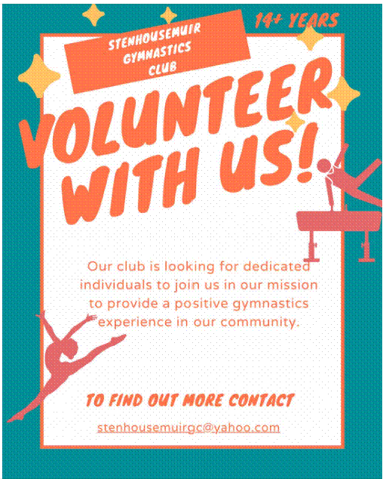

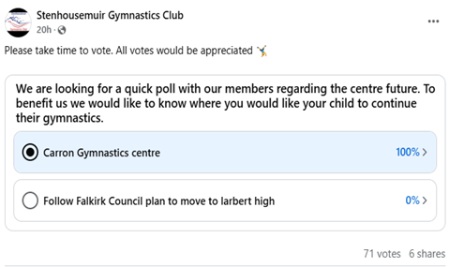

Numerous surveys have been shared via our social media:
SGC fb page: Survey to see what area our gymnasts live 87% within FC area, 3% outwith, 44 votes.
A survey to see if our gymnasts would like to move to Larbert High/ Mariner Centre or stay at Carron Gymnastics Centre: 100% voted to stay, 77 votes.
A survey shared via social media to ask local community how they would like to use our small hall. The survey collected over 80 responses with positive input and ideas including:
Community use for: Groups such as mother and toddler, book group, kids' parties or small gatherings.
Health and well-being: gym, yoga, fitness classes, Pilates etc.
A survey was put out via social media to ask local community how they would like to use our small hall. The survey collected over 80 responses with very positive input and ideas including:
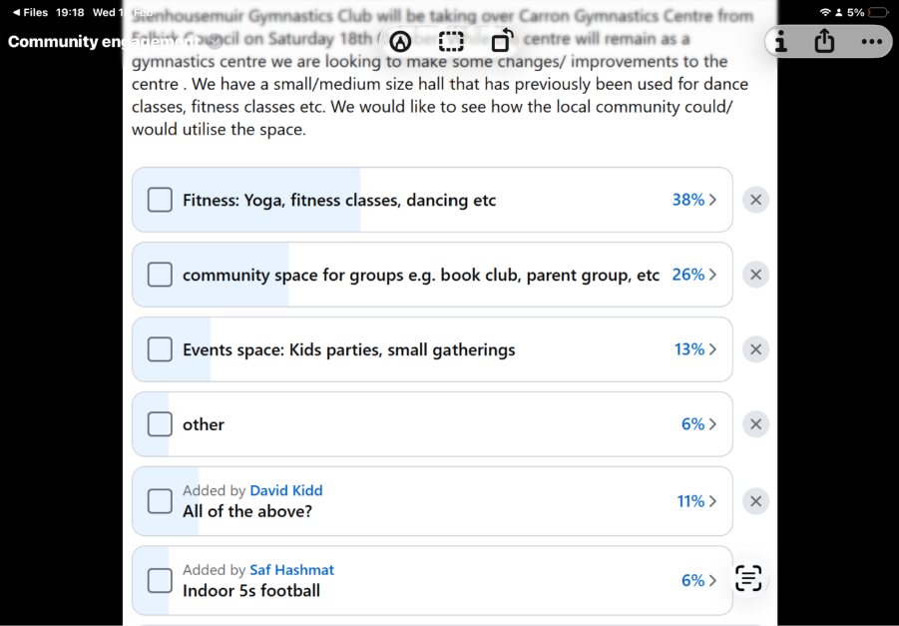

5.1.2 Have you consulted with other local stakeholder groups or agencies? Please provide evidence.
We have spoken to the other users of the gymnastics centre, and we have been in contact with other clubs in other council areas, who we regularly engage with in competition settings.
We have also contacted schools and other services promoting our classes and facilities.
5.1.4 Have you been in contact with any other communities or community groups
that may be affected? Please give details.
We have been in contact with the Tryst Gymnastics Club who used the centre but they have chosen to move to Larbert High along with FC.
We have also started to attend the Community Ownership Group meetings that are hosted by CVS Falkirk & District, where we are able to gain that much needed Peer support within our community.

5.1.5 Please provide any other information you think may be relevant.

- Financial Viability of Project
Your Business Plan should contain full information about the financial viability of the project, evidencing that the organisation will be able to sustain the project in the long term.
Please submit
- at least 1 year’s audited accounts to evidence your organisations financial stability (if available)
- where audited accounts are not available (for instance for new groups) please provide a bank statement.
- a projected 5 year income and expenditure account
- a cash flow forecast for the proposed asset transfer.
6.1 Please outline the Policies and Procedures your organisation has in place to govern the group’s finances
We recognise our organisation’s requirements as a registered SCIO. We will continue to submit audited accounts yearly to OSCR. Our finances are presented and scrutinised at every board meeting. We will follow OSCR’s Guidance and Good Practice for Charity Trustees (oscr.org.uk) to ensure we manage our finances correctly.
As a gymnastics club, we have in place the various policies required to ensure the safety of our users, coaches, and volunteers.

Since taking on the building under an FRI Licence, we have introduced all the necessary policies that are required, including health and safety policies, fire safety, safeguarding, GDPR, etc.

- Funding
  - Please outline how you propose to fund the price or rent you are prepared to pay for the land, and your proposed use of the land.
If you intend to apply for grants or loans you should demonstrate that your proposals are eligible for the relevant scheme, according to the guidance available for applicants.
7.1.1 Please show your calculations of the costs associated with the transfer of the land or buildings and your future use of it, including any redevelopment, ongoing, maintenance and the costs of your activities. All proposed income and investment should be identified, including volunteering and donations.
Solicitors fees: £ [REDACTED]
Insurance : Markel Direct- £ [REDACTED]
We have attached a 5-year cash flow within the financial appendices which shows all projected income and expenditure.
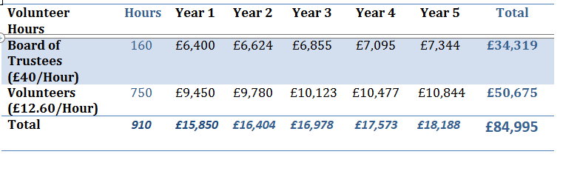
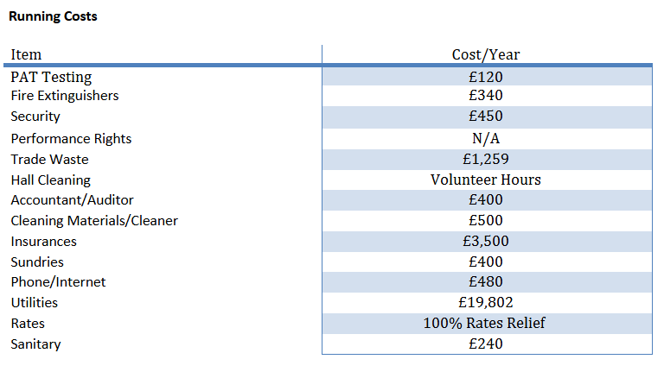

7.1.2 Please supply details of what funding you have received so far, and of any conditions attached to it.
No funding received so far, due to the short turnaround time of submitting the full CAT application.

7.1.3 Please supply details of any funding you have applied for but have not yet received a response or decision. Please include timescales if known.
Aldi Sports Fund: £1500- Volunteer/ coach training- unsuccessful but have reapplied.
Sport Scotland: currently working with them to look at funding, looking to remodel the gym to make it more accessible.
From our previous years of running our group, we have successfully managed to build our reserves to a level we feel comfortable with to take on the building through community ownership.
As a registered SCIO we will have access to overdraft and borrowing facilities with our bank.
7.1.5 Please outline your funding strategy if you have one, as well as any other relevant information.
We recognise that there is a need to continually update and upgrade our facilities, and we keep up to date with the various funding opportunities available to us, thanks to our local third sector interface, CVS Falkirk & District.
We have a good track record of receiving funding and this experience will be valuable to us moving forward.
The fundraising team along with the committee are experienced in funding and completing funding application. The committee have already identified relevant funding opportunities and started to apply for funding.
- Funding to make the centre fully accessible
- Funding to make the building more energy efficient
- Funding for Training and upskilling for volunteers and coaches
- Funding for new equipment


- Enablement Fund
Falkirk Council will hand the building over wind and watertight and compliant. However, this is quite light-touch and would involve (for example) patching of a leaky roof. For more significant building works, groups can apply to the Enablement Fund, to pay for capital improvements such as energy efficiency improvements or larger capital renewals which support the viability of the project going forward. Only capital items are eligible. Running repairs are revenue costs and are not eligible. You are strongly advised to email strategicpropertyreview@falkirk.gov.uk to confirm eligibility criteria before you submit this application.
Requests to the Fund must be supported by estimates / quotations from professionals which should be provided as supporting documents.
Please provide details of your request to the Enablement Fund, if applicable.
Enablement Fund request for larger capital renewals which support the viability of the CAT
Item | Estimate Provided By | Amount not more than (including VAT)
Building Work | [REDACTED] | £107,880
Roof Replacement | [REDACTED] | £51,000
Lighting Controls | [REDACTED] | £2,400
Solar PV with Battery Storage | [REDACTED] | £43,632
Destratification Fans | [REDACTED] | £14,400
Heating and Cooling Controls | [REDACTED] | £9,600
Total including VAT |  | £228,912

Checklist of accompanying documents
To check that nothing is missed, please tick which additional documents are accompanying this form.
☒Section 1 – You must attach your organisation’s constitution, articles of association or registered rules
☐Section 2 – Any maps, drawings or description of the land requested
☐Section 3 – Note of any terms and conditions that are to apply to the request
☐Section 4 – Any additional evidence regarding your proposals, their benefits, any restrictions on the land or potential negative consequences, and your organisation’s capacity to deliver.
☐Section 5 – Evidence of community support
☐Section 6 – Financial – Copies of accounts, forecasts, etc
☐Section 7 – Funding – Copy of Business Case etc
☐Section 8 – Enablement Fund – copies of estimates

Declaration
Two office-bearers (board members, charity trustees or committee members) of the community transfer body must sign the form. They must provide their full names and home addresses for the purposes of prevention and detection of fraud.
This form and supporting documents will be made available online for any interested person to read and comment on. Personal information will be redacted before the form is made available.

We, the undersigned on behalf of the community transfer body as noted at Section 1, make an asset transfer request as specified in this form.
We declare that the information provided in this form and any accompanying documents is accurate to the best of our knowledge.
Name [REDACTED]
Address [REDACTED]
Date 30/03/25
Position Chair
Signature [REDACTED]
Name [REDACTED]
Address [REDACTED]

Date 30/03/25
Position Secretary
Signature [REDACTED]

