Guide for Managers

Managers can view their team’s learning progress by selecting the My Team option:
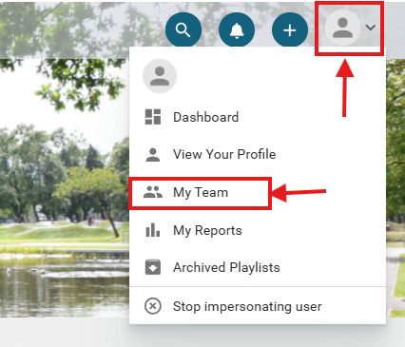
This section shows your team members and whether they have completed their assigned learning:
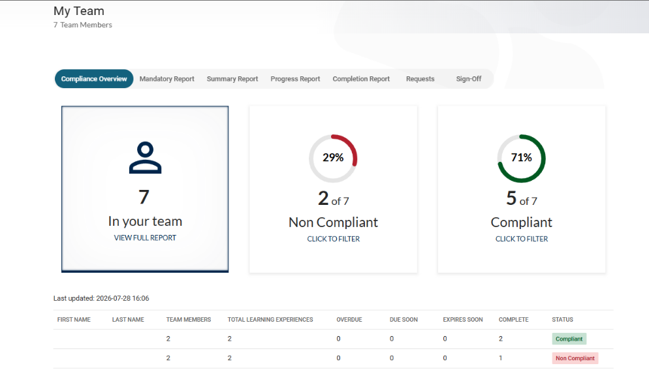
There are five key tabs to be aware of:
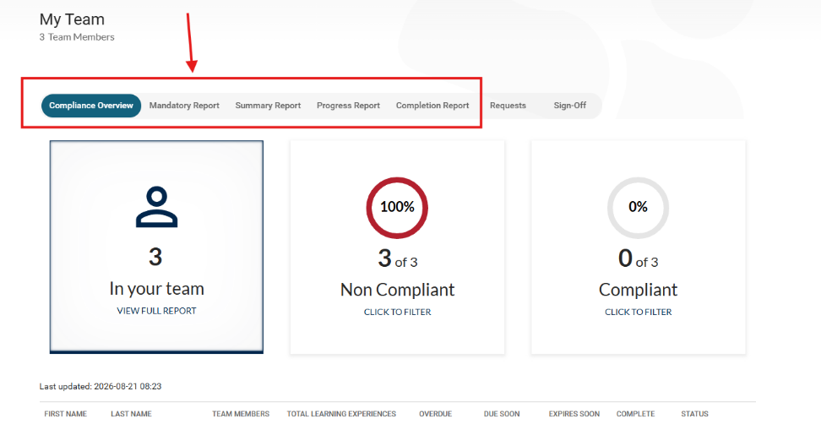
In the Summary Report tab, senior managers can view course completion information for their own teams and any teams that report to them by selecting the number shown beside each team member:
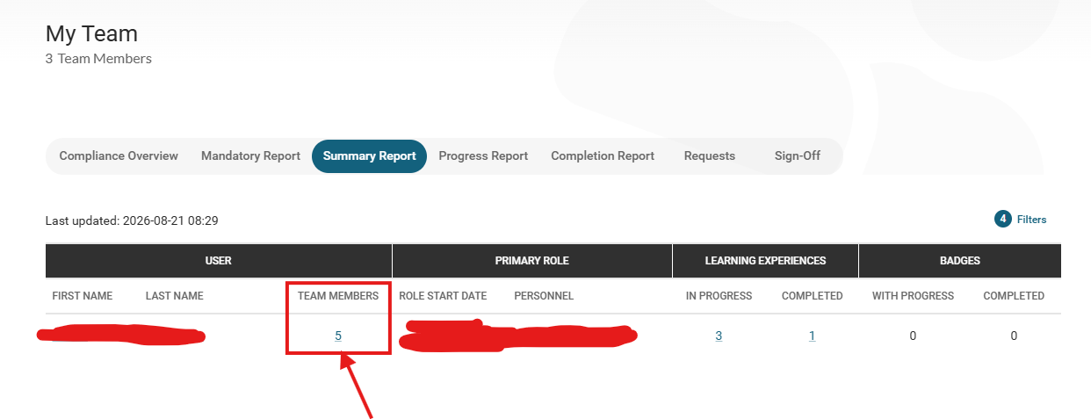

Further guidance is available on the Learning Platform provider’s page, including detailed information on how to use reporting features:
https://helpcenter.confirm.com/hc/en-us/articles/5862664939025-The-My-Team-page#h_01KBN5YCVGGZANKZKNC516YAKM

If any team members are missing, please email hrformsplus@falkirk.gov.uk with the employee name(s), Post ID(s) and employee number(s). The hierarchy will then be updated in MyView and reflected in the Learning Platform, as this information is pulled directly from MyView.

Please contact technicallearning@falkirk.gov.uk with any issues you may have with the platform.

