COMMUNITY EMPOWERMENT (SCOTLAND) ACT 2015
FALKIRK COUNCIL ASSET TRANSFER REQUEST FORM
IMPORTANT NOTES:
This is an application form which can be used to make an Asset Transfer request to Falkirk Council.
Any Community Body interested in making an Asset Transfer Request is advised to contact the Asset Team on strategicpropertyreview@falkirk.gov.uk before making the request so that we can discuss your proposal.
Please complete the asset transfer request form if the property/land is owned/leased/managed by Falkirk Council.
It is essential that you read the Asset Transfer guidance provided by the Scottish Government before making a request.
When completed, this form should be emailed to strategicpropertyreview@falkirk.gov.uk or sent to
The Asset Team
Falkirk Council
4 Stadium Way
Falkirk
FK2 9EE

Section 1: Information about the Community Transfer Body (CTB) making the request
  - Name of the CTB making the asset transfer request
Cowdenhill Community Centre (SCIO), SC047632
  - CTB address. This should be the registered address, if you have one.
Postal address: Cowdenhill Road,
Bo’ness.
Postcode: EH51 9NZ
  - Contact details. Please provide the name and contact address to which correspondence in relation to this asset transfer request should be sent.
Contact name: REDACTED
Postal address: REDACTED
Bo’ness

Postcode: REDACTED
Email: REDACTED
Telephone: REDACTED
☐ ✓We agree that correspondence in relation to this asset transfer request may be sent by email to the email address given above. (Please tick to indicate agreement)
You can ask Falkirk Council to stop sending correspondence by email, or change the email address, by telling them at any time, as long as 5 working days’ notice is given.

  - Please mark an “X” in the relevant box to confirm the type of CTB and its official number, if it has one.
 | Company and its company number is ………….
X | Scottish Charitable Incorporated Organisation (SCIO) and its charity number is ……………….. | SC047632
 | Community Benefit Society (BenCom) and its registered number is ………………………………
 | Unincorporated organisation (no number)

Please attach a copy of the CTB’s constitution, articles of association or registered rules.
Please note that under The Community Empowerment (Scotland) Act 2015, where a CTB is seeking ownership rather than a lease, the organisation must have at least 20 members. See the Scottish Government’s Guidance for Community Transfer Bodies.
  - Has the organisation been individually designated as a community transfer body by the Scottish Ministers?
No ☐✓
Yes ☐
Please give the title and date of the designation order:

  - Does the organisation fall within a class of bodies which has been designated as community transfer bodies by the Scottish Ministers?
No ☐
Yes ☐✓
If yes what class of bodies does it fall within?
Organisation is a SCIO

- Information about the land and rights requested
  - Please identify the property/land to which this asset transfer request relates.
You should provide a street address or grid reference and any name by which the land or building is known. If you have identified the land on the relevant authority’s register of land, please enter the details listed there.
It may be helpful to provide one or more maps or drawings to show the boundaries of the land requested. If you are requesting part of a piece of land, you must attach a map and give a full description of the boundaries of the area to which your request relates. If you are requesting part of a building, please make clear what area you require. A drawing may be helpful.
Cowdenhill Community Centre
Cowdenhill Road
Bo’ness
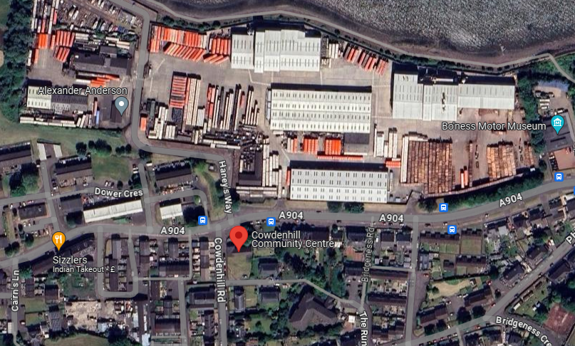
EH51 9JH

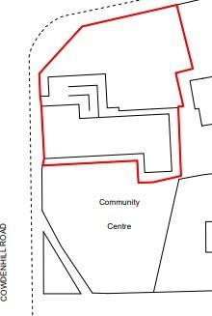

  - Please provide the UPRN (Unique Property Reference Number), if known.

UPRN: 136061434

- Type of request, payment and conditions
  - Please tick what type of request is being made:
✓
for ownership (under section 79(2)(a)) - go to section 3A

for lease (under section 79(2)(b)(i)) – go to section 3B

for other rights (section 79(2)(b)(ii)) - go to section 3C

3A – Request for Ownership
What price are you prepared to pay for the land requested?
Proposed price: £1
Please attach a note setting out any other terms and conditions you wish to apply to the request.

3B – Request for Lease

What is the length of lease you are requesting?

How much rent are you prepared to pay? Please make clear whether this is per year or per month.

Proposed rent: £ per

Please attach a note setting out any other terms and conditions you wish to be included in the lease, or to apply to the request in any other way.

3C – Request for other Rights
What are the rights you are requesting?
N/A

Do you propose to make any payment for these rights?
Yes ☐
No ☐
If yes, how much are you prepared to pay? Please make clear what period this would cover, for example per week, per month, per day?
Proposed payment: £ per

Please set out any other terms and conditions you wish to apply to the request.

- Community Proposal
  - Please set out the reasons for making the request and how the land or building will be used.
This should explain the objectives of your project, why there is a need for it, any development or changes you plan to make to the land or building, and any activities that will take place there.
4.1.1 Objectives of Project

Our objectives are: The provision of recreational facilities, or the organisation of recreational activities, with the object of improving the conditions of life for people within the Community
- To improve health and wellbeing of the local community
- Promote Social inclusion and prevent loneliness
- Provide increased social benefits
- Empower our community and families to have a say in how things are done
- Reduce poverty in the area by giving access to essential services to help improve the wellbeing of the community
- Provide a safe and supportive space for children to help alleviate child poverty in the area
- Promote Community Partnership and Involvement

4.1.2 Why there is a need for your Project?

Our vision is to provide a community led space that helps deliver long-term, social, economic, sustainable and environmental benefits to the local community. Our Project will provide an accessible local place for people to come together without the requirement to travel out with the Community, and enable them to “live well” within their own community. Recent closure of other local amenities has limited the options available within Boness increasing the need to maintain our local facility and amenities

Our values are based on:
• Working in an inclusive and respectful manner, not discriminating against anyone
• Being a not-for-profit organisation and investing any surplus in the advancement of facilities for the local community
• Being community led
• Intergenerational approach to serving all age ranges in the community
• Provide a space for mental health support services for the local community
• Innovative and proactive approach to local people’s needs

4.1.3 Will any Development/changes/modifications to the asset be required?

We have plans to upgrade the kitchen facilities to maximise Centre usage and increase the viability of the building.
We have engaged with Business Energy Scotland to consider what energy efficiency improvements we can make to the hall. We are in receipt of a report from Business Energy Scotland and are currently considering their recommendations. Once ownership of the hall is transferred we intend to commence to carry out these measures in order to lower energy bills and become more sustainable

4.1.4 What activities will take place?
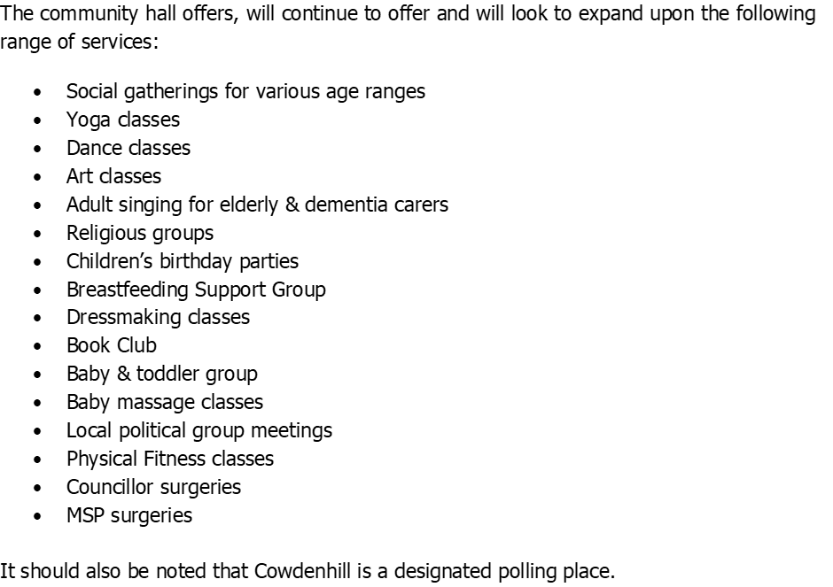

4.1.5. If the asset is to be used by the public, please provide details of lettings policy and opening times.

We use an online booking system for all of our hires for the main hall, kitchen, boardroom and meeting room. Our general opening times are 8am to 10pm.

4.1.6 What provision will be provided for people with disabilities?

We have a ramp at the entrance to the centre and all areas are accessible for wheelchair users, including having an accessible toilet.

4.1.7 Any other relevant information?

Benefits of the proposal
  - Please set out the benefits that you consider will arise if the request is agreed to.
Local Authorities are permitted to dispose of property at less than market value where there are wider public benefits to be gained. This is set out in the Disposal of Land by Local Authorities (Scotland) Regulations 2010. These public benefits are listed below.
In this section, please explain how the project will benefit your community, and others. Please refer to the Scottish Government guidance on how the Council will consider the benefits of a request.
Please explain how the project will benefit your community by detailing how your project will promote or improve:-

4.2.1. Economic development/income generation

ie. Please include details of any job creation or volunteering and training opportunities that will be available as a result of the Asset Transfer. Also details of how your organisation will involve the local community and of any incentives that may be available to encourage the local community to use the proposed services.

Our centre offers a choice of rooms which can accommodate meetings, events and regular classes in which the Community can participate. It provides essential services and spaces that might otherwise be inaccessible due to the financial constraints of our local community. We are actively recruiting members within the Community as well as looking to increase activities supported and run by Volunteers. The centre remaining open and in community ownership, will help to develop the skills and experience of our local community through volunteer places, to build upon an individual’s experience and skills capacity, thus supporting our community’s future employability. By offering volunteer positions, the centre will help residents develop new skills and gain valuable work experience. Volunteering can serve as a stepping stone to future employment, enhancing the employability of individuals and contributing to the overall skill level of the community. The centre can support local businesses by providing a venue for classes, workshops, and events. This can stimulate local commerce and provide additional income streams for small business owners.
Offering educational and training programs can help bridge the gap for those who are not in full-time education or employment. A community centre fosters social cohesion and well-being, which are essential for a thriving economy. By providing a space for community activities and support services, the centre can improve the quality of life for residents, and promote inclusivity making Bo’ness a more attractive place to live and work. This can indirectly boost the local economy by attracting new residents and businesses.
In addition ongoing maintenance contracts or improvement work is entirely locally sourced again supporting local businesses and job creation

    - Regeneration

i.e. Please include details of whether your organisation will contribute to the physical regeneration of the area, and how your proposal will impact the regeneration of the area, in terms of volunteering or employment, giving examples.

The closing of a vital community building would be hugely damaging to the local area. We have plans to upgrade our space and our garden area, so that it can be enjoyed by our whole community. We plan to continue our community work, seek input and feedback from members to introduce new initiatives and identify ways to contribute to the local regeneration of the area. We will work with other local organisations to enhance the lives of residents and offer future opportunities
We will be looking to upgrade the building with the help of various funders, including Falkirk Council, which will ensure that the building is improved and fit for purpose, encouraging regeneration in the local area, as the community engages with the new vibrant and modernised local centre.
The community centre can act as a hub for local economic activity.

    - Public Health

i.e. How likely is the proposal to improve the Public Health of the Community, in terms of physical and mental health, for example through volunteering, training, or taking part in activities, giving examples.

Our Centre offers a variety of social and physical activities which we continue to expand to accommodate different age groups and physical capabilities. By improving the overall health of the community, our group aims to help ease the pressure on public and social services, Health Centres and on other facilities. By engaging in regular social activities, our community can reduce stress, improve mood, prevent loneliness and gain a sense of purpose. Physical activities at our centre, such as yoga classes and dance classes, help maintain physical health and mobility for all those who attend them. Craft classes and interactive groups help individuals find a sense of self worth and help support charitable and community events. Together, these benefits contribute to a healthier, happier, and more connected community. When individuals have access to programmes that support their social, mental, and physical health, they are less likely to require intervention from public services. This proactive approach to community health not only benefits individuals, but also reduces the burden on public resources, allowing them to be allocated more effectively to areas where they are needed the most. Regular social activities can reduce stress, improve mood, and provide a sense of purpose, which can decrease the reliance on medication and mental health services.
Offering educational programs on nutrition, mental health, and preventative care can empower residents to take control of their health and wellbeing.
The community centre can collaborate with local health services to provide accessible health screenings, vaccinations, and other essential services. This can be particularly beneficial in ensuring that vulnerable populations receive the care they need.

    - Social Wellbeing

i.e. How will the proposal improve the Community's Social Well-Being and mental health, or how might it improve the learning offer and activities available in the area? Please give brief examples of these activities.

The activities and social interactions facilitated at Cowdenhill Community Centre contribute significantly to both the mental and social wellbeing of our community. Our centre provides a safe space for the local community to meet and engage with each other, and enjoy a range of activities and events.
A vibrant community centre can foster social cohesion by providing a space for residents to come together, share experiences, and support one another. The centre can host both regular weekly activities as well as one off events including a wide range of social activities and gatherings, from hobby groups to cultural celebrations. These activities foster a sense of community and belonging, which is essential for social well-being. Offering volunteer opportunities will further enhance social cohesion and provide residents with a sense of purpose.
We host supportive groups such as the adult singing for elderly & dementia carers class and chair yoga for those less able. These services can provide essential support to vulnerable populations and improve overall social well-being.
By facilitating intergenerational activities, the centre can bridge the gap between different age groups.
The centre can serve as a hub for community engagement, encouraging residents to participate in local decision-making processes. This can foster a sense of ownership and pride in the community, leading to greater social cohesion and well-being.

    - Environmental Wellbeing / Environmental Benefits

i.e. Will the proposal bring green / environmental benefits and / or have an impact on the local environment? Will it help mitigate the effects of climate change? If so please give details.

Currently Cowdenhill is a “zero waste” hall discouraging the use of disposable products and ensuring users make conscious decisions around environmental impacts. We plan to continue to work in an environmentally conscious way, and we have plans to cut energy costs with improved energy efficiency including installation of solar panels within our 5 year plan. Our aim being to reduce our carbon footprint on the environment and local community as well as reducing our energy costs. These improvements contribute to a healthier, more attractive, and more liveable community, benefiting all who live here. These energy-efficiency improvements can lower operational costs, making the hall more sustainable, allowing more funds to be allocated to community programs and services. Educational workshops on topics such as recycling, composting, and energy conservation can raise awareness and empower the community to make environmentally friendly choices, contributing to a greener Bo’ness.
By implementing energy-efficient technologies and sustainable practices, the community centre can reduce its environmental impact. This can include installing solar panels, using energy-efficient lighting, and implementing water-saving measures. These initiatives not only benefit the environment but also serve as a demonstration of the community’s commitment to sustainability.
The centre can engage the community in environmental initiatives, such as clean-up drives, tree planting events, and recycling programs. These activities can foster a sense of community pride and responsibility, encouraging residents to take an active role in protecting their local environment. We have a small outdoor area which can offer a garden space, and plan to utilise this to offer Volunteers opportunities to develop gardening skills and grow plants and flowers

    - Does your project contribute to the reduction of inequalities?

i.e. Will the proposal enable the community to access activities not otherwise available; will these activities be available at an affordable rate; how will your organisation work with other local providers to reduce inequalities?

We currently have lets from local community groups such as yoga classes, dress-making classes, dance groups. Singing groups, various keep fit classes and baby massage classes. The membership will have input into setting reasonable fees and we currently offer reductions for regular users to enable the costs of running activities to remain low. It is also an easily accessible and affordable venue for local community gatherings.
We work with the community, for the community. We will continue to develop partnerships with other local charities, organisations, service providers and community groups.
Our vision is to provide a community led space that helps deliver long-term, social, economic, sustainable and environmental benefits to the local community.
Our objectives are:
- To improve health and wellbeing of the local community
- Promote Social inclusion and prevent loneliness
- Provide increased social benefits
- Empower our community and families to have a say in how things are done
- Reduce poverty in the area by giving access to essential services to help improve the wellbeing of the community
- Provide a safe and supportive space for children to help alleviate child poverty in the area
- Promote Community Partnership and Involvement

4.2.7 Will local people be engaged in the use and management of the Asset?

A “community of interest” may not represent the people living near to the asset. Please provide evidence of how local people and communities will be engaged in the use and management of the asset, and how they have been consulted.

The group operates as a 2-tier membership organisation managed by a board of trustees and a broader membership base, composed of local individuals and organisations interested in the building's success. General membership is open to all individuals and groups residing or operating within Bo’ness and the surrounding areas. They may vote on matters to be decided at all Annual General Meetings. We regularly consult with members, regular groups and other hall users in order to ensure the hall continues to meet their requirements. Users as well as the wider community can contact us by email, phone or via our social media as well as the hall booking platform and do so regularly. Members are invited to attend meetings and consulted in advance of any planned changes in the way in which the hall is managed and used. All regular Groups and recent hall users have been written to inviting them to become members and provide feedback on their experiences in using the hall. We will continue this on an ongoing basis
Our online presence / social media is growing with approaching 800 followers now supporting the continuation of Cowdenhill Community Centre

4.2.8 How will you monitor whether the Asset Transfer is benefiting the community?

ie. Will you survey the users / invite feedback / compare user numbers with a baseline etc

We will track the success of the centre by increasing overall usage and ensuring the project’s economic sustainability. This will be evaluated quarterly during Board of Trustee meetings. We also compare and strive to increase membership on an annual basis
Our social impact will be monitored by collecting demographic data on hall users and gathering feedback regarding the health and social benefits they experience, with particular attention to the needs of our community

4.2.9 Any other relevant information?

Restrictions on use of the land
  - If there are any restrictions on the use or development of the land, please explain how your project will comply with these.
Restrictions might include, amongst others, environmental designations such as a Site of Special Scientific Interest (SSI), heritage designations such as listed building status, controls on contaminated land or planning restrictions.
N/A

Negative consequences
  - What negative consequences (if any) may occur if your request is agreed to? How you propose to minimise / reduce these?
You should consider any potential negative consequences for the local economy, environment, or any group of people, and explain how you could reduce these.
We have considered potential negative consequences of the group taking over the building through Community Asset Transfer as:
- Costly repair work is required for the building which we will need to seek both grant funding for as well as self fund.
- Utility costs are high for the building, and we understand the risk of these increasing, and are actively looking to reduce monthly bills.
- There is a risk of us not being able to attract enough monies by way of lets or funding to ensure the hall is able to continue.
- We understand there is a lot of volunteering work required for our proposal to work and are reliant on there being a continued involvement from the community to help with this.
- The hall is situated on the corner of a main road and residential street. On the occasion of hosting larger events there may on occasion be increased traffic/parking

The Trustees believe that the business plan and the proposals contained within demonstrate that these challenges can be met.

Capacity to deliver
  - Please show how your organisation will be able to manage the project and achieve your objectives.
This could include the skills and experience of members of the organisation, any track record of previous projects, whether you intend to use professional advisers, etc.
4.5.1 Has your organisation or any of its members managed projects or owned / leased property/land prior to this?
Yes X
2 Board Members manage Bloomin’ Bo’ness and currently lease the bothy
at Bo’ness Cemetery. They also lease and manage Bo’ness Public Toilets in
conjunction with Buzzness.

Please provide details of:
4.5.2 Skills and experience of the members of the organisation
The charity is called the Cowdenhill Community Centre (SCIO) and has the legal status of a Scottish Incorporated Charity, SCIO SC047632.
The group is a 2-Tier membership organisation and will be run by a board of trustees and a membership, these will be drawn from a range of local people and organisation who have an interest in the building.
Some of the Trustees have been involved in both the running of the Hall for over 10 years whilst under Falkirk Council Management, as well as long standing Committee members who have supported and secured the Halls charitable Status and viability. There is clear and invested continuity in making the hall a success and valuable Community Asset for Boness
As a Board of trustees, we are aware of our role and responsibilities in relation to good governance and take these seriously. We have already demonstrated our effectiveness as a Board and will continue to build on this. The Board is made up of a number of trustees with a wealth of experience across various commercial, legal and NGO sectors.
The hall will offer a full range of letting arrangements for groups, businesses and individuals. Initially it will be managed by volunteers from our membership group, however, we may in the future look at employing an individual to manage the building.
General membership is open to all individuals and groups residing or operating within Bo’ness and the surrounding areas. They may vote on matters to be decided at all Annual General Meetings.
Board/Trustees:
Name REDACTED
Role Chair Person
Experience
Working and liaising with Subject Matter Experts in law, finance, accounting and conveyancing for the development of business,
Previous Charity involvement fundraising for a local Hospice
Currently also a member of a Humanist Charity which provides wedding and funeral service for disadvantaged individuals

Name REDACTED
Role Treasurer
Experience
Retail Group Manager dealing with multi site locations within a high turnover environment. Strong commercial and operational skills. Ongoing experience of HR issues, financial management, logistics and personnel management
Relevant experience in Community involvement and currently also Volunteers with the Bethany Trust providing support to Homeless and disadvantaged individuals in Edinburgh

Name REDACTED
Role Secretary
Experience : local Business Owner and Operational Manager. Civil Service background with 30+ years working in Social/Welfare Benefit and Employability Services. Extensive knowledge on delivering services and contractual obligations
Stakeholder engagement working with a range of Charitable trusts, 3rd sector Organisations and Community and welfare Groups across the Lothians and Scottish Borders Local Authority and NHS Trust areas
Run a member led Community dance class for almost 40 years in West Lothian for a local Community Centre/CDT enabling all children and young adults to access dance/drama and self expression, building friendships and confidence as individuals. Removing the barriers and costs that would apply to this via commercial dance classes

Name REDACTED
Role Vice Chairperson
Experience
Working in the NGO sector for 18 years in a senior position. Additionally, 9 years experience in the Renewable Energy sector Strong operational, evaluation and community engagement skills.
redacted also has extensive experience in volunteering.
Previous Trustee of Kirknewton Development Trust.

Name REDACTED
Role Compliance Manager
Experience
Strong organisational skills working as a Merchant Navy Officer for 14 years, then as a Marine Consultant until 2017 including being berth master in Newfoundland for 6 years. Currently employed as a flight dispatcher at Edinburgh Airport Experienced in logistical management, emergency response, strong reporting abilities and compliance issues
Highly skilled in engaging with members of the public, providing support and dealing with sensitive and sometimes challenging situations
Name REDACTED
Role Board Member
Experience
Redacted is currently employed in a senior position in the Public Sector.
Redacted has a Wealth of experience in Volunteering and Community Engagement. As well as being a Board Member of Cowdenhill Lorna is also currently the Organiser of Bloomin Boness and is a member of Boness community Council
Name REDACTED
Role Board Member
Experience
Redacted is currently self-employed and is deeply involved in community activities
Similar experience in Volunteering and Community Engagement and invested in making Boness a great town to live in. Currently Joint Organiser of Bloomin Boness and is a member of Boness community Council in addition to being a Member of Cowdenhill
Name REDACTED
Role Board Member
Experience
Redacted is a Retired school teacher. Vast organisational skills as well as budgetary experience. Dedicated to the concept of life long learning
Redacted now volunteers for various groups in Bo’ness.
Previous Volunteering and Charity work includes working with the Samaritans and a Homeless Project in Dundee offering support and accommodation to adults with addictions
Name REDACTED
Role Board Member
Experience
After working in rural social and economic development previously, Helen now works within the Science Industry
Hailing originally from Shetland, Redacted is well acquainted with the concept of community effort organising local events and providing community facilities.
Charity and Volunteering experience includes working within Economic and Rural Development Organisations. Involved in setting up Charities, providing creative options for people in very rural areas of Scotland.
Befriender and welfare support to individuals with babies under the age of 2 in Edinburgh

4.5.3 Do you intend to use professional advisors? Please provide details.
We intend to continue our relationship with a local accountant who looks after our yearly accounts.
We intend to instruct a local solicitor to negotiate our agreement with Falkirk Council.
We intend to instruct a number of surveyors, architects, etc, as the need arises.
4.5.4 Do you currently lease/manage a property from Falkirk Council? If yes, please provide details.
We currently manage the running of the centre, the booking of lets, and the opening and closing of the hall
4.5.4 Please detail how you plan to manage the building?
For example opening and closing the building / managing lets / will you have staff etc?
The centre will be managed, and staffed, by a dedicated group of volunteers. A number of our Trustees, already successfully manage the running of the centre, the booking of lets, and the opening and closing of the hall
The centre will be open when lets are required.
In general, these are between the times of 9am to 10pm, 7 days a week.
We use an online booking system to help manage our bookings.
4.5.5 Please provide any other information you think may be relevant.

- Level and nature of support
  - Please provide details of the level and nature of support for the request, from your community and, if relevant, from others.
This could include information on the proportion of your community who are involved with the request, how you have engaged with your community beyond the members of your organisation and what their response has been. You should also show how you have engaged with any other communities that may be affected by your proposals.
5.1.1. What community engagement has taken place to help develop your business plan? Please provide evidence, for example any completed surveys, questionnaires, letters of support, minutes of public meetings etc.
We have engaged with the community on multiple occasions both in providing information on a personal/individual basis and through hosting events such as Christmas Markets, Boness Fair fundraisers etc and look to expand upon this in the future. Regular verbal and email communications with user groups and their appointed representatives.
We have had great interest, letters of support and over 100 respondents to a poll on keeping the hall in operation with an almost 100% positive response rate. Positive responses from the local community looking to engage with the voluntary running of the hall or asking how they can support us publicly.
Communication has been done through emails, questionnaires, polls and posts on ours and other local social media pages. Copies of letters of support from Users within the Community are available.
A recent communication has gone out resulting in over 25 new members and this will be further added to in coming months as we increase advertising and social media updates
There is a need, genuine desire, and support, for the community asset transfer and willingness from the community to support the hall and preserve its availability post Community Asset transfer.

5.1.2 Have you consulted with other local stakeholder groups or agencies? Please provide evidence.
We have worked with CVS Falkirk & District on our business plan and CAT application. We have formed links with other local groups such as Primary Schools, Boness Fair Committee and Bloomin Boness and will strive to build strong links and a collaborative approach going forward

5.1.4 Have you been in contact with any other communities or community groups
that may be affected? Please give details.
We have verbal support and willingness from other local community groups who share a desire to revitalise Boness and improve and retain the facilities for the local community. Impact statements have been considered where appropriate.

5.1.5 Please provide any other information you think may be relevant.

- Financial Viability of Project
Your Business Plan should contain full information about the financial viability of the project, evidencing that the organisation will be able to sustain the project in the long term.
Please submit
- at least 1 year’s audited accounts to evidence your organisations financial stability (if available)
- where audited accounts are not available (for instance for new groups) please provide a bank statement.
- a projected 5 year income and expenditure account
- a cash flow forecast for the proposed asset transfer.
6.1 Please outline the Policies and Procedures your organisation has in place to govern the group’s finances
All details of future costings and funding proposals are to be found in our Business Plan which fully sets out our budget and proposals for the next 5 years. A copy of the Business plan has been provided. Key budget projections for the next 12 months show our ability to drive increased revenue and reduce utility costs – key elements extracted below:
April 25- March 26
Hall lets (based on a reserved 10% increase) £11,700
Utilities (heat and light allowing for switching supplier mid year) £7,160 – this is our largest outgoing
Other expenditure (including cleaning, repairs, rental, insurances and admin charges) £3,990
While the Trustees would wish to keep a contingency fund of £20,000 at all times there is a significant reserve put aside to help with initial start-up/running costs.
We recognise our organisation’s requirements as a registered SCIO. We will continue to submit audited accounts yearly to OSCR. Our finances are presented and scrutinised at every board meeting. We will follow OSCR’s Guidance and Good Practice for Charity Trustees (oscr.org.uk) to ensure we manage our finances correctly.
We have set rates for each of our spaces available to let and will review these yearly at our AGM.
We have increased our usage since obtaining an FRI license in October 24 and plan to build on this as we take ownership.
We are also actively seeking to reduce running costs – for example as a result of inheriting the existing tariff for electricity from Falkirk Council we have established the Annual utilities bill of to be significantly higher than needed. We have recently negotiated a new Supplier/reduced tariff which should reduce the Annual cost. We continue to identify and seek ways to reduce avoidable costs and have this item as a standing agenda at monthly committee meetings

- Funding
  - Please outline how you propose to fund the price or rent you are prepared to pay for the land, and your proposed use of the land.
If you intend to apply for grants or loans you should demonstrate that your proposals are eligible for the relevant scheme, according to the guidance available for applicants.
7.1.1 Please show your calculations of the costs associated with the transfer of the land or buildings and your future use of it, including any redevelopment, ongoing, maintenance and the costs of your activities. All proposed income and investment should be identified, including volunteering and donations.
We recognise we will be required to instruct a solicitor to review and negotiate the terms of our purchase, conclude missives, and conduct the conveyance. We have yet to secure funding to upgrade the building and are currently identifying relevant Funders and preparing to seek funding by way of fully funded and match funded grants in the future.
Please see our Cash Flow for all our planned start up, ongoing, maintenance and planned redevelopment costs. Our Cash Flow also shows all proposed income and investment.
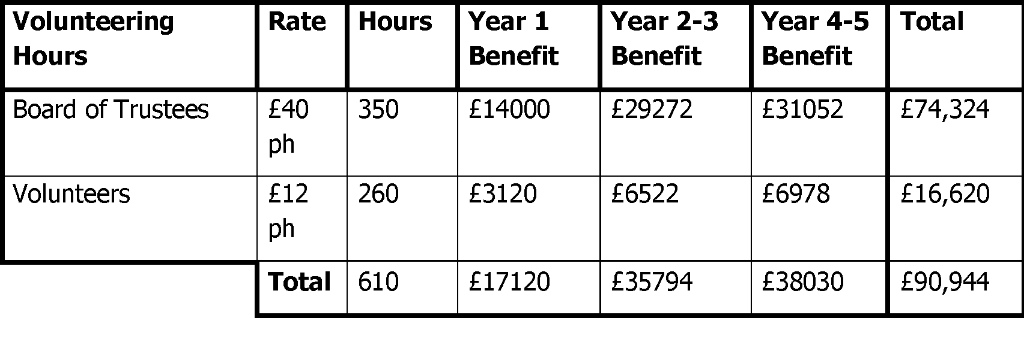
Our volunteer contributions can be seen in the table above.

7.1.2 Please supply details of what funding you have received so far, and of any conditions attached to it.
N/A – see above

7.1.3 Please supply details of any funding you have applied for but have not yet received a response or decision. Please include timescales if known.
n/a – see above

7.1.4 Details of any other funding you will have access to? i.e. voluntary contributions, borrowing etc.
Hall users are a regular funding stream and this has increased due to recent promotion of the hall. Accounts will fully illustrate this. We also have funds which we can draw upon as required – see bank statements

7.1.5 Please outline your funding strategy if you have one, as well as any other relevant information.
We recognise that there is a need to continually update and upgrade our facilities, and we keep up to date with the various funding opportunities available to us, thanks to our local third sector interface, CVS Falkirk & District.
We have commenced identifying sources of grant funding and are in the process of preparing bid submissions. A recent application was submitted for Falkirk Councils Empowerment Grant but the scheme was oversubscribed and subsequently our application was unsuccessful, however we are identifying alternative avenues on an ongoing basis. Our Strategy is to apply for both schemes which offer full grant funding as well as match funding

- Enablement Fund
Falkirk Council will hand the building over wind and watertight and compliant. However, this is quite light-touch and would involve (for example) patching of a leaky roof. For more significant building works, groups can apply to the Enablement Fund, to pay for capital improvements such as energy efficiency improvements or larger capital renewals which support the viability of the project going forward. Only capital items are eligible. Running repairs are revenue costs and are not eligible. You are strongly advised to email strategicpropertyreview@falkirk.gov.uk to confirm eligibility criteria before you submit this application.
Requests to the Fund must be supported by estimates / quotations from professionals which should be provided as supporting documents.
Please provide details of your request to the Enablement Fund, if applicable.
Enablement Fund request for larger capital renewals which support the viability of the CAT
Item | Estimate Provided By | Amount not more than (including VAT)
No requirements identified

Checklist of accompanying documents
To check that nothing is missed, please tick which additional documents are accompanying this form.
☐Section 1 – You must attach your organisation’s constitution, articles of association or registered rules
☐Section 2 – Any maps, drawings or description of the land requested
☐Section 3 – Note of any terms and conditions that are to apply to the request
☐Section 4 – Any additional evidence regarding your proposals, their benefits, any restrictions on the land or potential negative consequences, and your organisation’s capacity to deliver.
☐Section 5 – Evidence of community support
☐Section 6 – Financial – Copies of accounts, forecasts, etc
☐Section 7 – Funding – Copy of Business Case etc
☐Section 8 – Enablement Fund – copies of estimates

Declaration
Two office-bearers (board members, charity trustees or committee members) of the community transfer body must sign the form. They must provide their full names and home addresses for the purposes of prevention and detection of fraud.
This form and supporting documents will be made available online for any interested person to read and comment on. Personal information will be redacted before the form is made available.

We, the undersigned on behalf of the community transfer body as noted at Section 1, make an asset transfer request as specified in this form.
We declare that the information provided in this form and any accompanying documents is accurate to the best of our knowledge.
Name REDACTED
Address REDACTED

Date 18th September 2025
Position Chair
Signature REDACTED

Name REDACTED
Address REDACTED

Date 19th September 2025
Position Secretary
Signature REDACTED

