COMMUNITY EMPOWERMENT (SCOTLAND) ACT 2015
FALKIRK COUNCIL ASSET TRANSFER REQUEST FORM
IMPORTANT NOTES:
This is an application form which can be used to make an Asset Transfer request to Falkirk Council.
Any Community Body interested in making an Asset Transfer Request is advised to contact the Asset Team on strategicpropertyreview@falkirk.gov.uk before making the request so that we can discuss your proposal.
Please complete the asset transfer request form if the property/land is owned/leased/managed by Falkirk Council.
It is essential that you read the Asset Transfer guidance provided by the Scottish Government before making a request.
When completed, this form should be emailed to strategicpropertyreview@falkirk.gov.uk or sent to
The Asset Team
Falkirk Council
4 Stadium Way
Falkirk
FK2 9EE

Section 1: Information about the Community Transfer Body (CTB) making the request
  - Name of the CTB making the asset transfer request
Carron & Carronshore Community Hall Management Committee SCIO
  - CTB address. This should be the registered address, if you have one.
Postal address: Carronshore Community Centre, 62 Main Street, Carronshore, Falkirk
Postcode: FK2 8EY

  - Contact details. Please provide the name and contact address to which correspondence in relation to this asset transfer request should be sent.
Contact name: [REDACTED]
Postal address: Carronshore Community Centre, 62 Main Street, Carronshore, Falkirk

Postcode: FK2 8EY
Email: carronshorecommunitycentre@yahoo.com
Telephone: [REDACTED]
X We agree that correspondence in relation to this asset transfer request may be sent by email to the email address given above. (Please tick to indicate agreement)
You can ask Falkirk Council to stop sending correspondence by email, or change the email address, by telling them at any time, as long as 5 working days’ notice is given.

  - Please mark an “X” in the relevant box to confirm the type of CTB and its official number, if it has one.
 | Company and its company number is ………….
X | Scottish Charitable Incorporated Organisation (SCIO) and its charity number is ……………….. | SC049767
 | Community Benefit Society (BenCom) and its registered number is ………………………………
 | Unincorporated organisation (no number)

Please attach a copy of the CTB’s constitution, articles of association or registered rules.
Please note that under The Community Empowerment (Scotland) Act 2015, where a CTB is seeking ownership rather than a lease, the organisation must have at least 20 members. See the Scottish Government’s Guidance for Community Transfer Bodies.
  - Has the organisation been individually designated as a community transfer body by the Scottish Ministers?
No X
Yes ☐
Please give the title and date of the designation order:

  - Does the organisation fall within a class of bodies which has been designated as community transfer bodies by the Scottish Ministers?
No ☐
Yes X
If yes what class of bodies does it fall within?
SCIO

- Information about the land and rights requested
  - Please identify the property/land to which this asset transfer request relates.
You should provide a street address or grid reference and any name by which the land or building is known. If you have identified the land on the relevant authority’s register of land, please enter the details listed there.
It may be helpful to provide one or more maps or drawings to show the boundaries of the land requested. If you are requesting part of a piece of land, you must attach a map and give a full description of the boundaries of the area to which your request relates. If you are requesting part of a building, please make clear what area you require. A drawing may be helpful.
Details of Property:
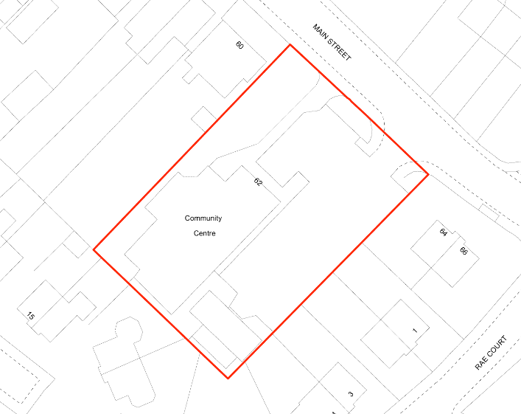
Figure : Map view of current boundary

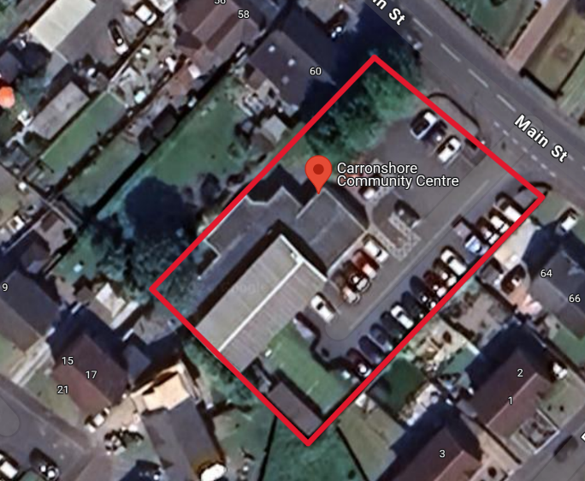
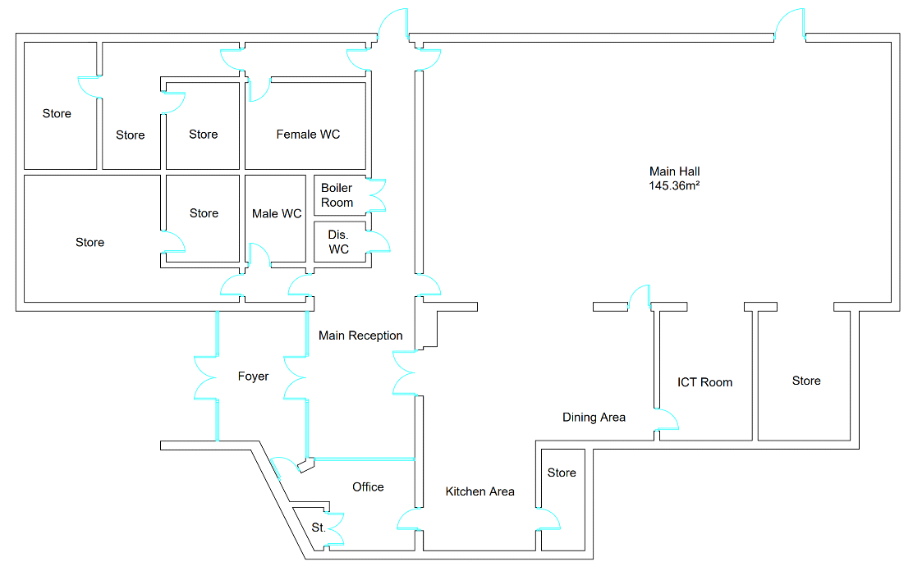
Figure 5: Floor plan of the building
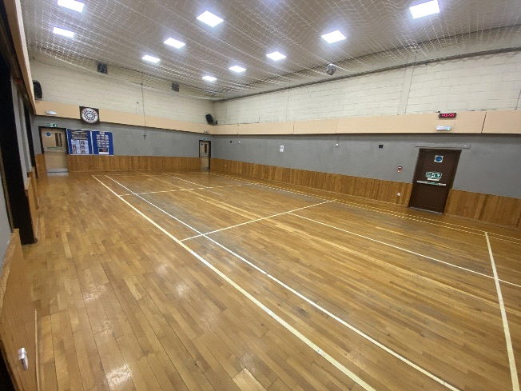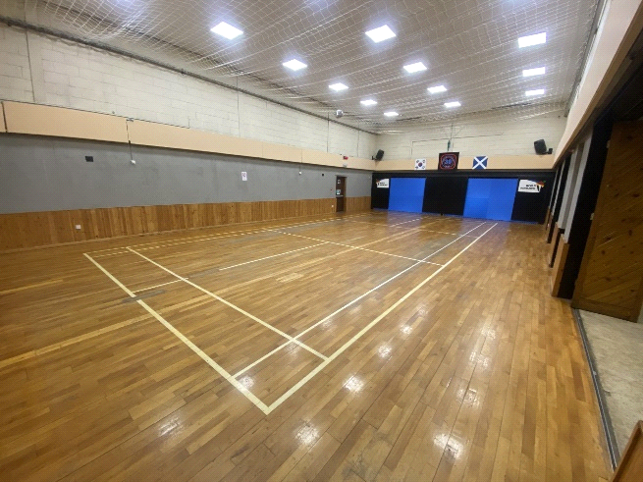

Address: Carronshore Community Centre, 62 Main Street, Carronshore, Falkirk
Postcode: FK2 8EY

  - Please provide the UPRN (Unique Property Reference Number), if known.

UPRN: 136032544

- Type of request, payment and conditions
  - Please tick what type of request is being made:

for ownership (under section 79(2)(a)) - go to section 3A
X
for lease (under section 79(2)(b)(i)) – go to section 3B

for other rights (section 79(2)(b)(ii)) - go to section 3C

3A – Request for Ownership
What price are you prepared to pay for the land requested?
Proposed price: £
Please attach a note setting out any other terms and conditions you wish to apply to the request.

3B – Request for Lease

What is the length of lease you are requesting?
20 Years

How much rent are you prepared to pay? Please make clear whether this is per year or per month.

Proposed rent: £ 1 per year

Please attach a note setting out any other terms and conditions you wish to be included in the lease, or to apply to the request in any other way.

3C – Request for other Rights
What are the rights you are requesting?

Do you propose to make any payment for these rights?
Yes ☐
No ☐
If yes, how much are you prepared to pay? Please make clear what period this would cover, for example per week, per month, per day?
Proposed payment: £ per

Please set out any other terms and conditions you wish to apply to the request.

- Community Proposal
  - Please set out the reasons for making the request and how the land or building will be used.
This should explain the objectives of your project, why there is a need for it, any development or changes you plan to make to the land or building, and any activities that will take place there.
4.1.1 Objectives of Project

The group has been working together to agree a robust plan of action which will secure the hall through a Community Asset Transfer 20-year lease agreement with Falkirk Council at a cost of £1 per year. We have started the process of having legal representation to advise us in this complex area.
The Management Committee will manage Carronshore Community Hall which provides a venue for social, recreational, leisure and health & well-being services and activities, both within Carron and Carronshore and the surroundings areas of Larbert, Stenhousemuir and Falkirk.

Our clear aims and objectives are:
- to keep the hall open and secure its future for local people.
- to make it financially viable and self-sufficient for the long-term.
- to have a wide range of income streams to cover the costs of maintaining and running the building such as grants, donations, hiring out space, delivering contracts and seeking sponsorship.
- to make use of good ideas and resources within the community that can adapt to changing circumstances.
- to be a collaborative effort where many people and stakeholders in the community are involved.
- to facilitate a place where different local partners in a neighbourhood can come together and address the issues that matter most to them.
- to use all forms of publicity, public relations and social media to imaginatively promote the hall and its facilities to the widest possible audience.
- to use the Hall to foster a real and palpable sense of "community" - conveying a sense of togetherness, positivity, solidarity, wellbeing, homeliness and pride to counter the village's historic decline.
- To improve health and wellbeing of the local community
- Provide increased social benefits
- Empower our community and families
- Reduce poverty in the area by providing essential services to help the wellbeing of the community

4.1.2 Why there is a need for your Project?

In the past, our community hall has lacked any strategic programme to develop and drive sustained usage for every day of the year. That was then. This is now. Here is how we propose to move forward.
We firmly believe that the committee has both the commitment and the necessary business skills to manage our building efficiently and effectively as a community facility for local people and take it forward. We have a clear vision of how the space fits into wider community needs. Plus a robust business plan. Proper financial systems and controls. Suitable governance and leadership. Expert advice guiding us. Enthusiasm. Positivity. Confidence. A "can do" attitude.
There are limited community facilities operating in the surrounding area. We have identified our main competition as:
- Falkirk Community Trust
- The Dobbie Hall, Larbert
We have thoroughly researched the above. Overall, while there is competition in the area, there is still a shortage of suitable and affordable social, recreational and leisure amenities, with potential users having to incur travel costs or wait a considerable amount of time to get a let. We are in an excellent position to meet that need.
We firmly believe these competitors offer little threat to us and that we can differentiate ourselves from them by offering a unique community space that is cost-effective and offers high-quality facilities. We will benefit from having committed volunteers drawn from community organisations who are experienced in providing services and know-how within the area.
Our preparation has been careful and thorough. To ensure our business plan is robust and rooted in reality, we have, among many things:
Taken advice from people like CVS, local businesses, tradesmen, hall users and people in the community.
Met with local groups who have successfully navigated the CAT process.
Sought the views of local people about what they want from the hall.
Worked on cash flow plans and ways to attract new users.
Sent our people on training courses such as Communication, Energy Efficiency and Facilities Management.
Spent serious money on items such as an energy survey, a structural survey, new lights, CCTV, plans for upgrading our toilets plus essential maintenance and decoration.
We have been methodical and rigorous in pulling our plan together.
Our aim in this document is to show that we are serious, responsible people who can be entrusted to take over this valuable community asset and make it work into the future.

4.1.3 Will any Development/changes/modifications to the asset be required?

Business Energy Scotland have provided a survey which includes recommendations for improvements to the energy efficiency of the building. We have applied for these improvements to be included in our Enablement Fund request as part of this application.

We have also provided quotes from contractors for works to the flat roof, cavity wall insulation and lighting/electrical works.

4.1.4 What activities will take place?

CCMC will be happy to accept a variety of different lets for social, recreational and leisure activities such as:
Open days | Sport and leisure clubs
Youth clubs | Cubs, scouts, guides and brownies
Toddlers and pre-school playgroups | Dance, aerobics and exercise classes
Parties | Spring fayres
Bingo nights | Film afternoons
Burns Suppers | Concerts
Race nights | Discos
Meetings | Training courses
Amateur dramatic groups | Band practice
Baby massage | Yoga
Coffee mornings | Senior Citizens keep-fit groups
Gymnastics | Car boot sales
Live singers and bands | Art clubs
Wedding receptions | Quiz nights
Carpet bowls | Exhibitions

4.1.5. If the asset is to be used by the public, please provide details of lettings policy and opening times.

Our opening times are 9am – 10pm daily. Our hall is available to all without any discrimination. Let’s are managed by our management committee. Each let is met by one of the committee members and they agree the terms and sign our contract of agreement and complete our let form (both in the appendices).

4.1.6 What provision will be provided for people with disabilities?

The community centre is all on the ground floor and accessible to those with limited disability. However a recent Currie Brown Condition Survey, carried out for Falkirk Council, highlighted that the fixed counter in the reception and cafe isn't DDA compliant and accessible. The WC floor needs to be replaced with sheet vinyl to make it level as 1.0 priorities in order to ensure the building is statutory compliant prior to the CAT.

4.1.7 Any other relevant information?

Benefits of the proposal
  - Please set out the benefits that you consider will arise if the request is agreed to.
Local Authorities are permitted to dispose of property at less than market value where there are wider public benefits to be gained. This is set out in the Disposal of Land by Local Authorities (Scotland) Regulations 2010. These public benefits are listed below.
In this section, please explain how the project will benefit your community, and others. Please refer to the Scottish Government guidance on how the Council will consider the benefits of a request.
Please explain how the project will benefit your community by detailing how your project will promote or improve:-

4.2.1. Economic development/income generation

ie. Please include details of any job creation or volunteering and training opportunities that will be available as a result of the Asset Transfer. Also details of how your organisation will involve the local community and of any incentives that may be available to encourage the local community to use the proposed services.

Our centre provides essential services and spaces that might otherwise be inaccessible due to the financial constraints of our local community. We plan to offer employment opportunities once the asset transfer is complete, in the form of a cleaner and a caretaker/project worker. The centre remaining open and in community ownership, will help to develop the skills and experience of our local community through volunteer places, to build upon individuals experience and skills capacity, thus supporting their future employability.

    - Regeneration

i.e. Please include details of whether your organisation will contribute to the physical regeneration of the area, and how your proposal will impact the regeneration of the area, in terms of volunteering or employment, giving examples.

Unfortunately, due to the economic climate and the cost-of-living crisis, there has been a decline in the number of businesses, venues, and amenities in our community. The closing of a vital community building would be hugely damaging to the local area. We have plans to upgrade our space and our outdoor area, so that it can be enjoyed by our whole community. We plan to continue our community work to contribute to the local regeneration of the area.

    - Public Health

i.e. How likely is the proposal to improve the Public Health of the Community, in terms of physical and mental health, for example through volunteering, training, or taking part in activities, giving examples.

By improving the overall health of the community, our group aims to help ease the pressure on public and social services, and on other facilities. By engaging in regular social activities, our community can reduce stress, improve mood, and gain a sense of purpose. Physical activities at our centre, such as yoga classes, martial arts classes, and dance classes, help maintain physical health and mobility for all those who attend them. Together, these benefits contribute to a healthier, happier, and more connected community. When individuals have access to programmes that support their social, mental, and physical health, they are less likely to require intervention from public services. This proactive approach to community health not only benefits individuals, but also reduces the burden on public resources, allowing them to be allocated more effectively, to areas where they are needed the most.

    - Social Wellbeing

i.e. How will the proposal improve the Community's Social Well-Being and mental health, or how might it improve the learning offer and activities available in the area? Please give brief examples of these activities.

The activities and social interactions facilitated at the Carronshore Community Centre, will contribute significantly to both the mental and social wellbeing of our community. Our centre provides a safe space for the local community to meet and engage with each other, in a vast range of activities and events.

    - Environmental Wellbeing / Environmental Benefits

i.e. Will the proposal bring green / environmental benefits and / or have an impact on the local environment? Will it help mitigate the effects of climate change? If so please give details.

We plan to continue to work in an environmentally conscious way, and we have plans to engage with funders to make energy efficiency improvements to reduce our carbon footprint on the environment and local community by having solar panels on our south facing roof. These improvements contribute to a healthier, more attractive, and more liveable community, benefiting all who live here. More attractive activities to reduce travel to other areas.

    - Does your project contribute to the reduction of inequalities?

i.e. Will the proposal enable the community to access activities not otherwise available; will these activities be available at an affordable rate; how will your organisation work with other local providers to reduce inequalities?

Our proposal also includes exploring partnerships with a range of organisations that can use our centre as a hub for their outreach services. This would include organisations who support people experience substance use, welfare and benefits advice, Citizens Advice Bureau (CAB), mental health and wellbeing services, suicide prevention initiatives, and Falkirk Council’s Adult Learning programmes, including digital skills and confident parenting.
Many of our user groups that require the facility to remain operational, contribute to the reduction of inequalities in our local community.
We work continually to develop partnerships with local organisations and community groups, which helps to support this aim.

4.2.7 Will local people be engaged in the use and management of the Asset?

A “community of interest” may not represent the people living near to the asset. Please provide evidence of how local people and communities will be engaged in the use and management of the asset, and how they have been consulted.

The group operates as a 2-tier membership organisation managed by a board of trustees and a broader membership base. General membership is open to all individuals and groups residing or operating within Carronshore and the surrounding areas. They may vote on matters to be decided at all Annual General Meetings.

As part of our Community Engagement, we asked local people what they would like to see at the community centre and we will continue to engage with the local community to ensure that local needs are met.

4.2.8 How will you monitor whether the Asset Transfer is benefiting the community?

ie. Will you survey the users / invite feedback / compare user numbers with a baseline etc

We need to check regularly how our space fits into wider community needs. We will therefore ensure there is constant dialogue and feedback with our clientele including regular surveys. This will allow us to assess what we are doing well and where we can improve.
We will continue to monitor the usage of the centre.

4.2.9 Any other relevant information?

Restrictions on use of the land
  - If there are any restrictions on the use or development of the land, please explain how your project will comply with these.
Restrictions might include, amongst others, environmental designations such as a Site of Special Scientific Interest (SSI), heritage designations such as listed building status, controls on contaminated land or planning restrictions.
No restrictions known

Negative consequences
  - What negative consequences (if any) may occur if your request is agreed to? How you propose to minimise / reduce these?
You should consider any potential negative consequences for the local economy, environment, or any group of people, and explain how you could reduce these.
We have considered potential negative consequences of the group taking over the building through Community Asset Transfer as:
- Costly repair work is required for the building we will need to fund
- Utility costs are high for the building, and we understand the risk of these increasing
- There is a risk of us not being able to attract enough business to ensure the hall is able to continue
- We understand there is a lot of volunteering work required for our proposal to work and are reliant on there being a continued involvement from the community to help with this
- Increase in the level of traffic due to increased usage of the hall
- Increase in the level of noise pollution due to the increase in usage of the hall
- Risk of over pricing and losing potential customers.
- Local school offering free use of ‘HUB’ annex for local child minders and knitting groups as school no longer uses it for enhanced provision learning therefore reducing interest in our community room for hire
- Getting a balance of ‘free’ activities to address isolation with groups that can pay hire costs. We are a charity and we want to continue with charitable support to these groups

Capacity to deliver
  - Please show how your organisation will be able to manage the project and achieve your objectives.
This could include the skills and experience of members of the organisation, any track record of previous projects, whether you intend to use professional advisers, etc.
4.5.1 Has your organisation or any of its members managed projects or owned / leased property/land prior to this?
Yes X
No ☐

Please provide details of:
4.5.2 Skills and experience of the members of the organisation
We have a balanced, fifteen-strong group of trustees, committee members and volunteers who are passionate about running and developing the hall. With a careful blend of youth and experience, we are a serious, positive, hands-on, motivated team who are committed to securing the future of the Hall for Carronshore and its residents.
Since coming together as a group to prepare for the Community Asset Transfer, we have focused on five key areas:
Communication. Planning. Strategy. Risk. Governance.
Amongst the group there is wide experience of both the public and private sectors plus specialist knowledge in many areas - from analytics to young people - which will be invaluable in moving the Hall forward.
We have looked carefully at the different skills our people offer and have moved fast to identify areas where there may be skills "gaps" that can be filled by training, mentoring and bringing in new people.
Here, we list our people along with a brief CV.
TRUSTEES
[REDACTED] is a sole trader and former senior civil servant with over thirty years' experience working with schools, families, children and adults. His skill mix includes leadership, teamwork, networking, community involvement, communication skills and organising major sporting events both in the UK and internationally.
[REDACTED] was a Senior Learning and Development Consultant with an international professional services company with significant experience in training delivery and coaching. She is passionate about customer service, goal-setting, brand-building, mentorship, governance, up-skilling and personal growth.
[REDACTED] lives in Carron and uses the hall and community room several times a week. He was Executive Chairman of a Glasgow-based Public Relations consultancy with over forty years' experience in retail, newspapers, local radio, marketing, publicity, advertising and public relations. He has advised airlines, airports, banks, Chambers of Commerce and health boards, arranging news conferences and journalist briefings, providing lobbying, crisis management and media and presentation skills training. Over the years he has learned it is impossible to over-communicate.

COMMITTEE MEMBERS
This group draws significant experience from the financial, industrial, education, sport and childcare sectors.

[REDACTED], our Committee Treasurer, is an unstoppable force of nature. She has led our application for the CAT with determination, passion and enthusiasm. She worked in the civil service for twenty-five years supporting people into work. Since leaving the civil service she has been involved in sport event management and various sporting projects. She has volunteered at the community centre for twenty-five years and knows every rivet, lock and switch in the hall. For [REDACTED], this project is personal: she is one hundred per cent committed to make our application successful for the long-term benefit of local people.
[REDACTED] is one of the Hall's biggest customers and one of our biggest supporters. Last summer she packed up her day job and set up the new "Carronshore Parent and Toddler Group" in the hall. Her innovative venture is meeting a real need because there is nothing else in the area that caters for the important 0-3 age group. She offers two mornings a week, providing a safe and inexpensive area indoors and outside for over one hundred and fifty parents and toddlers. And encouraged by the success of the toddlers group, she has now launched new dance classes in the Hall. They are attended by fifty people of all ages, giving local residents fun, friendly and inclusive dance workouts.
[REDACTED] has lived in the Carronshore area for over fifty years and possesses both excellent local knowledge and a strong community connection. He retired after forty years as a mechanical engineer with BP/Ineos which involved a variety of hands-on mechanical tasks working within the Petrochemical Industry. His practical skills extend to a wide range of projects including fencing, painting, constructing pathways, installing shelving, showers, light, and even designing/building a conservatory. A notable career achievement was being part of a team that made safe and repaired a blown-down refinery flare after two people were killed in 1989 in Grangemouth. He has participated in an Energy Awareness course for us. His skills and dedication make me a versatile and reliable committee member.
[REDACTED] has lived in Carronshore all her life and actually lives one minute from the Hall. She fully understands its value to the local community and is determined to see it remain open for the village. [REDACTED] has run her respected childcare business in Carronshore for over twenty years. She has qualifications in looking after social services children, young people and paediatric first aid and is fully up to speed on current child protection issues. With a particular interest in equity and inclusion, she has a deserved reputation as a positive and cheerful motivator.
[REDACTED], born and brought up in Carronshore, is an Executive Officer with the Department of Work and Pensions where she leads a team of twelve staff. She has an HNC in Early Education and Child Care and has excellent organisational, presentational, time management and communication skills. She is an assistant coach at her sports club and Team Manager for national and international competitions both for her club and for Scotland where attention to detail, time management and effective administration are paramount.
[REDACTED] has competed in Taekwondo at an international level and represented Team GB at major events, winning bronze at the World Championships. After competitive sport, she completed an honours degree in sport and exercise science. She has worked in numerous sporting and working environments which has given her the confidence, people and teamwork skills that are needed in helping to plan the hall's future. Sunny by nature, she is our social media expert and brings youth, energy, enthusiasm and vitality to our group.

VOLUNTEERS
Skills in sales, safety, project management, technology, education and customer service are particular strengths of this group.

[REDACTED] is a Lecturer and Researcher in Early Childhood Education at the University of Dundee. Her skills include data collection, qualitative data analysis and creating interactive presentations using multi-media. Her experience is focused on early childhood education, listening to children and leading change through play. Her most recent publication in the International Journal of Early Years Education is "Shall we play? Listening to Children’s Voices using a Playful Approach". Her notable achievements include successfully applying for three separate grants to funding bodies and publishing eight internationally-leading research publications.
[REDACTED] is a Senior Quantity Surveyor. From inception to project completion, he is responsible for ensuring that Surveying roles are effectively controlled. This includes valuations and final account agreements with distribution of technical information and procuring subcontractors of all trades for projects of various descriptions, with budgets of as much as £40m. Over the years he has been involved in numerous commercial fit-out and refurbishment projects. The most prestigious of these was the refurbishment of Dumfries House, part of The King's Foundation, which involved dealing with the King Charles' representatives at Clarence House.
[REDACTED] is a Senior Engineering Manager with over twenty-five years’ experience in consultancy and aerospace engineering. Working on multi-million pound projects, he has created and led engineering teams across various countries to provide support to major international companies. His skills include technical, people, analytics, problem-solving and project management. He recently became a Fellow of the Institute of Mechanical Engineers, the professional body for Mechanical Engineers in the UK, and Fellowship is the highest possible level of membership.
[REDACTED] is a highly motivated senior leader within the financial and telecommunication industry. She has excellent communication skills plus extensive experience in project management, people management, risk management, human resources and customer service. Recently she led a UK-wide project on attendance management involving some two hundred and fifty colleagues in customer service. Through training and coaching, her aim was how best to ensure support for employees during their absence and their return to work. It was highly successful: within six months it resulted in a 5% increase in attendance across the sector. [REDACTED] fully understands how important the hall is to the local community and how its loss would be devastating.
[REDACTED] is an account assistant with a local accountancy firm. She works for a large number of clients, adhering to many different deadlines throughout the month. This involves processing and reconciling bank accounts each week and month and processing purchase and sales invoices. She recently obtained her Xero qualification and regularly assists her team with any queries they have using this software. She is currently studying towards her ACCA qualification to become a qualified Chartered Accountant which she hopes to achieve in three years time.
[REDACTED] is the former Leader of Falkirk Council from 2010-2017. He held various senior posts including Convener of Economic Development, Convener of Central Scotland Fire Services, Convener of Falkirk Executive and trustee of Falkirk Council Pension fund. He is founder member and Secretary of Carronshore Heritage Forum since 2017 and was a member of Carronshore Gala Day committee 1988-1997. For over forty years he worked in the railway industry, latterly responsible for the safety of train movements. One of his most significant achievements on the Council was delivering The Kelpies and Helix Park in 2013 during very challenging financial times.

That is our versatile team which is committted to Carronshore. We believe we have a shared mindset which can be summed up in several words.
Perseverance. Adaptability. Collaboration. Confidence. Integrity. Mental toughness. Continuous Improvement.
Attributes that will be essential in taking on the challenges of the asset transfer.

4.5.3 Do you intend to use professional advisors? Please provide details.
We will carry out the necessary record-keeping/book-keeping from home. We pay an Accountant to complete our annual Return to OSCR.
We will undertake a full survey of the building including RAAC, asbestos and cavity wall insulation. In addition, we and our lawyers will work collaboratively with the Council to agree any remedial work it should carry out prior to any lease agreement. We intend to instruct a solicitor to negotiate an agreement with Falkirk Council.
We intend to instruct several surveyors, architects, etc, as the need arises.
4.5.4 Do you currently lease/manage a property from Falkirk Council? If yes, please provide details.
We currently lease the property from Falkirk Council.
4.5.4 Please detail how you plan to manage the building?
For example opening and closing the building / managing lets / will you have staff etc?
The centre is run fully by volunteers who manage the opening and closing of the building and managing lets. The committee may consider funding for a project worker in the future but in the meantime all projects will be run by CCMC to keep costs to an absolute minimum.
4.5.5 Please provide any other information you think may be relevant.

- Level and nature of support
  - Please provide details of the level and nature of support for the request, from your community and, if relevant, from others.
This could include information on the proportion of your community who are involved with the request, how you have engaged with your community beyond the members of your organisation and what their response has been. You should also show how you have engaged with any other communities that may be affected by your proposals.
5.1.1. What community engagement has taken place to help develop your business plan? Please provide evidence, for example any completed surveys, questionnaires, letters of support, minutes of public meetings etc.
We have engaged with the community on multiple occasions through online surveys, polls, open days, speaking with current user groups and other local stakeholders.
Our community engagement shows there is a need, genuine desire, and support, for the community asset transfer.
Online Survey
We have conducted an online survey using Google forms, posted on our own Facebook page, as well as two local Facebook groups. We were able to gather over 90 responses to allow us to engage with the local community, find out why people haven’t used the centre in the past and what local people would like to participate in as we go forward. A sample can be seen below, with the full data in our appendices.
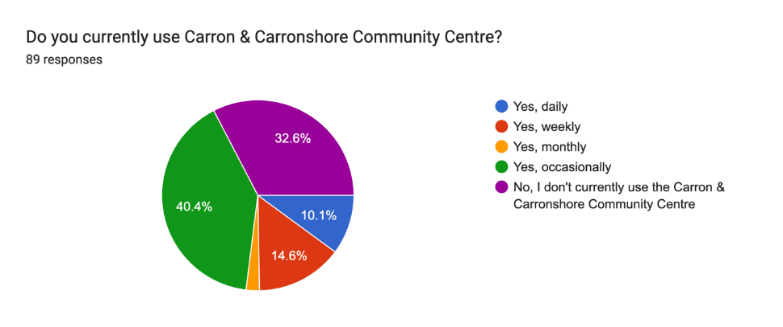
Figure 2: Do you currently use Carron & Carronshore Community Centre?

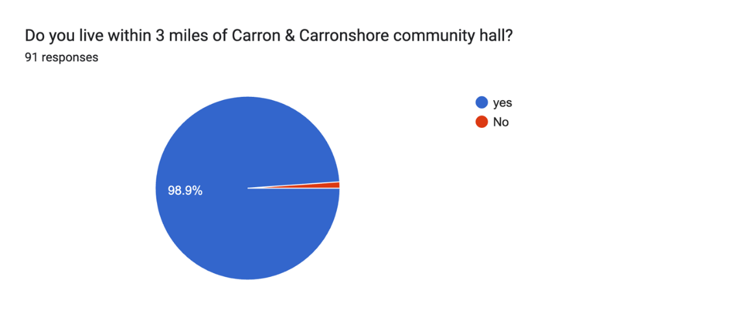
Figure 3: Do you live within 3 miles of Carron & Carronshore community hall?

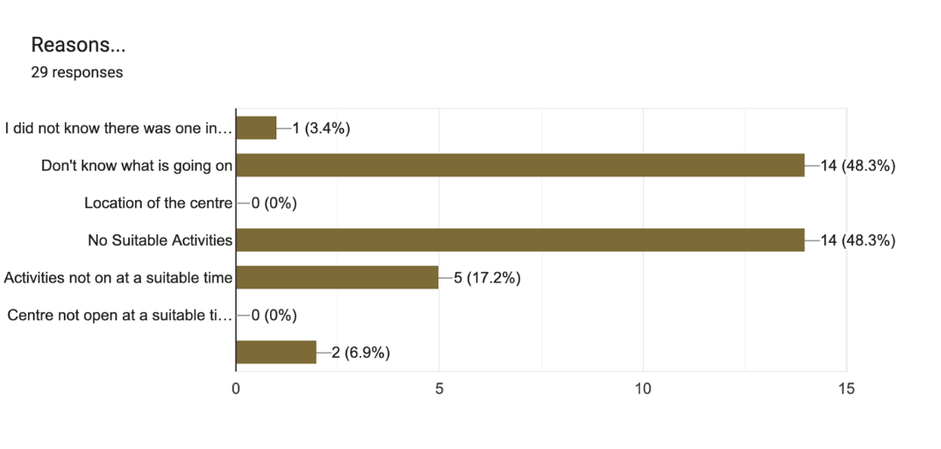
Figure 4: Reasons for not attending the community centre

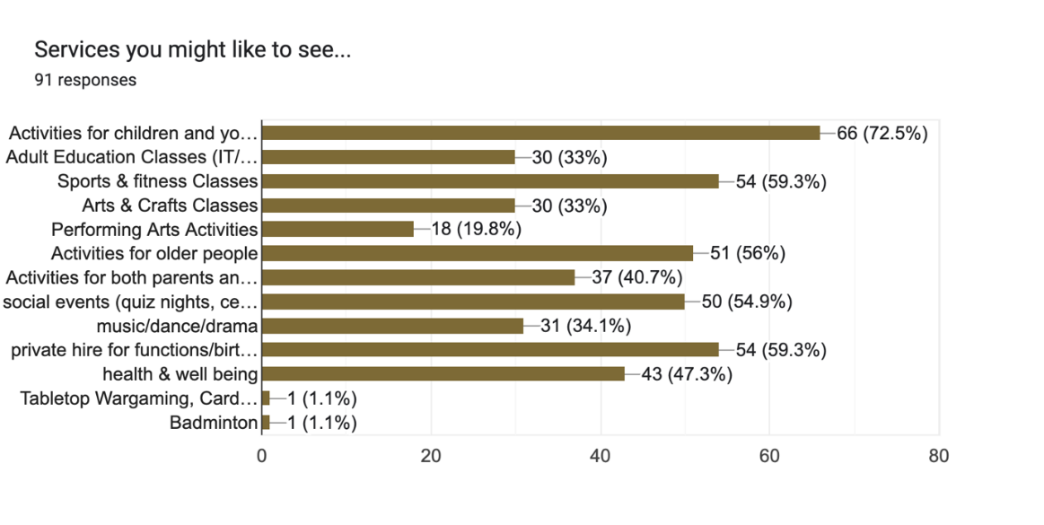
Figure 5: Ideas for services local people would be interested in attending

Community Open Day
We have already started this important process with a Community Open Day on May 25 last year.
Using the simple message - CARRONSHORE COMMUNITY HALL: USE IT OR LOSE IT! - we invited local people to come along to support us and help save it from closure.
We expected 80 people. But on the day, over 200 local residents and their families came along, an extraordinary response.
We believe this shows the commitment they have towards their hall, the last remaining large place in the village for people to meet socially.
The Hall Committee received generous funding to run the event from the National Lottery Community Fund.
This allowed us to arrange free food plus arts and crafts, a toddler bouncy castle, a magician, a free photo booth, a DJ, games and arts and craft stalls.
Collaborating with local groups and residents and listening to local voices is key to the hall's survival.
So, on the day we asked them to tell us what new things they wanted to see in their hall.
We received 37 ideas - from yoga to cake-making, from exercise classes for senior citizens to tap dancing sessions, guitar tuition, book clubs and woodworking classes.
We will carefully research all thirty-seven to see what is feasible in the future. We are delighted that new Yoga classes have already started, chair exercise is scheduled to start in March and we are determined more new lets will follow to provide a regular and sustainable income stream.
This shows the vital importance of engaging with the local community to gauge opinion and meet its needs.
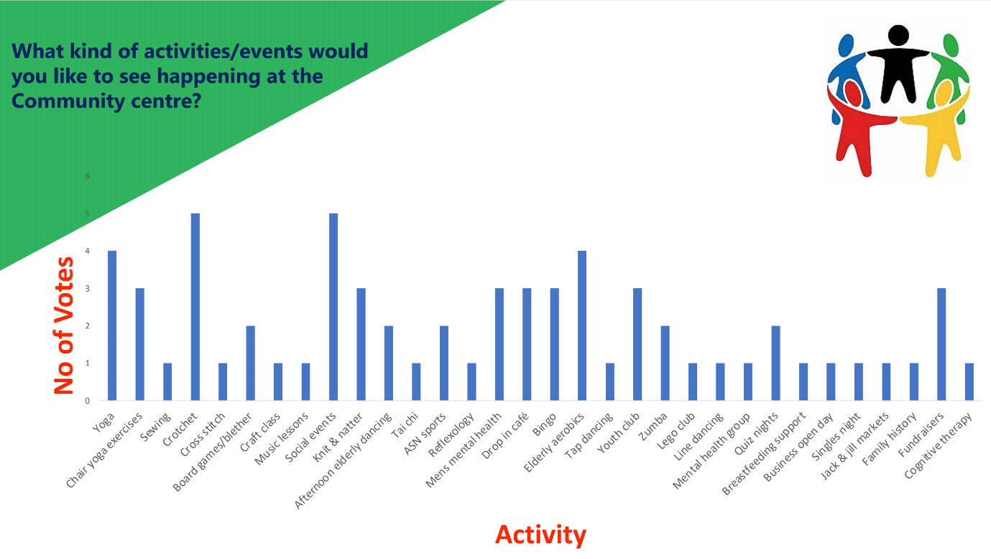
Figure 6 : Community feedback on what they would like to see at the Community Centre
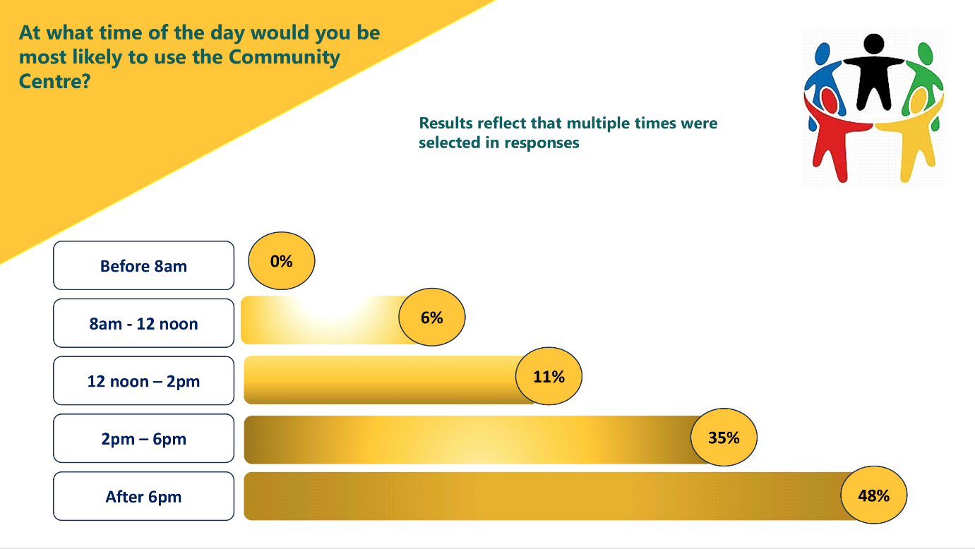
Figure 7 : Community feedback on what time of day they would most likely use the Community Centre

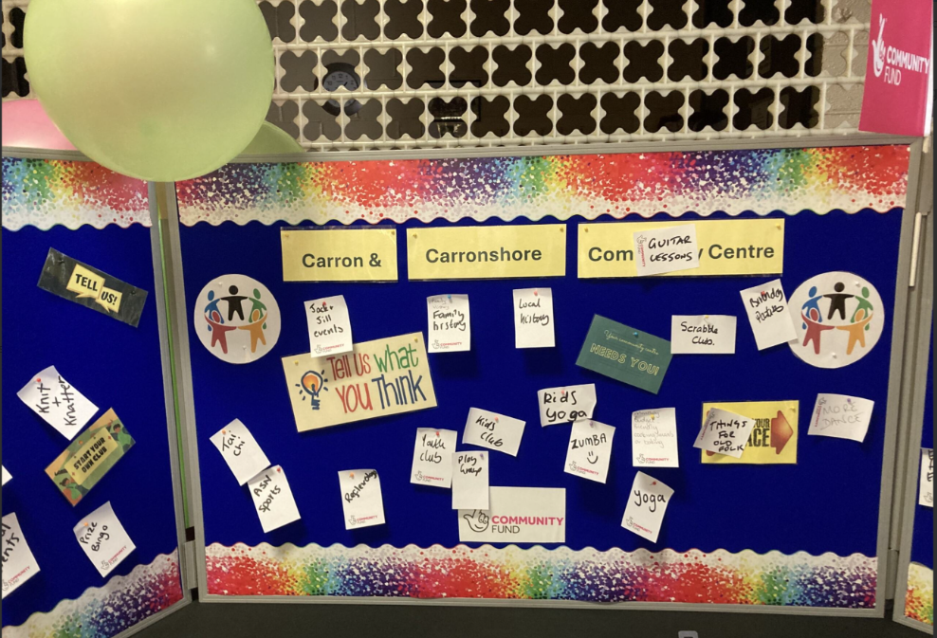
Figure 8: Feedback from the local community on our open day
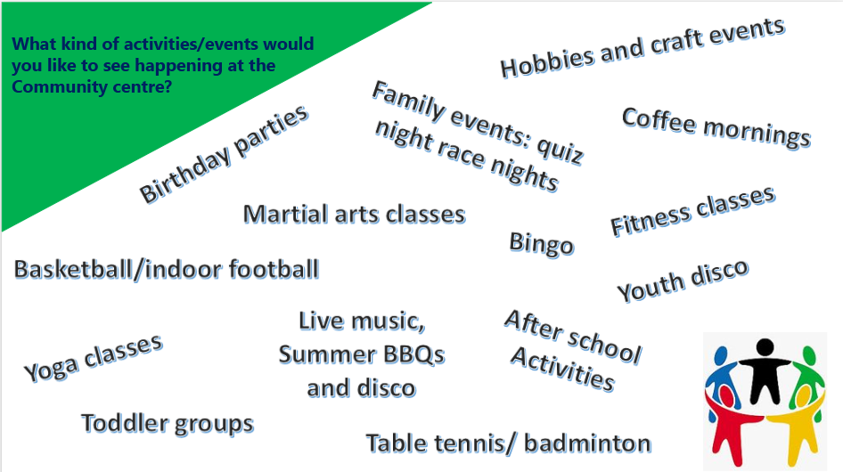
Figure 9: What kind of activities/events the community would like to see

Quotes
‘Your generosity in allowing us to use the Centre regularly for our events has been instrumental in our success. The Centre has become the heart of our activities, providing a welcoming space where our community can come together to learn, share, and celebrate our shared history.’ Carronshore Heritage (Group) Forum
‘Everyone involved with Central Academy are fully supportive of the Hall Committee’s Community Asset Transfer and have pledged to continue to support the upkeep of the hall in the future.’ Central Taekwondo Academy
Attached are letters of support from local users

How We Will Continue to Engage with the Community
We will undertake desk research and compile a list of local groups and organisations which currently are not using the hall. We will then approach them with an invitation to visit the hall and offer them an introductory discount.
We will research the groups using the Dobbie Hall and Falkirk Community Trust gyms and incentivise them to move to our hall by offering discounts.
We will attend appropriate community events - from Gala Days to Remembrance Sundays - to see if there might be a future role for the hall in their planning.
We will invite the owners of local shops and businesses to visit the hall. This will let them see our facilities at first hand, allowing them to use word of mouth to recommend us to their patrons.
Each of our trustees, committee members and volunteers will be tasked with finding just one of their family, friends, neighbours or contacts who might be interested in taking a let.
We need to check regularly how our space fits into wider community needs. We will therefore ensure there is constant dialogue and feedback with our clientele including regular surveys. This will allow us to assess what we are doing well and where we can improve.

5.1.2 Have you consulted with other local stakeholder groups or agencies? Please provide evidence.
We have worked closely with CVS Falkirk & District. They have supported the group with drafting the business plan, finances, governance support and more.
We have met with local MPs, MSPs and Councillors – Brian Leishman, Laura Murtagh, Gary Bouse, Michelle Thompson.
We have received letters of support from Craig Martin Sr.
We are in close contact with all our user groups such as Taekwondo, Stay & Play, JF Dancing, Party Hire, Training Course, Yoga/chair yoga, Fund raising/social, A 2 B Dancing, Sweaty Mamas, Mini Kickers, Sport Massage, Creative Writing.
We work with the Gala Day Committee to offer them the appropriate lets.
We regularly are in contact with other groups who are going through Community Asset Transfer in the Falkirk & District Area.

5.1.4 Have you been in contact with any other communities or community groups
that may be affected? Please give details.
We regularly attend the Community Ownership Group meetings facilitated by CVS Falkirk & District and are in regular contact with other local community groups who are taking on similar buildings through Community Asset Transfer.
We have engaged extensively with the community, our current users and potential future users of the centre. Evidence of this engagement can be found in our appendices.

5.1.5 Please provide any other information you think may be relevant.

- Financial Viability of Project
Your Business Plan should contain full information about the financial viability of the project, evidencing that the organisation will be able to sustain the project in the long term.
Please submit
- at least 1 year’s audited accounts to evidence your organisations financial stability (if available)
- where audited accounts are not available (for instance for new groups) please provide a bank statement.
- a projected 5 year income and expenditure account
- a cash flow forecast for the proposed asset transfer.
6.1 Please outline the Policies and Procedures your organisation has in place to govern the group’s finances
We have submitted our accounts for all previous years that we have been operational to OSCR, complete and on time, as is required of registered SCIOs. Our finances are presented and scrutinised on a quarterly basis at our board meetings. We will follow OSCR’s Guidance and Good Practice for Charity Trustees (oscr.org.uk) to ensure we manage our finances correctly.
The rates for each of our spaces have been set for the coming year, and these will be reviewed yearly at our AGM.

- Funding
  - Please outline how you propose to fund the price or rent you are prepared to pay for the land, and your proposed use of the land.
If you intend to apply for grants or loans you should demonstrate that your proposals are eligible for the relevant scheme, according to the guidance available for applicants.
7.1.1 Please show your calculations of the costs associated with the transfer of the land or buildings and your future use of it, including any redevelopment, ongoing, maintenance and the costs of your activities. All proposed income and investment should be identified, including volunteering and donations.
Please see our Cash Flow for all our planned start up, ongoing, maintenance and planned redevelopment costs. Our Cash Flow also shows all proposed income and investment.
We have fundraisers on a frequent basis to help generate income for the group.
All proceeds from lets will be used to continue or charitable purposes.
We recognise we will require a solicitor to review and negotiate the terms of our agreement.

7.1.2 Please supply details of what funding you have received so far, and of any conditions attached to it.
We received funding from the National Lottery to contribute to the costs of our community fun day, where we were able to really engage with our community and centre users. This helped us to receive some really good and engaging feedback.
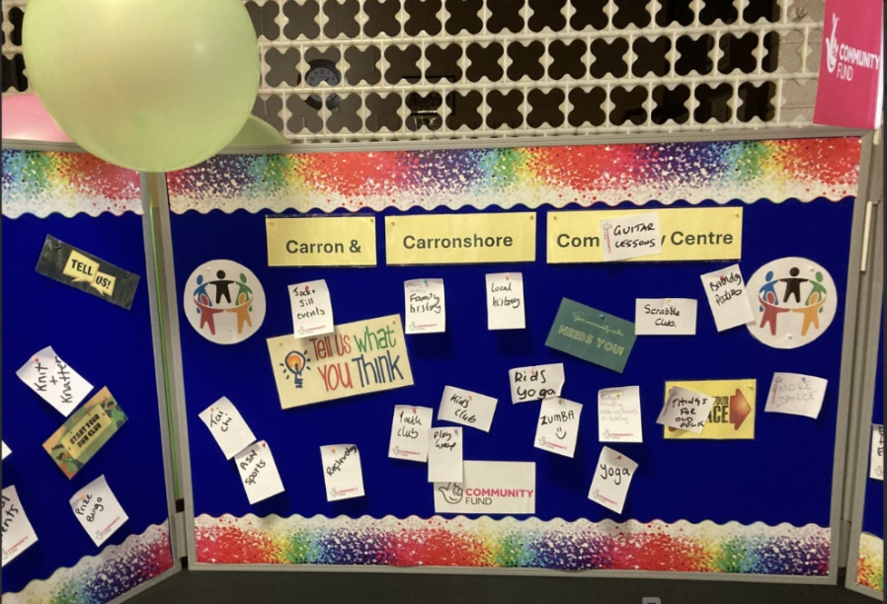
Our feedback board was set up at the community fun day, ready for our community to provide feedback and ideas.
We also received National Lottery funding to help create our Sensory Room within the centre, turning an unused space into a brand new area for our community to use.

7.1.3 Please supply details of any funding you have applied for but have not yet received a response or decision. Please include timescales if known.
We currently have no outstanding funding applications.
We have been successful in 5 funding application in the past 15 months.
National Lottery Community Fund for an Open Day - £1950
National Lottery Community Fund to convert an unused space into a community room for various activities - £3400
FC CEG Capital Equipment for IT for community room - £1289
FC CEG for condition survey - £2640
FC CEG for 2 energy surveys - £4740
National Lottery Community Fund for legal fees - £3,000
7.1.4 Details of any other funding you will have access to? i.e. voluntary contributions, borrowing etc.
We have successfully managed to build up our reserves to a level where we feel comfortable in our ability to take on the asset through community ownership.
Alongside our lettable income, we will also look to hold a number of fundraising events throughout the year, and we also welcome donations from the community, local businesses, and other groups.

7.1.5 Please outline your funding strategy if you have one, as well as any other relevant information.
We recognise that there is a need to continually update and upgrade our facilities, and we keep up to date with the various funding opportunities available to us, thanks to our local third sector interface, CVS Falkirk & District.
We have developed the following funding strategy that includes funders we have researched and we aim to apply to in the future.

- Enablement Fund
Falkirk Council will hand the building over wind and watertight and compliant. However, this is quite light-touch and would involve (for example) patching of a leaky roof. For more significant building works, groups can apply to the Enablement Fund, to pay for capital improvements such as energy efficiency improvements or larger capital renewals which support the viability of the project going forward. Only capital items are eligible. Running repairs are revenue costs and are not eligible. You are strongly advised to email strategicpropertyreview@falkirk.gov.uk to confirm eligibility criteria before you submit this application.
Requests to the Fund must be supported by estimates / quotations from professionals which should be provided as supporting documents.
Please provide details of your request to the Enablement Fund, if applicable.
Enablement Fund request for larger capital renewals which support the viability of the CAT
Item | Estimate Provided By | Amount not more than (including VAT)
Business Management System & Control Panel Installation | [REDACTED] | £61,710.96
Loft Insulation | [REDACTED] | £6,000
Suspended Ceiling Insulation | [REDACTED] | £9,600
Heating and Cooling Controls | [REDACTED] | £3,600
Solar PV & Battery | [REDACTED] | £20,400
Lighting Systems, Fitting and Controls | [REDACTED] | £6,000
Flat Roof | [REDACTED] | £11,600
Cavity Wall | [REDACTED] | £14,498
Air Source Heat Pump | [REDACTED] | £36,000
Radiant Heating Units | [REDACTED] | £18,000
New Radiators | [REDACTED] | £5,370.67
Total including VAT |  | £192,779.63

Checklist of accompanying documents
To check that nothing is missed, please tick which additional documents are accompanying this form.
☒Section 1 – You must attach your organisation’s constitution, articles of association or registered rules
☒Section 2 – Any maps, drawings or description of the land requested
☒Section 3 – Note of any terms and conditions that are to apply to the request
☒Section 4 – Any additional evidence regarding your proposals, their benefits, any restrictions on the land or potential negative consequences, and your organisation’s capacity to deliver.
☒Section 5 – Evidence of community support
☒Section 6 – Financial – Copies of accounts, forecasts, etc
☒Section 7 – Funding – Copy of Business Case etc
☒Section 8 – Enablement Fund – copies of estimates

Declaration
Two office-bearers (board members, charity trustees or committee members) of the community transfer body must sign the form. They must provide their full names and home addresses for the purposes of prevention and detection of fraud.
This form and supporting documents will be made available online for any interested person to read and comment on. Personal information will be redacted before the form is made available.

We, the undersigned on behalf of the community transfer body as noted at Section 1, make an asset transfer request as specified in this form.
We declare that the information provided in this form and any accompanying documents is accurate to the best of our knowledge.
Name [REDACTED]
Address [REDACTED]
Date 27th June 2025
Position Trustee
Signature [REDACTED]

Name [REDACTED]
Address [REDACTED]
Date 27th June 2025
Position Management Committee Treasurer
Signature [REDACTED]

