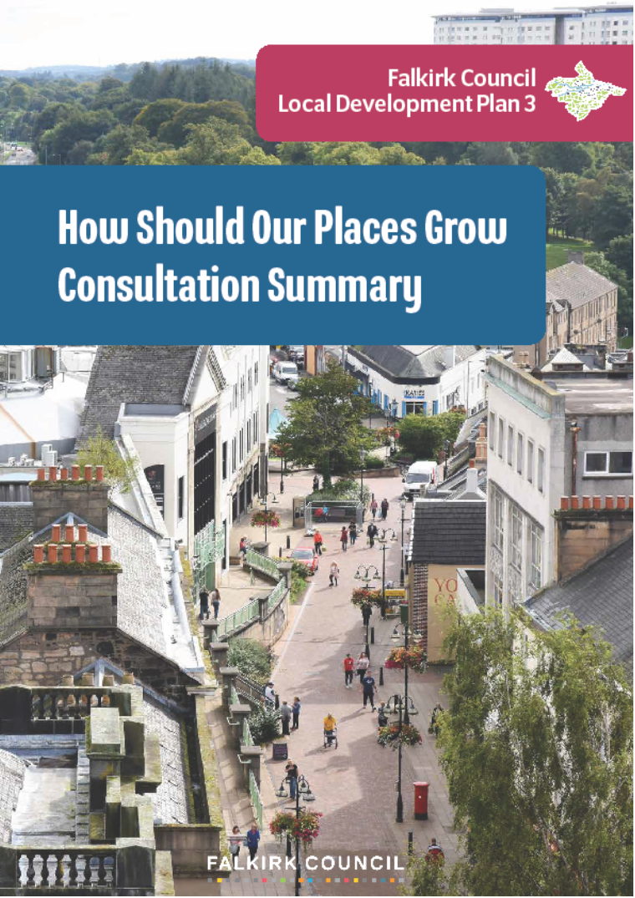
Contents
1. Introduction 1
2. How the Consultation was Carried Out 1
3. Number of Survey Responses 2
4. Profile of Survey Responses 2
Type of Respondents 2
Connection to the Council Area 3
Ethnicity 4
Age 5
Gender 5
Disability, Health Condition and Caring Responsibilities 6
Settlement Area 7
5. Analysis of Responses to Main Survey Questions 8
Place and Wellbeing 8
Climate and Nature 9
Infrastructure 10
Homes 12
Business 14
6. Conclusion and Next Steps 15

Introduction
    - This report presents the findings of our ‘How Should Our Places Grow?’ consultation that was carried out to shape the Proposed Plan for the Falkirk Local Development Plan 3 (LDP3). LDP3 is an important document that will guide growth and change across the council area for the coming years, setting out where development should and should not take place, what infrastructure is needed to support growth, and how our environment and greenspace can be improved. It will become part of the development plan for the area on its adoption and will be used alongside Scotland’s National Planning Framework to decide future planning applications for development in the area. The plan will replace the current Falkirk Local Development Plan 2 and cover a 10-year period.

    - Local development plans take many years to prepare and involve many stages. The process is set by planning legislation and guided by the Scottish Government's Local Development Planning Guidance. Our Development Plan Scheme sets out the revised timetable for LDP3 as well as an updated programme for engaging and consulting people on this new plan.

    - You can get regular news on the new plan by following us on Participate Plus and Facebook or by email by subscribing to our Development Plan Update. If you have any questions about LDP3, please contact us at ldp@falkirk.gov.uk .

How the Consultation was Carried Out
    - Our ‘How Should Our Places Grow?’ consultation was open to everyone and ran for 7 weeks, starting on 3 October 2025 and closing on 21 November 2025. There were multiple ways for people to take part in the consultation and express their preferences and feedback on the direction of the plan’s emerging spatial strategy. Methods included an online survey on the Council’s LDP3 Participate Plus webpage, and scheduled drop-in events with Planning Officers in attendance. Paper copies of the survey were available at all libraries and also on request. The drop-in events took place at various dates during the consultation period at venues including:
- Slamannan Library
- Denny Library
- Bo’ness Library
- Bonnybridge Library
- Grangemouth Library
- Falkirk Library
- Meadowbank Library
- Larbert Library
- Forth Valley College

    - There was varied attendance at the drop-in events, and the busiest events were at Bo’ness and Meadowbank libraries. Most people, however, accessed the consultation on the LDP3 Participate Plus webpage which received 2,873 visitors during the seven week consultation period.

    - Key stakeholders were made aware of the consultation through social media, press releases, and e-mailings to those registered on the LDP contact database. The consultation was also publicised on the LDP3 Participate Plus webpage and Council’s website. Information banners were placed in all public libraries, giving useful background to the consultation and a QR code to encourage those with mobile devices to access the survey online. In addition, a short video on the Council’s Youtube channel was shared through various channels to help explain the consultation. To date, the video has over 90 views.

    - The consultation followed on from the ‘Call for Sites and Ideas’ which ran from January to May 2025 and which gave developers and landowners the opportunity to suggest sites they wished to have considered for inclusion in the Proposed Plan. At the start of the consultation, we published an interactive map of the sites submitted. This map provides the location of each site and basic information including its proposed use, size and a copy of the masterplan or layout (if one was provided). Stakeholders were also able to view paper copies of the map and ask questions about the sites and site assessment process during the drop-in sessions.

Number of Survey Responses
    - Our ‘How Should Our Places Grow?’ consultation received a total number of 311 responses of which 297 were completed online surveys and 14 were completed paper copy surveys. Some emailed and letter comments were received including from Homes for Scotland and Lovell Strategic Land. It was not practical to account for these comments in the analysis of the survey but we have noted them.

Profile of Survey Responses

Type of Respondents
    - 94.5% (or 294) of the 311 survey responses were from members of the public. Community councils or community groups accounted for 1.9% (or 6) of responses. Local businesses comprised 1.3% (or 4) of responses while respondents categorise as ‘other’ represented 2.3% (or 7) of responses.
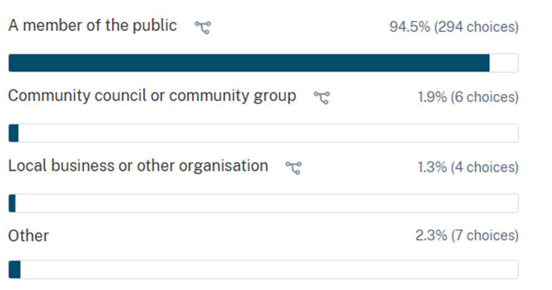

    - Respondents included:
- Barratt Redrow PLC
- GrowGreen
- Miller Homes
- Ogilvie Homes Ltd
- Hargreaves Land
- Scottish Rights of Way and Access (ScotWays)
- Polmont Community Council
- Reddingmuirhead and Wallacestone Community Council

Connection to the Council Area
    - The following analysis excludes all paper copy survey responses (14 in total) as they did not contain data on respondents’ connection to the council area. Only the 297 online survey responses had this information. Most respondents indicated a direct connection to the council area. 71% (or 210) of respondents identified as living within the area. 24% (or 71) of respondents identified as both living and working in the area. Only a small number of respondents indicated that they work in the area only or have another form of connection.

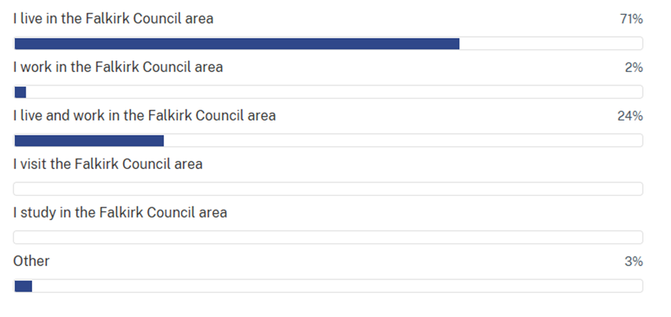

Ethnicity
    - The following analysis excludes all paper copy survey responses (14 in total) as they did not contain data on respondents’ ethnicity. Only the 297 online survey responses had a degree of ethnicity information. Of those responded to the online survey, 53% (or 157) of respondents identified as white Scottish, 6% (or 18) identified as white other British. 2% (or 6) identified as white European and 1% (or 3) identified as white other ethnic group. 36% (or 111) of respondents’ ethnicity was unknown as they did not provide an ethnicity response. 2% of respondents (or 6 people) preferred not to say their ethnicity.

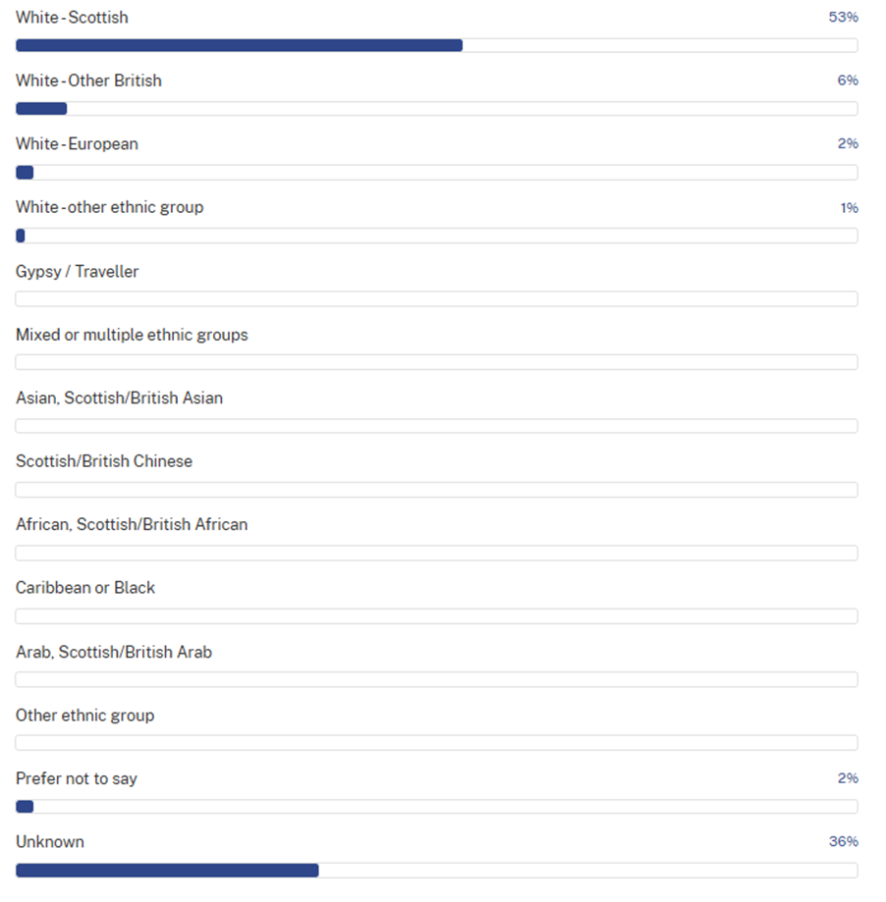

Age
    - The following analysis excludes all paper copy survey responses (14 in total) as they did not contain data on respondents’ age. Only the 297 online survey responses had age data. 53% (or 157) of online survey responses were from people aged between 35 and 64. 11% ( or 33) of responses were from the 25 to 34 years age group. The age groups with the least responses include up to and including 24 years of age (with 3% or 9 of responses) and the 75 plus group (with 2% or 6 of responses).

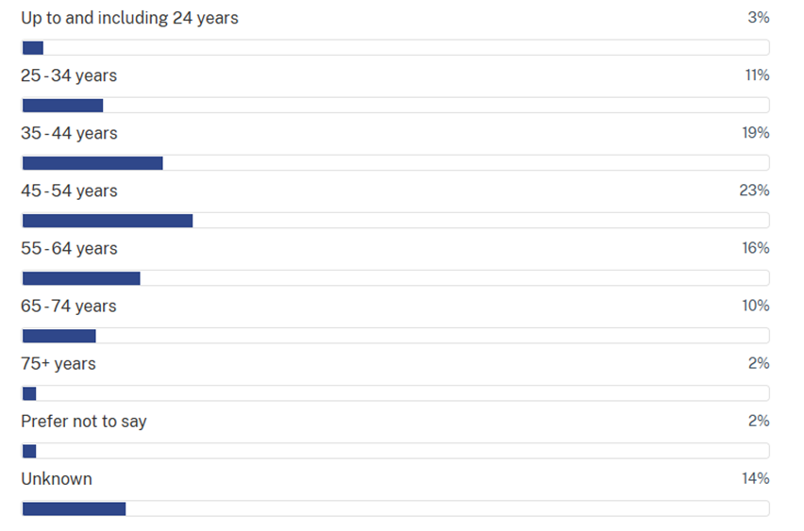

Gender
    - The following analysis excludes all paper copy survey responses (14 in total) as they did not contain data on respondents’ gender. Of the 297 people who responded to the online survey, 40% (or 119) identified as female and 26% (or 77) as male. The gender of 30% (or 89) respondents was unknown and 4% (or 11) of respondent preferred not to say their gender.
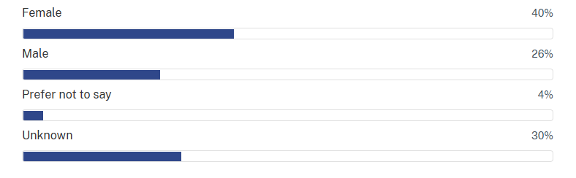

Disability, Health Condition and Caring Responsibilities
    - The following analysis excludes all paper copy survey responses (14 in total) as they did not contain data on respondents’ disability, health condition and caring responsibilities. Of the 297 people who responded to the online survey, 62% (or 184) stated they have no disability or health condition. 18% (or 53) indicated that they have a disability or health condition. Disability or health condition status was unknown for 16% (or 48) of respondents. Lastly, a number of respondents indicated that they are involved in caring for someone living with a disability or health problem.
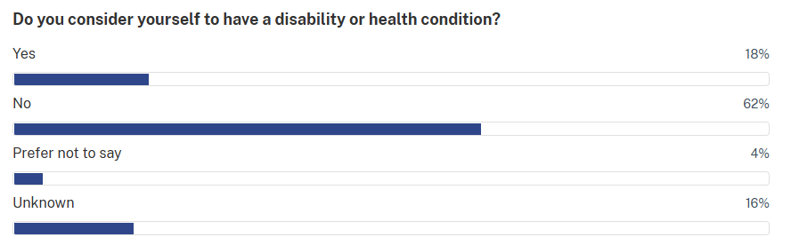

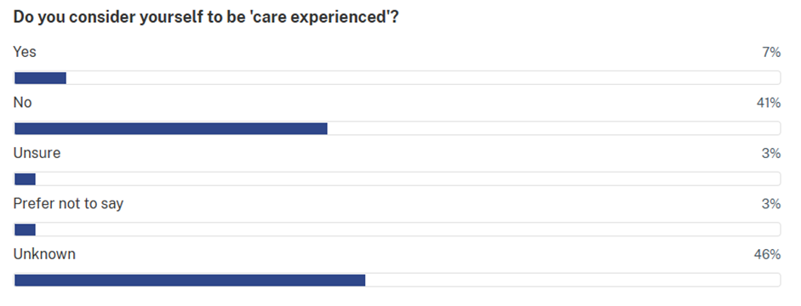
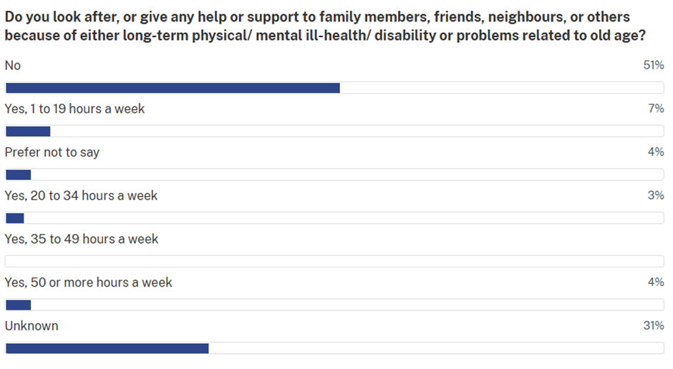

Settlement Area
    - The following analysis accounts for all online and paper copy survey responses (311 in total). Ward 9 - Upper Braes constituted 53% (or 165) of responses while the Ward 8 - Lower Braes comprised 20% (or 62) of responses. Together, the two wards represented 73% of all responses. Ward 1 - Bo’ness and Blackness represented the next highest proportion of respondents comprising 7% (or 22) of responses. Ward 4 - Care, Kinnaird and Tryst, Ward 6 -Falkirk North and Ward 7- Falkirk South each comprised 4% (or about 12) of responses. Ward 2 - Grangemouth, Ward 3 - Denny and Banknock and Ward 5 - Bonnybridge and Larbert each represented 1% (about 3) of responses. 5% (about 16) of responses were from ‘somewhere else’.

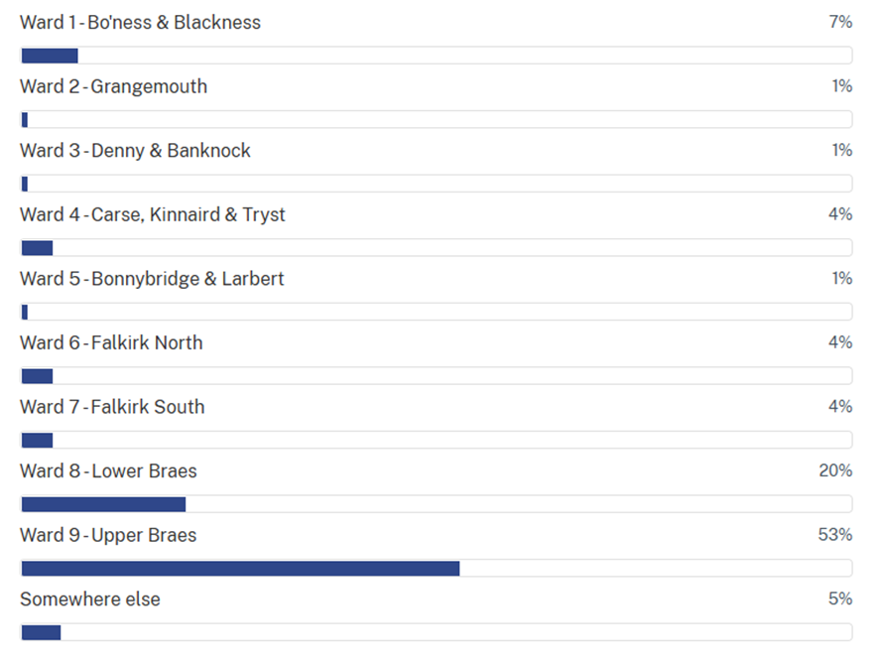

Analysis of Responses to Main Survey Questions
    - This part of the report provides a summary of the online survey and paper copy responses (311 in total) to the main survey questions. These questions were grouped around the LDP3’s five strategic themes of Place and Wellbeing; Climate and Nature; Infrastructure; Homes; and Business;

Place and Wellbeing
    - For this theme, respondents were asked to select their top three priorities for improving their place from a set list. The results are shown in the bar graph below:
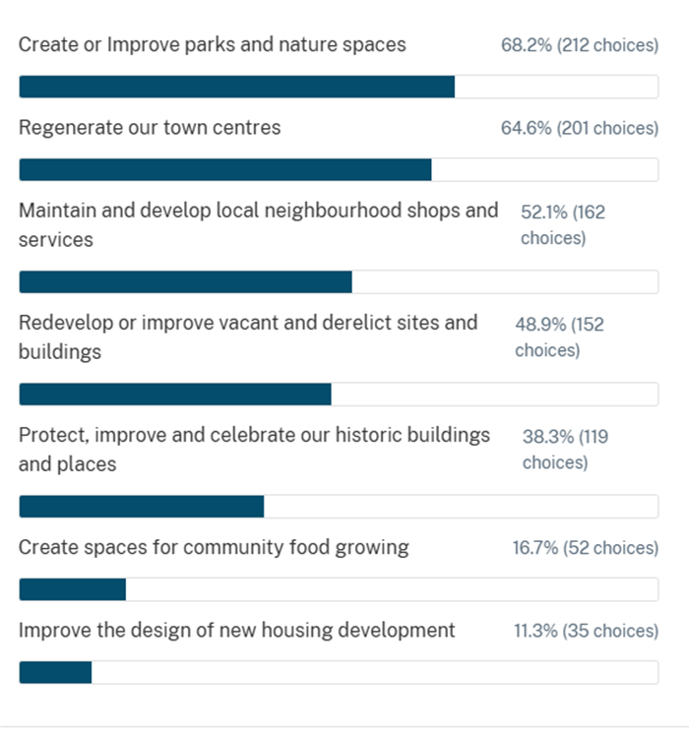

    - A majority of respondents identified the creation and improvement of parks and natural spaces as a key priority (68.2%), closely followed by the regeneration of town centres (64.6%). Roughly half the responses selected maintaining and developing local neighbourhood shops and services (52.1%) and redeveloping or improving vacant and derelict sites (48.9%) as priorities. The lowest scoring priorities were creating spaces for community food growing (16.7%) and improving the design of new housing developments (11.3%).

    - In the survey, respondents were asked: “Have you any other comments on how the Local Development Plan can make your place healthier and more attractive?”. This question was optional to answer. Most respondents mentioned they strongly oppose housebuilding on greenfield sites, particularly in Bo’ness and the Braes, and emphasised the need to protect existing green spaces. Respondents highlighted that local infrastructure (schools, health services, roads, public transport etc.) is already overstretched and must be improved before any new housing development should take place. Suggested improvements include better walking and cycling routes, safer paths, and enhanced public transport. Respondents also mentioned new or improved community and leisure facilities alongside better maintenance of public spaces and action on environmental issues like biodiversity loss. Overall, respondents indicated the protection of green spaces and improving infrastructure as key priorities in their place.

Climate and Nature
    - Under this theme, respondents were asked to select their top three priorities for tackling climate change and supporting nature in their place from a set list. The results are shown in the bar graph below:
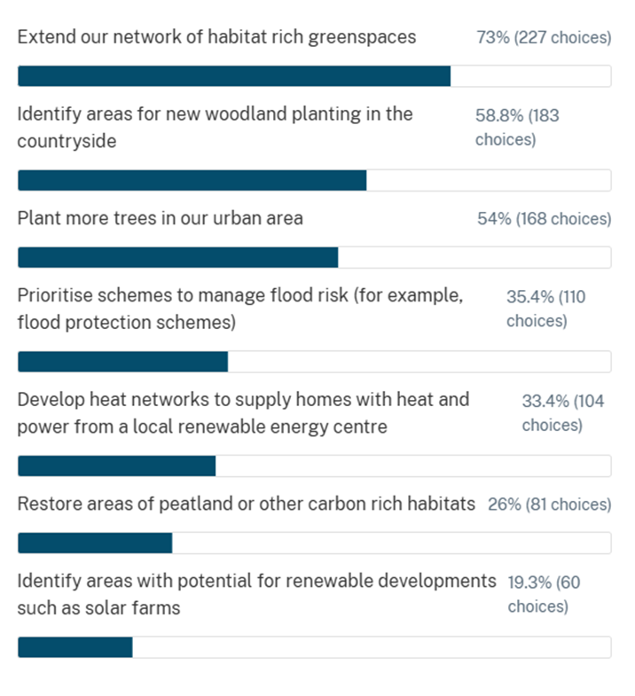
    - Extending greenspaces was the highest rated option, supported by 73% of respondents. New woodland planting in the countryside (58.8%) and urban tree planting (54%) were also identified as key priorities. Measures such as flood management schemes (35.4%), heat network development (33.4%), and peatland or habitat restoration (26%) received more moderate support. Identifying areas for renewable developments, such as solar farms were the least popular option, though nearly 20% of respondents expressed support.

    - Respondents were asked “Have you other comments on how the Local Development Plan could help tackle climate change and the nature crisis in your place?” This question was optional to answer. Most respondents called for improved public transport, including better bus routes, electric buses, and reduced reliance on cars. Many expressed strong concerns about the loss of green spaces and farmland, supporting the continued protection of the area’s Green Belt and prioritising the development of brownfield land first. Tree planting and community growing initiatives were welcomed by respondents and some respondents emphasised the need to protect existing trees and improve access to electric vehicle (EV) charging. Several people raised worries about the impacts of large developments, including air quality issues, and there were specific objections to new data centres.

Infrastructure
    - For this theme, respondents selected their top three priorities for future investment in infrastructure in infrastructure in the Council. The results are shown in the bar graph below:
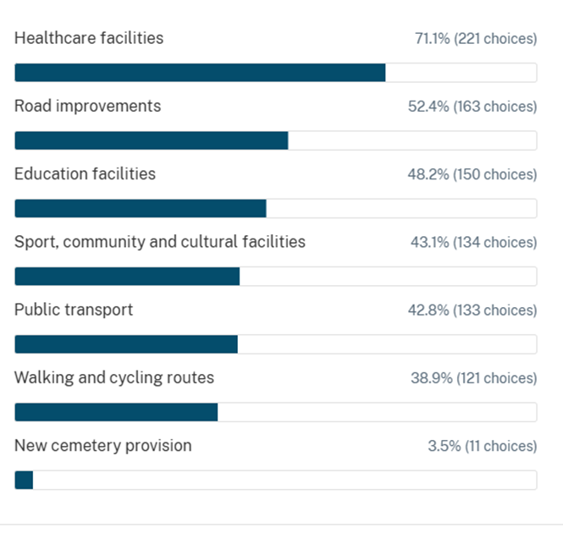

    - Healthcare ranked the most important consideration to respondents (71.1%), while approximately half of responses selected road improvements (52.4%) and education facilities (48.2%) as being a top priority for future investment in the area. Investment in sports, community and cultural facilities (43.1%), public transport (42.8%) and walking and cycling routes (38.9%) received similar number of choices from respondents.
New cemetery provision received just 3.5% of choices.

    - Respondents were asked “Have you any comments on specific infrastructure needs in your area?”. This question was optional to answer. Many respondents said infrastructure has not kept pace with new housing developments and has resulted in increased pressure schools, health services, and the local road network. Several respondents highlighted the need for more community facilities—particularly for children and young people—such as sports centres, swimming pools, and leisure spaces. The loss of community hubs, social spaces, and GP surgeries was also highlighted. Overall, the responses reflected frustration with the lack of infrastructure investment alongside development and a strong desire for enhanced community, leisure, and health facilities.

Homes
    - The supply of new and affordable housing is a key priority for LDP3. The survey included eight statements about how new homes should be planned in the Council area as a whole. Respondents were asked to specify their level of agreement or disagreement for each statement. The results are shown in the table below:
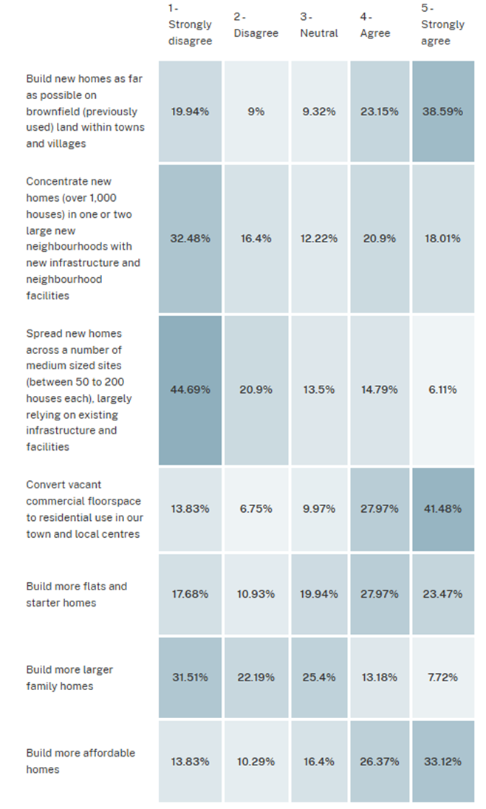

    - Most respondents were supportive of developing brownfield land within existing towns and villages with 38.6% strongly agreeing and 23.2% agreeing. Many were not supportive of concentrating new homes in one or two large new neighbourhoods with 32.5% strongly disagreeing and 16.4% disagreeing. Some support was shown with 20.9% agreeing and 18.0% strongly agreeing On balance, most people disagreed with spreading new homes across a number of medium sized sites (between 50 to 200 houses each) with 44.7% strongly disagreeing and 20.9% disagreeing. There was a strong preference for converting commercial floorspace in town and local centres into residential use with 41.5% of respondents strongly agreeing and 28.0% agreeing Generally, most respondents were supportive of more flats and starter homes within 23.5% strongly agreeing and 28.0% agreeing. The majority of responses indicated a lack of support for more larger family homes being built with 31.5% strongly disagreeing and 22.2% disagreeing. Conversely, it was evident that most responses favoured an increase in affordable provision with 33.1% of respondents strongly agreeing and 26.4% agreeing.

    - Respondents were then asked, “Have you any specific comments on the location and type of new homes which could be built in your area over the next 20 years?”. This question was optional to answer. Many respondents voiced their strong opposition to new housing on greenfield sites - particularly around Wallacestone, Standrigg Road, and other areas with limited infrastructure - citing the loss of greenspace and impacts on village character. Infrastructure capacity was cited as a major concern, with calls for adequate schools, healthcare, shops, public transport, and road improvements before any further housing developments take pace. Some suggested creating ‘new self-contained villages’ in the Braes or prioritising urban brownfield sites instead of expanding existing settlements. Some respondents welcomed small scale developments that would not overwhelm local services, and many emphasised the need for meaningful community engagement. Overall, respondents favoured protecting greenfield areas, improving infrastructure, and focusing on well planned development that maintains the local character and identity.

Business
    - Economic development is another key priority for the plan. The survey included five statements about our local economy could be developed. Respondents were asked to specify their level of agreement or disagreement for each statement. The results are shown in the table below:
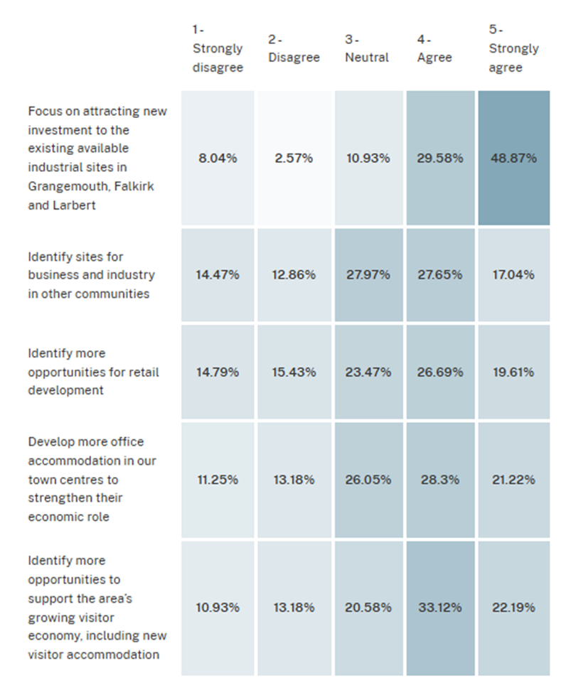
    - The vast majority of responses favoured focusing on attracting new investment to the existing available industrial sites in Grangemouth, Larbert and Falkirk. 29.5% agreed with this alongside the 48.9% that strongly agreed. The balance of responses indicated support for identifying businesses and industry in other communities. There was support for more opportunities for retail development in the Council area and most responses welcomed more office accommodation in our town centres and more opportunities to support the area’s visitor economy.

Conclusion and Next Steps
    - Our ‘How our places should grow?’ consultation provided valuable feedback to shape the spatial strategy of the proposed Falkirk Local Development Plan 3 (LDP3). Overall, participants expressed an overriding preference for prioritising brownfield land for housing development. There was strong support for starter homes and affordable housing but generally comments were against large and medium sized housing developments on greenfield land. Many highlighted concerns with infrastructure capacity, and the need for investment in community facilities, such as schools and local primary healthcare. Habitat creation, woodland and tree planting were seen as the highest priorities for tackling the climate and nature crisis. It was clear from the survey responses that many prioritised new investment in town centres and improving local shopping. The vast majority of responses favoured focusing on attracting new business investment to the existing available industrial sites in Grangemouth, Larbert and Falkirk.

    - The Proposed Plan will set out the Council’s settled view on the spatial strategy, under the themes of place and wellbeing, climate and nature, homes, business and infrastructure. The plan is expected to be published for formal public consultation in early 2027 and this will provide the opportunity for stakeholders to make representations in support or objection to the plan. We will publicise the consultation extensively through local newspapers, our e-mailings, neighbour notification and on the Council's website, social media and LDP3 Participate Plus webpage.

